T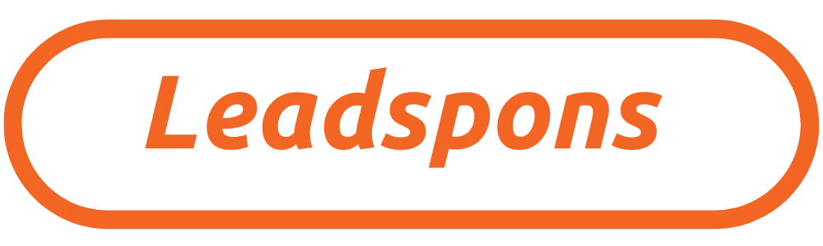
Sebastian flute
Geogwang ENG Co., Ltd. Amazon store entry and marketing agreement
We create the best marketing results for our CEO and employees.

Product: SEBASTIEN FLUTE

We produce the best sales results for our CEO and employees. Meet clients and potential customers
Classification | Detail | Requirements
Contract period | 5 weeks from start date | 5 weeks from start date
Payment details | Week 1 expense : 100 900,000 won | Check product details, provide required documents, Amazon store opening information, Information on product listing contents
Payment details | Week 2 expense :100 900,000 won | Competitor product prices and shipping costs; Check logistics costs, warehouse costs, Product details in English, trademark application information (country of entry)
Payment details | Week 3 expense : 100 900,000 won | Setting goals, establishing strategies, selecting content distribution channels, Product search SEO settings
Payment details | Week 4 expense : 100 900,000 won | Final marketing video production and store entry preparation completed, store entry document process completed
Payment details | Week 5 expense : 100 900,000 won | Customer Results Presentation  Reporting, documentation and performance reviews  Additional support, follow-up
Total contract amount | (New customer company 500, 500,000 won discount) 4.5 million won (VAT included) | entire Week 5 progress

Geokwang ENG Co., Ltd. (hereinafter referred to as “A”) and Leadspons.com Korean operator Time & Future Co., Ltd.(hereinafter referred to as “”) is as follows:Geogwang ENG Co., Ltd. enters Amazon stores and produces marketing content‘Conclude a contract.

Article 1 [Purpose of contract]
This contract is between “Party A” and “Party B.”Geogwang ENG Co., Ltd. enters Amazon stores and produces marketing content’ The purpose is to determine all necessary matters in entrusting the contract and the rights and obligations relationship between “A” and “B.”

Article 2 [Contents of Contract]
The details of the contract between “A” and “B” are as follows.

Qualitative sales results | Quantitative operating results
[Week 1 to 5 results report included]  Provides 15 types of analysis data | [Week 1 to 5 result DB delivery details]  Collection guarantee according to affiliates and interested parties
  List of provided items
  initial consultation | data collection | SWOT analysis
  Official Interview | industry research | Market segmentation
  Persona development | competitive analysis | Market Opportunity Identification
  Campaign development | Content Creation | Campaign Management
  performance review | Additional support | follow up
  Content distribution | Quantitative evaluation A/S | Completion report
  List of provided items
  - Download, application, overseas branch contact (including personal information), inquiry reservation
  - Delivery, fulfillment, Compared to competitors' prices Optimal price setting CPA (Cost Per Action) conversion settings, etc.
  - Guaranteed click conversion after marketing settings (potential customer conversion)
  - Production of more than 20 types of sales content (PC, Mobile, etc.)
  - Collect and provide more than 100,000 of the latest CPA advertising keywords
  - DA domain authority top level linkage work
  (Linked to TOP 1-30% worldwide)
[Table] Guarantee table for providing digital sales results for quantitative and qualitative results

Article 3 [Payment and progress of contract and down payment]

’ in accordance with this Agreement Geokwang ENG Co., Ltd. Amazon store and marketing contract’ In business, “Party A” and “Party B” may proceed with a contract even in the following cases.
1. In relation to depositing funds, “Party A” deposits the down payment in Korean Won to “Party B”.
(IBK Industrial Bank of Korea Co., Ltd. Time & Future: 490-085441-04-018) (Corporate Account)
2. After the contract between ‘A’ and ‘B’ begins, if the sales process development details are not delivered to ‘A’ within the contract period, a refund will be issued for the relevant portion. Refund means that the items in Article 2 [Contract Details] above are not delivered to ‘A’.
3. After the contracted information has been provided to ‘A’, no refund is possible, and if the contract is terminated due to circumstances of ‘A’, ‘B’ can rightfully claim the amount for the results of the business information provided to ‘A’.
4. In accordance with relevant laws and regulations, if “Party B” is unable to proceed due to war, natural disaster, force majeure, etc., “Party B” may refund all other amounts excluding the operating expenses incurred up to that point.
5. The start date begins on November 5, 2024.

Article 4 [Mutual Obligations]

“A” and “B” conduct weekly marketing according to the above marketing schedule, and the marketing company reports weekly to the customer and delivers supplies for digital sales in accordance with the contract. Work will be carried out by agreement on the schedule verbally or via messenger, and if Party A requests, information will be delivered to the customer within 1-3 business days through any available communication medium such as verbal communication or messenger. In addition, we promise to carry out all tasks in good faith between the customer and the sales agency.

Article 5 [Copyright-related matters/Confidentiality]
In relation to this contract, “Party A” holds the copyright for the final work related thereto and agrees as follows.
1. “B” does not disclose any final business details or business details of “A” and does not pass them on to third parties. (Confidential)
2. “B” is not responsible for portrait rights and copyright issues that arise separately within the source provided by “A”.
3. “Party B” can use the development results in its own portfolio after citing the source (with Party A’s consent after completing the results).

Article 6 [Contract period and A/S guarantee]

1. The contract between “A” and “B” for the above project is deemed to have been established when “A” deposits the down payment for the contract to “B,” and takes effect immediately.
2. Each stage begins when the deposit amount for each stage is deposited from “A” to “B,” and no refunds are possible for tasks that have been completed.
3. Quantitative evaluation (numerical results): For the customer (A), the marketing company (B) guarantees free after-sales service for one month to provide a quantitative database and results, and provides 100% quantitative and qualitative results according to the numbers.

Article 7 [Other Matters]
Each party is responsible for reporting and meeting its own tax compliance obligations arising under this Agreement. Each party operates its business legally in accordance with the policies of the country in which it operates, and as necessary, proceeds in accordance with relevant laws and regulations. The digital marketing agency signs a contract for the customer (client company) for digital marketing sales tasks in good faith, including free result guarantee services, and may file an objection to the competent court in the event of a dispute.

November 04, 2024

Customer | Digital sales executive
Company name : Geokwang Engineering Co., Ltd.  Korean business registration number : 301-86-32506  mail : mjis1@hanmail.net  Representative name : Kim Tae-heung (Senior) | Company name : Time & Future Co., Ltd. ( TimeandFuture.com )  Korean business registration number : 498-81-03673  mail : info@leadspons.com  Representative name : Yeom Seung-min (person)

