On the Job training 3 for Auto Marketing and Sales
for PM and Marketing Manager
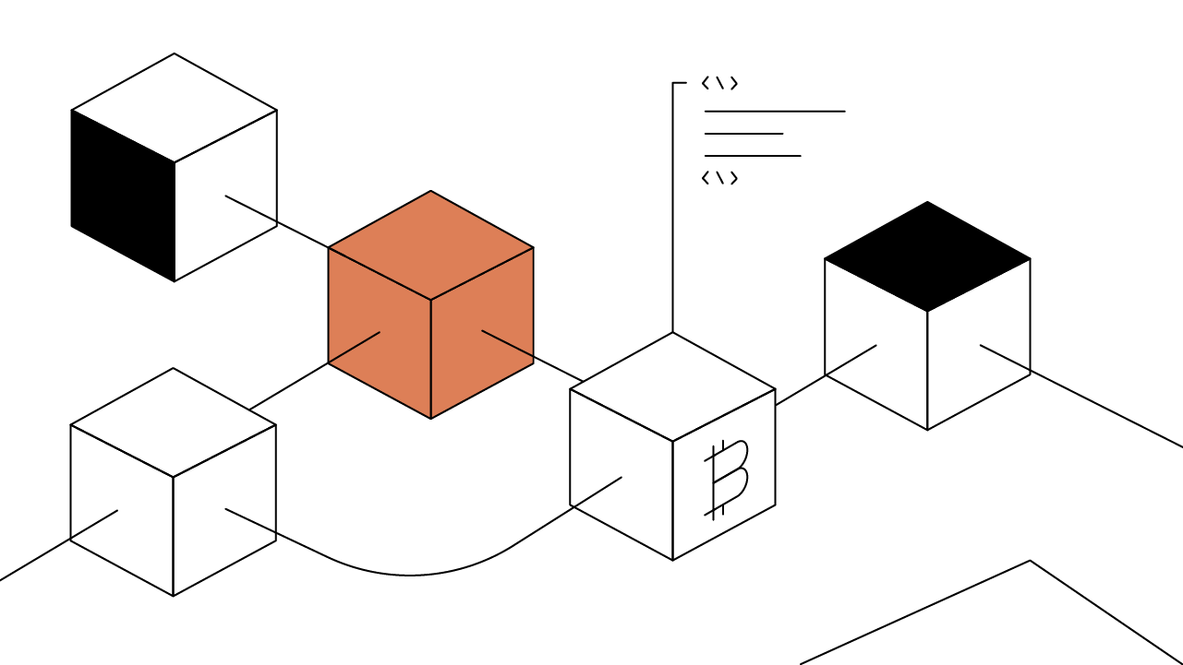
[Summary of IDO (Initial Dex Offering or Launchpad for the fundraising)]

1) Linkedin Automation : Automatic Sending + Reply to clients
2) Email Sales : VIP email sending + with Email expert
3) Thumbnail for each posting
4) Youtuber, Tiktoker Management
5) Google Ads (Key word marketing : Passive income, Auto income)

1) Linkedin Automation : Automatic Sending + Reply to clients
https://pro.fiverr.com/burakerdem/build-you-an-automated-linkedin-lead-generation-funnel?context_referrer=search_gigs_with_recommendations_row_3&source=top-bar&ref_ctx_id=5f18936d79a09bba43149296e91cd4f7&pckg_id=1&pos=3&context_type=auto&funnel=5f18936d79a09bba43149296e91cd4f7&imp_id=28b96783-8acc-4d68-9679-ba8ce011a7df

2) Email Sales : VIP email sending + with Email expert
https://pro.fiverr.com/taimoorali146/create-high-conversion-flows-in-klaviyo?context_referrer=search_gigs_with_recommendations_row_3&source=top-bar&ref_ctx_id=cb9623c4bd1bc76bec165ac3b35af470&pckg_id=1&pos=2&context_type=auto&funnel=cb9623c4bd1bc76bec165ac3b35af470&fiverr_choice=true&imp_id=90f94c41-64c4-4ab9-b2a4-debe21787550

3) Thumbnail for each posting https://pro.fiverr.com/jerrygraphicx/design-viral-clickbait-youtube-thumbnail-within-1-hour?context_referrer=search_gigs_with_recommendations_row_3&source=top-bar&ref_ctx_id=55250c521611b1d3a86c8579189e35af&pckg_id=1&pos=34&context_type=auto&funnel=55250c521611b1d3a86c8579189e35af&seller_online=true&imp_id=b08892db-8342-4dc9-bd74-a8a7f14da1c2

4) Youtuber, Tiktoker Management
https://pro.fiverr.com/beendi/do-youtube-seo-for-rapid-ranking-to-boost-views?context_referrer=search_gigs_with_recommendations_row_3&source=top-bar&ref_ctx_id=0d3a27cf0d1f4e9f42a9113bf5a3e638&pckg_id=1&pos=4&context_type=auto&funnel=0d3a27cf0d1f4e9f42a9113bf5a3e638&seller_online=true&imp_id=a6f61264-fa71-48ab-80e5-bb3a0f5784e8

5) Google Ads (Key word marketing : Passive income, Auto income)
Crypto Promotion
https://pro.fiverr.com/bilakmastar/drive-sales-to-your-crypto-token-marketing-bitcoin-nft-cryptocurrency-promotion?context_referrer=search_gigs_with_recommendations_row_3&source=top-bar&ref_ctx_id=c4575c0b1265401f6e3f1ecff3e2fdcc&pckg_id=1&pos=8&context_type=auto&funnel=c4575c0b1265401f6e3f1ecff3e2fdcc&imp_id=964afeea-2043-42ac-9725-5bf2bc005f03

