How to develop the crypto exchange?

1. Codono
https://codono.com/

2. Cryptocurrency script
https://www.cryptocurrencyscript.com/cryptocurrency-exchange-development

3. Blockchain app factory
Website :
https://www.blockchainappfactory.com/real-estate-tokenization

Whatsapp : https://api.whatsapp.com/send?l=en&text=Hi!%20I%27m%20interested%20in%20one%20of%20your%20products%20at%20BLOCKCHAIN%20APP%20FACTORY&phone=916369250989 (+91 6369 250 989)

4. Inblockchain
Website :
https://www.innblockchain.com/cryptocurrency-exchange-development (10,000-35,000)

Whatsapp : https://web.whatsapp.com/send?phone=+919361357439&text=Hi%20There,%20I%20am%20interested%20to%20know%20about%20your%20services%20-%20Cryptocurrency%20Exchange%20Development%20-%20https://www.innblockchain.com/cryptocurrency-exchange-development

Telegram
https://telegram.me/teaminnblockchain



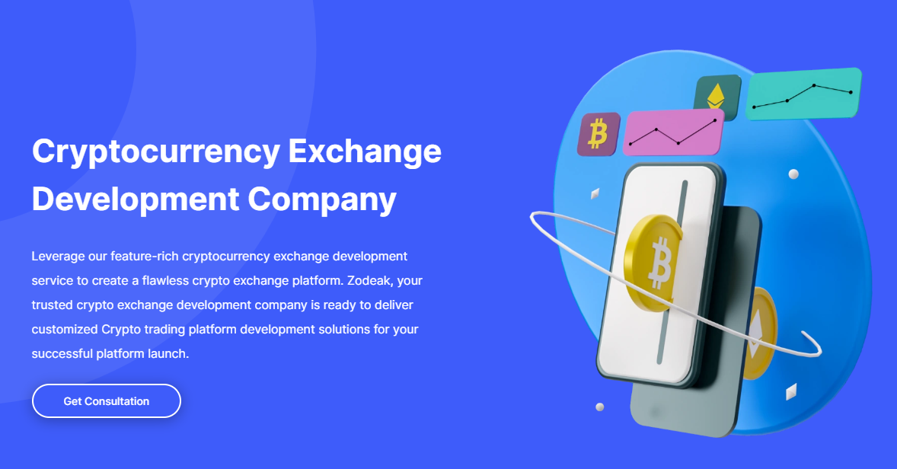
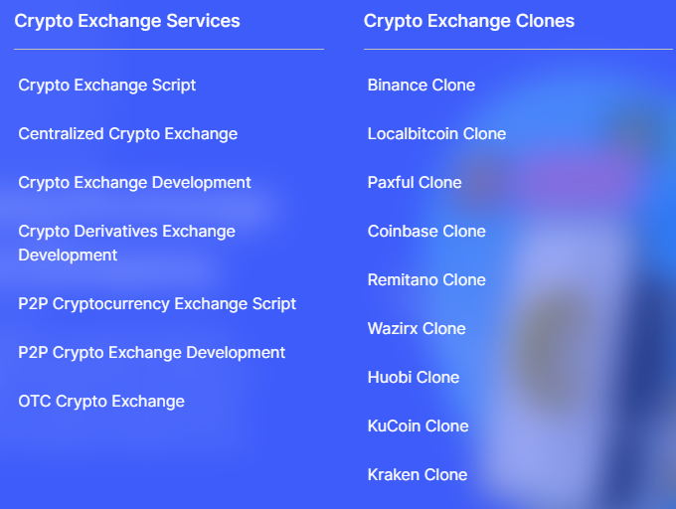
https://www.cryptocurrencyscript.com/cryptocurrency-exchange-development

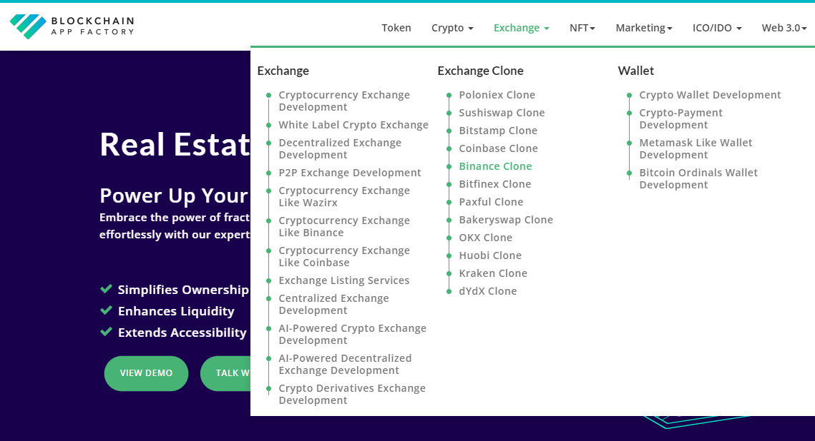
https://www.blockchainappfactory.com/real-estate-tokenization

Price reference
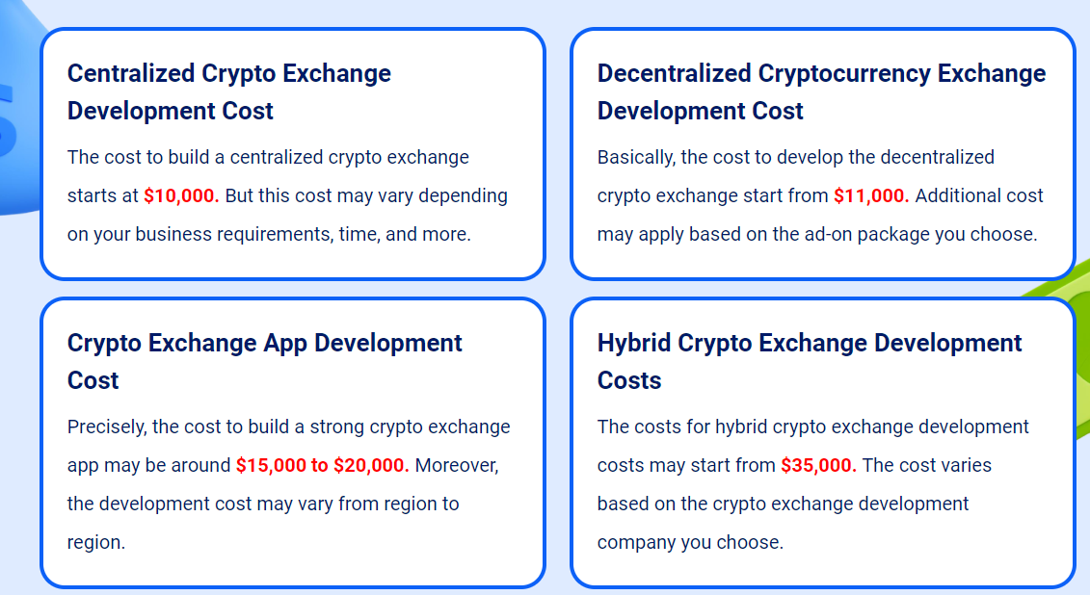
https://www.innblockchain.com/cryptocurrency-exchange-development

