GENERAL INSTRUCTIONS
- Don't forget to let the client know when the due date is passed or the due date is coming.
- Let clients know about current status all the time each project with project sheet and To-do list
- Ensure that every team member reports to the client ahead of time. The project manager should check and complete each task three days in advance as a precaution.
- If time is late [Midnight 04:30 AM, book the message in the telegram : right click button on blue send button > you can book a message to client or your teammate]
- Remember to update your client in the group chat every morning if you're working remotely. Additionally, on Mondays, provide them with a weekly to-do list that aligns with the schedule.

Follow up Standards after task completion
- Ask to manager or 3rd party developer(or designer, and others too) if one of them is absent
- Until the manager replies to you, keep in contact with all methods (Email, Telegram, Discord, Calling or others) continuously. (Essential Process!)
- If HR team detect hesitating in these process, we count minus incentive point (-5)
- Every 5 mins I have to check and take action.
- If C team requests about the job process in case of compliance check, you should prove that you've done tracking process
- If you succeed in time (we count up incentive points (+5) please check ASAP

IMPORTING AND REPLACING A LOGO IN CHROME SECRET MODE TAB
How to check the imported data with Ctrl+Shift+N
(Chrome secret mode : The user can see the new updated version without cache)
Here we will learn how to change a logo in a secret mode tab. It has been recommended using logos from mass media or affiliate companies like Tesla. It's important to keep login details safe. AdWords can be connected with a UK or South Korean phone number.
Step by step instructions:
- Import Completion:
  - After importing is complete, press control + shift + n to create a new tab in secret mode.
- Logo Replacement:
  - Replace the logo in the new tab.
  - Verify that the replacement is successful.
- Logo Options:
  - Consider using logos from mass media (e.g., Mass Media PR) or affiliate companies like Tesla.
- Credential Security:
  - Ensure the safety of your credentials.
  - Hide your photo ID and password.
- Integration with AdWords:
  - Integrate AdWords.
  - Use a UK or South Korean phone number.

If you want a recorded video tutorial for the above instructions, please go to video tutorial section of the drive.
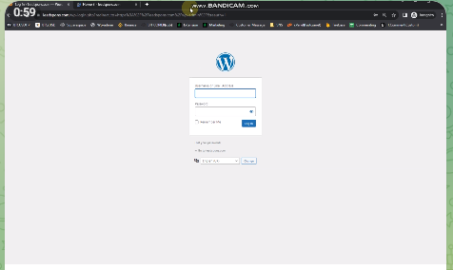

HOW TO DETECT CODE ERRORS AND SOLVE THEM
The paragraph discusses the process of seeking support for code errors. While facing an error on the code, one should seek support from the manufacturer. Please check the manual and guidelines for the API first. If you bought the code from Code Canyon, a subsidiary company of Envato Market, go to the support center using your purchase code. Report the error, and the support team will email you with help. Wait for the email or contact them directly for quick assistance. Find their email through a Google search. It's important to fix code problems quickly, and be thankful for the help you get.
Step by step instructions:
To seek support for code errors and resolve them, follow these steps:
- Manufacturer Support: If you encounter a code error, reach out to the manufacturer for assistance.
- Check the Manual and Guidelines: Before seeking support, review the manual and guidelines for the API to understand the process.
- Purchase Code from Code Canyon: If you bought the source code from Code Canyon (Envato Market subsidiary), access the support center.
- Access Support Center: In the support center, use your purchase code to report the error. This code is vital for assistance.
- Describe the Error: Clearly explain the error you're facing and submit a support request.
- Wait for Email Response: The support team will respond to your email and provide assistance. Be patient and wait for their reply.
- Contacting Support Team: If urgent, consider contacting the support team directly. You can find their email through a Google search.
- Provide Purchase Code to Teammates: If needed, share your purchase code with teammates to ensure collaborative support.
- Follow the Support Process: Follow the support process, reporting bug issues or other problems with the source code.
- Immediate Contact Option: If you don't receive a timely response, search for the support team's email on Google and contact them directly.
- Review Email Response: Once you receive a reply, carefully review the information and instructions provided by the support team.
- Implementation Deadline: If there's an implementation deadline, prioritize resolving the code issues promptly.
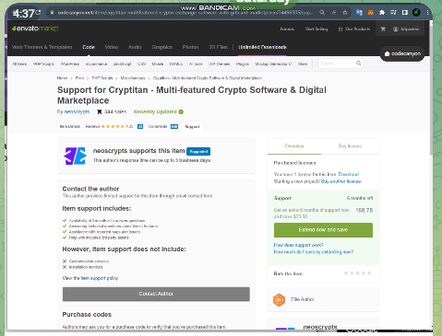
By following these steps, you can effectively detect and solve code problems with the support of the manufacturer or source code provider.
If you want a recorded video tutorial for the above instructions, please refer to the video tutorial folder of the drive.

MongoDB ATLAS INTEGRATION
- MongoDB Atlas reference.
- Create your MongoDB Atlas account
- You can start with selecting the free option:
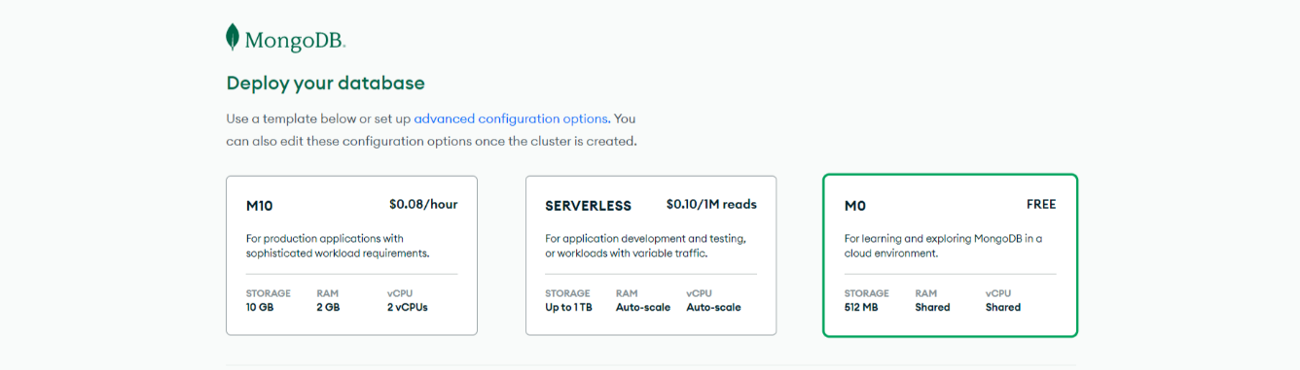

- Pick the cloud provider, location and create the cluster:
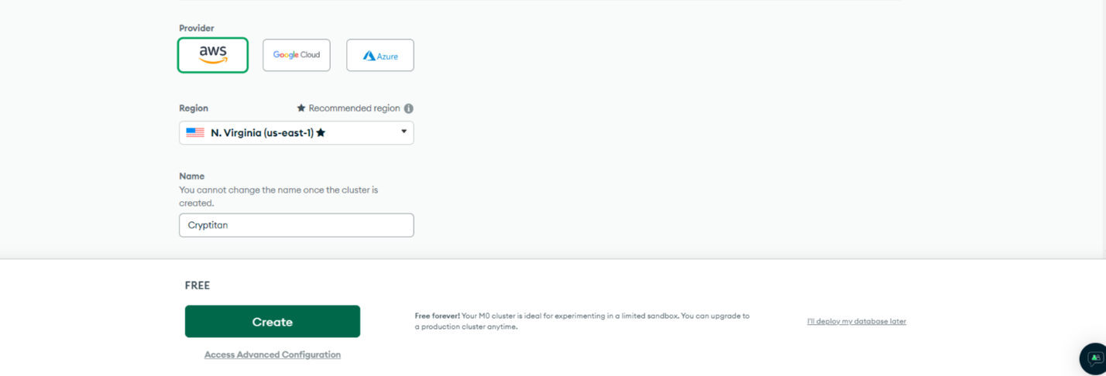
- Creating User Credentials
Make use of the security tab for creating user credentials for the database. Please note that these are not the same credentials you use for logging into MongoDB Atlas. These will be used for your application to connect to the database.
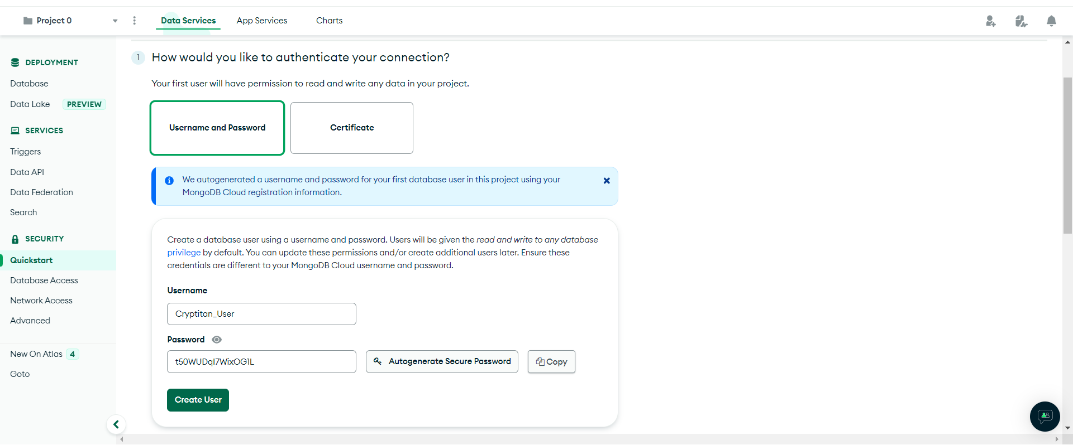
- Add the "Read and write to any database" built in role to the user created.

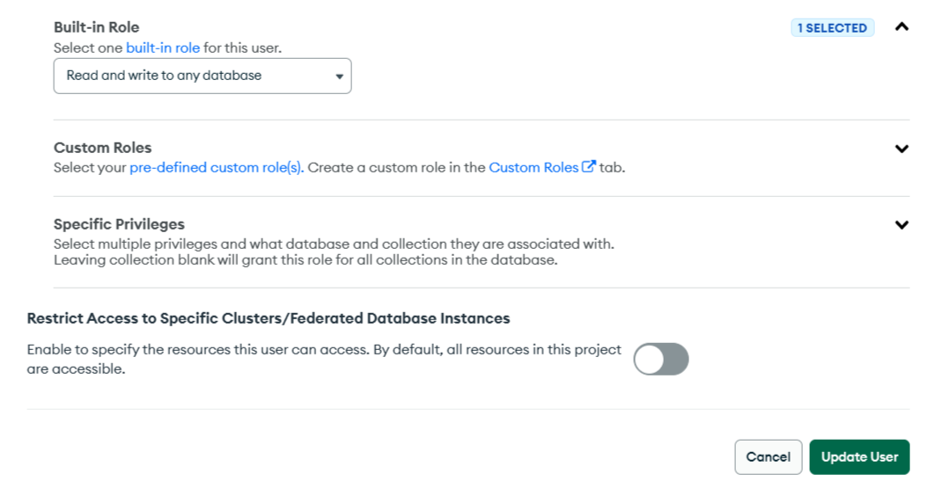

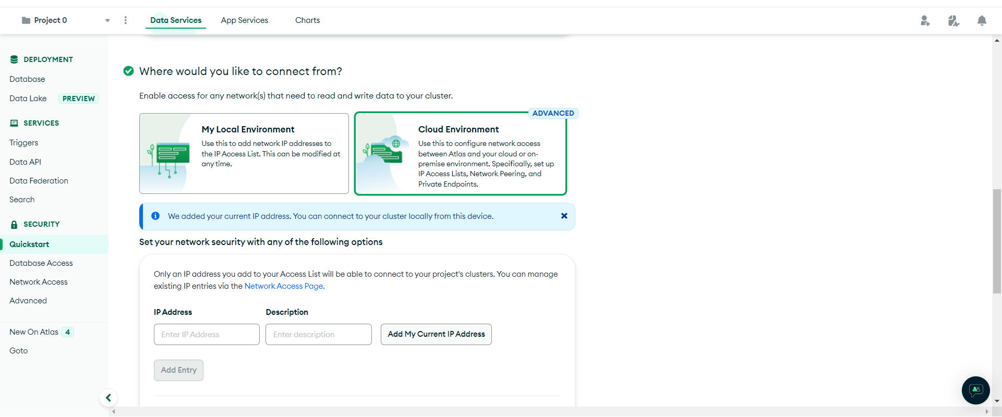
- Define The IP Addresses
Next, we have to define the IP addresses that are allowed access to the database. You should choose cloud environment and allow access from your server's IP address:

- Connect To Our Database
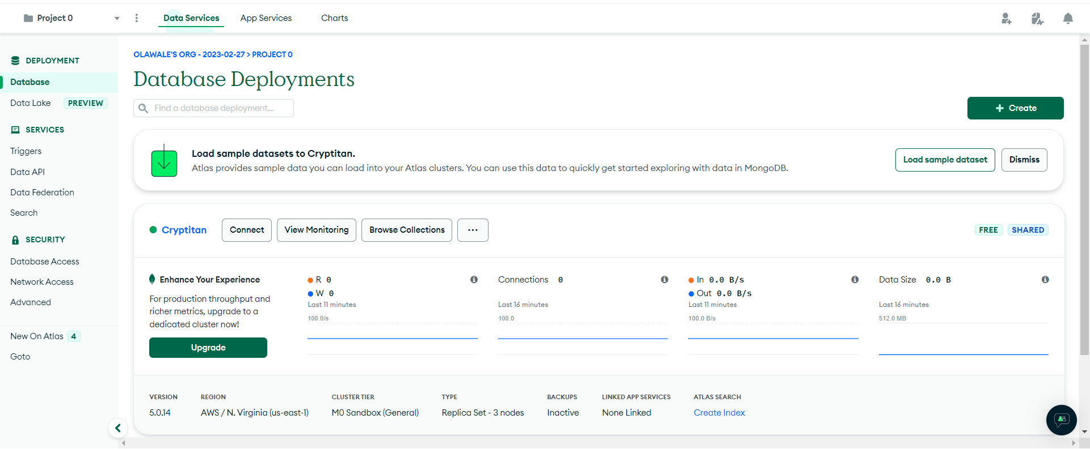
Finally, we are ready to connect to our database. Start by clicking connect:

- And choose: Connect your application:
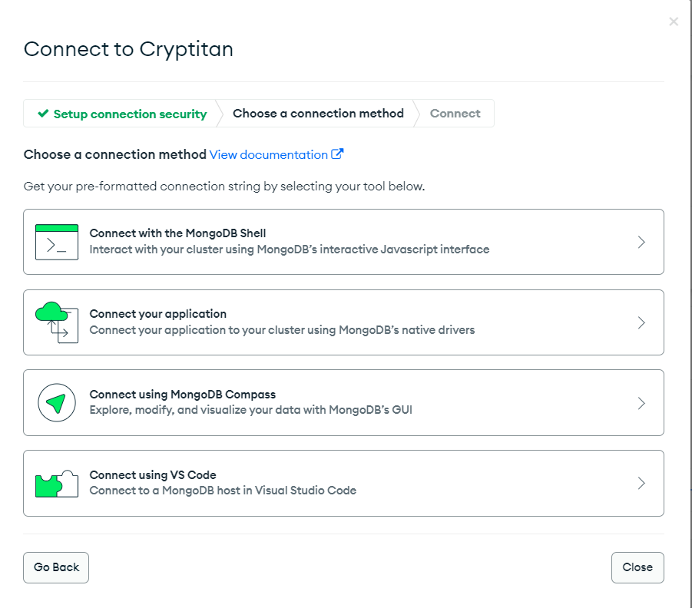

The view displays the MongoDB URL, which is the address of the database that will be supplied to the environment variable MONGODB_URL. The address looks like this:
"mongodb+srv://Cryptitan_User:<password>@cryptitan.fwtfp53.mongodb.net/?retryWrites=true&w=majority"

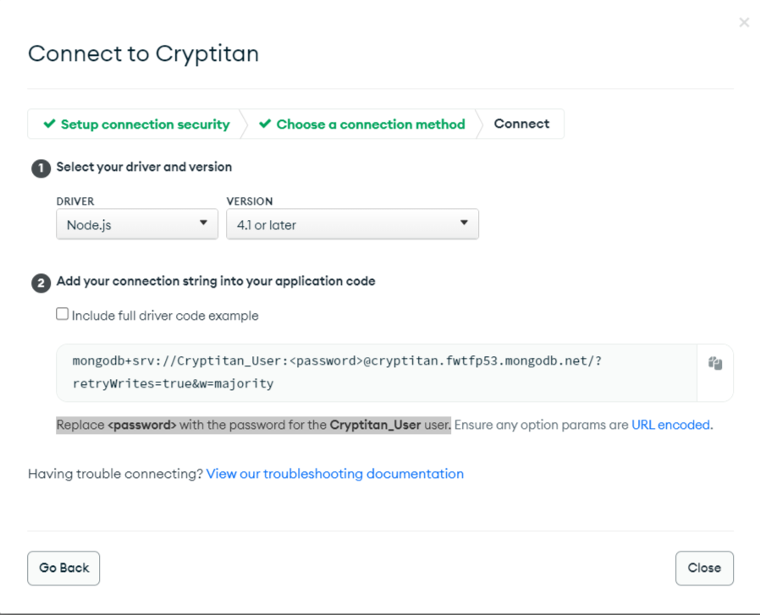

- Replace <password> with the password for the Cryptitan_User user.
After successful installation of cryptitan, you should check the database through mongodb atlas to ensure that the encrypted private keys are stored in the newly created database.

TROUBLESHOOTING ERRORS ON MongoDB IN MANGO, BITCOIN, REDIS, AND MYSQL APPLICATIONS
The paragraph discusses how to troubleshoot errors that may occur in various applications such as Mango, Bitcoin, Redis, and MySQL.
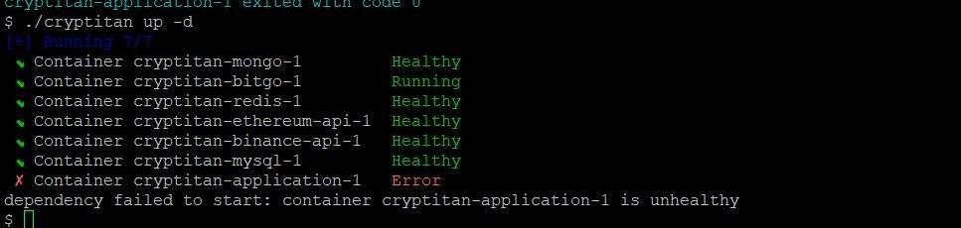
It is important to maintain a healthy status for these applications and provide instructions on how to search for application environments and databases. Get instructions on checking the status and setting up the app environment with the terminal. Connect the app to the database smoothly. We suggest registering for a MongoDB account and providing information for the sign up and check the status.
Step-by-Step Guide:
- Check Application Status: Ensure the Cryptician, Mango, Bitcoin, Redis, and MySQL applications have a healthy status.
- Update Information: Search for application updates and relevant information using terms like "application environment" and database names.
- Explore Environment Setup: Go to your system settings and learn how to set up the application environment using the terminal.
- Connect to MongoDB: Connect your application to MongoDB, a database service. This step is crucial for database functionality.
- Test Connections: Verify the connections between your application and the database. Test to ensure everything is working smoothly.
- Sign Up for MongoDB Account: If you don't have a MongoDB account, sign up. Provide necessary billing and credit card information.
- Easy Registration: Follow the registration process, which is designed to be straightforward.
- Check Status: After registration, check the status to ensure a successful setup.
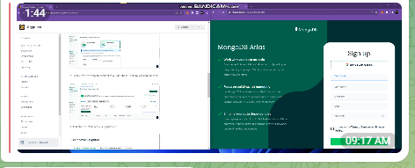
If you want a recorded video tutorial for the above instructions, please refer to the video tutorial folder of the drive.

REGISTERING BILLING ADDRESSES AND CREDIT CARD INFORMATION FOR CLIENTS
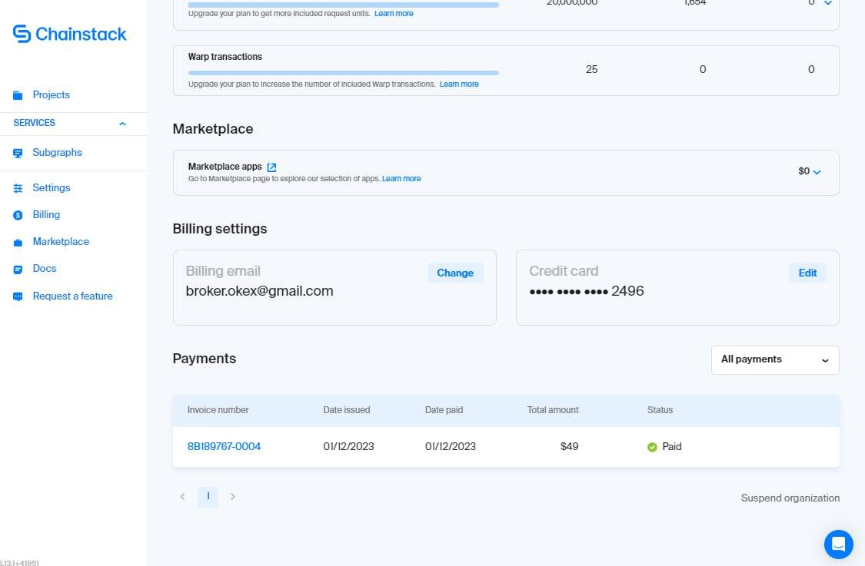
To smoothly handle projects, it's essential to register clients' private debit or credit cards. First, register these cards to ensure projects run without problems. If there are changes or replacements to credit card information, let clients know promptly. Also, inform clients about any additional modifications. Make sure to notify clients of alterations in building information and provide screenshots as proof. The project manager or developer team usually takes care of these tasks. Consistently update clients on any changes or replacements.

Important logins:
https://openexchangerates.org/
broker.okex@gmail.com
Gbrick123### or gbrick123###

https://console.chainstack.com/
broker.okex@gmail.com
Gbrick123### or gbrick123###

[Google Gmail account when they do social login]
broker.okex@gmail.com
qmfhzj123#

You can copy and paste it when you request the registration of billing]

- Client registration needed
When you let client to register the Domain and 3 rd party API, we should fill in the client billing address and info privately.

- Ownership Should be registered
To register the ownership on blockchain API integration service, this service should be registered by credentials info with client's billing info to here. The info should be compatible to residence info. It will be used for the only each usage

If our developer already registered by client's email, you can register debit card info of yours first and let them replace it later.
Step-by-Step Guide:
- Register Building Address and Credit Card: Right after registering the building address and credit card info, ensure the client registers their private debit or credit card for the project to proceed smoothly.
- Replace Credit Card Information: If there's a need to replace credit card information, request the client to update it. Inform them clearly about this change.
- Inform Clients About Changes: Let clients know about any changes or modifications, like building address adjustments. Provide clear instructions on where to make these updates.
- Provide Screenshots: Always accompany change requests with screenshots. This helps in confirming and visualizing the modifications needed.
- Take Pictures and Inform: If necessary, take pictures of the changes and inform the client. Ensure they are aware of every step and modification.
- Project Manager or Developer Team: Assign the task of handling these changes to the project manager or developer team. They will take charge and communicate with the client consistently.
- Consistent Communication: Stress the importance of ongoing communication. Clients should be informed about replacements, updates, or any changes related to the project.
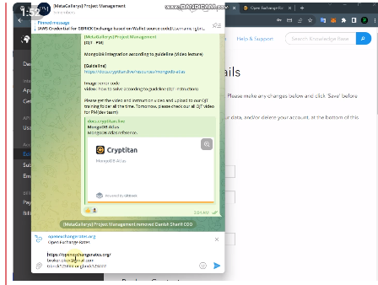
Thanks for paying attention to these details and ensuring a smooth project progression.
If you want a recorded video tutorial for the above instructions, please refer to the video tutorial folder of the drive.

