[ WEB 3 Set ] Project Guideline for
the each client’s project
Copyright : www.metagallerys.io

1. Materials to Proceed each development by Role(Charger)
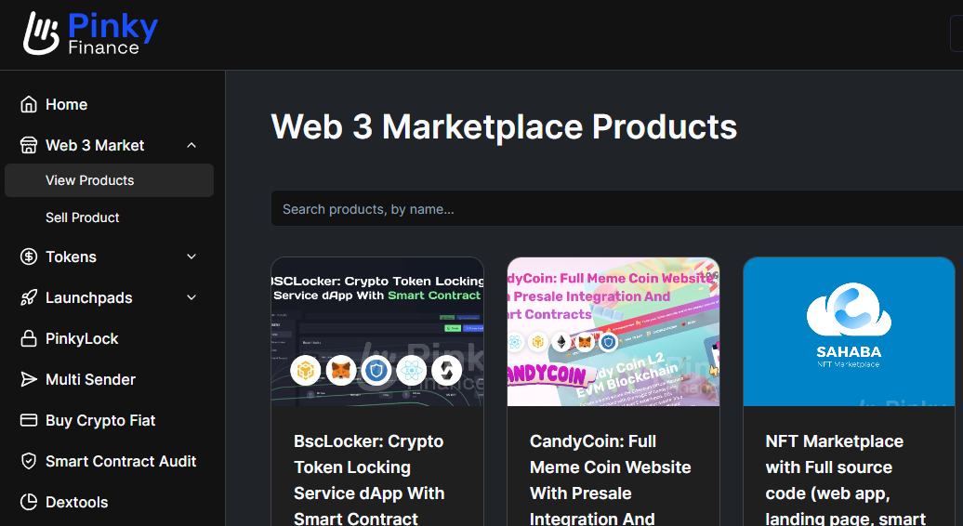
Web3 Set Source Code Marketplace : https://www.pinky.finance/marketplace

No. | Role category | Request to
1 | Developers Team | Zillab (They’re supporting deployment service for us)  Or Our own team after purchasing the source code
2 | Client | Request to client to get the logo, whitepaper(vesting plan), business model file, smart contract address and etc
3 | Source Code  (request to Zilab) | https://www.pinky.finance/marketplace (According to PM’s decision ‘web3 set’) (Dev team has to purchase)
4 | Server Account (request to Client) | AWS or recommended server (we can request AWS account credential from each client)
5 | DNS  (request to Client) | Namecheap.com (we can request ID,PW credentials from each client)
2.Budget and Estimation
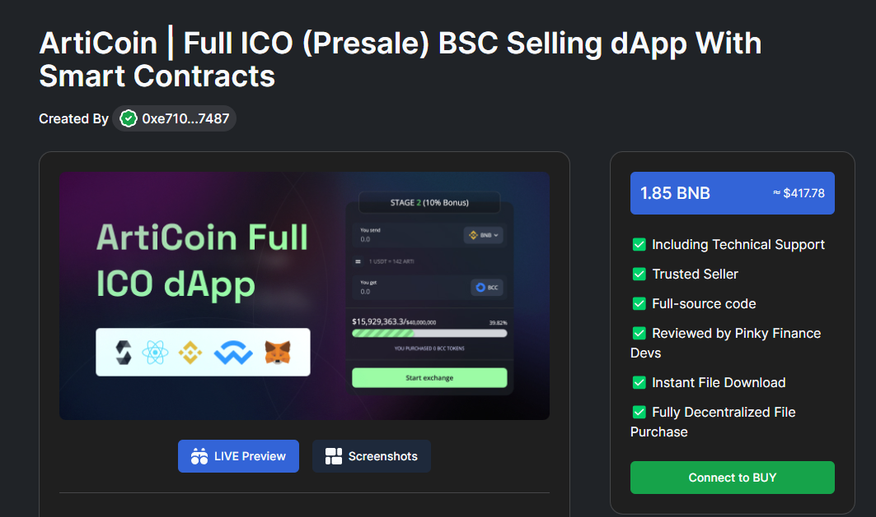
You can order source code to replace the logo and launch immediately

No. | category | Price | List of Development
1 | Web 3 set | Total 10 BNB  (2000 USD) | 1)https://www.pinky.finance/marketplace/articoin-full-ico-presale-bsc-selling-dapp-with-smart-contracts  2)https://www.pinky.finance/marketplace/defi-full-website-with-integrated-multi-chain-presale-supported-evm-networks-bsc-eth-exzo-and-more  3)https://www.pinky.finance/marketplace/defi-full-website-with-integrated-multi-chain-presale-supported-evm-networks-bsc-eth-exzo-and-more
2 | Option | Staking, Lock up (Vesting release) | 3-4 web platforms (ICO, Presales, Airdrop, Landing page or etc) we usually choose 3 of them to launch the service as [web3 set], we can proceed that at once. We have a extra budget all the time additionally just in case for the customization to put the custom vesting plan such as monthly XX % or releasing after 6 months later like this.  More than that, clients can possibly request [claim button] to release their token on staking (lock up vesting) web service to minimize their releasing token.

3.Roles to Proceed
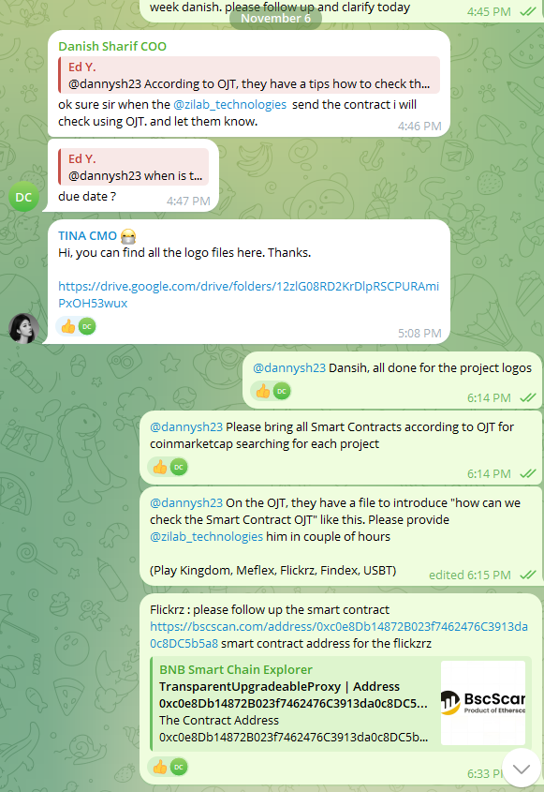 | Hi, you can find all the logo files here. Thanks.  https://drive.google.com/drive/folders/12zlG08RD2KrDlpRSCPURAmiPxOH53wux  Ed Y., [11/6/2023 6:14 PM]  @dannysh23 Dansih, all done for the project logos  Ed Y., [11/6/2023 6:14 PM]  @dannysh23 Please bring all Smart Contracts according to OJT for coinmarketcap searching for each project  Ed Y., [11/6/2023 6:15 PM]  @dannysh23 On the OJT, they have a file to introduce "how can we check the Smart Contract OJT" like this. Please provide @zilab_technologies him in couple of hours  (Play Kingdom, Meflex, Flickrz, Findex, USBT)  Ed Y., [11/6/2023 6:33 PM]  Flickrz : please follow up the smart contract https://bscscan.com/address/0xc0e8Db14872B023f7462476C3913da0c8DC5b5a8 smart contract address for the flickzrz
[Screenshot]  to request the materials(logo, whitepaper, token address, business model) for web3 | [Text]  to request the materials(logo, whitepaper, token address, business model) for web3
[Example of Works]
Charger | Charger Job Description
Developer | Zilab team or our own developers (Zilab can make those modifications on the current sale contract, but this will cost something additionally and it would be ready tomorrow with full testing for additional or specific functions)
Project Manager | Charger from Metagallerys.io
Communicator | Charger from Metagallerys.io (Collecting the materials (logo, and description via whitepaper(vesting plan)))
Marketing | they can re-write for web page (landing page) description and catch phrase
4.Requirement for the Presale Token

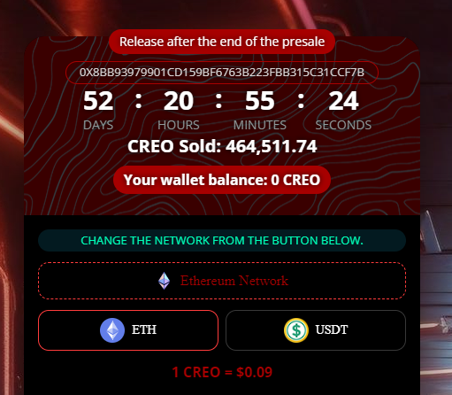 | 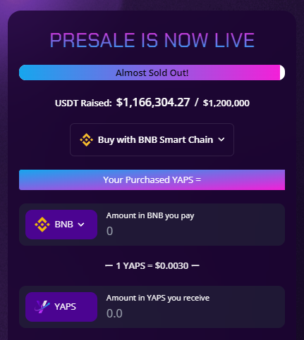
10 Mins time limits and counter | 6 months lock up

1. 10 Mins time limits and counter
2. 6 months lock up (ex. If people purchase 100 our token 1 Dec 23 > 6 months later > 1 Jun 24 releasing, 10% (10 Tokens) only at that day (10% Release monthly after 6 months later)
(Every month, 10% release)

Total | 2023-12 | 2024-01 | 2024-02 | 2024-03 | 2024-04 | 2024-05 | 2024-06 | 2024-07 | 2024-08 | 2024-09
100 | 10 | 10 | 10 | 10 | 10 | 10 | 10 | 10 | 10 | 10
[Table] Release schedule (Vesting for early investor)

3. More than that, clients can possibly request [claim button] to release their token on staking (lock up vesting) web service to minimize their releasing token.

5. Collect Client Token’s Smart Contract Address
(From Coinmarketcap.com or token’s scan website : www.bscscan.com , www.etherscan.io or others)

Meflex : 0xe846Dd34Dc07ab517e78f5e58edae79D80222FD0 (BSC)
Play kingdom : 0xF0aAa03cd21c989C98074aDED9c942FF938b2AB0 (BSC)
Flickrz : 0xc0e8Db14872B023f7462476C3913da0c8DC5b5a8 (BSC)
Gbrick : 0xaD1a818C61548Fb9A0669245079e606e6CeCD04f
USBT : (TBD)
Findex : (TBD)
(Token is not issued, and then, you can create the token by https://www.smartcontracts.tools/token-generator/ for TBD projects by yourselves)

6. Coin Information Update (If needed)
Registration : https://support.coinmarketcap.com/hc/en-us/requests/new
Guide : https://support.coinmarketcap.com/hc/en-us/articles/360043659351-Listings-Criteria

7. How can we set up the staking(lock up vesting plan)
for the Early bird sales(=Presales) with the Pairing tokens
USDT - OOOO Tokens : Normally, token

Staking Example
[ USDT - OOOO Tokens ] Pairs are available to stake
[ OOOO Tokens - OOOO Tokens ] Pairs are available stake

[Same as Condition 4.ㅁ↑] : 10 months releasing plan
1. From ICO platform 1 web page (landing page)
10 Mins time limits and counter
(to let people feel hurry to buy the token immediately)

2. 6 months lock up
ex. If people purchase 100 our token 1 Dec 23 > 6 months later > 1 Jun 24 releasing, 10% (10 Tokens) only at that day (10% Release monthly after 6 months later)
(=Every month, 10% release)

3. Wallet setting
Metamask or any others wallet
(all in one wallet including all types of wallet to people purchase our tokens)
- End -

[Work Guideline Step 1 ]
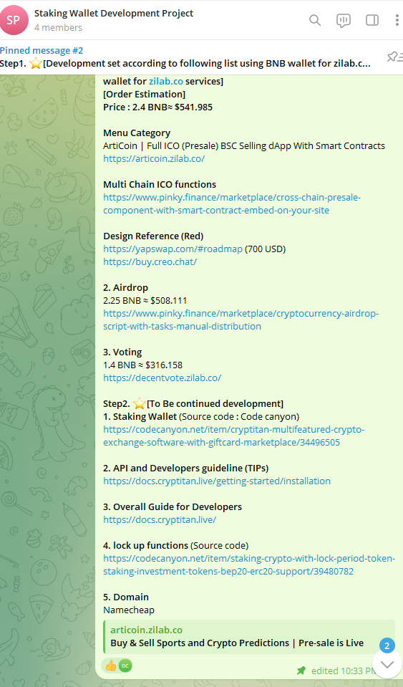 | Hi, Zilalb, Thanks for your consultation today-!  Danish Sharif Hi Danish(PM), This is @zilab_technologies ZiLab IT. which has a brilliant web 3 software for development. we discussed to order for following software for Zilab IT.  Step1. ⭐️[Development set according to following list using BNB wallet for zilab.co services]  [Order Estimation]  Price : 2.4 BNB≈ $541.985  Menu Category  ArtiCoin | Full ICO (Presale) BSC Selling dApp With Smart Contracts  https://articoin.zilab.co/  Multi Chain ICO functions  https://www.pinky.finance/marketplace/cross-chain-presale-component-with-smart-contract-embed-on-your-site  Design Reference (Red)  https://yapswap.com/#roadmap (700 USD)  https://buy.creo.chat/  2. Airdrop  2.25 BNB ≈ $508.111  https://www.pinky.finance/marketplace/cryptocurrency-airdrop-script-with-tasks-manual-distribution  3. Voting  1.4 BNB ≈ $316.158  https://decentvote.zilab.co/  Step2. ⭐️[To Be continued development]  1. Staking Wallet (Source code : Code canyon)  https://codecanyon.net/item/cryptitan-multifeatured-crypto-exchange-software-with-giftcard-marketplace/34496505  2. API and Developers guideline (TIPs)  https://docs.cryptitan.live/getting-started/installation  3. Overall Guide for Developers  https://docs.cryptitan.live/  4. lock up functions (Source code)  https://codecanyon.net/item/staking-crypto-with-lock-period-token-staking-investment-tokens-bep20-erc20-support/39480782  5. Domain  Namecheap
[Screenshot]  to request the development for web3 | [Text]  to request the development for web3

[Screenshot]  to request the development for web3 | [Text]  to request the development for web3

[Staking Example] by Developers team (Zilab teams example)
So currently it works like this:
X buys 1000 tokens on the presale

Owner stops the sale and sets unlock to be pssible at 2025, 1st of January (for example)
X claims 1000 tokens on 1st of January 2025

they pay a gas fee and get the tokens automatically.

It’s also possible to split 1000 in 10 unlocks, like 100 in 1st of January, 100 in 1st of Feb and so on, but this would require smart contract changes. And then people and request claim when they click the claim

- End -

