This video explains the basic functions of the exchange, such as spot and futures trading, as well as additional features like a calculator and premium services.

📹 Functions and services of the exchange, including spot and futures trading, calculator, premium services, wallet functionality, AI fund products, and transaction fees.

🧮 Calculator for investment ratios and returns, premium service for managing customer assets, and wallet functionality for transferring assets.

💼 Premium service and wallet functionality accessed through payment, availability depends on user's payment status.

This video contains explanations about the functions and services of the exchange. It provides basic functions such as spot trading and futures trading, as well as additional features such as a calculator and premium services. The calculator calculates investment ratios and returns, while the premium service manages the assets deposited by customers. In addition, wallet functionality is provided, allowing assets to be transferred between wallets. The premium service and wallet functionality can be accessed through payment, and the availability of features depends on the user's payment status. Furthermore, pages related to AI fund products are also provided, allowing users to deposit assets into funds. Lastly, details regarding transaction fees are also explained. This video can enhance understanding of the exchange's functions and services.

Content
Interactive SummaryText SummaryTranscript
00:03 - 00:26
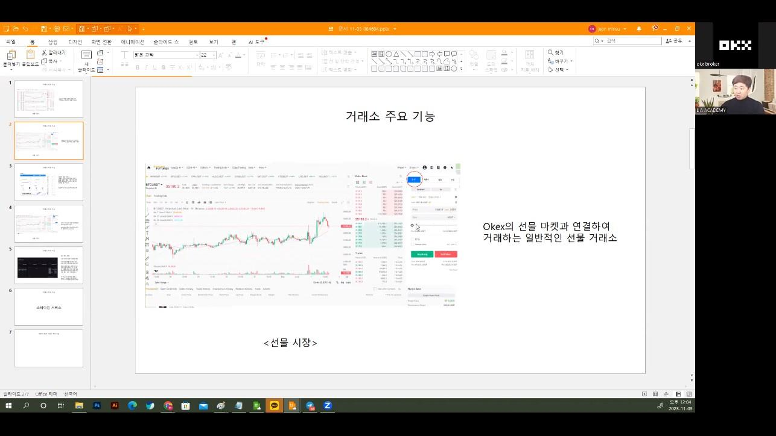
Exchange with spot market and futures trading features
00:42 - 01:25
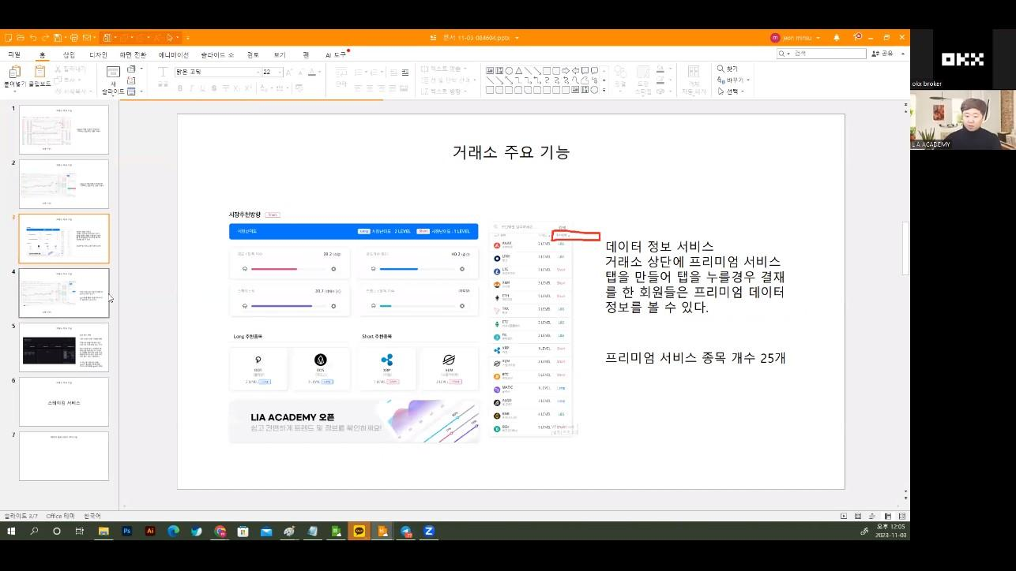
Page and data services for premium services
01:36 - 05:06
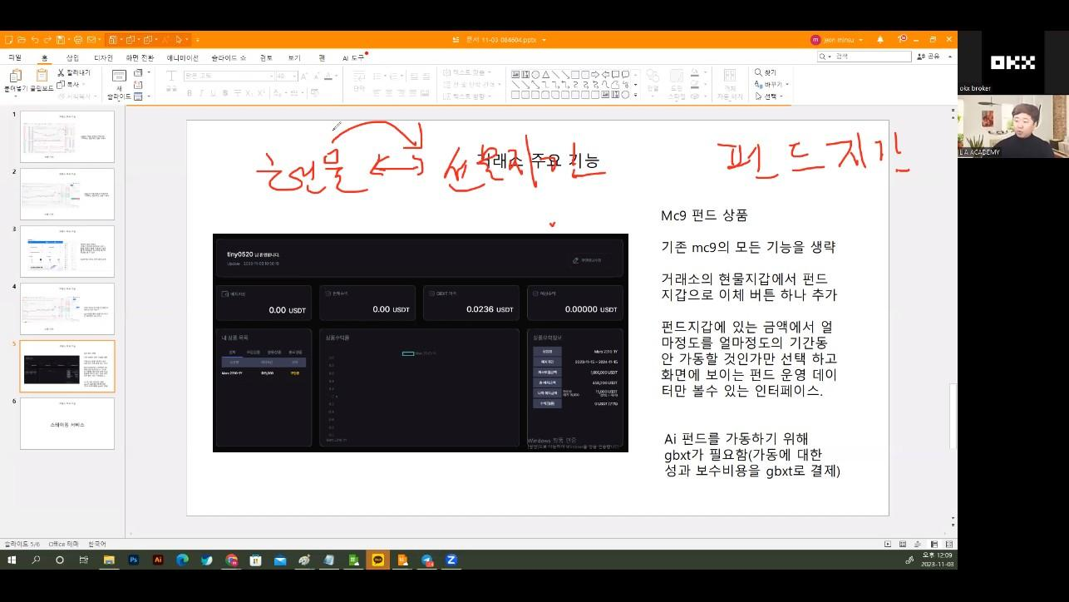
Moving function of spot wallet, futures wallet, and fund wallet
05:41 - 08:46
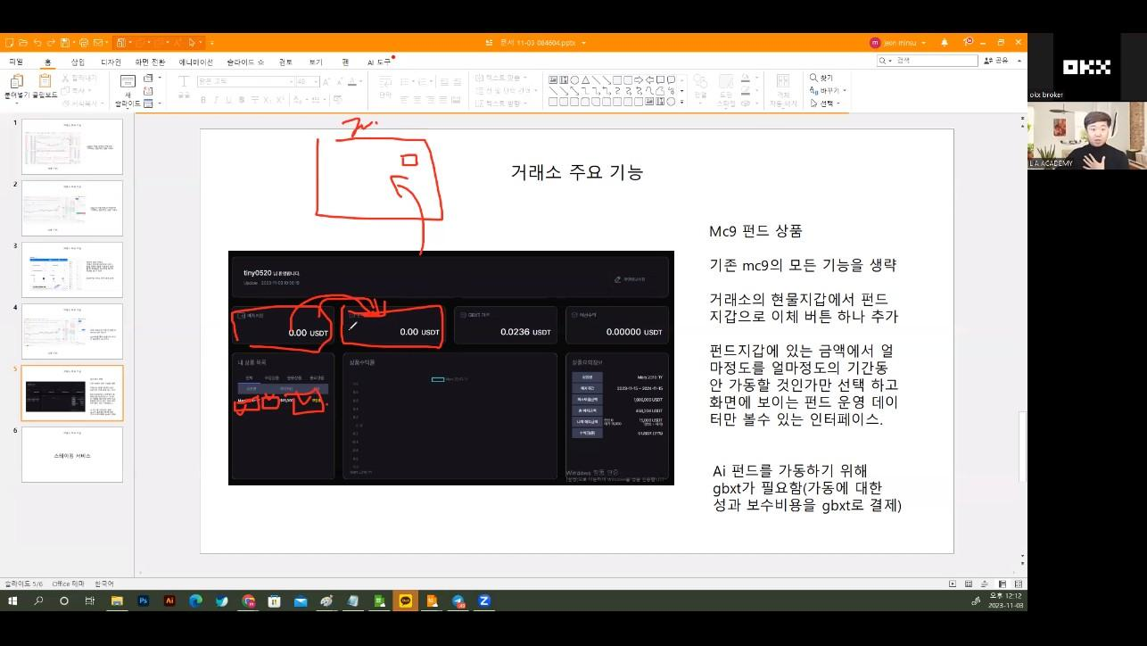
Selection and operation of AI fund products
09:12 - 13:20
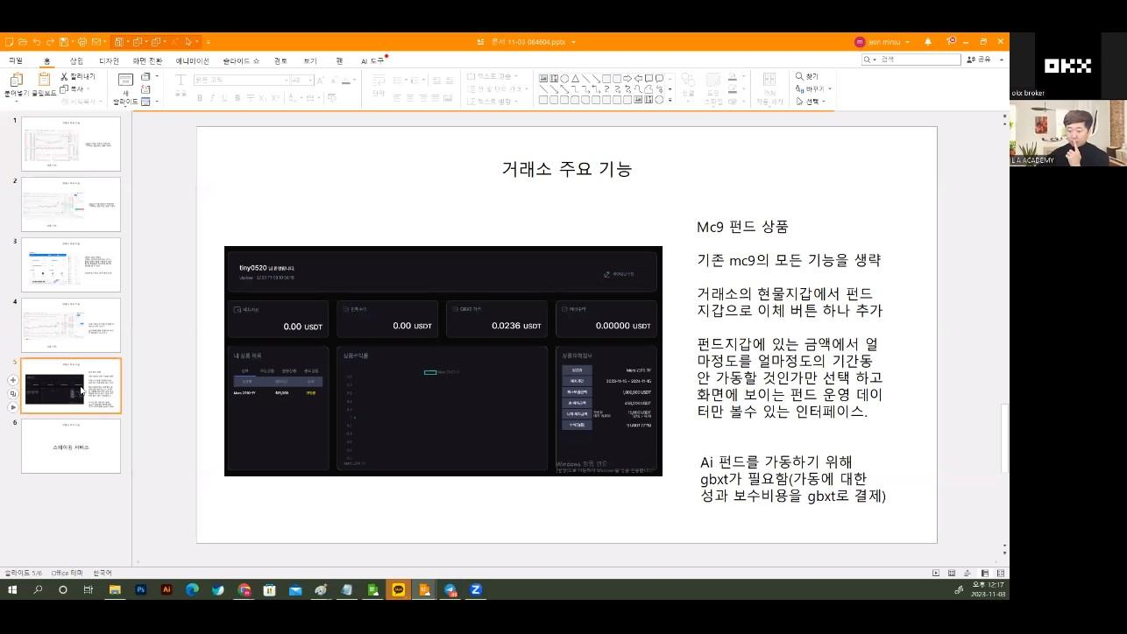
Investment ratio and order placement function of calculator model
16:57 - 18:17
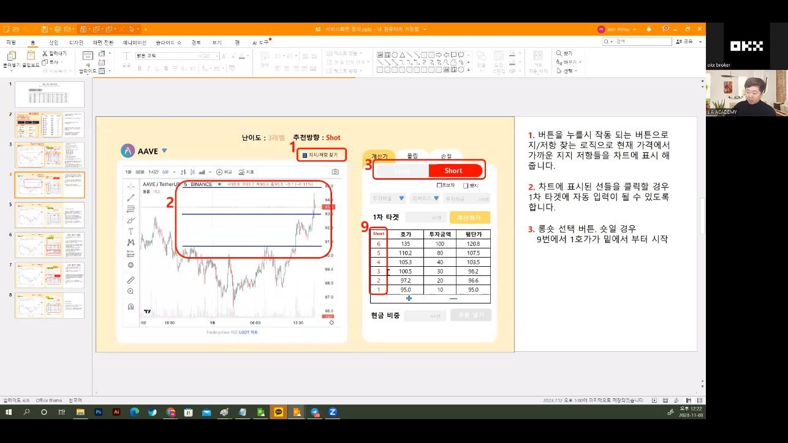
Display and data retrieval of indicators
18:17 - 19:03
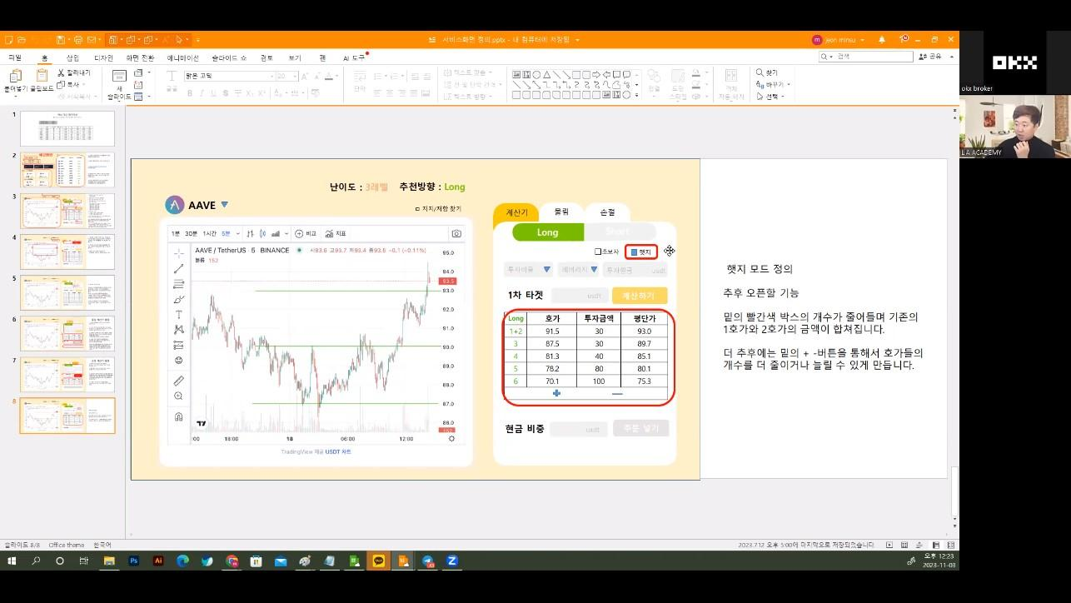
Display and profitability of fund product list
19:17 - 19:58
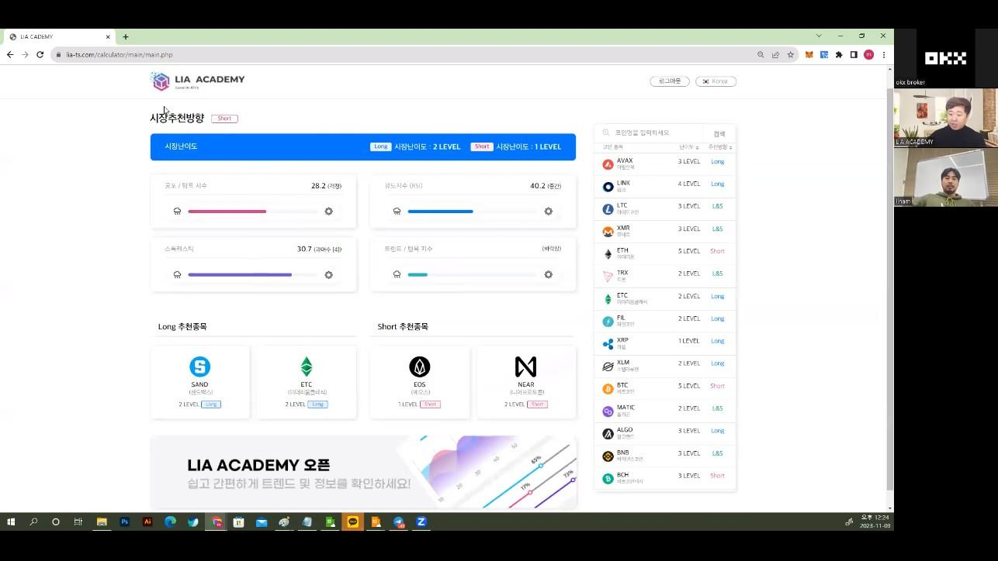
Display and order placement of calculator screen
20:44 - 20:46
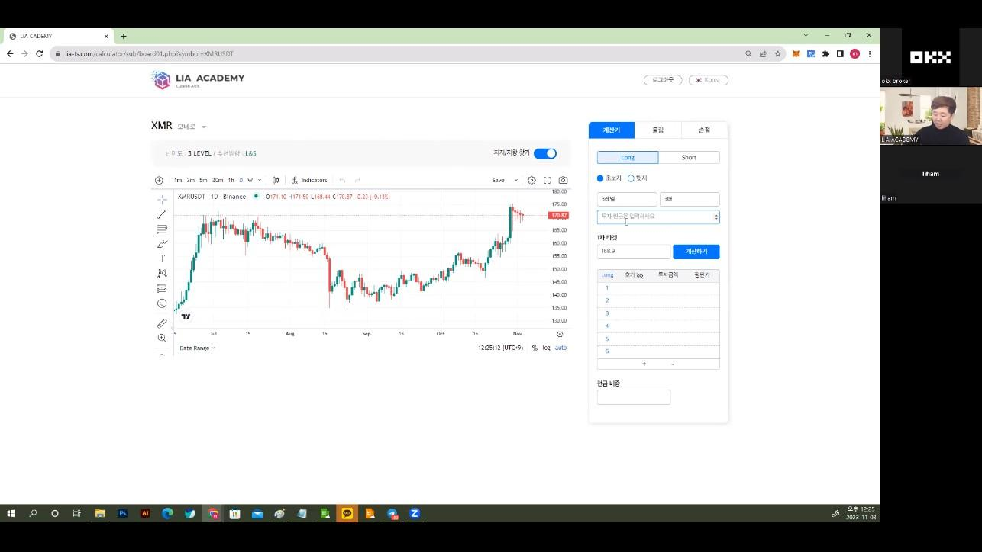
Customers can input how much they want to invest.
20:46 - 21:11
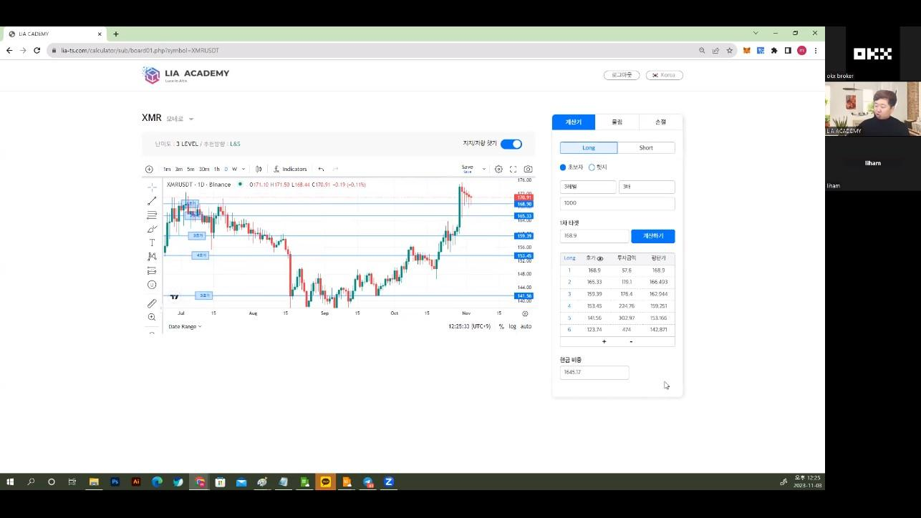
Customers can set the betting line up to 600 million.
21:11 - 21:19
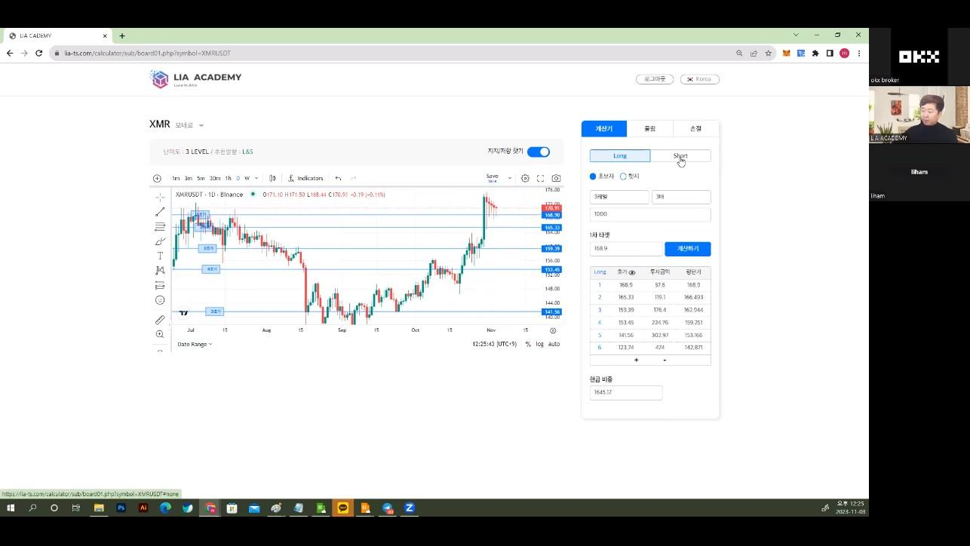
When placing an order, it will automatically go into the exchange.
21:19 - 21:37
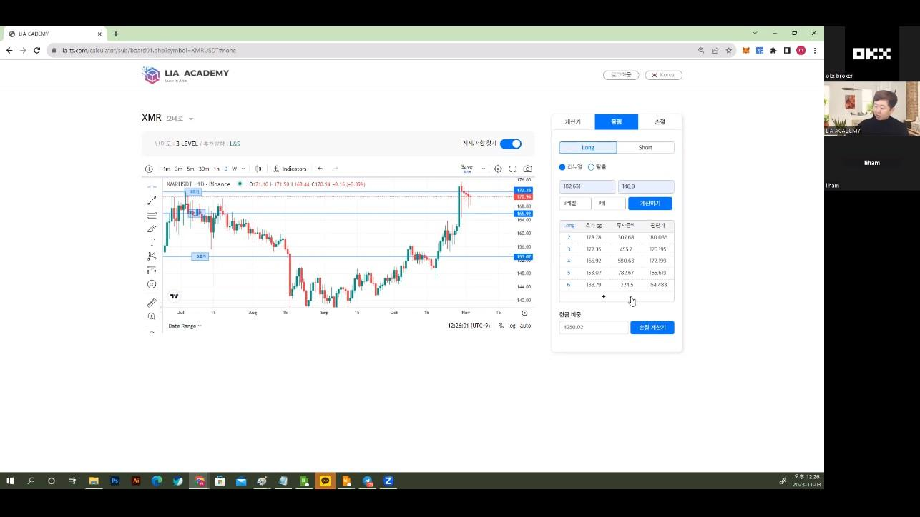
Customers can adjust the quantity using the calculation formula.
21:37 - 22:12
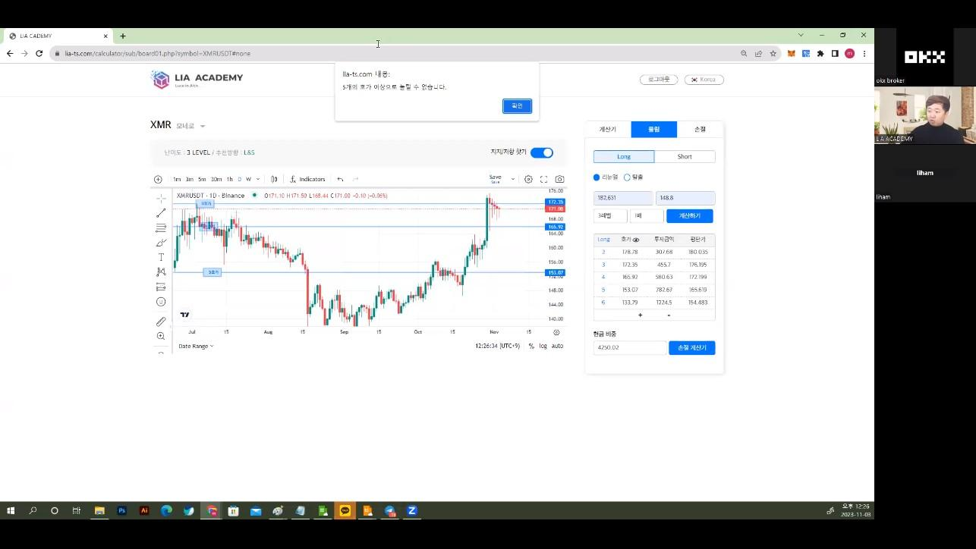
The UI is simple, and detailed functions occur when buttons are pressed.
22:16 - 22:28
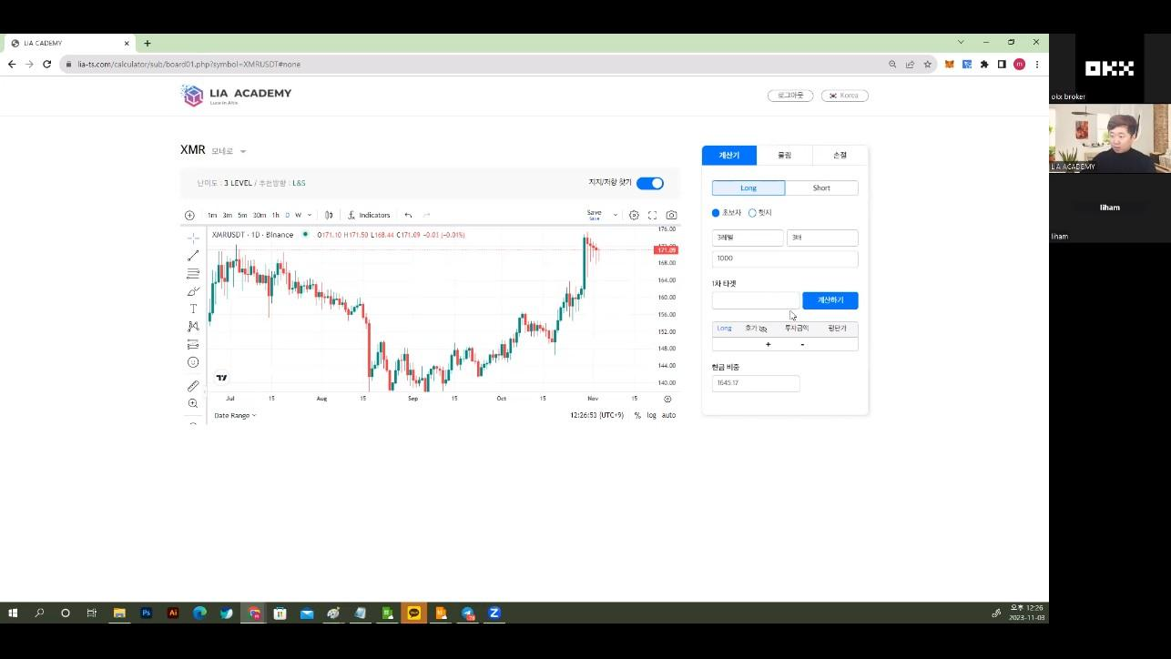
The stop loss tab is currently implemented.
22:36 - 23:01
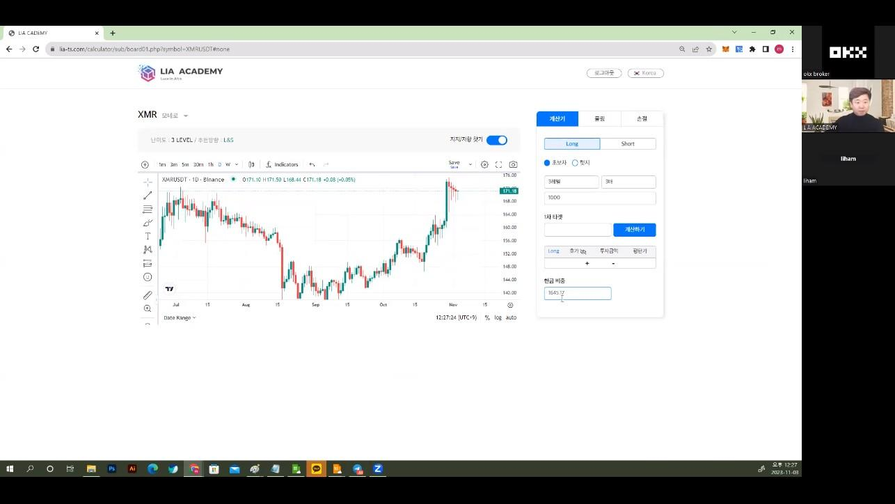
There are additional update plans, and you can check the details in the PPT.
23:01 - 23:01
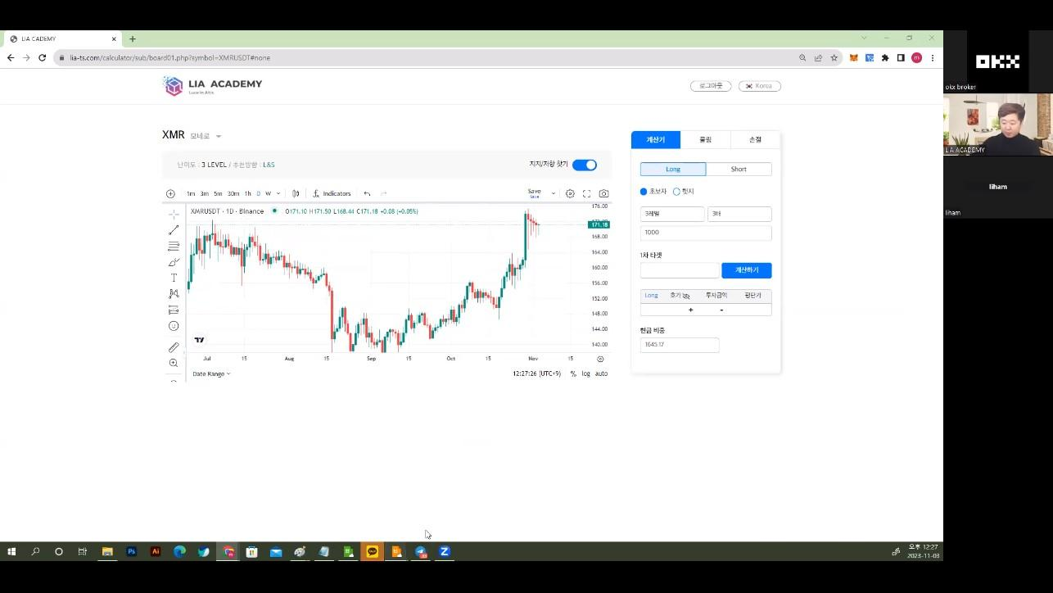
Add a start investing button to make it easy for customers to start.
23:01 - 23:01
The dashboard is one page, and the product summary information is displayed on the right.
23:01 - 25:50
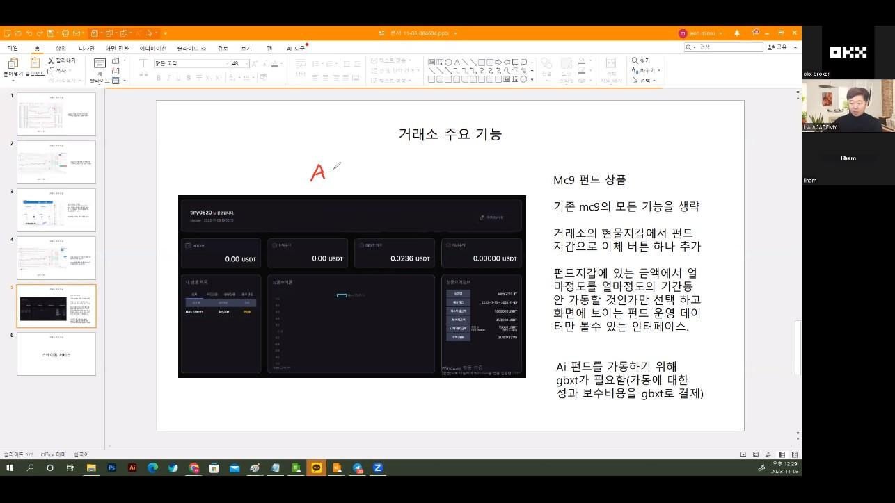
Premium service is a feature that can be used after payment.
25:50 - 28:03
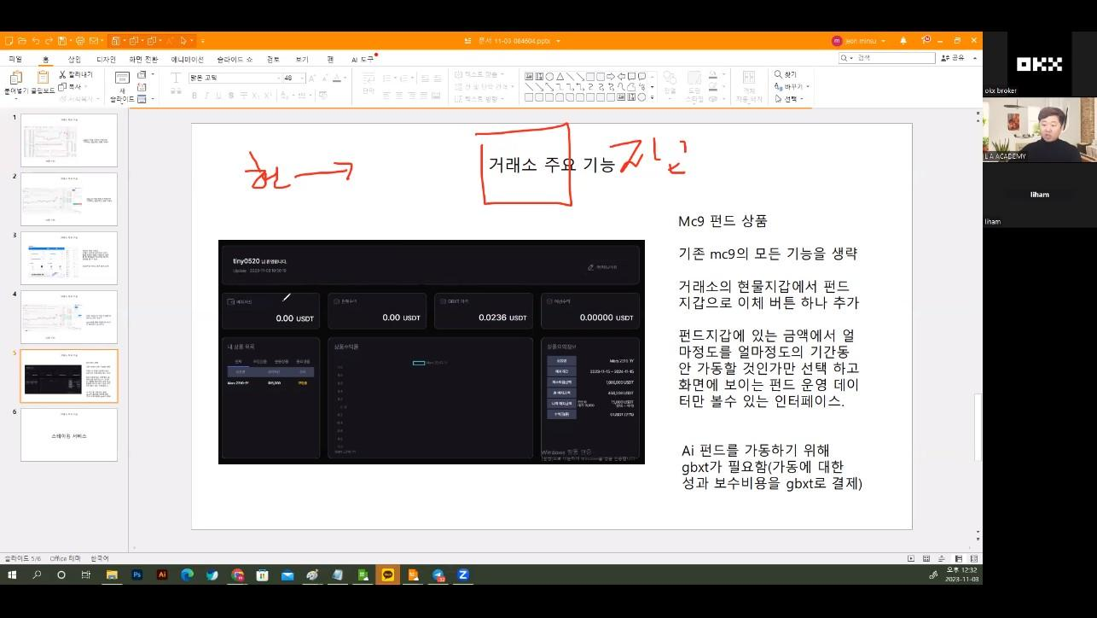
The transaction fee is paid in mc9, and a portion of the fee is discounted if there is a profit.
28:07 - 29:57
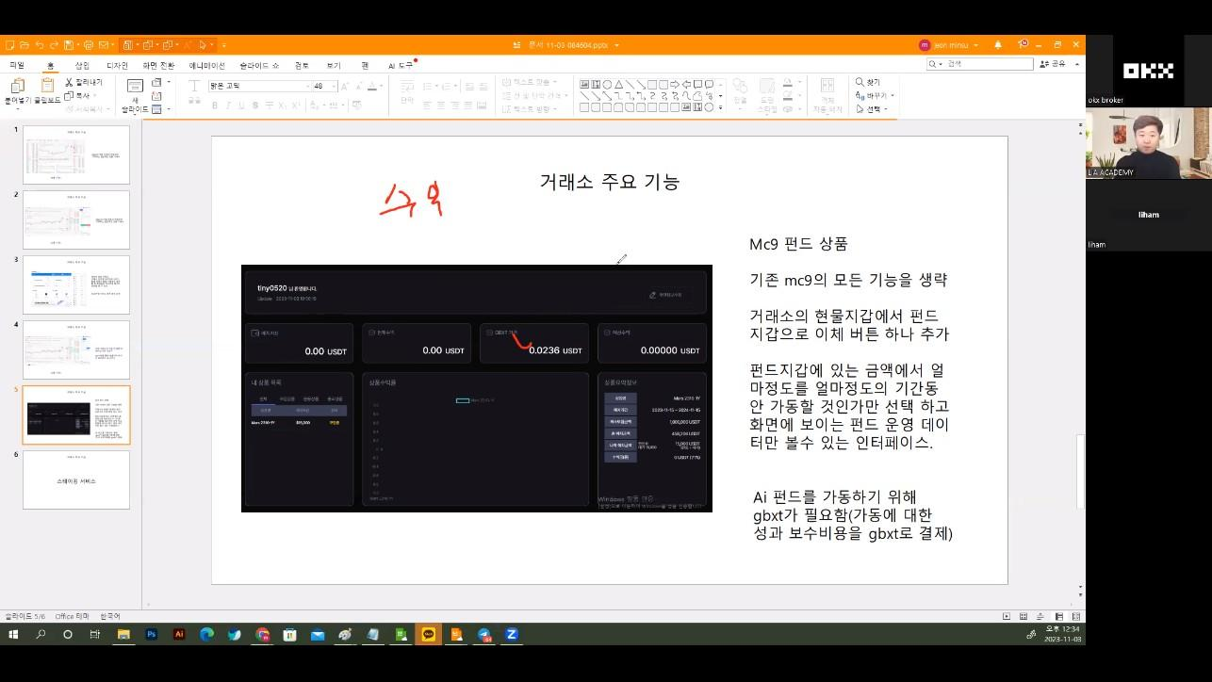
You can exchange gbxt and receive a discount on the fee.
29:57 - 32:44
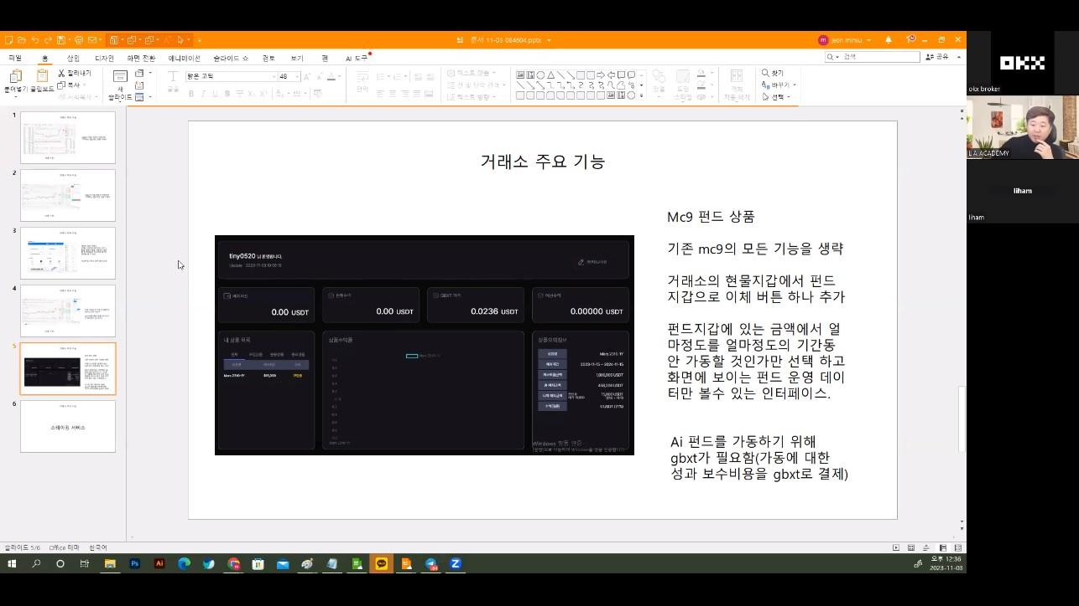
You can automatically deduct transaction fees through the token payment system.
32:44 - 34:48
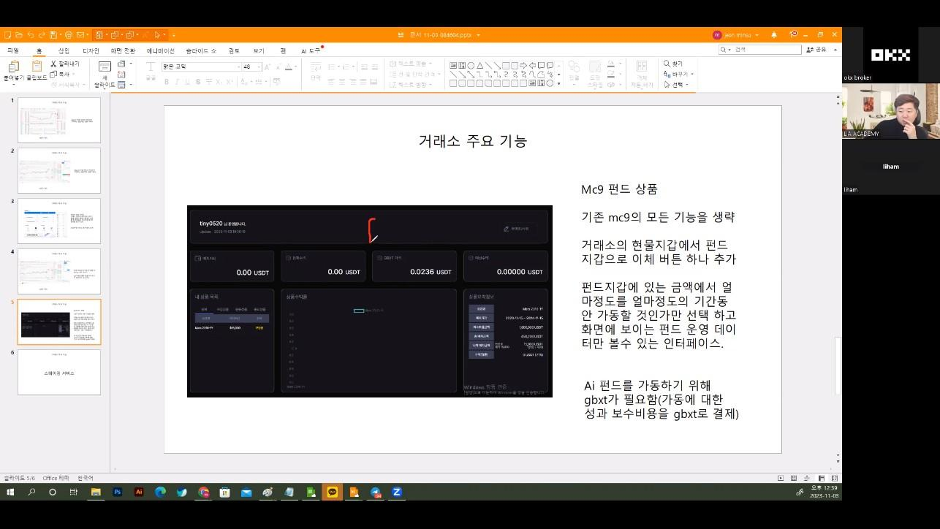
You can receive a discount on transaction fees through GBS staking.
34:48 - 37:43
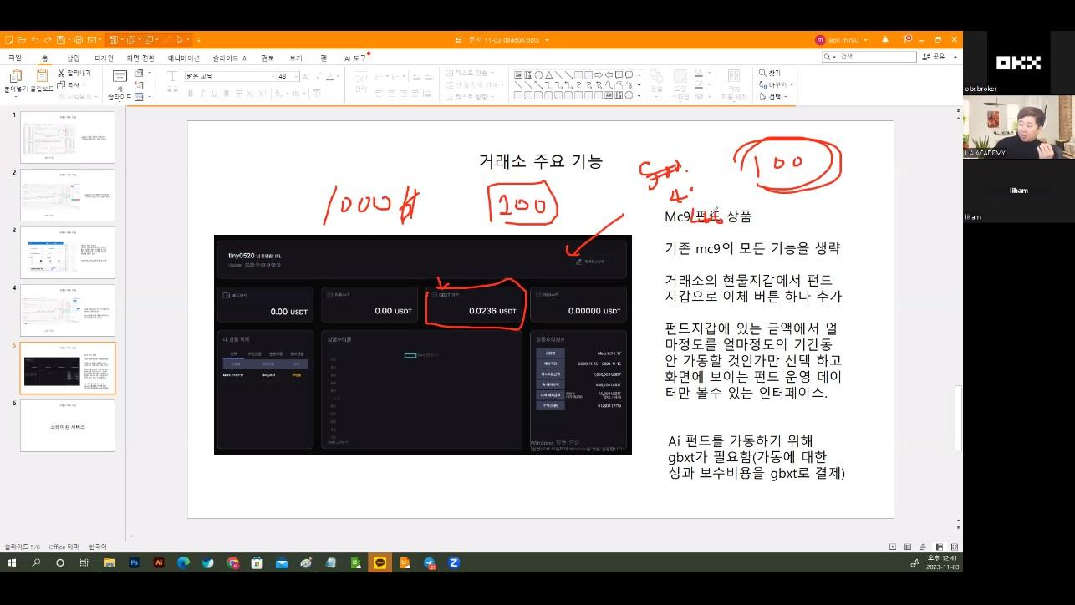
When withdrawing GBXT, a portion of the fee is deducted and the rest is stored in GBS.
37:43 - 38:47
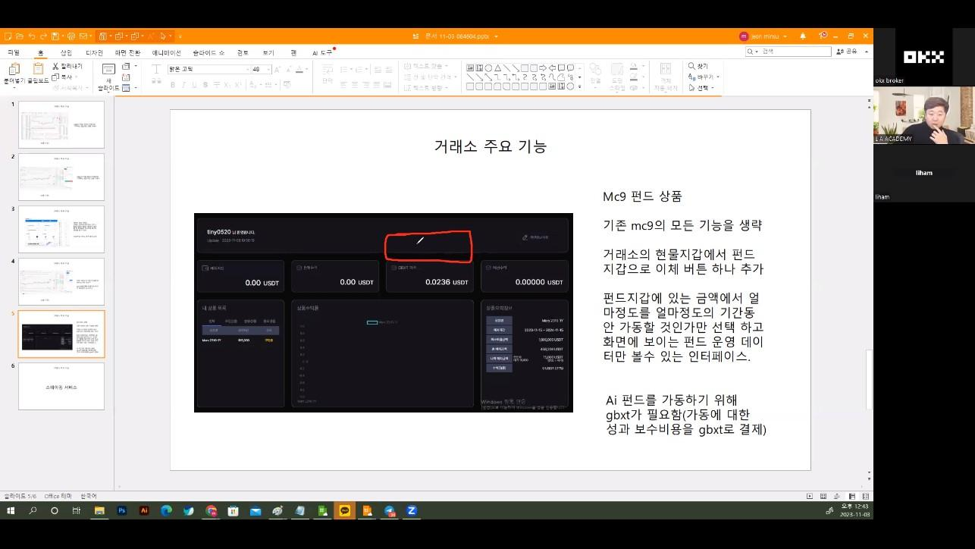
If customers prepay a certain amount, the transaction fee will be discounted.

