OJT: LinkedIn Marketing - How to Prevent Suspension and Use Ads Effectively
This OJT provides guidelines on safely using LinkedIn for marketing without risking account suspension, along with strategies for effectively using LinkedIn Ads and Sales Navigator.

1. Introduction
LinkedIn is a powerful platform for marketing, networking, and lead generation. However, improper use can lead to account suspension. This guide will help you navigate LinkedIn's rules and optimize your use of LinkedIn Ads and Sales Navigator.

2. LinkedIn Marketing Best Practices
- Personalize Messages: Avoid sending repetitive, generic messages. Personalize your outreach to increase engagement and reduce the risk of being flagged as spam.
- Engage Naturally: Interact with posts, join groups, and participate in discussions to build a genuine presence.
- Limit Connection Requests: Do not send too many connection requests in a short period. Aim for quality over quantity.

3. Preventing Account Suspension

DOs
- Personalize Invitations: Invite people you know or those with a clear professional connection to join your network.
- Send Relevant Communications: Ensure your messages are welcome and relevant to the recipient.
- Adhere to LinkedIn's Guidelines: Follow LinkedIn's Professional Community Policies and User Agreement.

DON'Ts
- Send Spam: Avoid sending spam-like or other unwelcome communications to others.
- Mass Messaging: Do not send messages to distribution lists, newsgroup aliases, or group aliases.
- Unsolicited Advertising: Refrain from posting any unsolicited or unauthorized advertising, "junk mail," "spam," "chain letters," pyramid schemes," or any other form of solicitation unauthorized by LinkedIn.
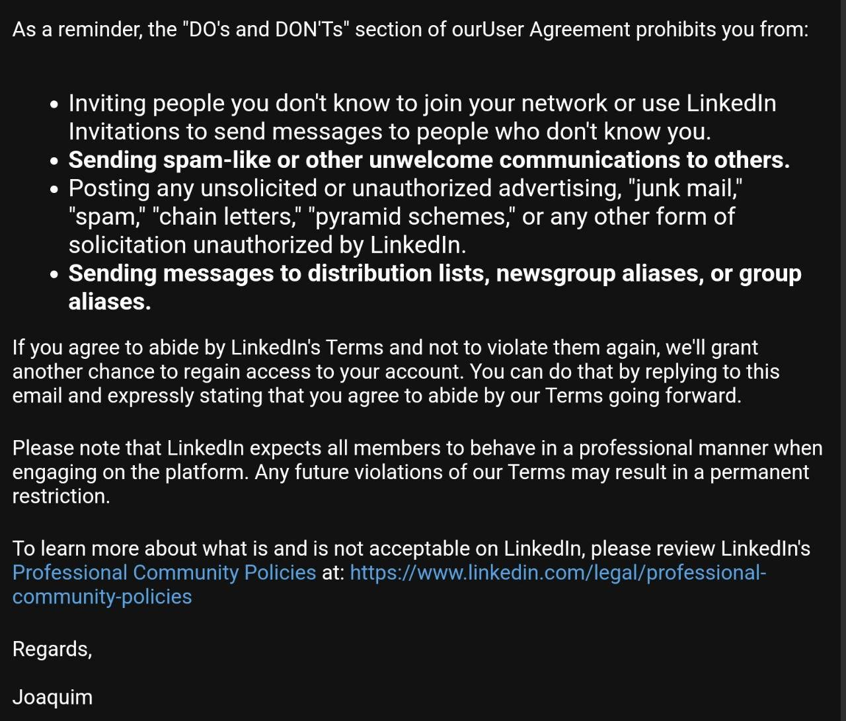

4. Using LinkedIn Ads
- Create Compelling Ads: Design ads that are relevant, engaging, and provide value to your target audience.
- Segment Your Audience: Use LinkedIn’s targeting options to reach the right audience based on industry, job title, and other criteria.
- Monitor Ad Performance: Track the performance of your ads and make data-driven adjustments to optimize results.

Steps to Create LinkedIn Ads:
- Access LinkedIn Campaign Manager: Go to the LinkedIn Campaign Manager to create and manage your ads.
- Set Up Your Campaign: Choose your campaign objective (e.g., brand awareness, lead generation).
- Define Your Audience: Use LinkedIn’s targeting features to specify your audience.
- Create Ad Content: Design your ad, including images, copy, and call-to-action.
- Set Your Budget: Determine your budget and bidding strategy.
- Launch and Monitor: Launch your ad campaign and continuously monitor its performance.

5. Utilizing Sales Navigator
- Advanced Search Filters: Use Sales Navigator’s advanced search filters to find and connect with potential leads more effectively.
- Save Leads and Accounts: Organize your leads and accounts to keep track of important prospects.
- Send InMail Messages: Use InMail to reach out directly to prospects who are not in your network.

6. Creating and Managing Pseudo Accounts
- Purpose of Pseudo Accounts: Use pseudo accounts for market research and testing without risking your main account.
- Creating a Pseudo Account: Follow LinkedIn’s sign-up process using a different email address.
- Manage Responsibly: Avoid using pseudo accounts for spam or excessive outreach to prevent suspension.

Steps to Create a Pseudo Account:
- Sign Up with a New Email: Create a new email address for the pseudo account.
- Register on LinkedIn: Use the new email to register on LinkedIn and complete the profile with realistic details.
- Gradual Engagement: Slowly build connections and engage with content to avoid suspicion.
- Monitor Activity: Regularly check the account to ensure it remains in good standing.

7. Summary
By following these best practices and leveraging LinkedIn Ads and Sales Navigator effectively, you can maximize your marketing efforts on LinkedIn while minimizing the risk of account suspension. Always prioritize genuine engagement and compliance with LinkedIn’s guidelines.
For any further assistance or clarification, please feel free to reach out to the LinkedIn support team or your internal LinkedIn marketing advisor.

