(OJT) module for partnership announcements
Step 1: Define Learning Objectives

- Understand the strategic importance of partnership announcements.
- Learn to set up and utilize Wordpress auto-posting for Partnerscan.
- Master the creation of engaging banners and posts for HYVE announcements.
- Develop skills in scheduling, monitoring, and engaging with posts on various platforms.

Step 2: Develop Content and Materials

2.1 Wordpress Auto-Posting Setup

- Setting up Wordpress plugins for auto-posting, step-by-step guides with screenshots.

2.2 Banner Design for Announcements

Design a banner for a hypothetical HYVE partnership using design software.

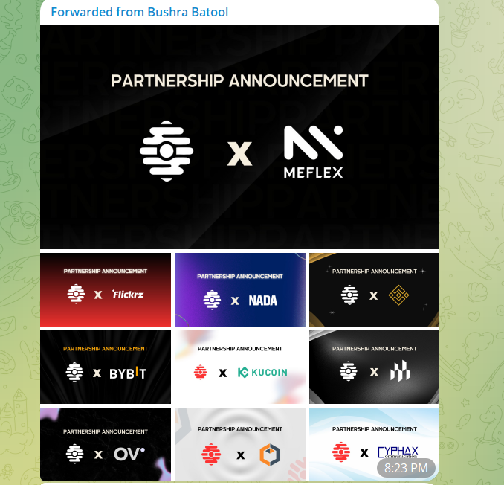

2.3 Crafting Engaging Announcement Posts

Write an announcement post for the previously designed banner, incorporating key messaging and a call to action.




2.4 Announcement Scheduling and Monitoring

Schedule the mock post for publication and outline a plan for monitoring and engaging with the community post-announcement.

Step 3:
Setting up partnership announcement posts to be scheduled in WordPress is a straightforward process that helps in ensuring your content goes live at the optimal time for engagement. Here's how you can do it:

1. Log into your WordPress Dashboard
Access your WordPress site by logging in with your credentials. Once logged in, you'll be directed to the WordPress dashboard.
2. Create a New Post
- Navigate to the left-hand side menu, look for "Posts" and then click on "Add New" to create a new post.
- Start by adding a title to your post and then the content of your announcement in the body section. Make sure to include engaging and relevant images if necessary.
3. Set Up Scheduling
- Once your post is ready, instead of immediately publishing it, look for the "Publish" box on the right-hand side of the screen.
- Inside the "Publish" box, click on the "Immediately" next to "Publish." This will allow you to select a future date and time for the post to be published automatically.
- Choose the date and time you want the post to go live. Consider the time when your audience is most active for maximum engagement.
4. Preview and Schedule
- After setting the date and time, click on "Preview" to review your post. This step is crucial to ensure everything looks good and the formatting is correct.
- If you’re satisfied with the preview, go back to your post editor and click on "Schedule" to set your post to be published automatically at the selected time.
5. Confirmation and Adjustments
- WordPress will confirm that your post is scheduled with a note at the top of the editor. You can always come back to edit the post or change the scheduling if needed.

