Out-Bound Marketing and Sales

Title : Arrange the IR and Sales meeting for partnership and profit providing agreement

Step 1.
Preparing the Marketing materials
(Text, Image, Video, Website + Admin)

1) Login our every single Linkedin account (Make sure the update)

2) Find the “Recruiting” company at DMCC
(C team can extract the list for Recruiting DMCC) +(1) Email + (2) Linkedin Messenger

3) Using that link + Email, we can approach to (1) Admin or (2)Headquarter as much as we can. And then, suggest our services

Ex. Services Introduction Samples

Marketing text QnA Simulation when we message with (Possible or Potential) customer
https://docs.google.com/document/d/1tLIFbMnLN8wChuzXr45ryW9lhagQZ75Dsn9C9D0Cm0k/edit?usp=sharing

[Telemarketing Script] - Introduction:

Agent: Good [morning/afternoon/evening], [Customer Name]. My name is [Your Name], and I'm reaching out on behalf of [Your Company : Snovacapital.com, Meflex, Flicrkz, SOMI, Findex and etc]. How are you doing today?

[Building Rapport and Connection]

Customer Response:

We have a great project who done the referred or affiliated program [Project Name]

Goal : Not only for this tesla, but also our project has a lot of services. Look at our roadmap-! We have a lot of plans(Roadmap of whitepaper). (You can freely customise marketing attraction message This year all of FED from USA, they announced that they will decrease the interest )

If positive: That's great to hear!
If neutral/negative: I understand; we aim to make your day a bit brighter with something exciting.
[Transition to Tesla Referral Program]

Agent: I'm calling today to share an incredible opportunity with you. Are you familiar with Tesla, the innovative electric vehicle company?

Customer Response:

If familiar: Fantastic!
If not familiar: Tesla is renowned for its cutting-edge electric vehicles.
[Introduce Tesla Referral Program]

Agent: Tesla has a referral program that lets you earn exclusive benefits by simply referring friends and family to purchase their first Tesla product. Imagine enjoying perks like buyer benefits, referral credits, and loyalty benefits.

Customer Interest:

If intrigued: That sounds interesting.
If unsure: Tell me more.
[Highlight Tesla Referral Program Benefits]

Agent: Let me break it down for you. By using a valid referral link when ordering your first Tesla product, you unlock buyer benefits. And here's the exciting part – you can continue earning referral credits by referring others! These credits can be redeemed for various Tesla benefits.

[Connect to [PROJECT NAME] Project]

Agent: Now, speaking of exciting opportunities, have you heard about the [PROJECT NAME] project? It's a groundbreaking initiative that combines the pleasure of gaming with the chance to earn extra income. Picture yourself immersed in fun activities that align with your interests, all while earning rewards in [PROJECT NAME] tokens.

Customer Interest:

If intrigued: That sounds fascinating.
If unsure: How does that work?

[Highlight [PROJECT NAME] Project USPs]

Agent: [PROJECT NAME] is designed for everyone. It's user-friendly, meaning you don't need to be a tech expert to enjoy the benefits. With a platform that offers diverse, flexible, and entertaining opportunities, you can earn in a way that suits your lifestyle. It's about making earning genuinely pleasurable.

[Wrap-Up and Call to Action]

Agent: So, [Customer Name], wouldn't it be fantastic to combine the innovation of Tesla with the excitement of the [PROJECT NAME] project? I can guide you on how to get started and maximize these unique opportunities. What do you say?

Customer Response:

If positive: Yes, tell me more!
If unsure: I'm interested but need more information.
If not interested: Thank you for letting me know.

[Closing]

Agent: I appreciate your time today, [Customer Name]. Let's explore these exciting possibilities together. Can we schedule a time for a more in-depth discussion, or would you prefer I send you some detailed information via email?

Feel free to customize the script based on the specific details of your offerings and the preferences of your target audience.

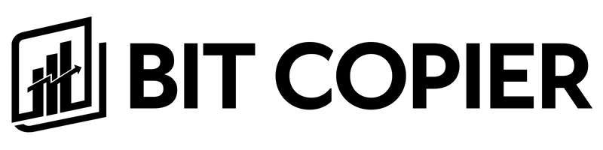
(At Rockefeller Center) 1270 Ave of the Americas, 7th Fl -1072 New York, NY 10020

Bit Copier, There is the most safe way to do an investment. Don't hesitate to join for free.

#cryptocurrency #investment #gigworker #freelance #investor #finance
#crypto, #trading, #income, #passive income, #money, #bitcoin, #investment

ROBOT
+ LIVE GUIDE = REVENUE

The Most Trading Volume and Profits Came from Robots

ROBOT +
HUMAN =
HUGE INCOME

GET THE LESSON FROm WORLD CLASS INSTRUCTOR

NO-ONE COULD WIN THE ROBOT

now IT's
YOUR INCOME

YOU WILL SEE THE BRILLIANT MOMENT IN LIVE TOKEN GUIDE SERVICE

YOU DON'T KNOW? The Most Trading Volume and Profits Came from Robots

BEYOND
HUMAN
TRADING

GUARANTEED
REVENUE
WITH ROBOT

CRYPTO PROFIT? Don't WORRY.
We have millions ROBOTS

DROP?
YOU HAVE TO DO FUTURE TRADING!

FOR OUR Membership User,
We provide VIP Info to protect our User's Asset overally

#CryptoCast VIP Crypto-Caster ROBOT + LIVE GUIDE = REVENUE
The Most Trading Volume and
Profits Came from Robots

GET THE LESSON FROM WORLD CLASS INSTRUCTOR

Token Foundation use their Volume Robots. For your profit? You have to use 'Bit Copier' !

Wait until Signal from Foundation

Join our Incredible ROBOT AND HUMAN GUIDE
FOR TRADERS

Investment Profit Result Sample report 1
(Staking)
https://docs.google.com/document/d/1tLIFbMnLN8wChuzXr45ryW9lhagQZ75Dsn9C9D0Cm0k/edit?usp=sharing

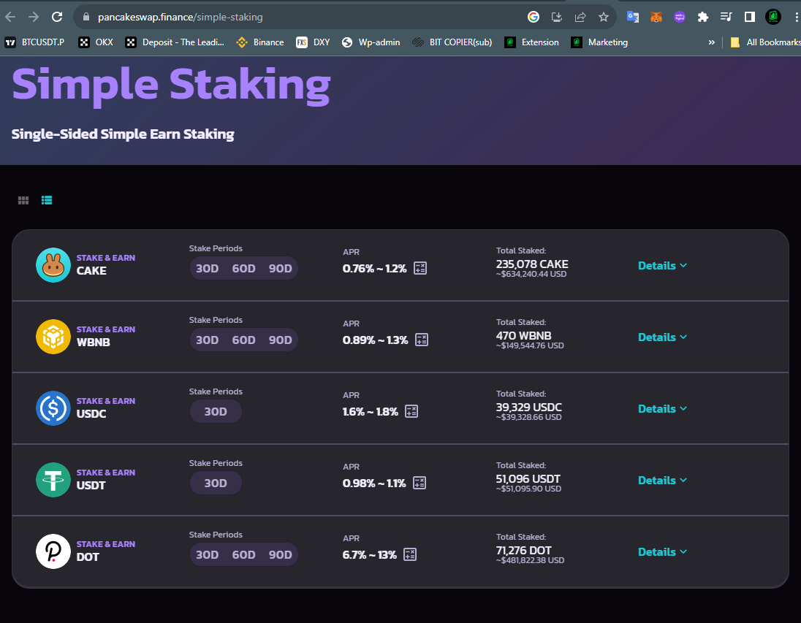

Sample : Target Profit (APY(Annual Percentage Yield) +30~150%)
(with contract)

[Sample]
https://pancakeswap.finance/simple-staking
Like this sample, we can let users to do fundraising for each project (Meflex, FLickrz, SOMI, Fandom)

[Only for our internal developers team as well]
https://codecanyon.net/item/multicurrency-crypto-wallet-and-exchange-widgets-for-wordpress/23532064

A, C, D, M and All team can refer to these materials. Additionally, Canva.com has this design source. If you need video resources please request to Ed. he will help to modify them all.

1.SNOVA Fund Product ADs (Image Collection) (Brand sample will be replaced to SNOVA)
https://drive.google.com/drive/folders/1CvlYF0vLkqLk72rdq18ZmnEpu4RAzEkj?usp=sharing

2.SNOVA Fund Product ADs (Video) (Brand sample will be replaced to SNOVA)
https://drive.google.com/drive/folders/1SFL69J2iNwN7BMqXqcfTTuBn_dchGdDe?usp=drive_link

3.SNOVA Textbook (Reference : Fidelity)
https://drive.google.com/file/d/1D8uBRVX5IY2waVaa4Y1OsUFqovRlqeLZ/view?usp=sharing

4. Banner Design
https://drive.google.com/drive/folders/1ROskK3XyYuuHUrDiG0DnZSFmDQ5HZIOI?usp=sharing

5. Sample logo
https://drive.google.com/drive/folders/1MW3q0dWVDKnai4VNtnJ1_45pzc-3adtd?usp=sharing

6. Sample Image (Image sample will be replaced to SNOVA)
https://drive.google.com/file/d/1f29nYrsrq0esPAwk-zdX6K1PIPHnJLkI/view?usp=sharing

7. Sample lecture (We can change this channel too for our new broadcaster) (Image sample will be replaced to SNOVA)
https://www.youtube.com/@CryptoCapitalVenture (Reference)
https://www.youtube.com/@bitcopier (We owned this channel and available to change the title to SNOVA too)

8. Crypto Ad image (Image sample will be replaced to SNOVA)
https://drive.google.com/drive/folders/1kFSnX3ShsZEJyPgk5LNnl5ZgIAtEFKlH?usp=sharing

9. Crypto Exchange Logos
https://drive.google.com/drive/folders/1stbYBQBjqKcT9ubLyHYNLaRpQ9f8xL2U?usp=sharing

(For snova, meflex, flickrz, Somi)

Investment Profit Result Sample report 2
(B2B Fund Management)
By www.Snovacapital.com

[Investment and Fund Management] : Funding “If you fund our service, we make the profit during 18-24 months

Propose each service(Investment) (Snova, Findex) : Marketing team should create proposal 1)Text 2)Image 3)PPT for each project

1. VVIP Management Account Info through Binance 2024

We appreciate the client's trust for mutual growth. We’ll report about our monthly process for our trustful result. Following info is based on the client's deposit who invested in our project.

Deposit Owner | Sir.OOO
Level of Client | VVIP
Amount | 100,000 USDT
Effective Date | 22nd DEC 2023

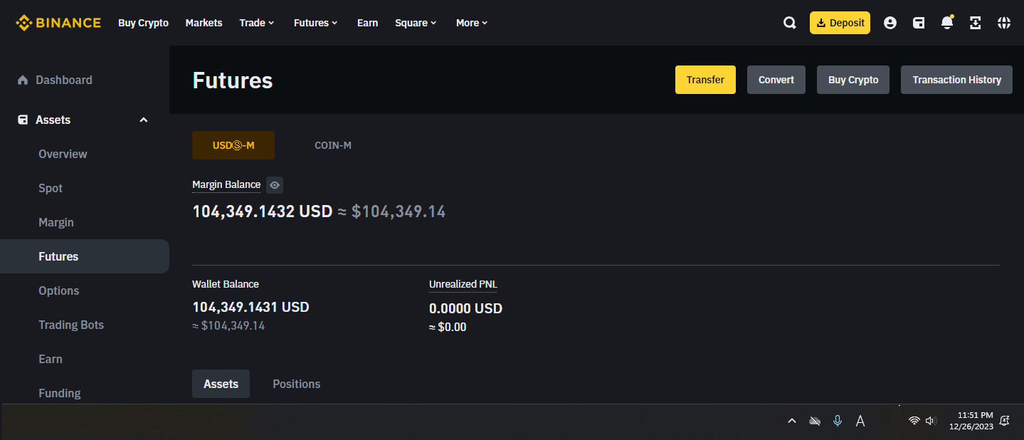
[Figure] Profit Making References (Current Status : 2023-12-26 11:51)

2. Target Profit (APY(Annual Percentage Yield) +30~150%)
(with contract)

For your new profit, our professional team is handling all the risk based on the risk management system for the sustainable project.

Accumulated Deposit | 100,000
Expected CAGR | +80 ~ +120%
Targeted Profit | +150 ~ +450%
Current Profit | +4,349 USD / 30,000 USDT  Processing Started / 70,000 USDT
3. Continuous Profit Making
Effective Date | 22nd DEC 2023
Profitable Terms | 18-36 Months
Targeted Profit (ROI) | +150 ~ +450%
References for Commodity Management | CPI, PPI, NFP, PCE, FED Announcement and 30 Number of standards

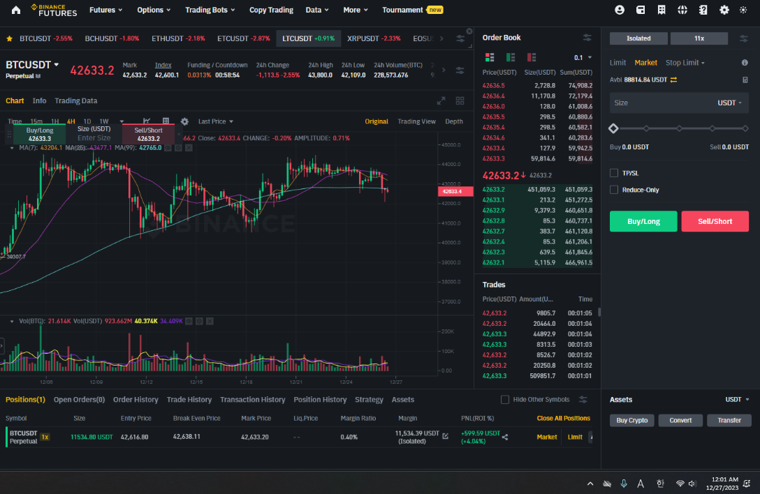
[Figure] Profit Making References (Current Status : 2023-12-26 12:03)

Comment | XXXXXX USDT (2024-XX-XX) is deposited additionally. So the total accumulated deposit is 100,000 USDT. It will be profitable after 1 month trading according to CPI, PPI, NFP, PCE, and FED announcements.

ROI
[Blockchain partnership and Staking]
Staking “If you fund our service, we make the profit during 18-24 months

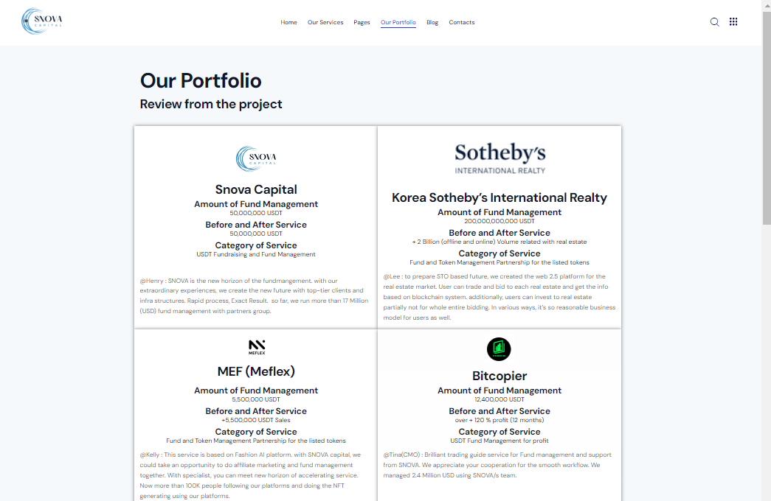
https://snovacapital.com/our-portfolio-2/

[Materials to advertise each service]
Describe each project’s advantages + Blockchain services (Meflex, Flickrz, SOMI, Fandom) : Marketing team should create proposal 1)Text 2)Image 3)PPT for each project

Findex

Step 2.
Arrange the Offline MOU and Agreement Schedule (Dubai or any places okay)
(Even ZOOM is available)

Scheduling (HR + A team) (For dispatching process)
cheapest and high rated review + Transportation + Housing (Airbnb) + Schedule tabling + Auto Linkedin sponsorship communication + Proposal with marketing team with chatGPT

We have to arrange the Snovacapital.com 's MOU project

Goal of Dispatch1 : MOU with CEX, Blockchain projects at offline at DMCC
(Marketing team > Proposal Creation for each foundation)
(Accounting)

Make sure about Advantages
https://snovacapital.com/our-portfolio-2/

Goal 2: Apply DMCC crypto center program submission
(Accounting)

Goal 3 : Contacting DMCC foundation (Such as Solana or global fund companies)

[VIP Email list : 1400 number of VIP (VC : Venture Capitalist)]
https://docs.google.com/spreadsheets/d/1pKT5FmTPHweKDyTp25VisQ6m1MrYMcg3cEZ4lVPLBQA/edit#gid=0

Goal 4 : getting the orders and contracts as much as we can
= We have to make sure the meeting arrange with major VC

[Contract : +15% we guarantee about the deal for incentive]
(with hidden contract for our internal team, we’ll provide that)

Ex1 . Each Contract
Ex. Blockchain service development 100,000 USD (15% immediately once they put the money to our account), 15,000 USD we guarantee for the commission

Ex2 . Digital Marketing we can proceed
35% (Expense for raising the MAU)
20% (Company)
20% (Final Task owner at the end of point) (10% we provide at the first input of money, + 10% if we finish the project)
25% (R&D : Development for company and salary)
( https://leadspons.com/ )

Step 3.
Main Result

Summary

To do list (C + M + D + A) (If we classify about Role & Responsibility for each team, it would be great)
(In case of co-work project each team, we distribute project’s profit each like 1/N for incentive once we got the input the money from the client order with contract)

Process
1)Linkedin Affiliate marketing
https://www.linkedin.com/learning/content-marketing-funnel-for-creators/attracting-sponsorships

2)VC marketing service approach (not only for VIP list, but also linkedin sponsorship marketing we’ll do together) (ex. Linkedin + Email + Google Keyword + Youtube + Tiktok)

3) Linkedin sponsorship marketing
get the marketing order for that company and get the contract with them with plan scheduling (“I want to find my customer using your Digital Marketing service “B2B AI marketing service contract for 1 month : XXX,XXX)

A + C team : Create Estimation (Time, budget, ROI) with contract

3)Linkedin VC (Venture Capitalist) contact (“We’ll fund XXX,XXX USDT for your company)
A + C team : Create Estimation (Time, budget, ROI) with contract

4)crypto projects and central exchange CEX(Binance, Bybit, Kucoin, OKX, Gate io) MOU agreement

We can get the advice from the partnercompany (we got a lot of contact from marketing team. Tina(CMO) marketing team’s list. Let’s contact them and do the partnership for our new order.

Result

[Agile Process]

1.Marketing contents creation
2.Proposal + Sponsorship (Social Media : Linkedin + Youtube + tiktok + instagram + FB, Twitter and etc)
3.Estimation
4.Contract
5.Incentive Distribution
6.Project Reminder with auto TG reminder according to universal task table

(Rotating these process : Agile Process)

Out-Bound Marketing and Sales Process summary
To do list and R&R(Role and Responsibility)
Team | A | A | C | D | M | Dev | HR
Step1.  Once you got the order | Estimation | Contract | OJT | Design | Sponsorship setting | Landing page | Schedule
Step 2.  Google Drive | Estimation | Contract | Guide for Google Drive Organization for each team | Landing page setting + Contents creation (Text + Image + video) using the Canva or Chat GPT | [Linkedin + Youtube + Tiktok and etc] Contents creation (Text + Image + video) using the Canva or Chat GPT (Wordpres s auto posting for SEO ) | Contents replacement + SEO check up | Check up for each teammate’s Linkedin Profile update (Collect all Ambassadors’s info + internal team’s info)
Step 3.  Copy the template and Provide the result in (Due time) / each project | 24hrs | 1 hrs | 24hrs | 24hrs | 24hrs | 6hrs-72 days | 24hrs / 4 people (Update Profile As much as you can)
TG : Sales Telegram for each service (Separately) excluding client. And freely discuss it to make sure about the contents

- End -

