OJT for MOD Daily Recurring Task

- Firstly, go to the shared drive and search for the Social Media ID sheet as shared with all.
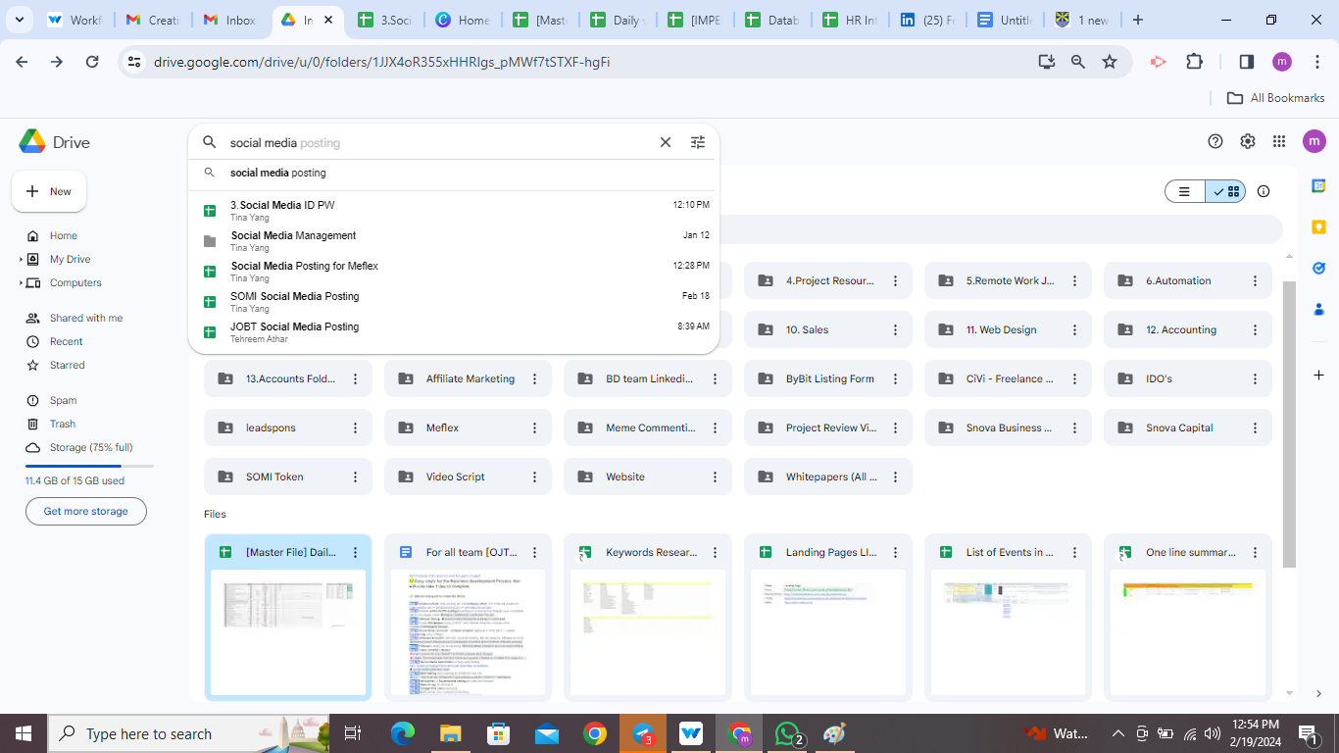

- Open the sheet shared with you all. 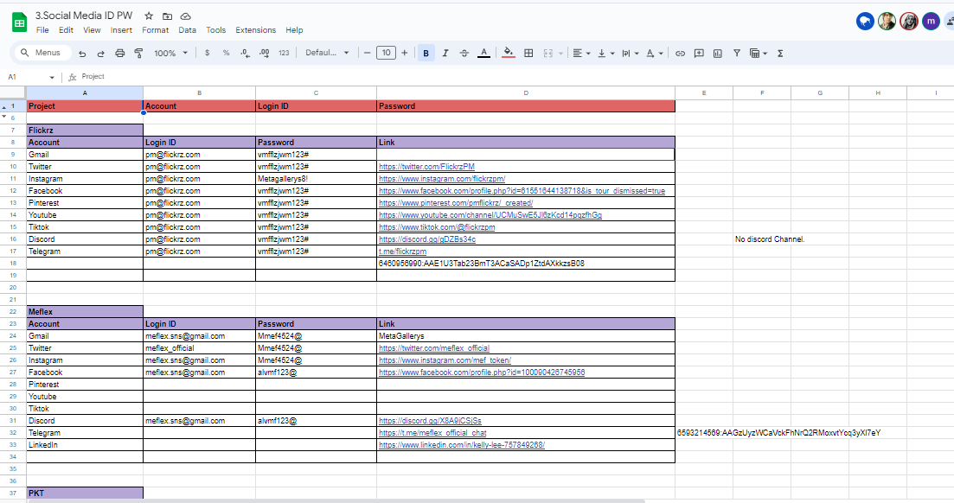

- Let's take one client example(JOBT) from the sheet. Go to their social media account credential details. Open JOBT Discord Link and join the group.

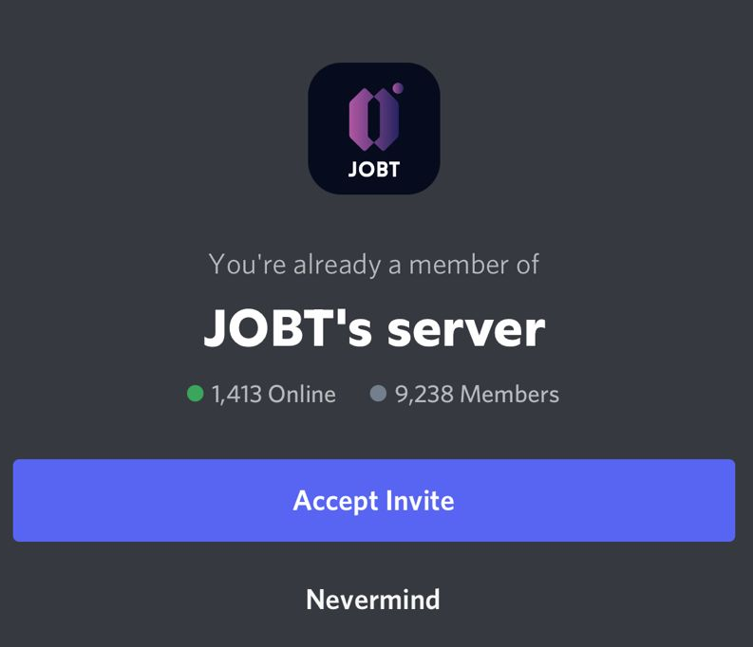
- Initiate the conversation by saying hello or good morning or whatever you like but you should at least give 10 to 20 minutes to every discord group all day whenever you see someone having a conversation there and initiate the viral community by describing the goals and features.
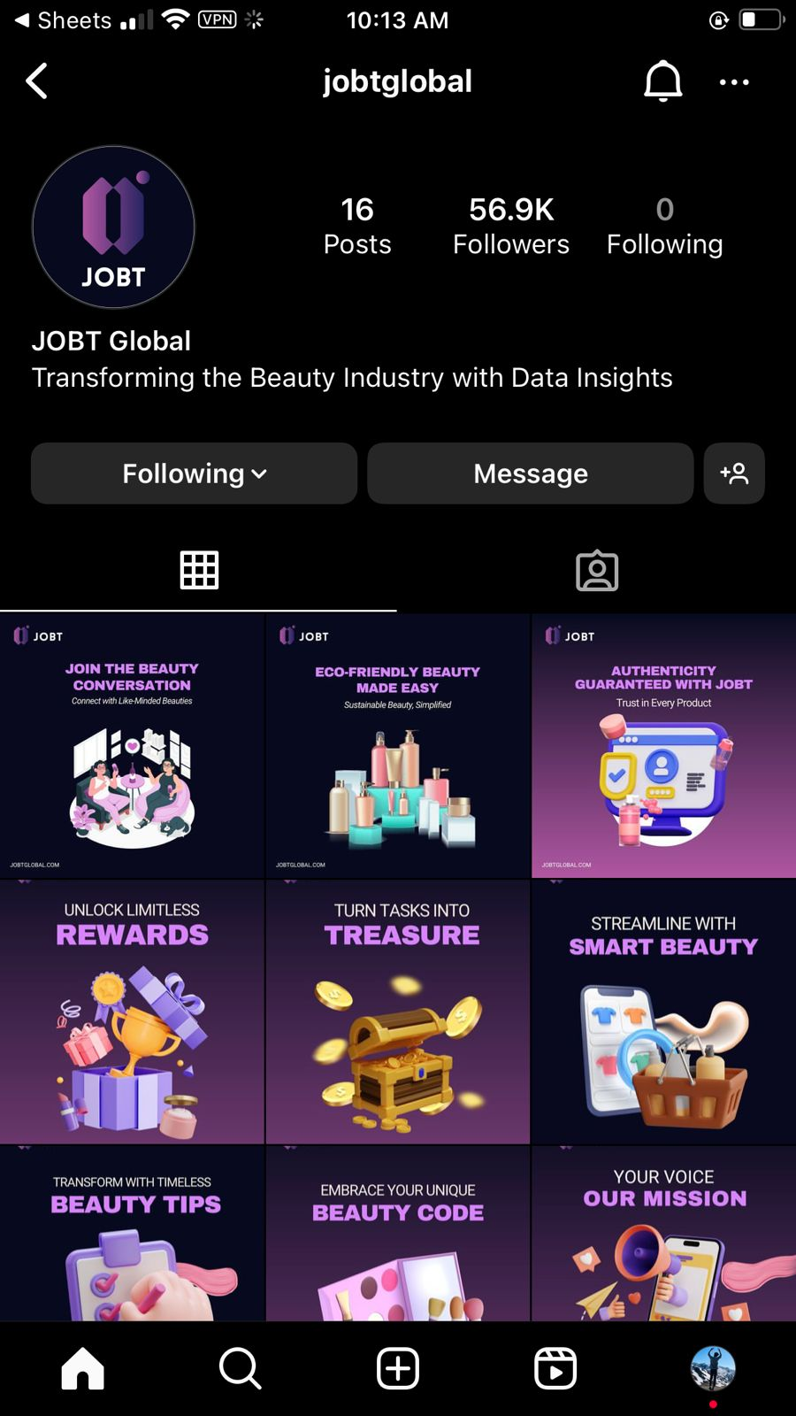
- Then go back to the social media account detail sheet and open the next social media acc, Open JOBT Instagram link.

- Here lets see the first post. I haven't liked it. Let's give it a like and write comments according to the description and content present in the image. With hashtags and emoji.
- Follow step 5 again and check for another social media detail of JOBT. Open JOBT Twitter account and see for the tweets. Let's like each of them and retweet that tweet and let's write a comment related to the description and with the imagery that is attached above with hashtags and emoji for better crawling.

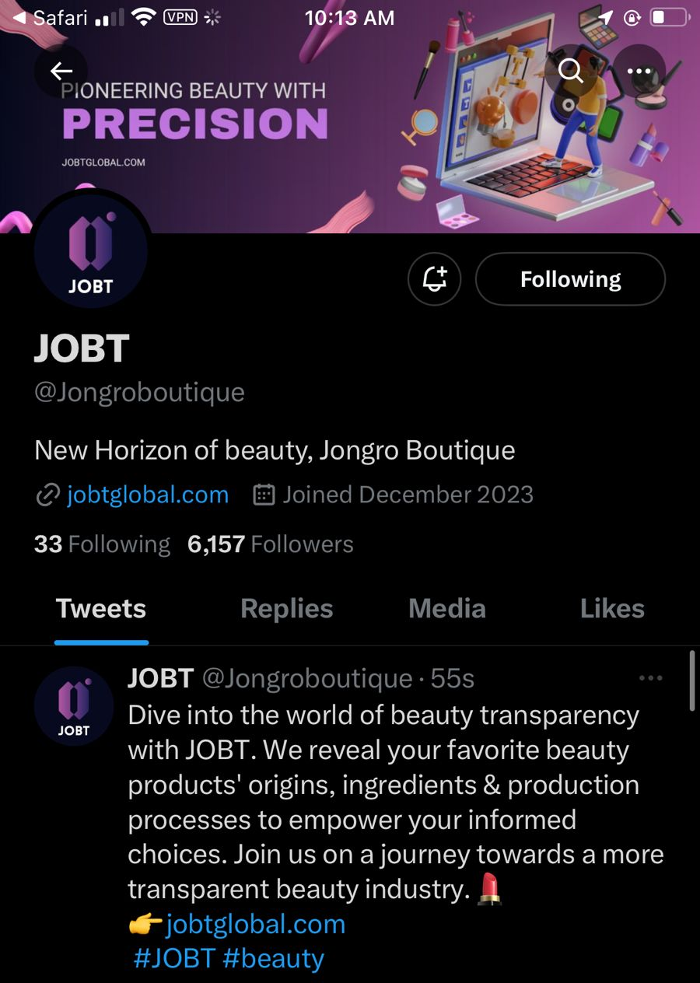

- Once you complete all the process of doing MOD regarding the assigned project, kindly update in the sheet, link is below for the sheet https://docs.google.com/spreadsheets/d/1k5Qu29FJYGft2TNbHTKe1aq5Kx0GpMNb6J1Ld85r8Ik/edit#gid=290903710
- Below is the link attached for the same process explained above. In this video, no instructions were followed for facebook and youtube. You have to do the very easy steps for them as well. Please do follow and write comments on facebook and share those posts on your walls as well. Thank you. https://drive.google.com/file/d/1ROUXneo3ZczeGLXQQbuCDqLQ7u_XK0Tf/view?usp=drive_link

