Social Media Followers and Comments Setting

Reference to Purchase1
https://buzzvoice.com/instagram/real-comments/order
(This Platform can deal with all social media)


Reference to Purchase2
https://useviral.com/#
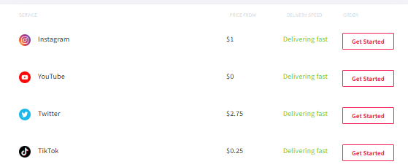
Reference to Purchase3
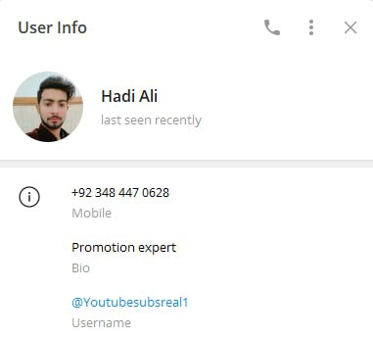 | Just FYI,  In order to buy followers for the social media accounts. We have used him for the Telegram, Discord to increase active users.  For other social media accounts such as Instagram, Facebook, Twitter, we used :  https://useviral.com/

