OJT - Setting Up a Google Ad for all Projects
This guide will walk you through creating a Performance Max campaign for all projects on Google Ads. While there are no images within the Google Ads interface, we'll provide detailed instructions for each step.
Before you begin:
- Make sure you have a Google Ads account. You can sign up for free at https://ads.google.com/home/.
- Have your headlines, descriptions, and visuals prepared for your ad.

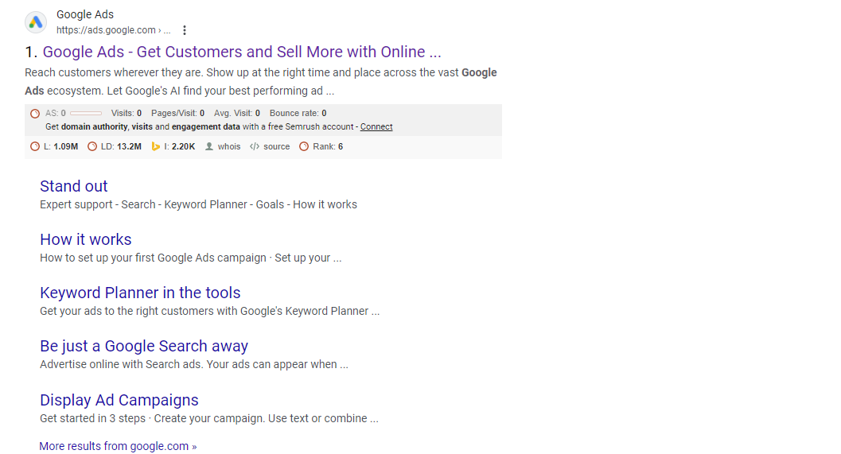
Step 1: Create a New Campaign
- Sign in to your Google Ads account and navigate to the "Campaigns" tab.
- Click the blue "+" button and select "New Campaign."

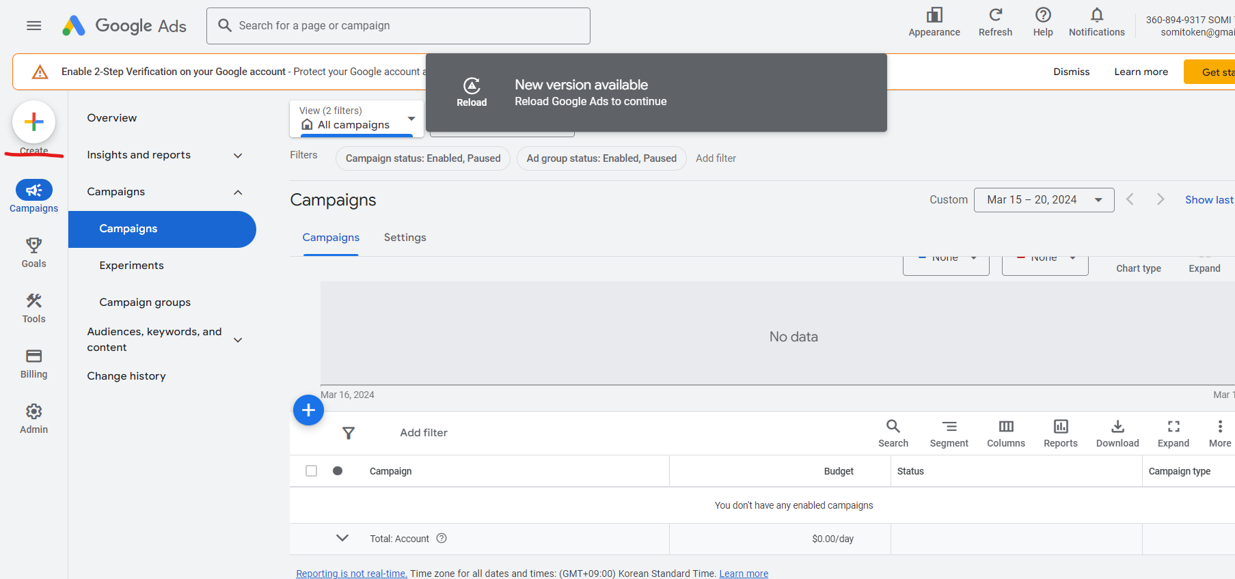

- Choose your campaign goal. In this case, select "Leads" if PartnerScan generates leads, or "Website traffic" if the goal is general awareness.

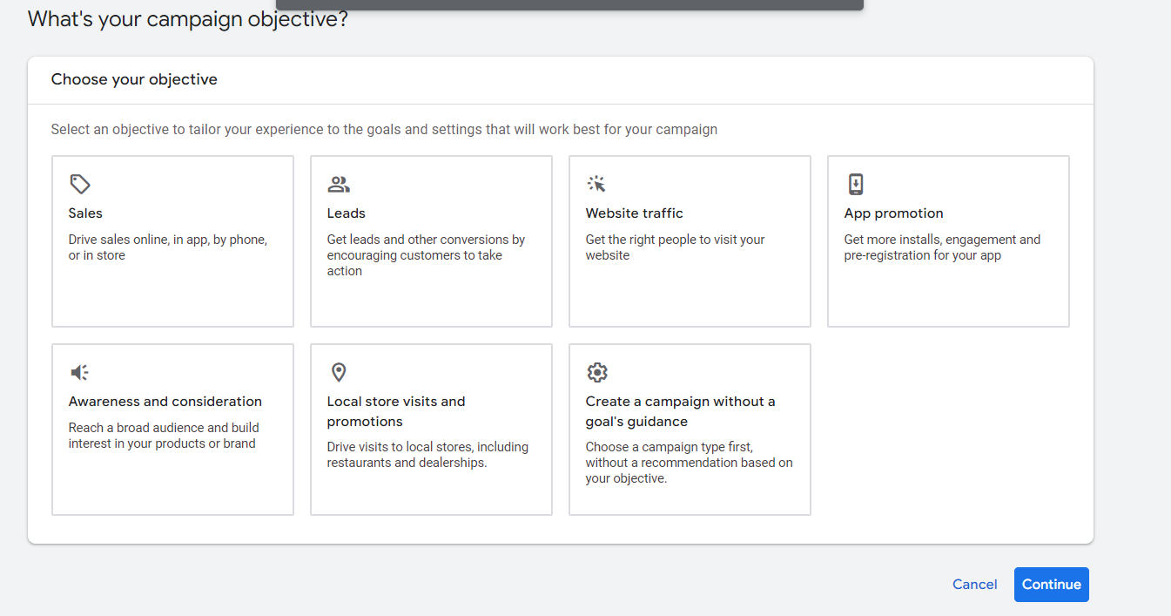
Step 2: Select Campaign Type
- Under "Campaign type," choose your campaign type "Performance Max.", “Google search ad”, “Google Display ad” etc.
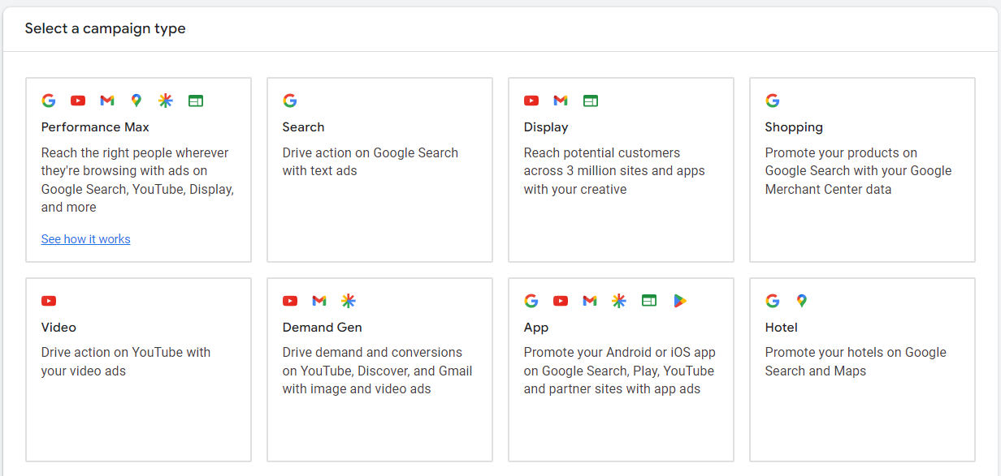
Step 3: Enter Campaign Details
- Give your campaign a descriptive name (e.g., "PartnerScan Web3 Partner Matching").
- Set your daily budget. With a $1,000 total budget for a 1-week campaign, consider a daily budget of around $143.
Step 4: Configure Bidding
- Under "Bidding," choose "Maximize conversions" to focus on clicks most likely to lead to conversions (leads).
- (Optional) If you have historical data, set a target cost per acquisition (CPA) for your leads.

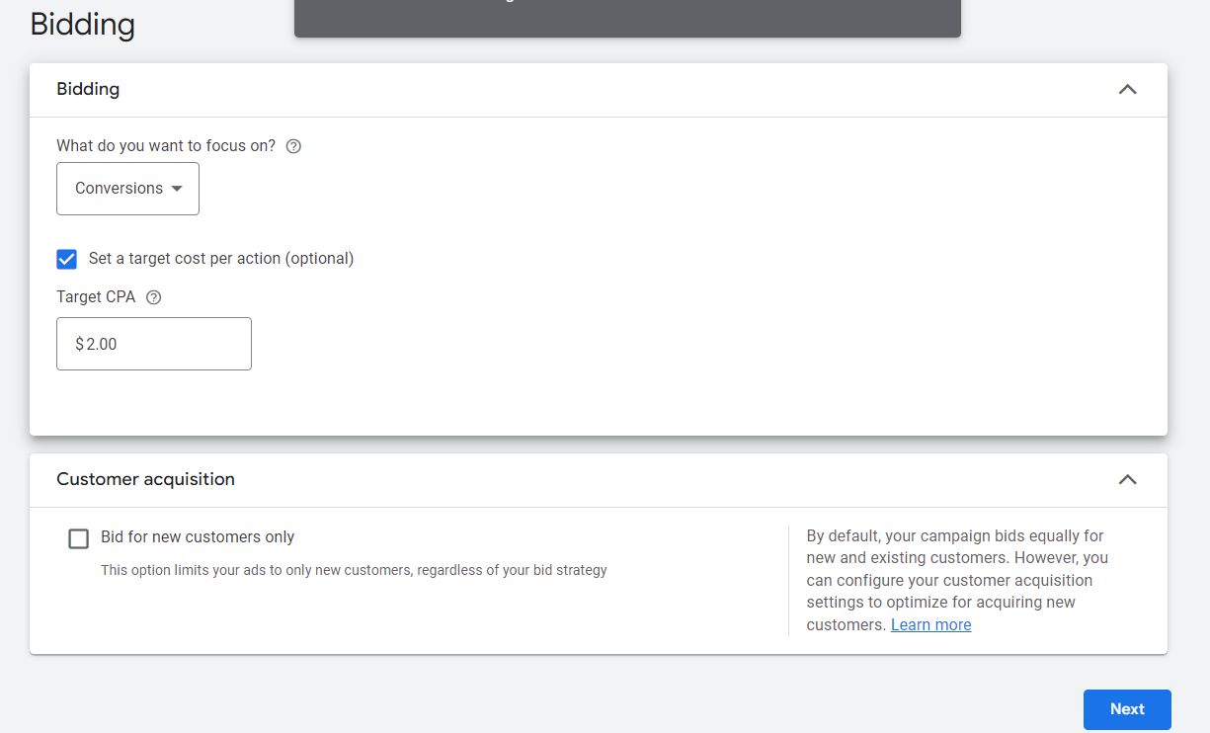
Step 5: Set Locations and Languages
- In the "Locations" section, target your desired locations. Start with the United States and consider adding additional countries later.
- Under "Languages," select "English" as the primary language.

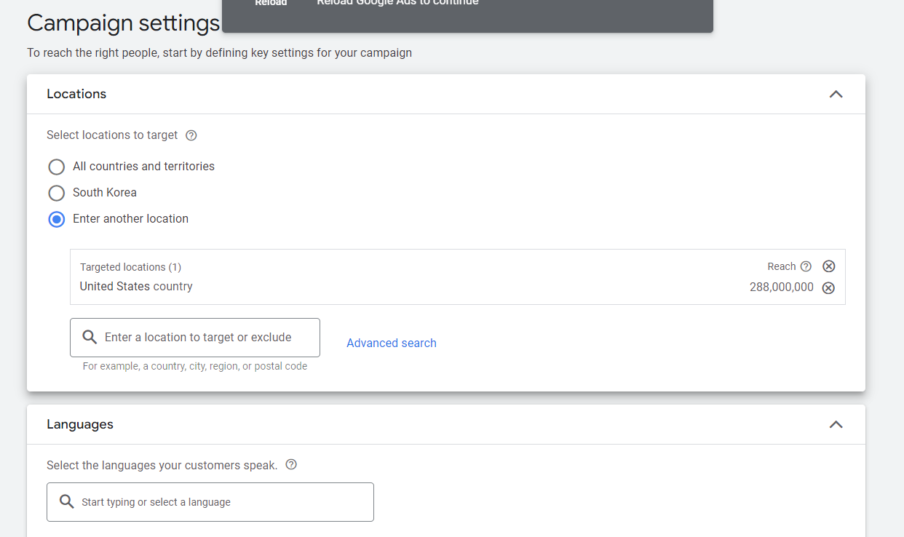
Step 6: Set Audience Signals (Optional)
- Click "Audiences" and then "Browse" to explore audience segments.
- Consider targeting users interested in "Blockchain technology," "Cryptocurrency," "Fintech," etc., under "Interests."
- Adjust demographics (age) based on PartnerScan's target audience.

Step 7: Create Ad Group
- Click "Ad groups" and then "New ad group."
- Give your ad group a relevant name (e.g., "Web3 Partner Matching").
Step 8: Add Keywords (Optional)
- While Performance Max doesn't require keywords, you can add some for more control.
- Use a mix of broad, phrase, and exact match keywords related to Web3 partnerships (see previous suggestions).

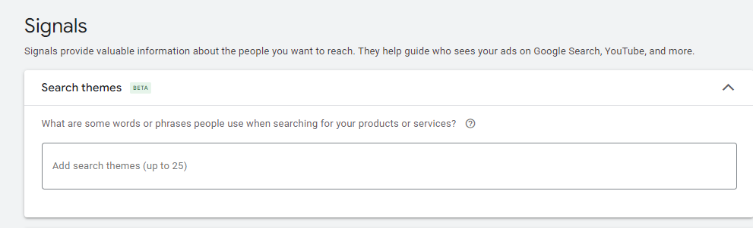
Step 9: Write Ad Text
- Click "Ads" and then "New ad."
- Paste your prepared headlines (up to 4) and descriptions (up to 4) for your ad.
- Include a clear call to action (CTA) in your descriptions, urging users to "Join Now" or "Sign Up."

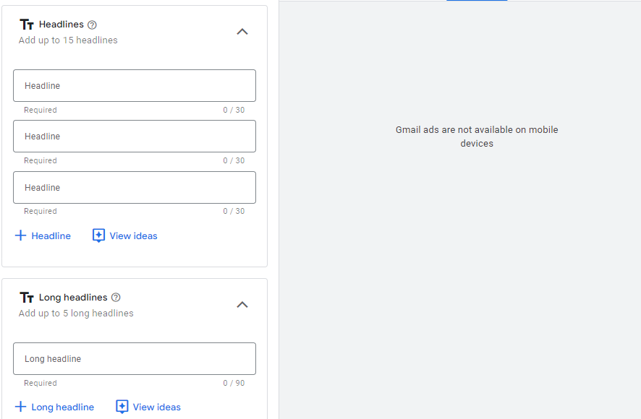

Step 10: Add Final URL
- Enter the landing page URL where users will be directed after clicking your ad.
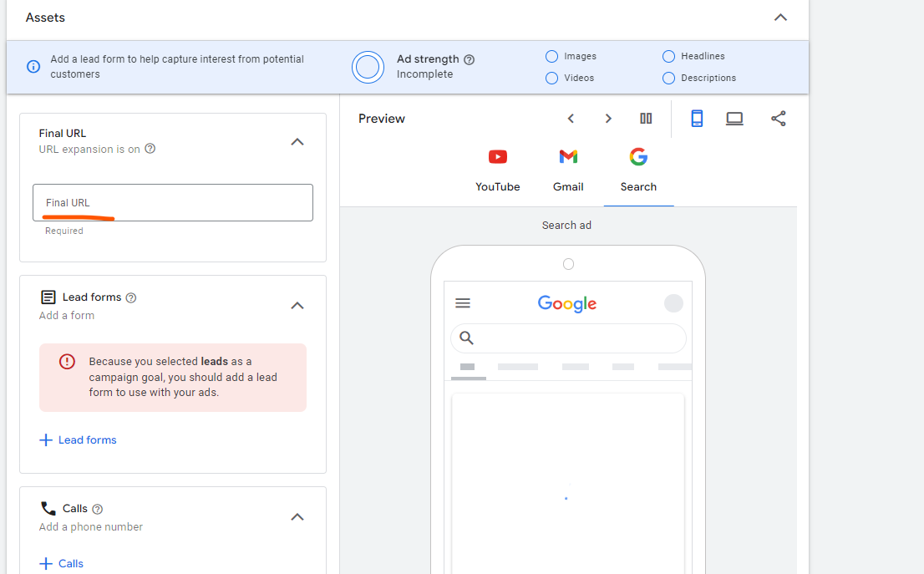
Step 11: Add Images & Videos (Optional, Highly Recommended)
- Click "Assets" and then "Upload new assets."
- Upload high-quality visuals showcasing Web3 projects, successful partnerships, or the PartnerScan platform.
- Use a variety of image sizes and aspect ratios as recommended by Google Ads.

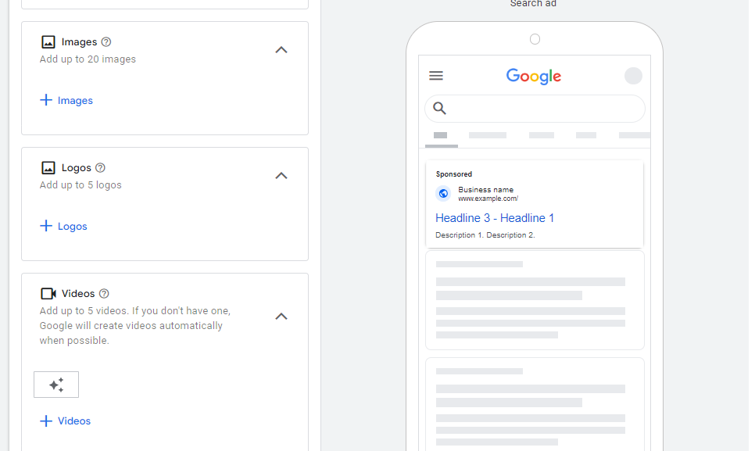
Step 12: Review and Launch
- Carefully review all campaign settings, targeting, ad text, and visuals.
- Once satisfied, click "Start campaign" to launch your campaign.

