Google SEO and Sponsored Marketing Summary
Guide for each industry field (Number is Major of Marketing)

Please make sure the SEO all the time
https://keywordtool.io/

1. Main Key Phrase as Sample (Emphasise about the number such as 100 % guarantee, 100% free trial, 15 % D/C this month, Profitable)

- Get a 2-5 X investment for your token and cryptocurrency - Maximise the reward and earn
- Free trial 30 days and Money back guarantee for Marketing result service

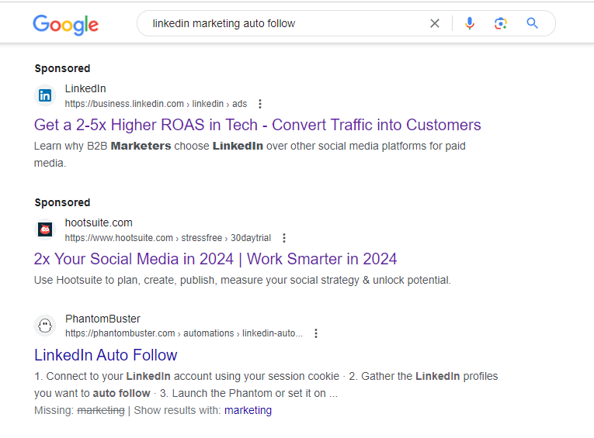

2. Finance Service

High 18% Fixed Returns | 100% Bond Buyback Protection
https://bond.aixinvestors.com › bonds
We help clients set up college funds, plan for retirement, meet mortgage payments and more. 4.5% risk-free quarterly returns, 100% Bond Buyback Protection — We help clients set up college funds, plan for retirement, meet mortgage payments and more

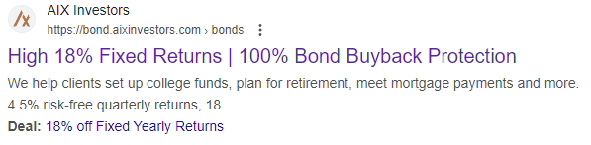
3. Staking Service
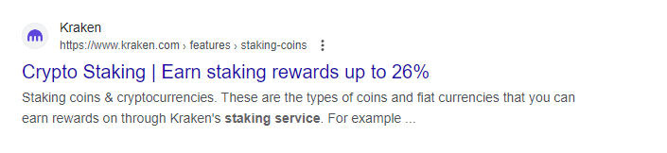
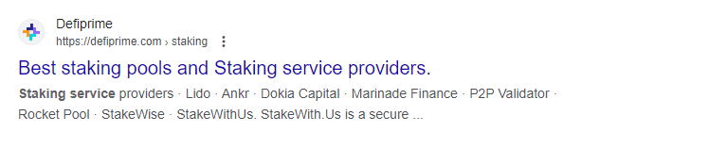
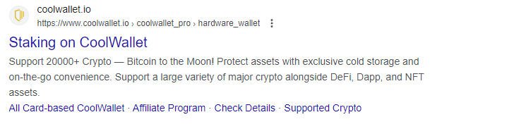

Support 20000+ Crypto — Earn Staking rewards up to 26% Bitcoin to the Moon! Protect assets with exclusive cold storage and on-the-go convenience. Support a large variety of major crypto alongside DeFi, Dapp, and NFT assets.

Staking coins & cryptocurrencies. These are the types of coins and fiat currencies that you can earn rewards on through Kraken's staking service

Earn staking rewards on your cash and crypto twice a week with just a couple of clicks. Instantly unstake at any time with no penalties

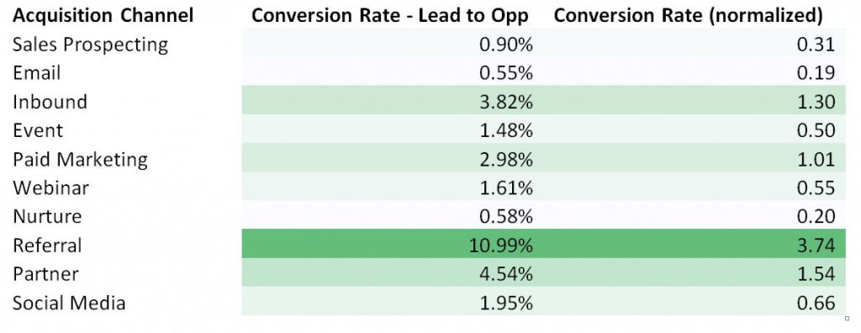
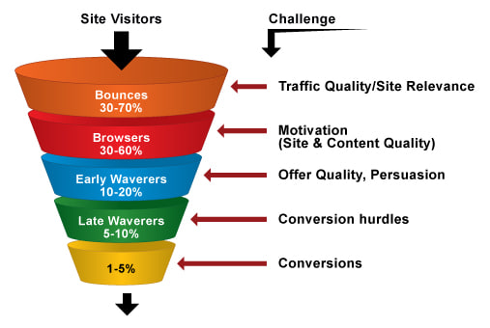
[Make sure the DB and Conversion funnel] everyday. (Finally only 1-3 % from 100% people consider to do investment according to result of searching the service and social media

1. Don't hesitate to set sponsorship marketing for website using [Google Ads, Social Media, youtube, Tiktok and etc]

2. Play the website from A to Z and newsletter (test it from users side and detect that what is the problem-!)

3. Set the D/C all the time and Price table various (Wordpress has a coupon system to display to users suddenly)

4. Give them a sudden coupon to get D/C

5. Social media should type always "If you want to discount, please click 'Like' and reply your email to my "Youtube", "Facebook" and etc to reply, I'll give you 15% D/C Coupon-! (Make the traffic all the time and list up all product page each posting)

6. Make sure the @ tag # hashs for SEO (for own brands, service, cost efficiency SEO tags)

DB makes the leads, and definitely some people purchase it with well organized-referral-reward-discount based offer for customer (treat customer as VIP all the time) (and give them a Time limit to get D/C)

Reference

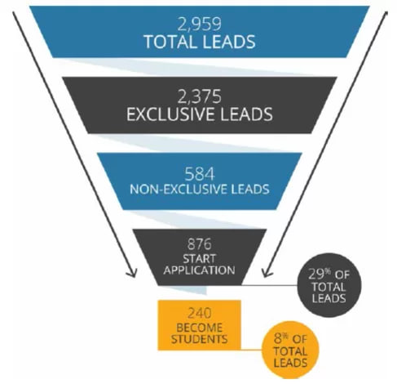
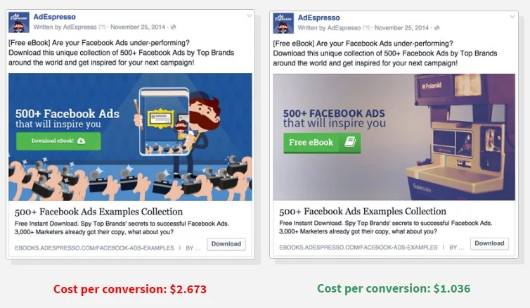
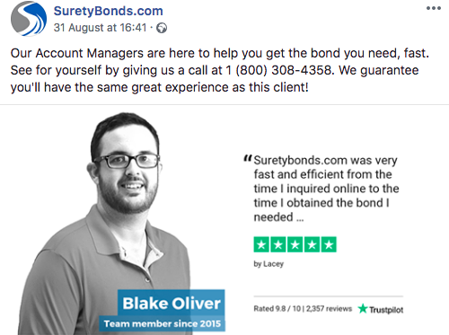

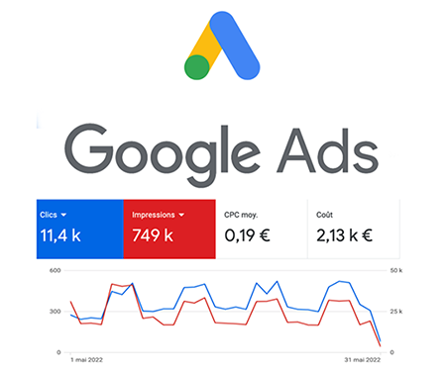

Don’t hesitate to set the post and sponsorship marketing-!
We have to be aware of our services

