Case Study: Preventing Facebook Account Suspension and Utilizing Effectively

1. Introduction
Facebook is a leading social media platform used for personal networking, business promotion, and community engagement. However, accounts can sometimes be suspended or banned due to violations of Facebook's policies. This report aims to identify the common reasons for these suspensions and provide guidelines to prevent such issues.

2. Common Reasons for Account Suspensions

2.1 Violation of Facebook's Community Standards
Facebook enforces a set of Community Standards that users must follow. Violations of these standards can lead to account suspension or banning. Common violations include:
- Hate Speech and Harassment: Posting content that promotes violence, hatred, or discrimination against individuals or groups based on attributes such as race, ethnicity, religion, gender, or sexual orientation.
- Nudity and Sexual Content: Sharing explicit images, videos, or other sexual content that violates Facebook's policies.
- Violence and Threats: Posting threats or content that glorifies violence can result in immediate account suspension.
- False Information and Misinformation: Spreading false information, particularly about sensitive topics like health, safety, or elections.

2.2 Spam and Inauthentic Behavior
Facebook actively combats spam and inauthentic activities, including:
- Spamming: Sending unsolicited messages, posting repetitive content, or using fake accounts to promote products or services.
- Fake Accounts: Creating accounts with false information, using someone else's identity, or impersonating others.
- Engaging in Misleading or Fraudulent Activities: Running scams, phishing, or engaging in deceptive practices.
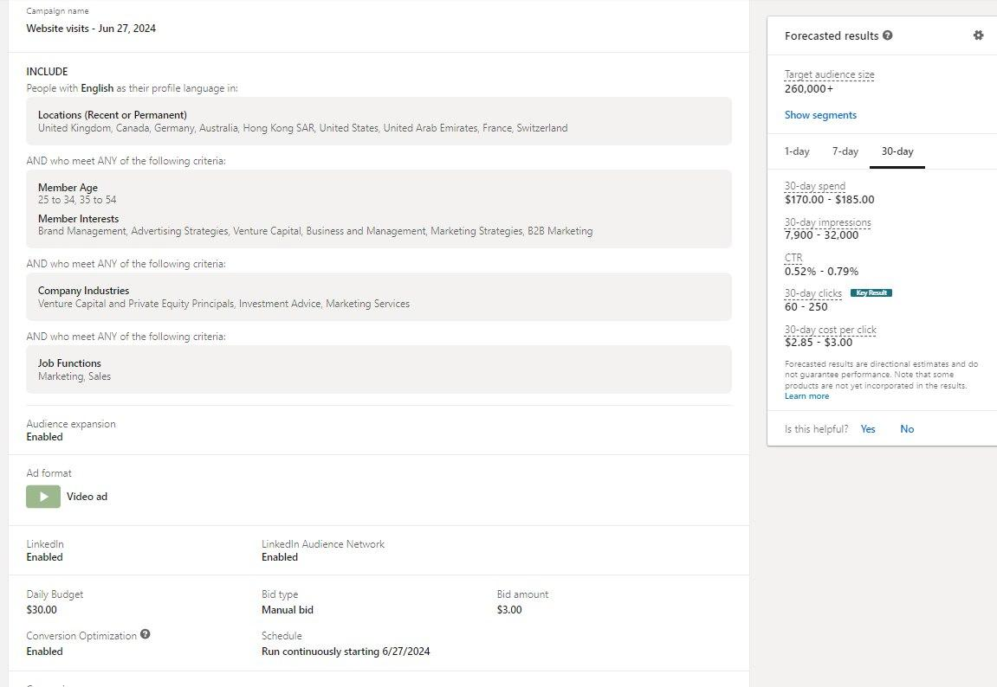

2.3 Violation of Advertising Policies
For businesses and advertisers, failing to comply with Facebook's advertising policies can lead to restrictions or suspensions:
- Prohibited Content: Promoting illegal products or services, misleading ads, or prohibited items like tobacco, drugs, and weapons.
- Misleading Ads: Ads that misrepresent products or services, or contain false information.
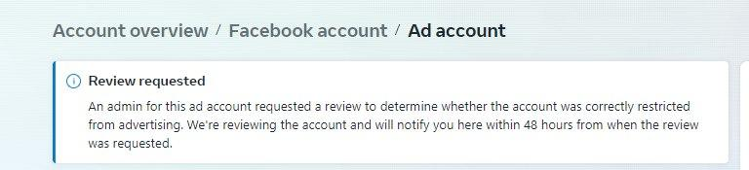

2.4 Security Concerns and Unusual Activity
Facebook may temporarily suspend accounts if it detects unusual activity that might indicate the account has been compromised. This can include:
- Unusual Login Attempts: Logging in from different geographic locations in a short period.
- Unusual Posting or Interaction Patterns: Sudden changes in activity, such as a spike in posts or friend requests.
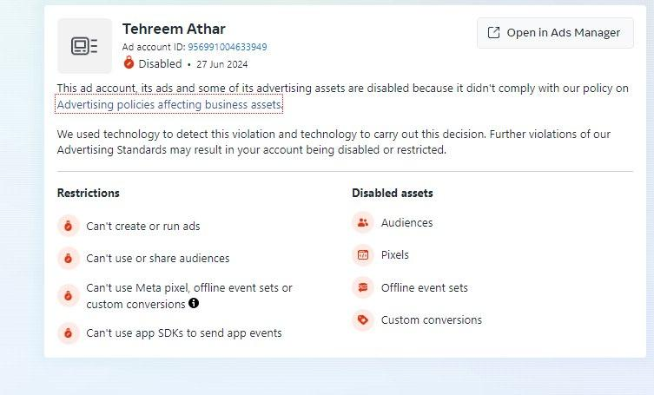

2.5 Violation of Facebook’s Platform Policies
Using Facebook's platform in a way that violates its terms, such as exploiting loopholes in Facebook’s algorithms or using bots to manipulate engagement metrics, can result in suspensions.

3. Case Studies

3.1 Case Study 1: Hate Speech
An account was suspended after posting content that incited violence against a specific religious group. This was flagged as hate speech and violated Facebook's Community Standards.

3.2 Case Study 2: Fake Account
A user created multiple accounts using false identities to engage in fraudulent activities. Facebook detected the inauthentic behavior and banned the accounts.

3.3 Case Study 3: Misleading Advertising
A business account was suspended for running ads that falsely claimed health benefits from unapproved supplements, violating Facebook's advertising policies.

4. Facebook's Policies and Guidelines
Facebook’s policies and guidelines are designed to ensure a safe and respectful environment for all users. Key points include:
- Community Standards: These cover a wide range of issues, including hate speech, harassment, nudity, and misinformation.
- Advertising Policies: Detailed rules govern what can and cannot be advertised on Facebook, focusing on truthful and safe advertising practices.
- Platform Policies: These include guidelines for developers and businesses using Facebook’s platform.
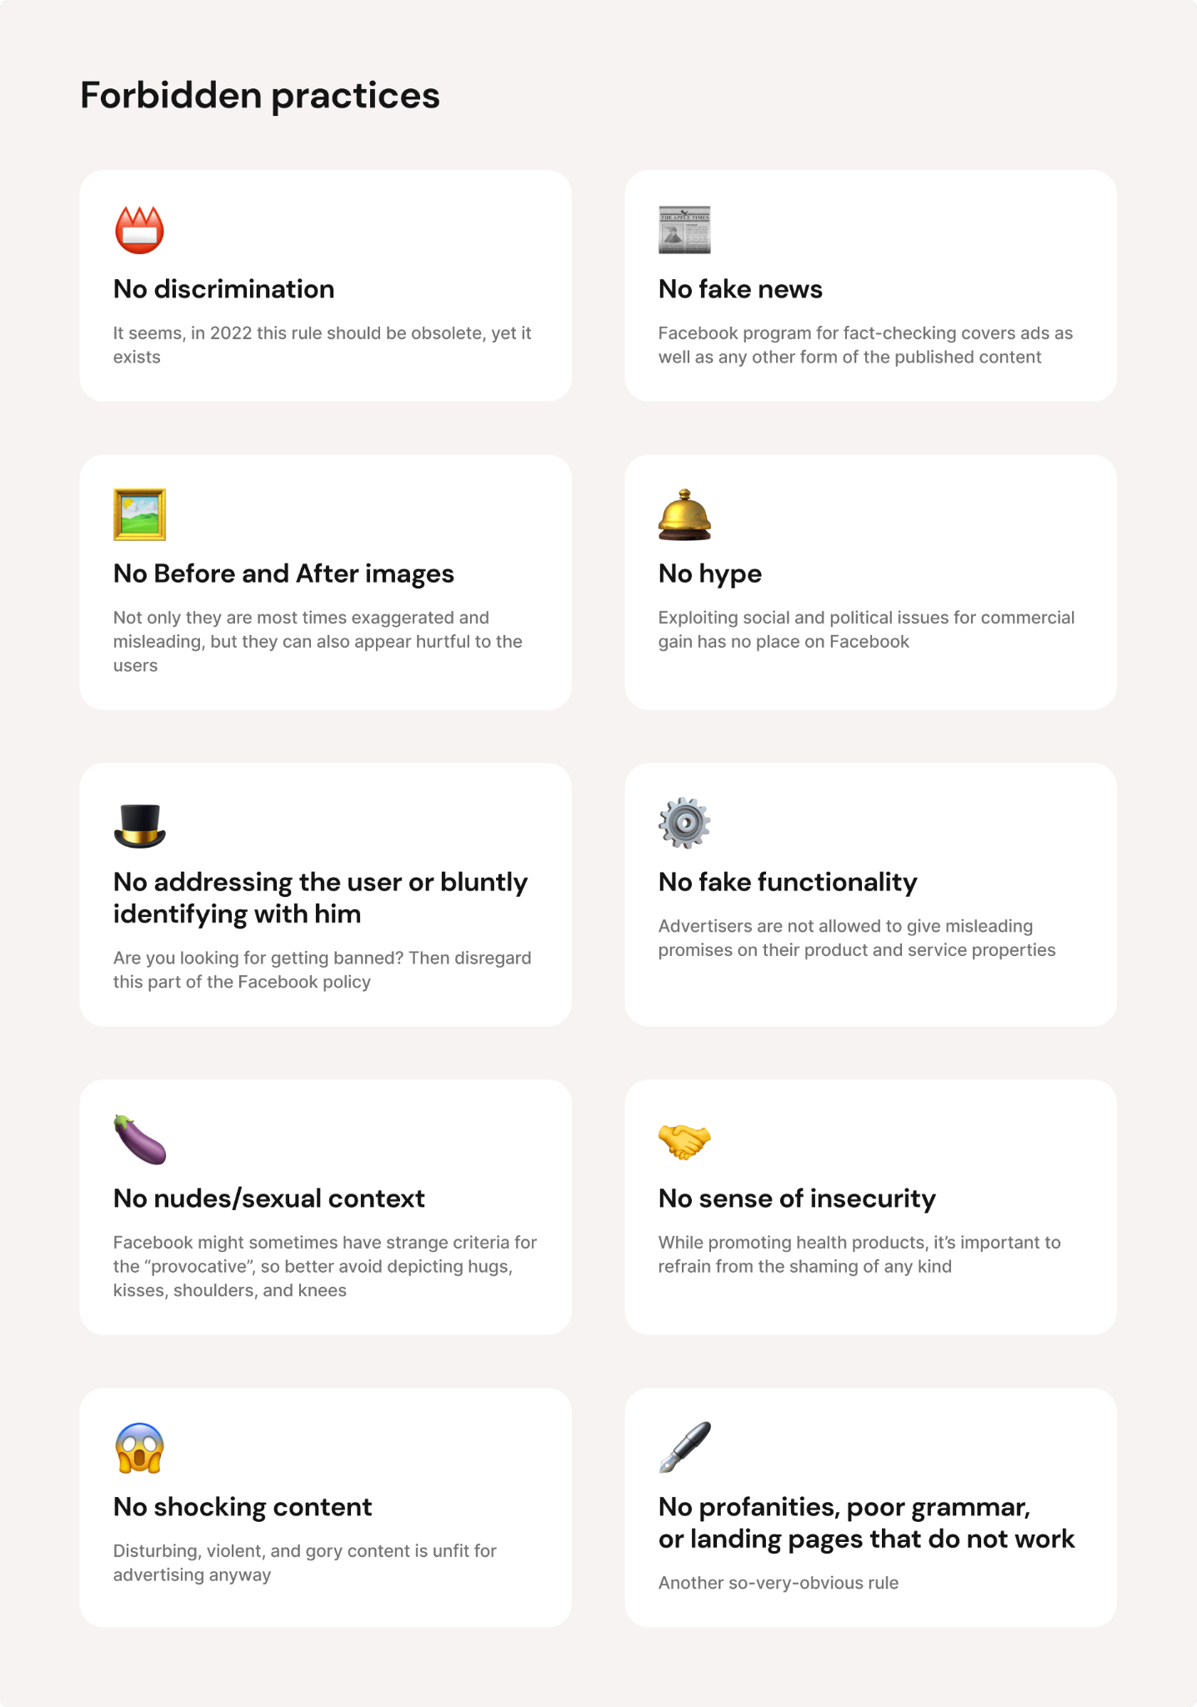

5. Preventive Measures and Best Practices

5.1 Adhering to Community Standards
Always follow Facebook's Community Standards by avoiding the posting of prohibited content, engaging respectfully with others, and avoiding hate speech.

5.2 Ensuring Authenticity
Use real information to create and maintain your account. Avoid creating multiple accounts or using fake identities.

5.3 Complying with Advertising Policies
For businesses, ensure that all ads comply with Facebook's advertising policies, avoiding misleading claims or promoting prohibited products.

5.4 Monitoring Account Security
Regularly update your password, enable two-factor authentication, and monitor your account for unusual activity.

5.5 Reporting Suspicious Activities
Report any suspicious or harmful behavior to Facebook to help maintain a safe platform for all users.
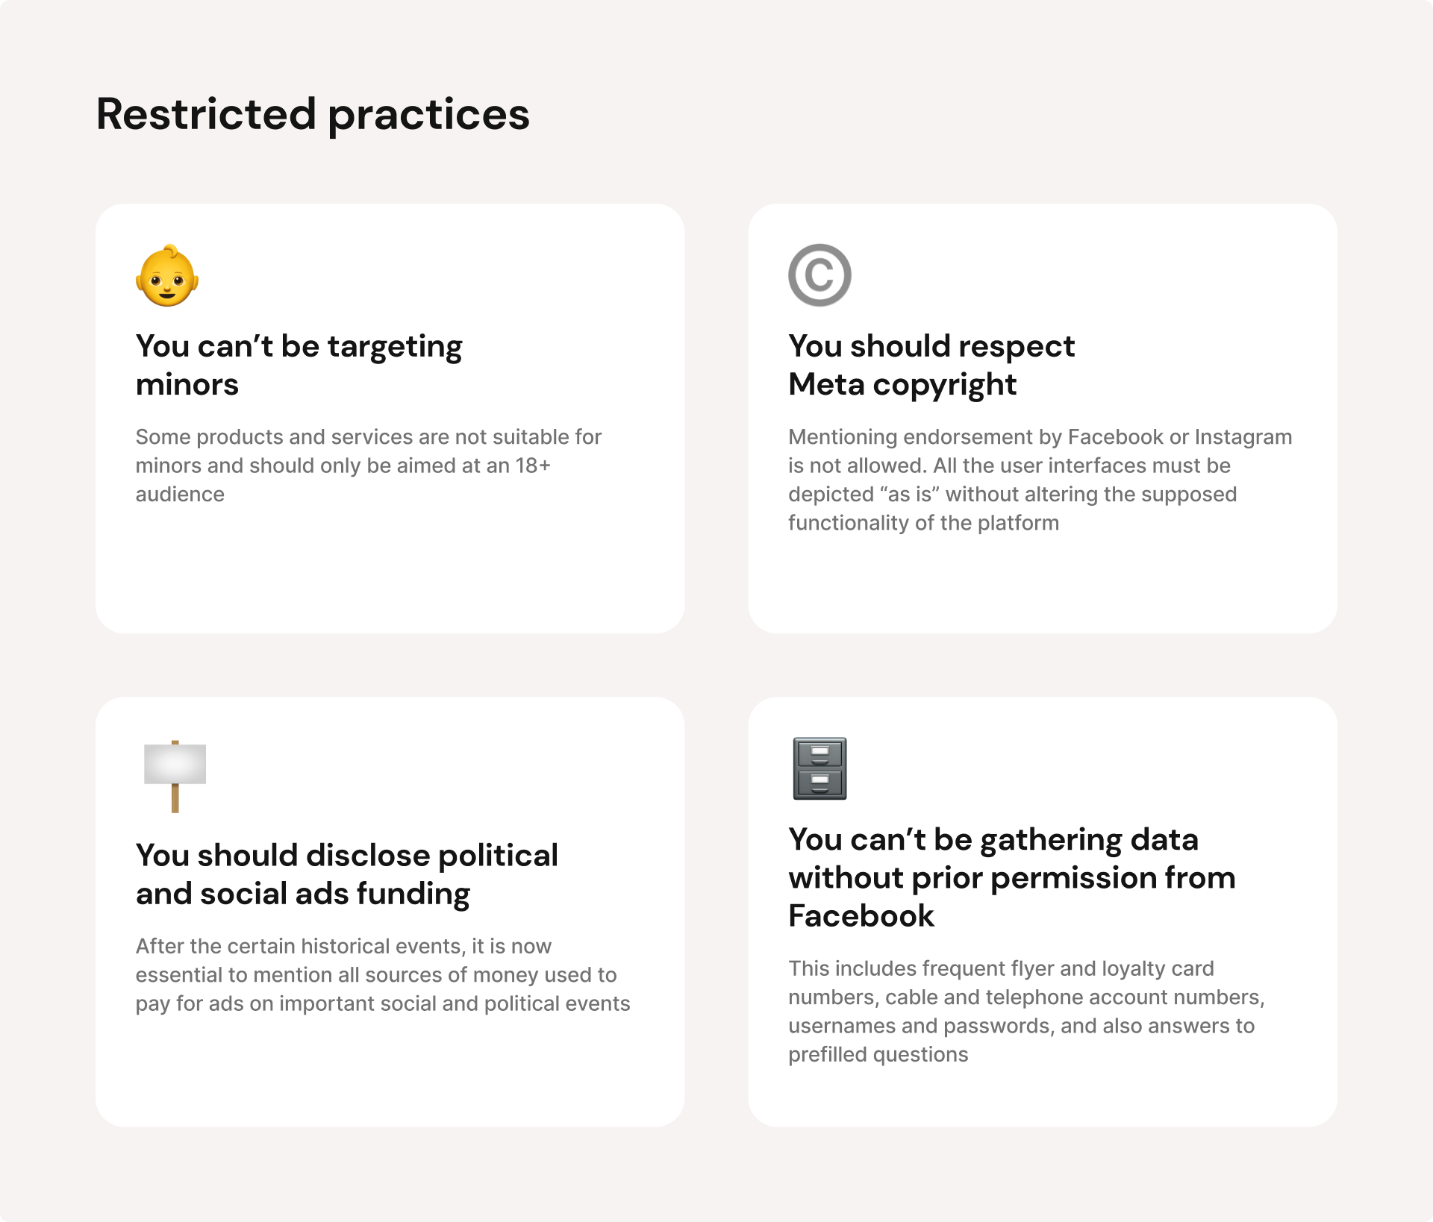

6. Conclusion
Facebook is a valuable platform for personal and professional engagement, but it requires users to adhere to its policies and guidelines. This report has outlined common reasons for account suspensions and provided best practices to prevent such issues. By following these recommendations, users can ensure a positive and secure experience on Facebook.

