Case Study: Preventing Twitter Account Suspension and Utilizing Effectively

1. Introduction
Twitter is a major social media platform that facilitates real-time communication, networking, and content sharing. However, accounts on Twitter can be suspended or banned for various reasons, often related to violations of Twitter's rules and policies. This report aims to identify the common reasons for these suspensions and provide guidelines to help users avoid such issues.

2. Common Reasons for Account Suspensions

2.1 Violation of Twitter's Rules
Twitter has a comprehensive set of rules that users must adhere to. Violations of these rules can lead to account suspension or banning. Common violations include:
- Abuse and Harassment: Engaging in abusive behavior, harassment, or targeting individuals or groups with hate speech or threats.
- Hateful Conduct: Promoting violence, threatening, or harassing other people based on race, ethnicity, national origin, sexual orientation, gender, gender identity, religious affiliation, age, disability, or serious disease.
- Violence and Terrorism: Promoting or threatening violence or terrorism, including direct threats and glorification of violent acts.
- Sensitive Media and Graphic Content: Posting or sharing media that is excessively violent, gory, or sexually explicit.

2.2 Spam and Inauthentic Behavior
Twitter actively combats spam and inauthentic activities, including:
- Spamming: Posting unsolicited tweets, sending repeated and identical replies, mentions, or Direct Messages (DMs).
- Fake Accounts: Creating accounts with false information, using stolen identities, or engaging in impersonation.
- Manipulation and Disinformation: Engaging in coordinated activities that artificially amplify information, including using bots or fake accounts to manipulate Twitter's platform.

2.3 Violation of Platform Manipulation and Spam Policy
This includes behaviors that artificially inflate or suppress information, disrupt others’ experience on Twitter, or engage in manipulative tactics:
- Mass Following/Unfollowing: Following and unfollowing large numbers of accounts in a short period to build followers.
- Misuse of Hashtags: Using unrelated hashtags to draw attention or engage in hashtag spamming.

2.4 Security and Privacy Concerns
Twitter may suspend accounts if they detect security issues or breaches, such as:
- Compromised Accounts: Accounts showing signs of being hacked or compromised may be temporarily locked or suspended.
- Phishing: Sharing or attempting to collect sensitive information through deceptive means.

2.5 Copyright and Trademark Violations
Posting content that infringes on copyrights, trademarks, or other intellectual property rights without permission can result in account suspension.

3. Case Studies

3.1 Case Study 2: Fake Account
A user created an account impersonating a celebrity, posting misleading information. Twitter identified this as a violation of its policies on fake accounts and impersonation, leading to the account's suspension.
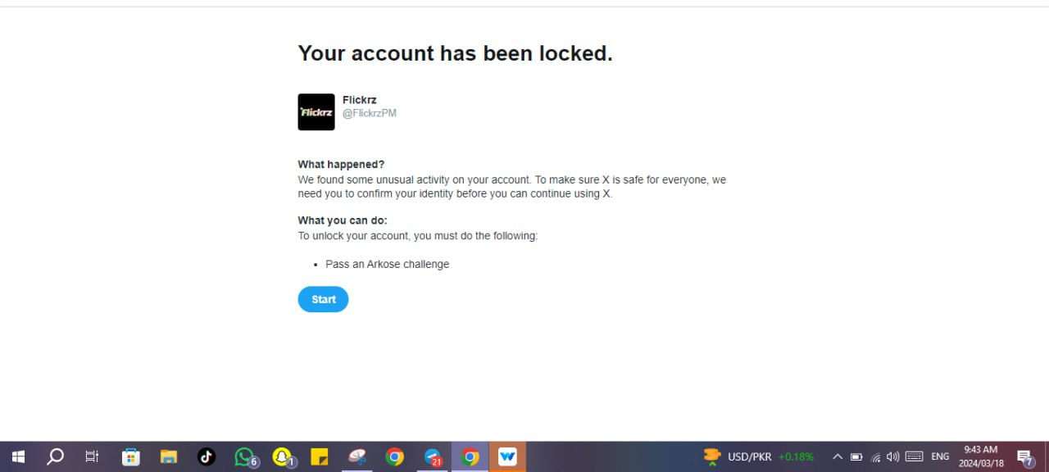

3.2 Case Study 3: Spam Behavior
An account was banned for engaging in mass following and hashtag spamming. This was flagged as manipulative behavior, contrary to Twitter's spam policy.
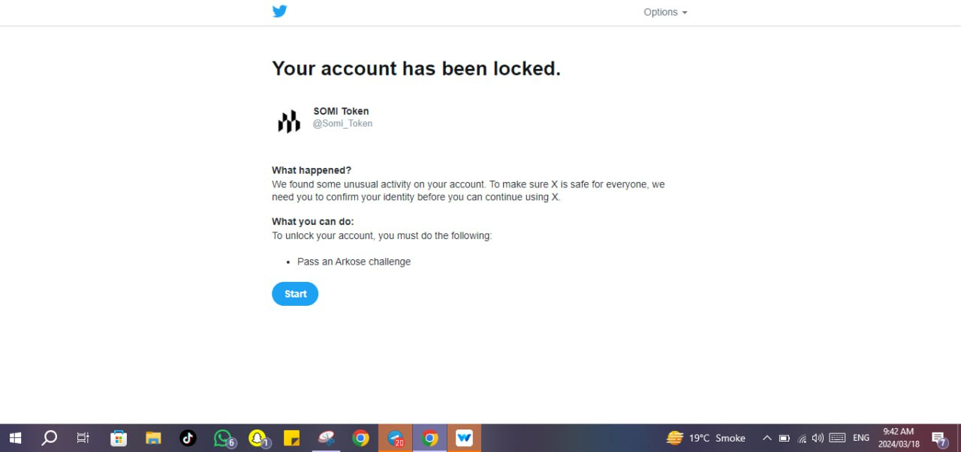

4. Twitter's Policies and Guidelines
Twitter’s policies and guidelines are designed to create a safe and fair environment for all users. Key points include:
- Twitter Rules: Covering aspects such as violence, harassment, hateful conduct, and sensitive media.
- Platform Manipulation and Spam Policy: Outlining prohibited behaviors such as spamming, fake engagements, and coordinated manipulation.
- Copyright Policy: Protecting intellectual property rights and prohibiting unauthorized use of copyrighted content.

5. Preventive Measures and Best Practices

5.1 Adhering to Twitter Rules
Follow Twitter's rules regarding content and conduct, avoiding harassment, hate speech, and violent threats.

5.2 Ensuring Authenticity
Use accurate and truthful information in your profile and avoid impersonating others. Maintain genuine interactions and avoid using bots or fake accounts.

5.3 Avoiding Spam Tactics
Do not engage in mass following/unfollowing or spammy behavior such as hashtag spamming. Focus on organic growth and genuine engagement.

5.4 Monitoring Account Security
Regularly update your password, use two-factor authentication, and monitor your account for unusual activity.

5.5 Respecting Intellectual Property
Ensure that all content shared respects copyright and trademark laws, and always credit original creators when sharing content.

6. Conclusion
Twitter is a powerful platform for communication and networking, but users must adhere to its rules and policies to maintain a positive and active presence. This report has outlined the common reasons for account suspensions and provided best practices to avoid such issues. By following these recommendations, users can ensure a safe and engaging experience on Twitter.

