Case Study: Preventing LinkedIn Account Suspension and Utilizing LinkedIn Ads Effectively
To explore strategies for safe LinkedIn marketing, preventing account suspension, and maximizing the effectiveness of LinkedIn Ads and Sales Navigator.

Introduction
LinkedIn is an essential platform for professional networking, marketing, and lead generation. However, improper use can result in account suspension, hindering your marketing efforts. This case study outlines best practices for using LinkedIn safely and effectively, focusing on personalized outreach, compliance with LinkedIn guidelines, and the strategic use of LinkedIn Ads and Sales Navigator.

1. LinkedIn Marketing Best Practices
- Personalize Messages: Personalized communication is key. Avoid generic, repetitive messages that can be flagged as spam. Tailor your messages to each recipient to foster engagement and authenticity.
- Engage Naturally: Actively participate in groups, discussions, and comment on posts. This organic engagement builds a genuine presence and strengthens your network.
- Limit Connection Requests: Quality over quantity is crucial. Sending too many connection requests in a short period can lead to account restrictions. Prioritize connecting with professionals who are relevant to your field or industry.

2. Common Reasons for Account Suspensions
2.1 Violation of LinkedIn's User Agreement and Community Guidelines
- Spamming: Sending unsolicited messages or connection requests, often in large volumes, is considered spamming and is against LinkedIn’s policies.
- Misrepresentation: Using fake names, photos, or impersonating someone else can lead to account suspension. Authenticity is crucial on LinkedIn.
- Harassment or Inappropriate Behavior: Posting offensive content or sending inappropriate messages to other users is prohibited.
- Using Automation Tools: The use of bots or automated tools to send messages or manage the account can result in suspension.
- Payment Policy Issues: Issues with payment methods, especially during ad runs, can lead to account restrictions.
- Different Location Login Attempts: Multiple login attempts from different locations can trigger security concerns and lead to account suspension.
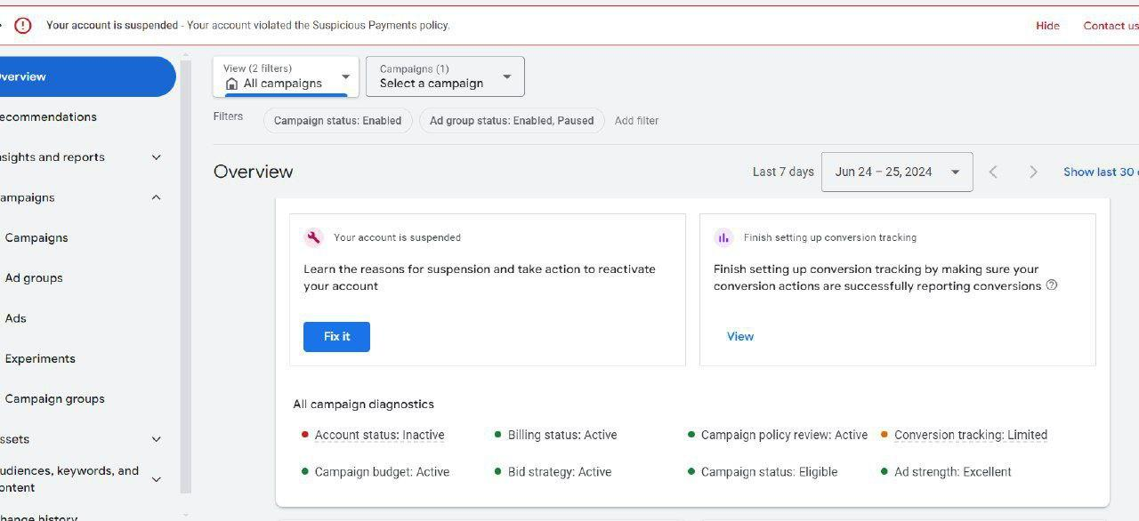
2.2 Excessive Connection Requests Sending a large number of connection requests in a short period can be flagged as spammy behavior. LinkedIn encourages meaningful connections, and indiscriminate outreach may lead to restrictions.
2.3 Use of Automated Tools The use of bots or automation tools to send connection requests, messages, or endorsements violates LinkedIn’s policies. These tools can create an unnatural pattern of activity, which LinkedIn may flag as suspicious.
2.4 Incomplete or Misleading Profiles Having incomplete or misleading information on your profile can raise red flags. LinkedIn values transparency and accuracy in profile information.
2.5 Engaging in Prohibited Commercial Activities Using LinkedIn to sell products or services in a manner that violates their guidelines, such as unsolicited promotional messages, is prohibited.
2.6 Posting Prohibited Content Sharing content that is deemed inappropriate, such as hate speech, misinformation, or promoting illegal activities, can lead to immediate account suspension.
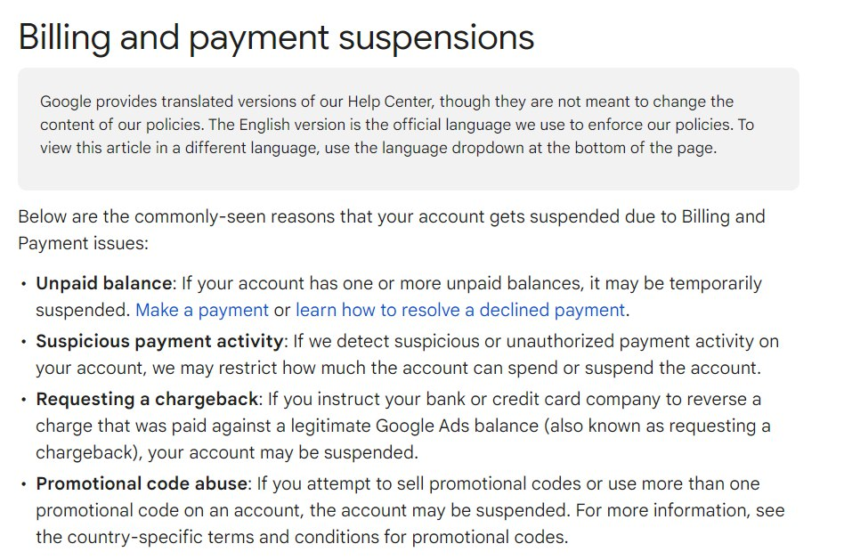

3. Using LinkedIn Ads
- Create Compelling Ads: Design ads that are engaging and relevant to your target audience, ensuring they add value.
- Segment Your Audience: Utilize LinkedIn’s targeting features to reach specific demographics, industries, or job titles.
- Monitor Ad Performance: Track your ad campaigns' performance and adjust based on data-driven insights.
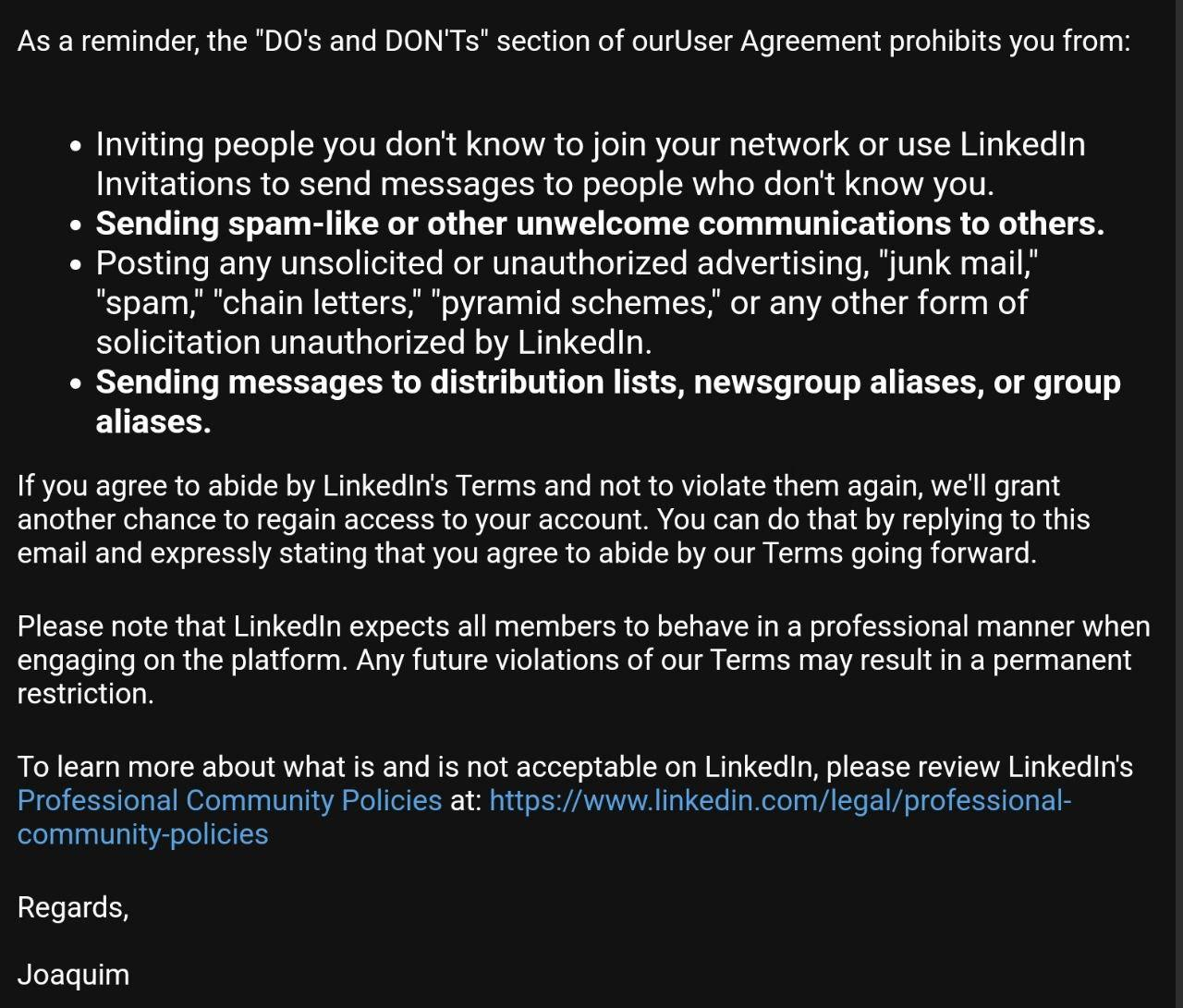
Steps to Create LinkedIn Ads:
- Access LinkedIn Campaign Manager: Use this tool to create and manage your ad campaigns.
- Set Up Your Campaign: Define your campaign objective, such as brand awareness or lead generation.
- Define Your Audience: Specify your audience using LinkedIn’s targeting options.
- Create Ad Content: Develop your ad content, including visuals and a compelling call-to-action.
- Set Your Budget: Decide on a budget and bidding strategy.
- Launch and Monitor: Start your campaign and continuously monitor its performance for optimization.

4. Utilizing Sales Navigator
- Advanced Search Filters: Use these to find and connect with potential leads effectively.
- Save Leads and Accounts: Keep track of important prospects by saving them within the tool.
- Send InMail Messages: Reach out to prospects outside your network using InMail.

5. Creating and Managing Pseudo Accounts
Purpose: Pseudo accounts can be used for market research and testing, keeping your main account safe from risks.
Steps to Create a Pseudo Account:
- Sign Up with a New Email: Use a new email address to create the pseudo account.
- Register on LinkedIn: Complete the profile with realistic details.
- Gradual Engagement: Build the account's connections and engagement gradually to avoid suspicion.
- Monitor Activity: Regularly check the account's status to ensure compliance with LinkedIn policies.

6. Summary
To maximize your LinkedIn marketing efforts, follow best practices, engage genuinely, and adhere to LinkedIn’s guidelines. Using LinkedIn Ads and Sales Navigator strategically can significantly enhance your reach and effectiveness. For any issues or guidance, contacting LinkedIn support or an internal advisor is recommended.

