Case Study on Gmail Account Suspensions

1. Introduction
Gmail, a service provided by Google, is one of the most widely used email platforms globally. It is essential for personal and professional communication. However, Gmail accounts can sometimes be suspended or banned due to violations of Google’s policies. This report aims to identify potential reasons for these suspensions and provide guidelines to prevent such occurrences.

2. Common Reasons for Account Suspensions

2.1 Violation of Google's Terms of Service and Policies
Google has a comprehensive set of rules outlined in its Terms of Service and various policies. Violations of these rules can lead to account suspension or banning. Common violations include:
- Spamming: Sending large volumes of unsolicited emails, particularly commercial messages, is considered spam and is against Google’s policies.
- Phishing and Fraud: Using Gmail to impersonate others, collect sensitive information, or conduct fraudulent activities is strictly prohibited.
- Malware and Hacking: Distributing malware or engaging in hacking activities using Gmail can lead to immediate suspension.
- Content Policy Violations: Sharing content that is illegal, such as hate speech, harassment, or explicit material, can result in account suspension.

2.2 Unusual Activity or Security Concerns
Google may temporarily suspend an account if it detects unusual activity that might indicate the account has been compromised. This can include:
- Login Attempts from Different Locations: Logging in from different geographical locations in a short period.
- Multiple Failed Login Attempts: Repeatedly entering incorrect passwords.
- Unusual Sending Patterns: Sending a high volume of emails in a short time or to a large number of recipients.

2.3 Use of Automated Tools
Using automated tools or scripts to manage emails, send messages, or perform other actions can violate Google’s policies and lead to suspension.

2.4 Violation of Age Requirements
Google requires users to be at least 13 years old (or the minimum age required in your country) to create a Gmail account. Accounts created by users below this age may be suspended.

2.5 Payment and Billing Issues
For paid services associated with Gmail (such as Google Workspace), issues with payment or billing can lead to account restrictions or suspension.

3. Case Studies

3.1 Case Study 1: Spamming
An account was suspended after sending thousands of unsolicited promotional emails in a single day. This behavior was flagged as spam and violated Google’s anti-spam policies.

3.2 Case Study 2: Phishing Attempt
An account was banned for sending emails with links to a fake website designed to collect personal information from recipients. This activity was identified as phishing.

3.3 Case Study 3: Unusual Login Activity
An account was temporarily suspended after being accessed from multiple countries within a few hours. Google flagged this as a potential security breach.

4. Google's Policies and Guidelines
Google’s policies and guidelines are designed to protect users and maintain the integrity of its services. Key points include:
- Anti-Spam Policy: Gmail has strict limits on sending bulk emails and requires adherence to anti-spam regulations.
- Security and Privacy: Users must protect their account information and avoid sharing sensitive data inappropriately.
- Content and Behavior Standards: Users must avoid sharing illegal content or engaging in harmful activities.

Multiple Failed Login Attempts Leading to Account Suspension
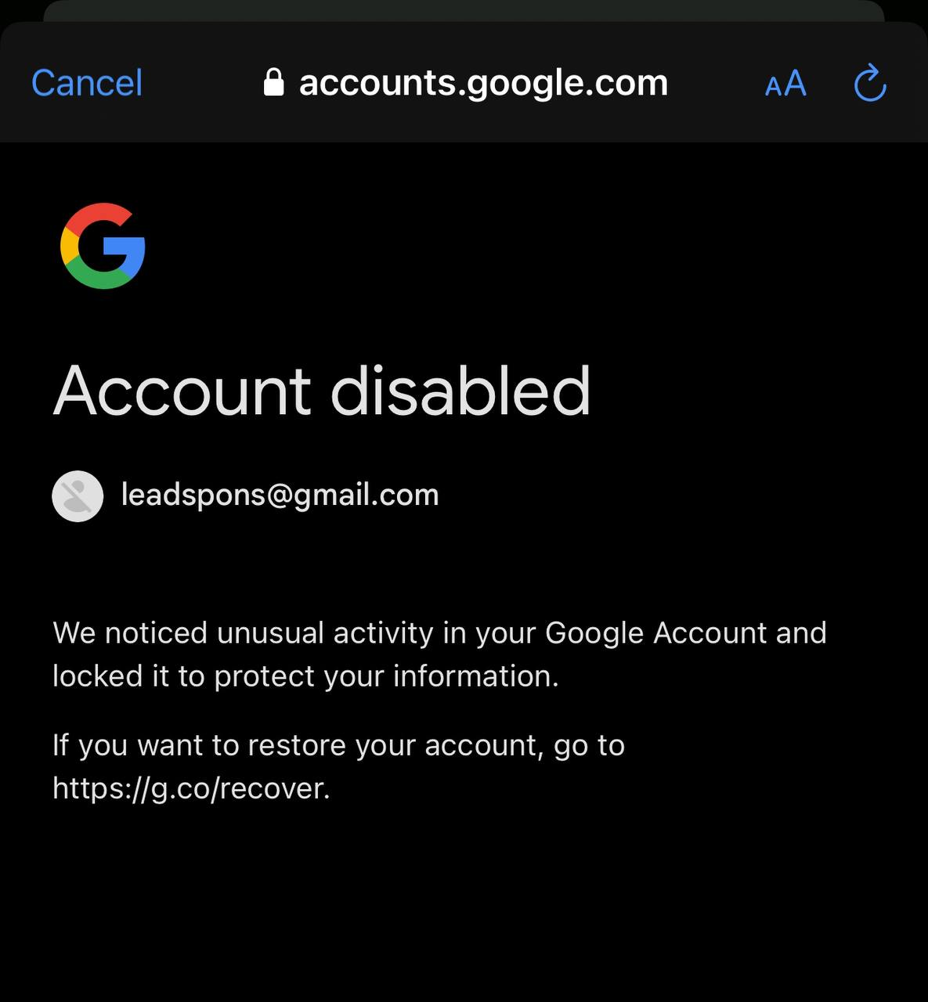
In our experience, one of our Gmail accounts was suspended due to multiple failed login attempts. The user repeatedly entered incorrect passwords, triggering Google's security protocols. This situation arose because the account owner had forgotten their password and attempted to guess it multiple times, leading to the temporary suspension of the account to protect against potential unauthorized access.
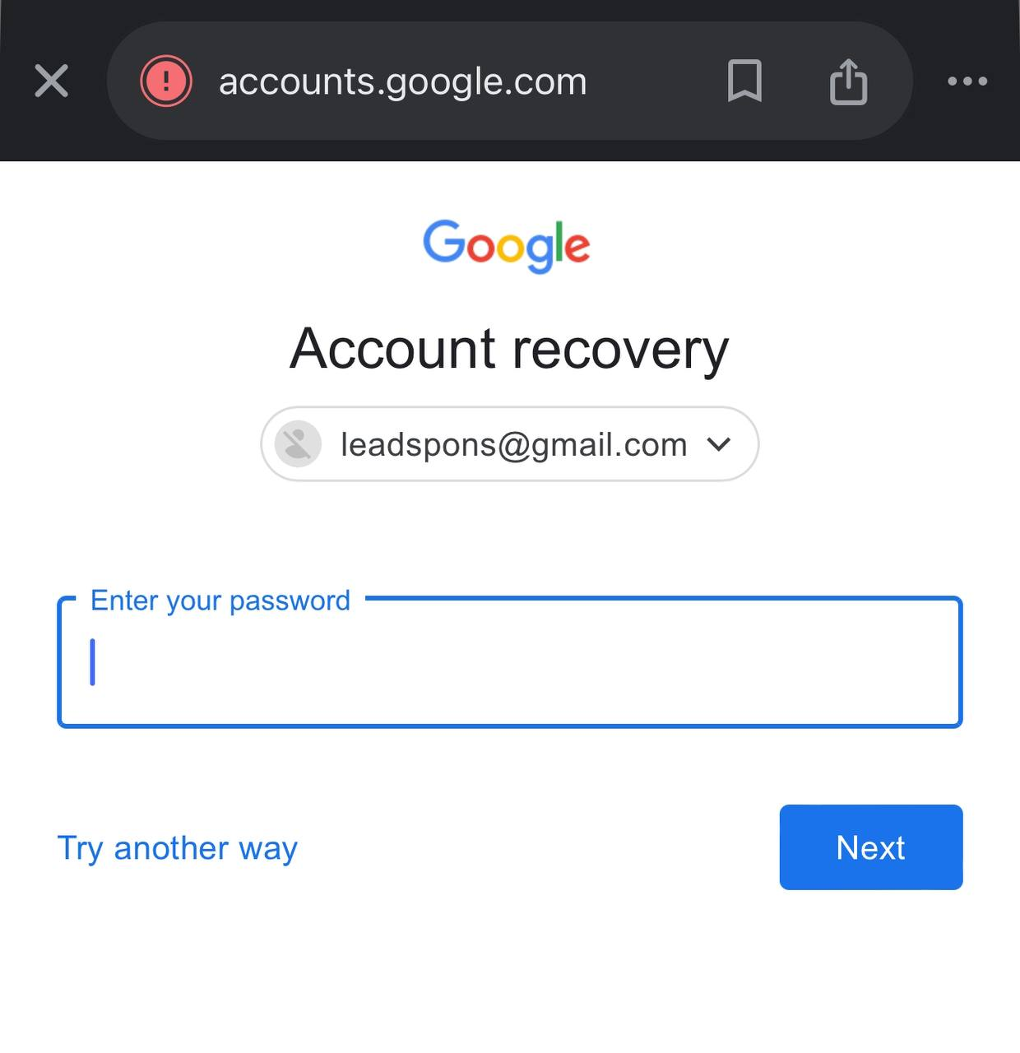
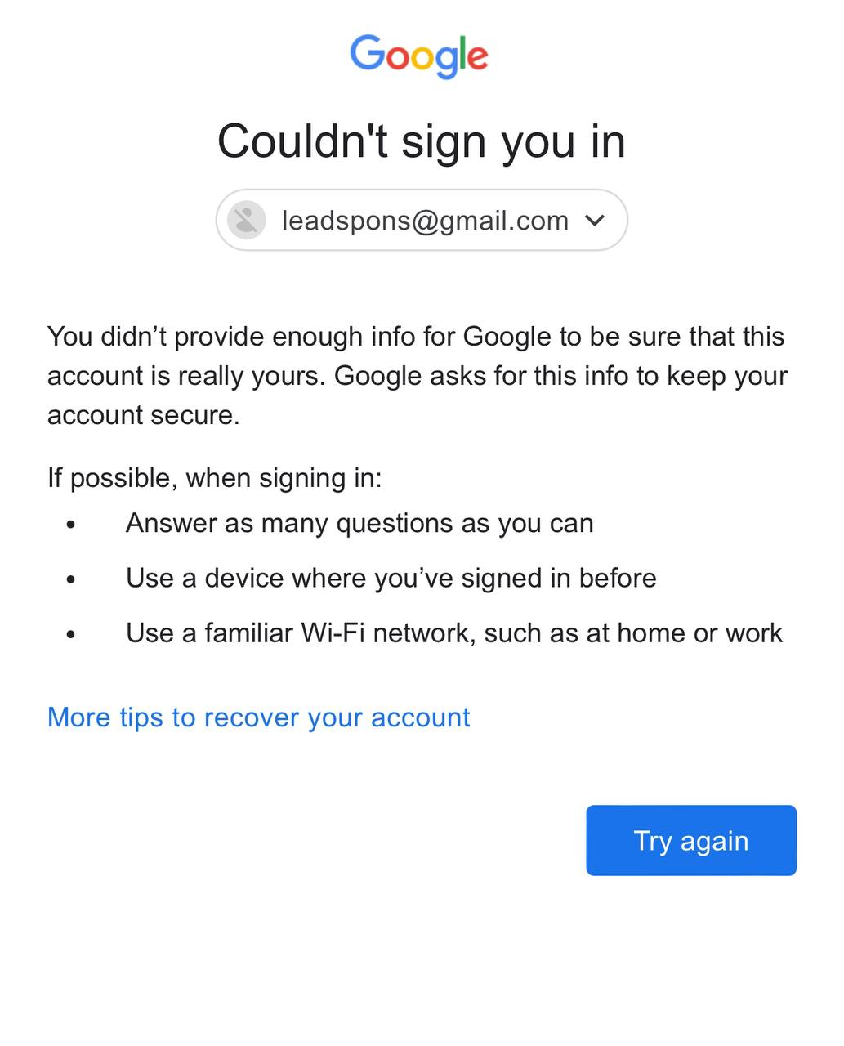

Key Takeaway:
To prevent such incidents, it is crucial to ensure that the correct credentials are used when accessing your Gmail account. Here are some best practices to avoid similar issues:
- Use Strong and Memorable Passwords: Create a strong, unique password for your Gmail account that is easy for you to remember but difficult for others to guess.
- Password Recovery Options: Set up recovery options, such as a secondary email address or phone number, to facilitate account recovery if you forget your password.
- Two-Factor Authentication (2FA): Enable 2FA to add an extra layer of security to your account. This requires not just your password but also a verification code sent to your device.
- Avoid Multiple Incorrect Attempts: If you cannot recall your password, use the "Forgot password?" link instead of making multiple incorrect attempts, which can lead to account suspension.
- Monitor Account Activity: Regularly check your account activity for any unusual login attempts or unauthorized access.
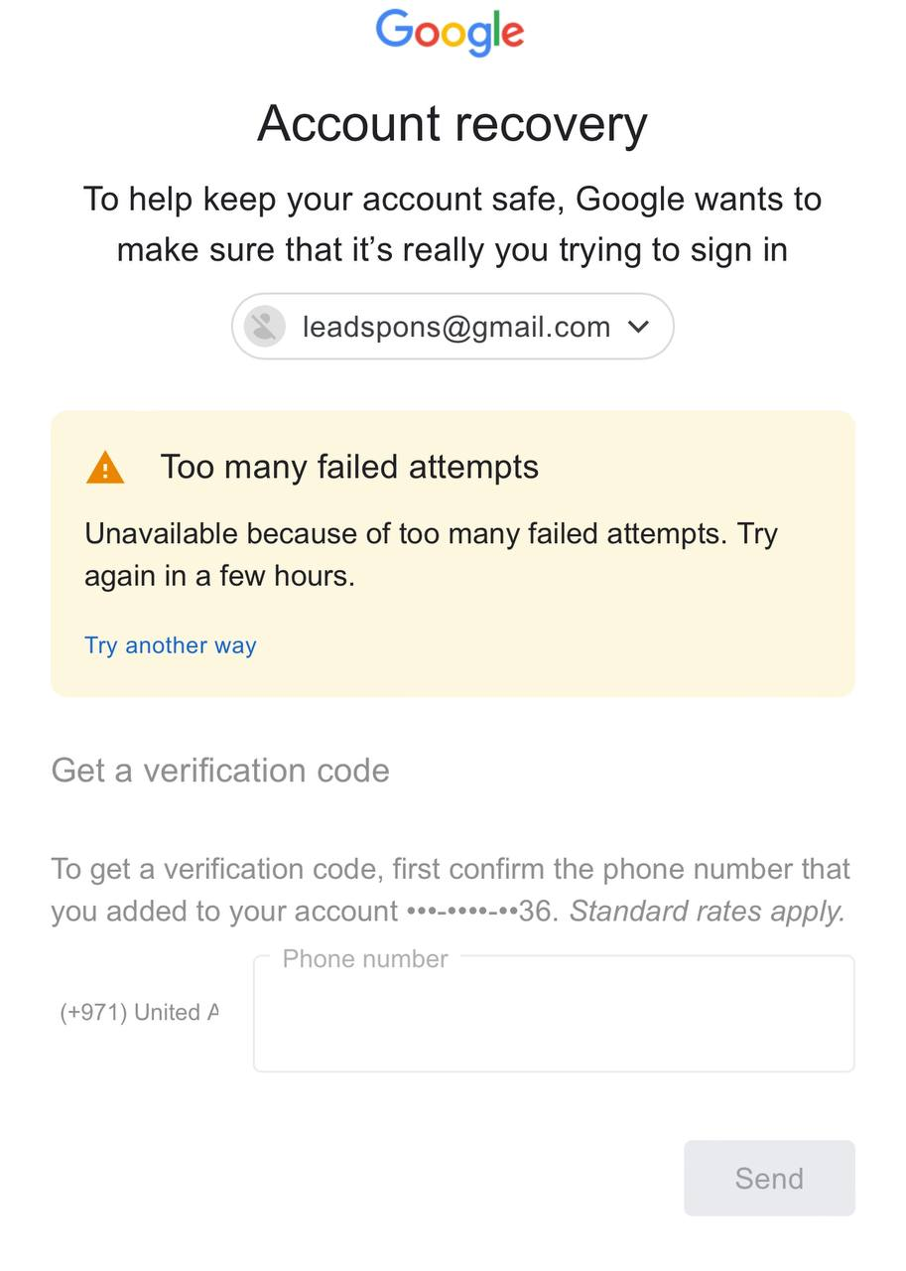
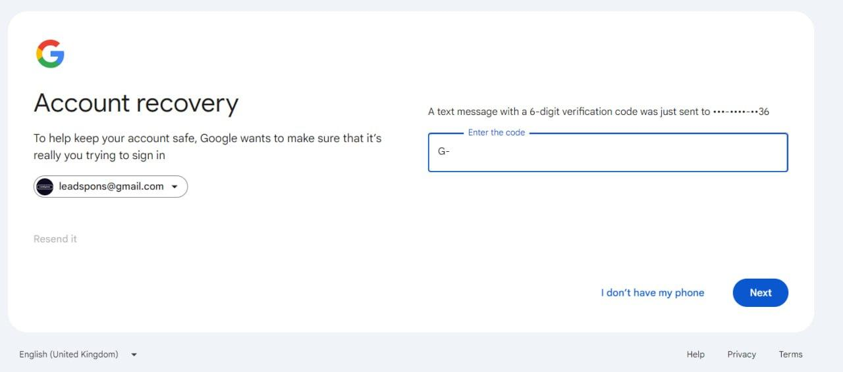

5. Preventive Measures and Best Practices

5.1 Monitoring Account Activity
Regularly check your account for any unusual activity and update your security settings as needed.

5.2 Avoiding Automation
Do not use automated tools to send emails or manage your Gmail account, as this can trigger security alerts or policy violations.

5.3 Following Content and Usage Guidelines
Ensure that all emails sent through Gmail comply with Google's content policies and do not include spam, malicious content, or illegal material.

5.4 Maintaining Accurate Account Information
Keep your account information accurate and up to date, including recovery options, to facilitate account recovery if needed.

5.5 Reporting Suspicious Activities
Report any suspicious emails or activities to Google to help prevent account abuse and protect the community.

6. Conclusion
Gmail is a crucial tool for communication, but users must adhere to Google’s policies and guidelines to maintain their account. This report has highlighted the common reasons for account suspensions and provided best practices to prevent such issues. By following these recommendations, users can ensure a secure and uninterrupted experience with Gmail.

