Marketing & Sales Team Checklist
for all staffs to collaborate with vendors and in-house

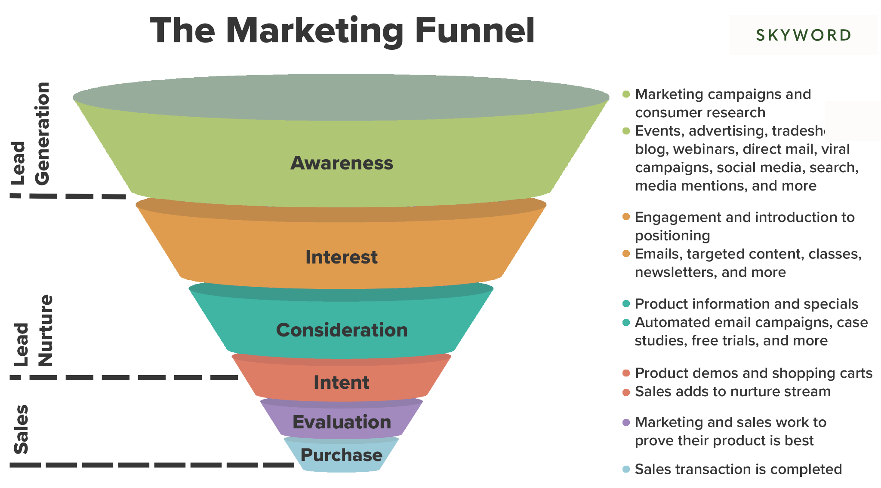
The Marketing funnel logics

Marketing Manager Roles
- PR
- Social Media Marketing & Community Management
- Affiliate marketing
- Paid Advertisement
- Direct Marketing
- Other Tasks

PR Checklist
No. | Category | Description
1 | Content Creation | Content planning and execution
2 | Copywriting | Utilizing ChatGPT to create articles
3 | SEO keywords | Keyword optimization
4 | Adding in UTM link, Referral code | Creating UTM link for tracking
5 | Google Analytics | Conversion rate, Bounce rate etc
6 | Media allocation & Booking | Contacting media platforms for publishing
7 | KPI Report | Reporting based on KPI
8 | Re-use the content for other platforms as advertisements | Use the published contents on the social media accounts (twitter, instagram, etc)

Social Media Marketing & Community Management

No. | Category | Description
1 | Content Creation | Texts, Posts, Videos, etc
2 | Promote product and increase brand awareness | Consistent posts that aligns with the brand and social media strategy
3 | Schedule social media posts | Use applications such as Facebook business, Hootsuite, Tweetdeck, etc
4 | Content Calendar | Create a content calendar to keep track
5 | Develop Social Media Strategy | Planning and execute campaigns
6 | Manage the budget | Plan monthly budget for PPC ads
7 | Data tracking and analysis | Analyze performance, traffic, etc
8 | Customer engagement | Interact with customers and communicate with them on a daily basis
9 | Increase followers | KPI measurement

Affiliate marketing

No. | Category | Description
1 | Content creation | How to promote affiliate products
2 | Contact affiliate agency | Expand buyers field
3 | Develop content schedule | Oversee content publishing
4 | Traffic and revenue report | Google Analytics
5 | Referral link creation | To be requested
6 | Use SEO tools | Find new promotional opportunities
7 | Test different types of contents | To maximize revenue
8 | Research affiliate market data

Paid Advertisement

No. | Category | Description
1 | Develop and Execute Strategy | Marketing campaign across multiple media - paid search, display, video, social platforms
2 | Management | Launch, optimization, strategy, data, budget, etc
3 | Identify optimization opportunities | Test of ad copy, A/D testing, landing pages, etc
4 | Analytics and reporting | Conversion, etc

Direct Marketing

No. | Category | Description
1 | Communication, Reach | Contact via Linkedin, Auto DM, email marketing, find new leads
2 | Convert Leads | Selling point to convert leads
3 | Keep existing customers/client | Customer Relation Management
4 | Increase sales | Recognize target pain points, wants, needs
5 | CRM | Email personalization, segmentation, loyalty programs, tailored targeted marketing
6 | Target Audience research | Offer tailored to their preferences
7 | Brand messaging | Consistency in the brand messaging

Other tasks include -

- Providing contents (Image, text, etc) for any development project
- Cross checking with other project managers if the Brand is consistent with the design such as the color, copywriting, images, tone and manner, etc (Website (PC, Mobile) or APP)
- SEO audit report and On-page strategy
- Google Analytics Report
- Inbound QnA List (QnA Simulation)

