OJT: How to Create a Stripe Account Using a Payoneer Bank Account

Step 1: Create a Citibank (USA) Account
- Requirements:
  - You will need an ITIN (Individual Taxpayer Identification Number) or FTIN (Foreign Tax Identification Number).
  - A valid South Korea passport can also be used for identification and eligibility purposes.
- Process:
  - Visit the Citibank USA website or a local Citibank branch.
  - Complete the application form with your personal details.
  - Provide your ITIN, FTIN, or South Korea passport as identification.
  - Once approved, you will receive your Citibank account details.
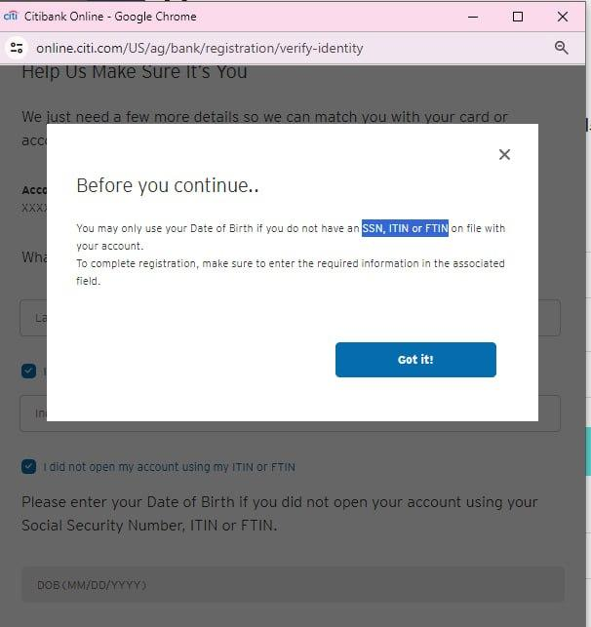

Step 2: Connect Citibank Account to Stripe
- Create a Stripe Account:
  - Go to Stripe's website.
  - Click on "Start Now" and follow the registration process.
  - Enter your email, full name, and create a password.
- Verification:
  - Verify your email address.
  - Provide personal details including your address and business information.
  - Enter your Citibank account details for payouts.
- Manual Bank Account Addition:
  - If manual bank account addition is available, navigate to the "Bank Accounts" section.
  - Add your Citibank account by entering the account number and routing number.
  - Confirm the bank account through the micro-deposit verification method, if required.
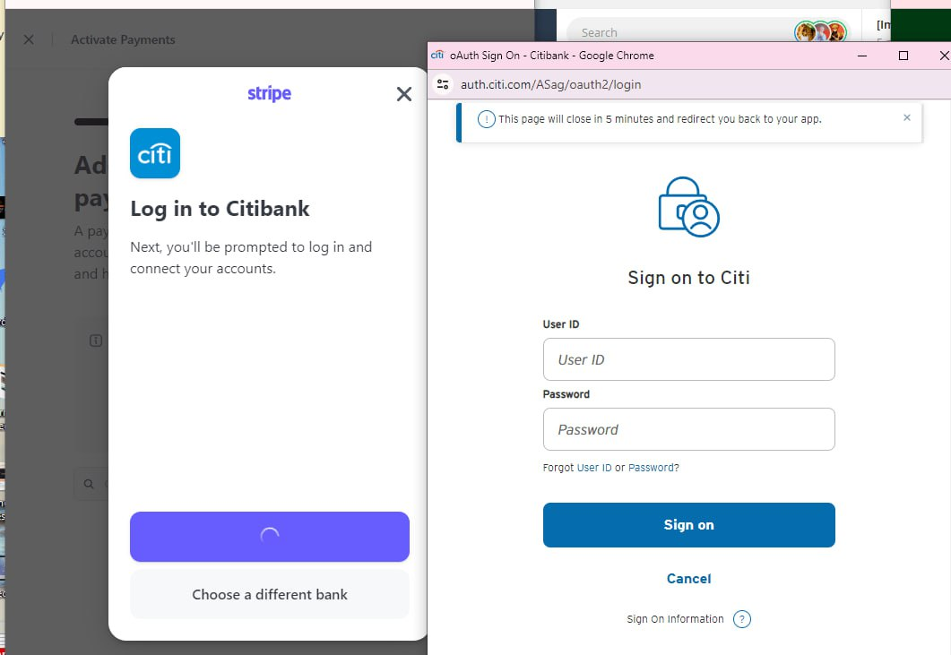

Step 3: Use Payoneer for Receiving Payments
- Create a Payoneer Account:
  - Visit the Payoneer website and sign up.
  - Complete the registration form with your personal details.
  - Verify your account using your South Korea passport or other identification.
- Receive Payments via Payoneer:
  - Log in to your Stripe account.
  - Go to the "Bank Accounts" or "Payouts" section.
  - Add your Payoneer bank account details.
- OTP Verification:
  - Stripe may require an OTP (One-Time Password) verification sent to your registered phone number.
  - Ensure your phone number is up-to-date and accessible.

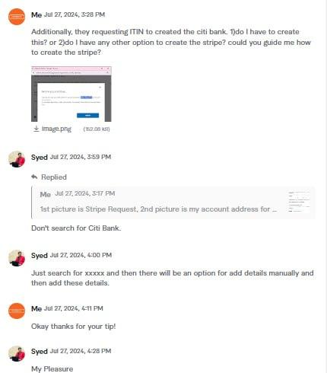

Step 4: Verify and Test
- Verification:
  - Check your Stripe dashboard for the status of your bank account verification.
  - If needed, verify your bank account by confirming the micro-deposits.
- Testing:
  - Test the connection by receiving a small payment through Stripe and ensuring it is transferred to your Payoneer account.
- Complete the Setup:
  - Once everything is verified and tested, your Stripe account is ready to receive payments via your Payoneer bank account.
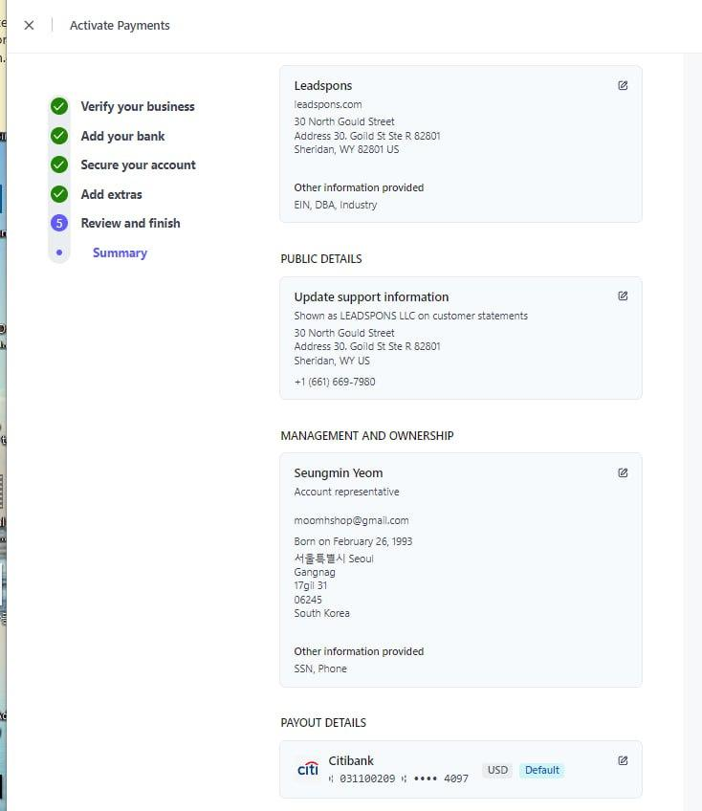
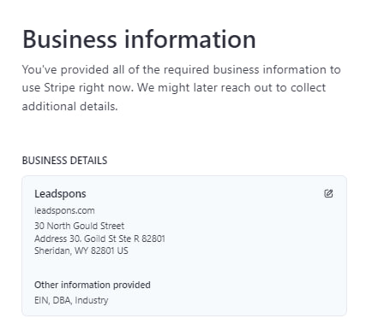

Important Notes:
- Keep your identification documents and bank account details secure.
- Monitor your Stripe and Payoneer accounts for any discrepancies or issues.
- Contact Stripe support if you encounter any problems during the setup process.

