OJT for HR (for Practice)

Work Simulation and Caution

1. Pin on Group chat
(Recruitment website ID PW and Workflow ID PW)
When you join the company, don’t forget to pin the ID PW to check applicants in real time.
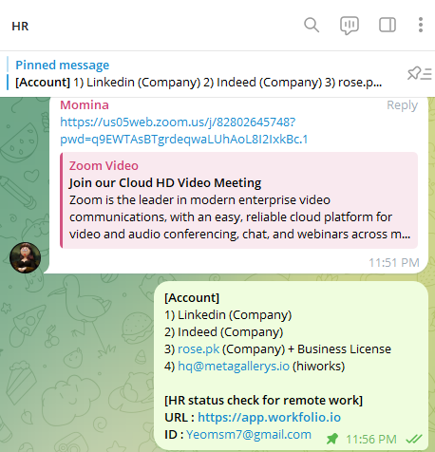
In the HR team, what we have to pin on Group chat is account for recruitment

Account
1) Linkedin (Company)
2) Indeed (Company)
3) rose.pk (Company) + Business License

HR status check for remote work
URL : https://app.workfolio.io
ID : Yeomsm7@gmail.com
2. List up to Google SpreadSheet
(After you contacted every single applicants)

every hour about interviewees who you HR team tried to recruit

Name, CV, contact number, expected Salary, Whatsapp account and etc on Google Sheet (Everyday)

No. | Candidate Name | Position Applied For | Contact No. | LinkedIn URL | Expected Salary | Date of Joining | Status (Call Back, Scheduled, Rejected, Joined) | Job Offer Letter
1 | Ramsha Zahid | HR Executive | 92 308 2862780 | https://www.linkedin.com/in/ramsha-zahid-85686125a/ | 250usd | Can Join immediately | Interview planned ommorow | TBD | TBD
2 | Tehreem Fatima | HR Executive | 92 328 4200306 | https://www.linkedin.com/in/tehreem-fatima-27496a224/ | TBD | TBD | Call back done | TBD | TBD
3 | Anosha Khan | HR Executive | 92 335 2528047 | https://www.linkedin.com/in/anoosha-khan-b03614189 | TBD | TBD | Call back done | TBD | TBD
4 | Muhammad Shaharyar | Accountant | 92 321 5989244 | linkedin.com/in/muhammad-shaharyar-589897200/ | 300usd | Jan 15, 2024 | Waiting to join | TBD | Accepted the offer will be joining
5 | Muhammad Saqib | PM/WP Dev | 92 307 7683235 | https://www.linkedin.com/in/muhammadsaqibphp/ | 650usd | Jan 15, 2024 | Waiting to join | TBD | Accepted the offer will be joining

[Sample for OJT] of HR Interview Details
https://docs.google.com/spreadsheets/d/1oVdQBWPdkSiehkrTuVjz-rLrPX7qJ_IEGbnUW7tZ7o8/edit?usp=sharing (Daily Update required when we do recruitment)

