ALL TEAM’S OJT
Why is TASK OWNERSHIP important

Worst case compilation and Caution
(3 Strike out (Firing) Process)

1. Saying yes, but there is no action, backup and result

Teammate or General Manager of Company to designate Task owner
@Developer
Hi, Please make the compilation each and send our client @liham_lim with Google drive link including docs (guideline)

[Compilation for the finishing the wallet development]
1. source code file (give him a Server ID PW with AWS)
2. User + Admin Guide compilation (video with traw.ai based documentation)
3. Install or Wallet setting guide ( URL > Sign up > Check their Gbrick and other Token wallet address guide with video and docs)
4. Etc guide video or docs (if you have etc guide video and docs, provide him)

(if you done the record, please convert video to docs using www.traw.ai and make the translation to KOREAN with C team and provide these 4 types to client @liham_lim )

Thanks

[Critical Issue Detected because Task owner didn’t reply and clock off the office without any backup]

(General Manager Request this but task owner didn’t make the result at that day, even though it (Qualification Video) it take only 5 mins

In case of this, what HR and C team know about their team mate?
[Action for Explanation to Task owner] (CAUTION)

This is the message to help you to keep employment. Last night we detected severe problem related with your task ownership

You didn't make sure the Today's task and didn't update it even though due date was today.

[Back up Required Always]
1) You didn't make up the any result (-5)
2) You didn't make any back up to report to this client (-5)
Don't forget to back up always to report. If we detect more like this, your employment contract will be discussed about termination.
Don't forget it later. Hope you doing well all the time

Attachment (REAL CASE SAMPLE)
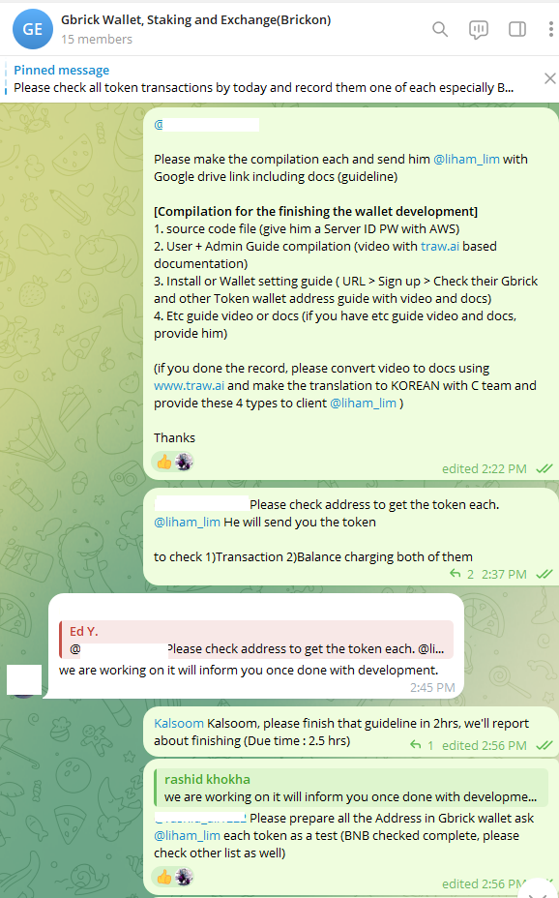

Time 1. Task Owner said he will check and thumbs up about Job Task

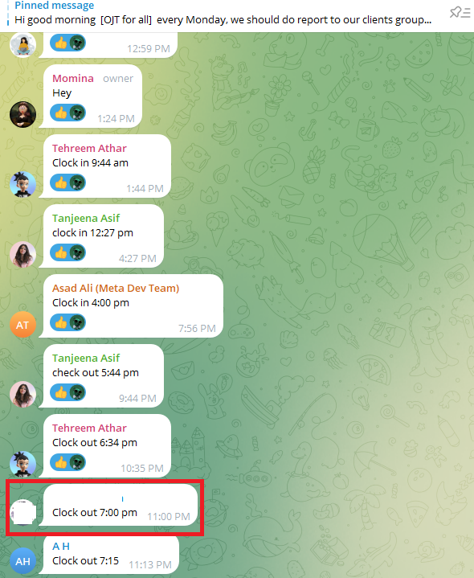
Time 2. Without any response, backup, result and report, clock out (There is no responsibility and result) It’s severe problem and issue for all teammate and company)
(Even though same teammate is working because of late work for the due date finishing)

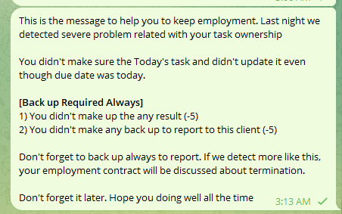
Time 3. HR, C team should let that task owner know about these caution at that day and record monthly incentive points. And we can discuss about Employment contract duration or expiration. Let every task owner to help their team mate in the same team group.

For example, if developers team’s A is working hard and need a support, developers’ B should help until today’s task report to client

NEVER FORGET TO SET THE BACKUP EXPLANATION AND PLAN TO CLIENT IF task owner already passed the due time (if you clock out that day withou any explanation, employment contract possibly expired and compensation of penalty can be charged to task owner

Best Answer for Client with Report
(In case of Finishing development and test)

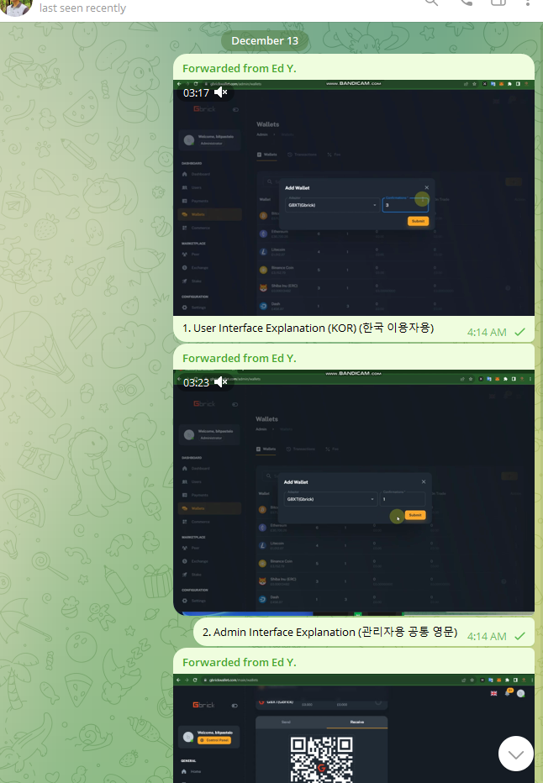
Numbering(1,2,3,4), Description for Guide video(Qualification and Functions Introduction video)

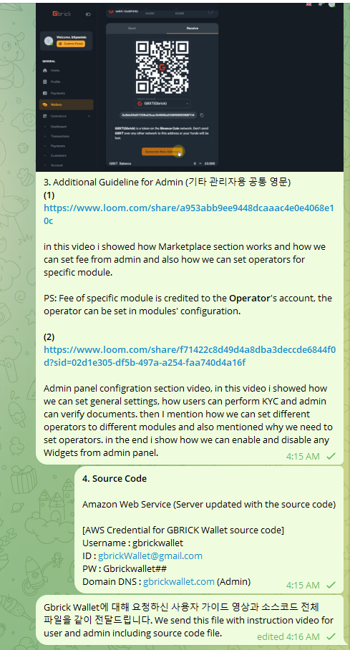
Numbering(1,2,3,4), Description for Guide video(Qualification and Functions Introduction video)

[Example]

3. Additional Guideline for Admin (기타 관리자용 공통 영문)
(1) https://www.loom.com/share/a953abb9ee9448dcaaac4e0e4068e10c

in this video i showed how Marketplace section works and how we can set fee from admin and also how we can set operators for specific module.

PS: Fee of specific module is credited to the Operator's account, the operator can be set in modules' configuration.

(2) https://www.loom.com/share/f71422c8d49d4a8dba3deccde6844f0d?sid=02d1e305-df5b-497a-a254-faa740d4a16f

Admin panel configration section video, in this video i showed how we can set general settings, how users can perform KYC and admin can verify documents. then I mention how we can set different operators to different modules and also mentioned why we need to set operators. in the end i show how we can enable and disable any Widgets from admin panel.

Wallet Functions Specification 지갑 기능명세서
https://docs.google.com/document/d/1Zg7AXG65GV8X4d27sIrbdnSwuJ5DIQCMMHgvGmhKz-s/edit#heading=h.g4bvh0uc7yc0

Team mate can see each video how to record the introduction video and review that as well. (Best Example for the report)

