Onboarding New Team Members

Welcome HR Team Members! This guide is designed to help you effectively onboard and integrate new team members into Imperial Assets. Your role is crucial in facilitating a smooth transition for new employees, and this guide outlines the essential steps and responsibilities involved in the process.

Step 1: Preparing for New Team Member Arrival
- Pre-Arrival Checklist: Ensure that all necessary equipment and access credentials are prepared prior to the new team member's arrival.
- Introduction Email: Send an introductory email to the team announcing the new member's start date and role.

Step 2: First Day Orientation
- Welcome Meeting: Conduct a welcome meeting to introduce the new team member to the company culture, policies, and their specific role.
- Orientation Schedule: Provide a detailed orientation schedule, including meetings with key team members and training sessions.

Step 3: Pairing and Mentorship
- Team Pairing: Assign the new member a current teammate as a mentor for guidance and support.
- Mentorship Follow-up: Regularly check in with the mentor to monitor the new member's integration and address any concerns.

Step 4: Training Resources and Learning Plan
- Training Materials: Provide access to OJT documents, video lectures, and other relevant training materials and share drive links where all material is saved.
- Learning Plan: Outline a clear learning plan with objectives and timelines to ensure structured development and keep monitoring the progress.

Step 5: Attendance and Reporting Processes
- System Training: Train the new member on the attendance system for clocking in and out on Workfolio.
- Reporting Guidelines: Explain the process for updating the daily task sheet.

Step 6: Project Allocation and Tracking
- Project Assignment: Instruct on how to use the universal Google Spreadsheet for project allocation.
- Progress Tracking: Regularly update project progress and provide support in managing assignments.

Step 7: Performance Assessment and Feedback
- 360Learning.com Test: Schedule and monitor the completion of an assessment test after the first week of training.
- Feedback Sessions: Conduct feedback sessions to discuss performance, challenges, and areas for improvement.

Step 8: Compliance and HR Monitoring
- Compliance Checks: Ensure the new member's skills and performance are in line with company standards.
- Weekly Updates: Update the team and the new member on KPIs, incentives, and other relevant information.

Step 9: Documentation and Record Keeping
- Documentation: Keep detailed records of the onboarding process, training progress, and assessments.
- Google Drive Updates: Regularly update the Google Drive with information about the new team member's progress and milestones.

Step 10: Continuous Support and Communication
- Open Door Policy: Encourage new team members to seek help and ask questions freely.
- Ongoing Support: Provide continuous support and guidance throughout the onboarding and integration process.
Remember, as HR professionals, your approachability, attentiveness, and proactive support are key to the successful onboarding of new team members. Let's work together to create a welcoming and productive environment for all our new colleagues!

Imperial Asset Leave Policy
Working remotely indeed offers several advantages, and Imperial Asset seems to recognize and leverage these benefits. Following are the types of leaves which we will be providing to our employees
- One - Day leave: A resource will be allowed to avail one day paid leave if for one month his attendance is full.
- Sick leave: 1 x sick leave is allowed to avail during one month.
- Maternity Leave: 15 days of maternity leave will be granted after successful completion of 1 year.
- Gazetted Holidays: All gazetted holidays in Pakistan will be given to employees.

NOTE: It is important to share that no leave is paid, except for Point no 1.

This policy aims to strike a balance between providing employees with the necessary time off for various reasons while ensuring the smooth functioning of Imperial Asset. It also acknowledges the importance of remote work in achieving a better work-life balance, particularly for those who may face challenges leaving their homes for employment.

POLICY FOR TELEGRAM
Imperial Assets uses Telegram as its official communication channels. Following points are essentials to follow for every new joiner at the time of joining:
- Always use your full name as your username while creating an account on telegram.
- Profile picture should be an NFT Image.
- Your privacy setting for adding into new Group Chat should be set as below:
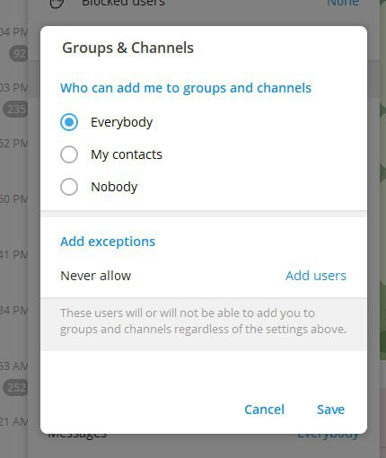

- Remove the setting of “No one can Add You”.
- If telegram shows error on Laptop, download Browsec and for mobile use SuperVPN

POINT WHILE SHARING AN EXCEL SHEET

While making any sheet which needs to be shared with another resource or with the top management, following points should be taken care off:
- Sheet name should be mentioned clearly showing what's inside the sheet.
- There should be concise columns, no extra information should be mentioned which can confuse others.
- Columns and Rows should not be hidden.
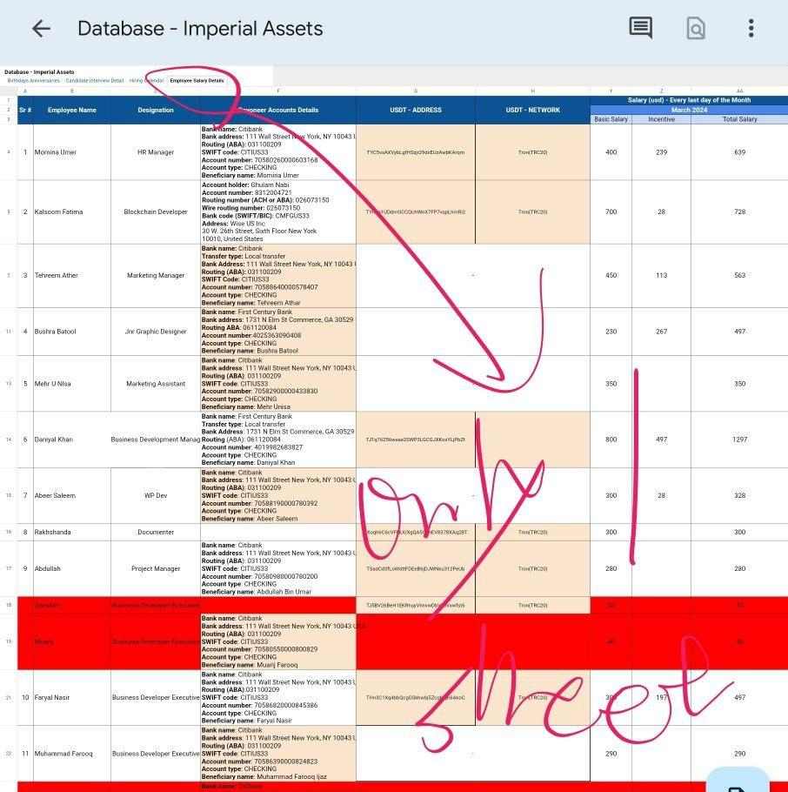
- Title row should be coloured and all used sheets should be boarded.
- Each sheet should be maintained separately instead of multiple sheets in one file.
- All data should be uploaded in the drive under the relevant folder.
