😃On the Job Training for all team and process

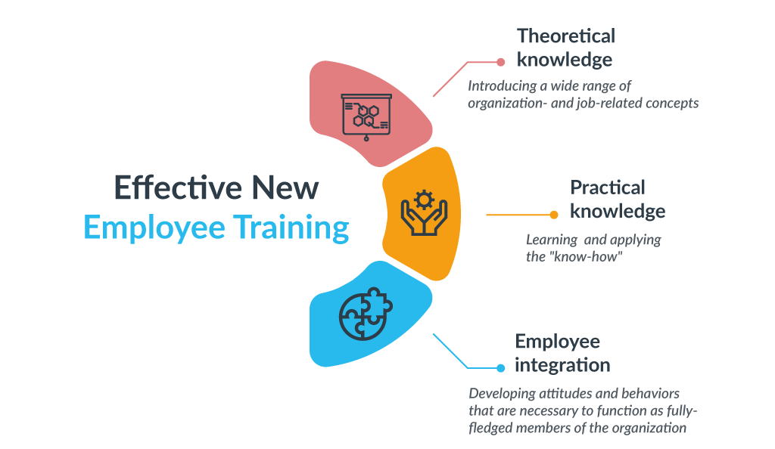

1. [Welcome to our Company]

Welcome on-board to our On The Job Training.
The following table of description is the Job Summary for each team. Kindly read through each of the job roles and understand the overall job position of our company.

2. [Incentive and Profit]

All our employees will 100% receive incentives every quarter (at least 100% max 400%). As this is our crucial phase for development and growth, we hope to create history together with your expertise, creativity, and intelligence.

In order to improve your performance and your work history, time management and compliance to the assigned tasks are the most important aspects to determine your incentives. Please make sure to complete the task each and every time, with consistent communication with the teammates to follow up in order to succeed in all assigned tasks. This will eventually reflect our overall profit to the company.

Manager Position | Senior PM for the Recruitment (CEO)  Timeline Management and Due Date check |  | Senior PM  for Development (COO)  Timeline Management and Due Date check |  | Senior PM  for the Sales (CMO)  Performance Check using the marketing funnel
Team No. | 1😃 | 2 📢 | 3📄 | 4🤼 | 5🖼️ | 6📞
Symbol | HR (Auditor) | BD | Project(Auditor) | Development | Designer, Marketers | BD
Full Name of Team | Human Resource | Communication | Project  Management | Development | Designer and Marketers | Sales
Task 1 | 1.Recruitment | 1.OJT(On The Job Training) Documentation related with company | 1.Always alert of the due date, precise time management with the outsource team | 1. Check Requirements according to Client’s requests | 1.Compile Logo Files + Website collection + Image File support to PM team | 1.Linkedin Auto DM, Email marketing, Sponsorship
Task 2 | 2.Resume shortlisting and Job Interview scheduling | 2.Job Performance Tracking with Project Sheet (due time sheet) | 2.RFP check with Checklist | 2. Due Time Check with timetable | 2. Design UX UI for the website with CMS tool or Wordpress (Elementor drag and drop) | 2.Google Inbound form and Zoom Counseling
Task 3 | 3.Measure KPI for each employees according to the company compliance every week | 3.Collection of Clients Credentials and Requirements | 3. QAQC (Result Qualification with service test) | 3. Result and Fee Contract / A/S Guarantee check | 3.PR SEO Marketing Contents design and Creation with SEO | 3.Facebook Form, Page, Community Management
Task 4 | 4.Prepare and update the OJT and PM Sheet | 4.Law Compliance, Contract(Order, NDA, MOU and etc) Management | 4. Create a progressive sheet and share to HR to show project progress | 4. Qualification Video submission and Result report (End) | 4. Sponsorship marketing A/B test with sales team records | 4. Wordpress Auto Press Release  5. SEO
Full Name of Team | Human Resource | Documentation & Translator | Project  Management | OutSourcing  Company | Designers and Marketers | Sales

On-boarding Process to Project Execution
Steps | Step 1 >> | Step 2>> | Step 3>> | Step 4>> | Step 5>> | Step 6
Summary of Job | Welcome on board, we have designated a manager to each team. Let’s go to Step 2 after OJT! | Top Management will inform the PM of all the RFP(Requirements) to the PM to start the project. PM(Step 3) will proceed the project according to RFP | Development : Test should be done  Marketing : Marketing and Performance Check require to maximize the performance | Normally, Out-sourcing will be done according to the mutual contract. PM can check their output according to Top management's guideline with the HR guideline | 1)Marketing Strategy creation  2)Marketing contents forwarded to sales manager  3)Sponsorship marketing setting and targeting  4)Marketing Strategy checklist check  5) A/B Test to check performance | 1)Auto DM for Linkedin, Discord, Twitter, Instagram  2) Email Marketing (Auto DM)  3) ZOOM inbound using form (Marketing site from marketing team)  4)Referral code marketing through youtuber or tiktoker and Sponsorship marketing

Each time, we must cross-check with other teammates to check the due date.

No. | Symbol | Full Name | Job Description  (Role and Responsibility)
1 | HR😃 | Human Resource | 1) Recruitment  https://www.rozee.pk/  2) Job Interview  (Zoom interview and Record)  3) Job Description Upload & Compile  (Google Drive)  4) Contract and Salary, Incentive Guideline  (USD or USDT monthly + Incentive Guideline)  5) Issuing Paycheck  (Every 30th of Month issuing)
2 | DT📢 | Documentation & Translator | 1) OJT(On The Job Training) Documentation related with company  2) Job Performance Tracking with Project Sheet (due time sheet)  3) Collection of Clients Credentials and Requirements  4) Contract(Order, NDA, MOU and etc) Management  5) Law Compliance  Compliance team forwards RFP(Requirements) to the PM to start the project. PM(Step 3) will proceed the project according to RFP
3 | PM📄 | Project Management | Top Management will inform the PM of all the RFP(Requirements) to the PM to start the project.  1.Always be alert for the due date and time management with the outsourcing team  2.RFP check with Checklist  3. QAQC (Result Qualification with service test)  4. Create a progressive sheet and share to HR to show project progress  - Development : Testing should be done, give feedback for any changes, track deadline  - Marketing : Performance marketing check & report the result
4 | OUT  SOURCING🤼 | OUT  SOURCING | 1) MUST check the requirements (clients request)  2) Check due date, work logging on the timetable  3) Result and Fee Contract / A/S Guarantee check  4) Record an instruction video for the outsourcing team so that they will clearly understand the guidelines (Use Bandicam, or others)  5) Report result (End)  Usually, Out-sourcing will be made through mutual contract. The PM can check their output according to Top management’s guidelines.
5 | DM 🖼️ | Designer and Marketer | 1)Marketing strategy creation  2)Marketing contents forwarded to sales manager  3)Sponsorship marketing setting and targeting (KOL marketing)  4)Marketing strategy plan checklist check  5) A/B Test to check performance
6 | S 📞 | Sales | 1)Linkedin Auto DM, Sponsorship, Direct marketing, Email marketing  2)Google Inbound form and Zoom Counseling  3)Facebook Form, Page, Social Media & Community management  4) Wordpress Auto Press Release  1) Auto DM for Linkedin, Discord, Twitter, Instagram  2) Email Marketing (Auto DM)  3) ZOOM inbound using form (Marketing site from marketing team)  4)Referral code marketing through youtuber or tiktoker and Sponsorship marketing

🙋Summary of the OJT Process for the new employee (First 1-3 days)

1.E-learning (Exam Test online with video practical lecture) – self-paced, on-demand learning

2.Job shadowing (After finishing each OJT) – shadowing job performance, feedback

3.Mentoring (Once a week 15 mins) – Assigned mentor must provide advice and guidance in order for the smooth on-boarding, transition to the job.

⭐OJT and HR Team and DT Checklist for new hiring

No. | To do list summary | Description
1 | Prepare Documentation | Capture the Conversation using Print Screen in the Telegram. This is to encourage practical conversation in the job in-house and outsourcing.
2 | Schedule and Checklist | Create a document and checklist to proceed each job and schedule time management for each Team’s OJT. Each manager MUST keep track of the checklist. Let’s create and upgrade our OJT once a week to multiply growth together as a team with the company.
3 | Progress Sheet | Each team should follow a universal google sheet to record project progress sheet and due date
4 | Screen Recording to Explain Job Requirements | After you have completed the documentation, record the video to describe and explain each document that you have made and explain about each case. Record the screen video for our new teammate to understand each task in case of emergency.

Start before your new hire’s first day – That doesn’t mean that you should require them to complete a training before they even start working for you. But they will appreciate it if you let them know what they can expect and what Learning and Development at your organization looks like.

Create an agenda – An agenda or a schedule should include a timeline, trainers (if there are any), training materials, goals, etc. It will give your new hires a good idea of what awaits them.

Make the training targeted and relevant – Make sure that the initial training focuses on core competencies and tasks that the new employee will need in their job. A role-specific training will help new team members become productive faster and set them up for long-term success.

Consult existing employees on training content – They will have unique insights on what new hires really need to know, when, and how it can be taught.

Employ peer training – Your more experienced colleagues can help train their peers.

Appoint mentors – These experienced people can help guide the employees through the training process and help them develop the necessary competencies. Create learning paths – Explain to employees how they build their skills over time. Combine different training methods – Like job shadowing, on-the-job learning, online courses, group training, and more. That way, you’re also catering to different learning styles.

Focus on team building – Making the new hire training a team activity will help you ensure that the new employees start feeling like they’re part of the team early on. Exchange feedback frequently – Your new employees want to know how they’re doing. Take your time to provide feedback on how their training is going. However, you’ll also want to know how they see the training.

Focus on ongoing training – New employee training shouldn’t stop once you assume that the employee can now do the basics. You can continue with cross-training them or creating a leadership development plan if they are high-potential. Provide access to training resources – Ensure that the new employees can find training materials and continue learning independently.

Monitor progress – And check whether the employees have the understanding of what you’re teaching them.


We make history together.
Our best is your best.

Contact : hq@metagallerys.io

