Development OJT

1.Crypto, Commodity Exchange Development Order
Don’t order for private developers or freelancers anymore, just order a complete exchange first.
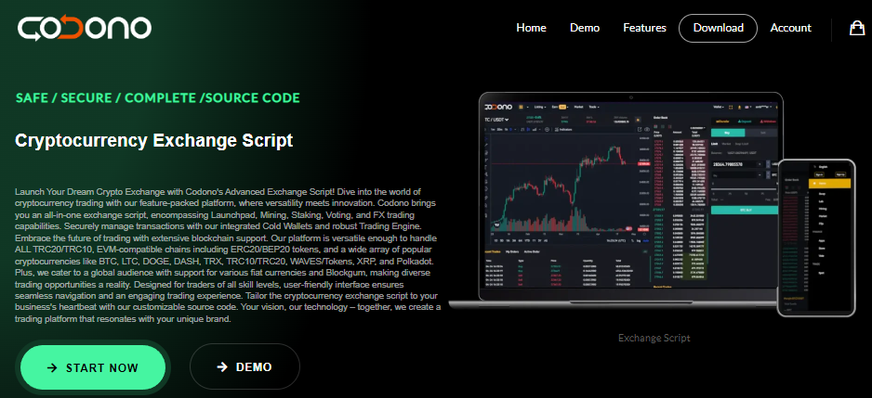

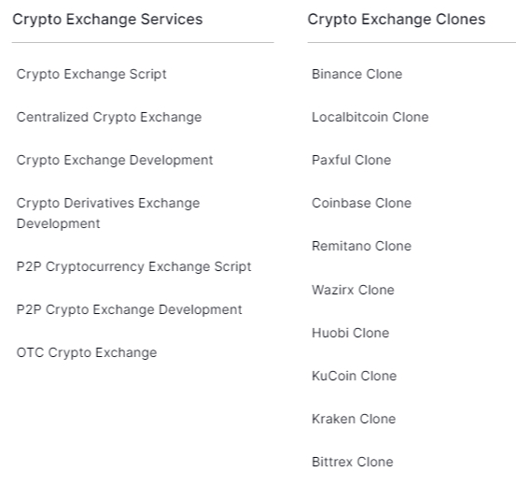
Reference : https://blog.cryptostars.is/top-10-cryptocurrency-exchange-script-provider-in-2023-922404b7c10c
2.List of Source Code Provider and Specification
(with full custom Development services)

No. | Company Name | Source Code Providing | Modification | PC/Mobile | App Development | Price ($) | Term (weeks) | Contact
1 | Zodeak  (https://www.cryptocurrencyscript.com/binance-clone |  | O | O | O |  |  | Telegram : https://telegram.me/teamcryptocurrencyscript
2 | InnBlockchain https://www.innblockchain.com/cryptocurrency-exchange-development |  |  |  |  |  |  | Whatsapp : +91 936135, 7439  TG: https://telegram.me/teaminnblockchain
3 | Codono https://codono-com.webpkgcache.com/doc/-/s/codono.com/ |  |  |  |  |  |  | https://t.me/ctoninja
4 | Trioangle https://www.trioangle.com/cryptocurrency-exchange-script/ |  |  |  |  |  |  | TG : https://t.me/teamcryptocurrencyscript
5
6
7
8
9
10

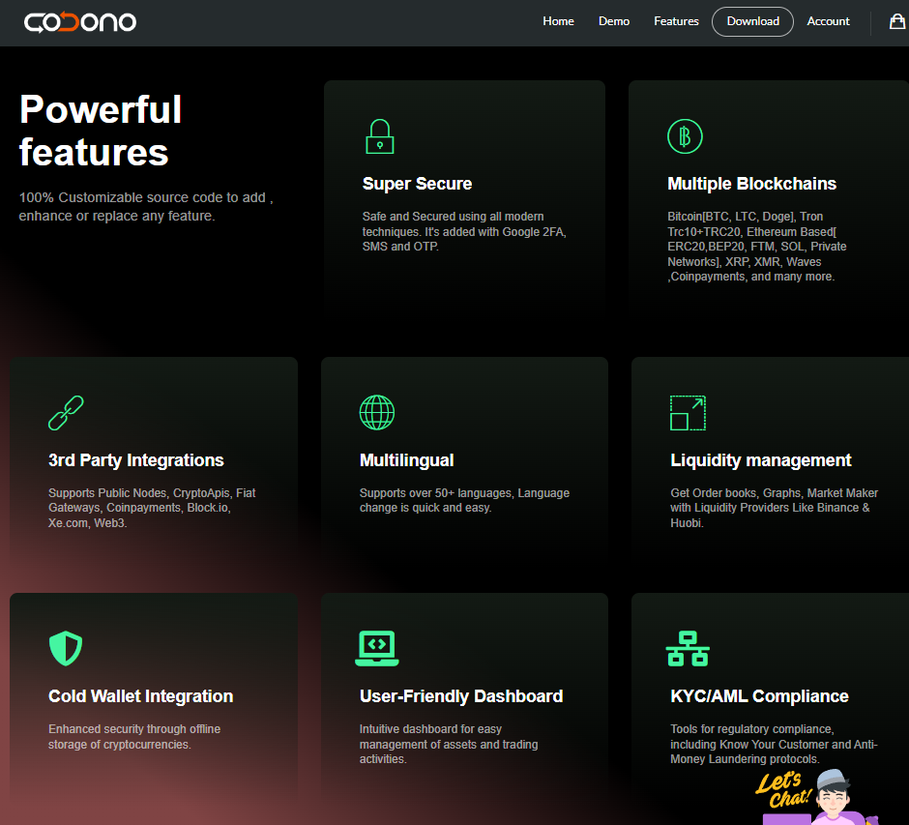

Can You Provide the Source Code for Your Cryptocurrency Exchange Platform?
Absolutely, we offer the complete source code for our cryptocurrency exchange platform. Our commitment to transparency and customer empowerment is reflected in our approach to providing open access to the source code. This empowers our clients to fully customize and adapt the platform to their unique requirements. Having control over the source code means you can seamlessly tailor every aspect of your crypto exchange – from functionalities and design to specific features. It opens up a world of possibilities for modifications, enhancements, integration of innovative third-party tools, and aligning the platform with your distinct business goals. We are dedicated to delivering a holistic crypto exchange solution that not only fulfils your immediate requirements but also provides the flexibility and scalability to grow and evolve with your business.

Are There Any Hidden or Recurring Fees for the Cryptocurrency Exchange Source Code?
Absolutely not! Our cryptocurrency exchange source code comes with a straightforward, one-time payment policy. We assure you there are no hidden fees or recurring charges involved. Once you purchase the source code, it is entirely yours without any additional costs. We believe in transparent pricing, ensuring our clients have complete clarity and confidence in their investment. This one-time payment model is part of our commitment to providing a fair and straightforward business solution, enabling you to focus on building and growing your crypto exchange without worrying about unforeseen expenses.

Is It Possible to Host the Codono Crypto Exchange Platform on My Own Server and Maintain Full Control?
Yes, indeed! Codono offers a self-hosted solution, empowering you to host the exchange platform on your own servers. This approach gives you complete control over your exchange, ensuring that you manage all aspects of its operation and security. By hosting the Codono platform on your servers, you benefit from enhanced autonomy, allowing for greater customization, control over data security, and the ability to make real-time adjustments as per your business needs. Our platform is designed to seamlessly integrate with your infrastructure, providing a robust, reliable, and fully manageable crypto exchange solution.

What Exactly is Cryptocurrency Exchange Software?
Cryptocurrency exchange software is a comprehensive solution designed for the trading of various assets, including cryptocurrencies, tokens, fiat currencies, and other digital assets. This software serves as the backbone of a cryptocurrency exchange platform, facilitating the smooth execution of trades. It typically includes advanced features like market making and liquidity options, which are essential for maintaining a dynamic and efficient trading environment. The software ensures seamless order matching, secure transactions, and user-friendly interfaces, making it an integral tool for anyone looking to operate a successful and reliable crypto exchange platform. By leveraging this software, you can provide a robust and scalable trading platform to users, catering to the evolving demands of the digital asset market.

What Range of Coins and Tokens Does Codono Support?
Codono boasts extensive support for a wide array of coins and tokens, catering to diverse cryptocurrency market needs. Our platform is compatible with virtually any Coin or Token available in the market. This includes major cryptocurrencies like Bitcoin (BTC), Litecoin (LTC), Dogecoin (DOGE), and Tron (TRC10 and TRC20 tokens). We also support Ethereum-based tokens such as ETH, ERC20 tokens, BNB (BEP20), as well as other prominent networks like FTM and SOL, including private networks. Additionally, our platform extends support to XRP, Monero (XMR), and Waves. For broader accessibility, we’ve integrated with Coinpayments, further enhancing the range of cryptocurrencies you can trade and manage on our platform. This comprehensive support ensures that our clients can cater to a wide user base with varying preferences in digital assets.

Can Codono Support Fiat Currencies Like USD, EUR, and TRY for Trading?
Absolutely, Codono fully supports all fiat currencies, including popular ones like USD (United States Dollar), EUR (Euro), and TRY (Turkish Lira). Our platform is designed to facilitate diverse market pairings, enabling you to create markets between Fiat-Crypto, Fiat-Fiat, and Crypto-Crypto. This flexibility allows for a wide range of trading possibilities, catering to the needs of a global user base with different currency preferences. Whether your users want to trade in traditional fiat currencies or explore the dynamic world of cryptocurrencies, Codono’s platform provides a comprehensive and versatile trading environment.

How Do Deposit and Withdrawal Processes Work in Codono?
In Codono, the deposit and withdrawal processes are designed to be both efficient and user-friendly. We support an automatic detection system for deposits, where each user is assigned a unique deposit address per coin. This ensures that deposits are instantly detected and promptly credited to the respective user’s account.

For withdrawals, Codono offers flexibility and security. Users can initiate withdrawals automatically, and we also provide the option for manual approval to enhance security. This dual approach ensures that while users enjoy a seamless withdrawal experience, the platform maintains high security standards to safeguard assets. This balance of efficiency and security is key to providing a trustworthy and convenient trading environment on our platform.

What is a Cryptocurrency Exchange Clone Script?
Cryptocurrency exchange clone script is a pre-designed software solution used to develop cryptocurrency exchange platforms similar to well-known exchanges like Binance, Huobi, and Coinbase. These clone scripts are turnkey solutions, providing a comprehensive set of features and functionalities that replicate the capabilities of established crypto trading platforms. By using a clone script, you can rapidly launch your own crypto exchange, often within a week, equipped with similar trading features and user interfaces found in leading exchanges. This approach significantly reduces development time and costs, making it an ideal choice for entrepreneurs and businesses eager to enter the cryptocurrency exchange market quickly and efficiently.

How Can I Start a Bitcoin Exchange Platform?
Starting a Bitcoin exchange platform is an exciting venture in the burgeoning world of cryptocurrencies. To embark on this journey, the first step is to connect with blockchain experts who can guide you through the process of building a live crypto exchange. By consulting with professionals in the field, you’ll gain valuable insights and advice on the essential components of a successful exchange, such as security measures, user interface design, liquidity management, and regulatory compliance.

Our team of blockchain experts is well-equipped to assist you in this endeavor. We offer comprehensive services tailored to your specific needs, helping you develop a robust, secure, and efficient Bitcoin exchange platform. Whether you’re looking for technical guidance, strategic advice, or end-to-end crypto exchange services, our expertise will ensure that your platform is well-positioned to succeed in the competitive cryptocurrency market. Reach out to us to start shaping your vision into a dynamic and thriving Bitcoin exchange.

What is the Top Crypto Exchange Script Available in the Market?
Codono stands out as a top-tier crypto exchange script in the market, backed by six years of experience in developing sophisticated crypto exchange software. This software is highly adaptable, making it suitable for businesses ranging from small startups to large-scale enterprise firms. With Codono, you have the option to receive comprehensive cryptocurrency exchange development services, including both web version and mobile app deployment.

This flexibility ensures that your users can trade easily and efficiently, regardless of their preferred platform. Codono’s commitment to offering versatile and user-friendly solutions makes it an ideal choice for anyone looking to establish a robust, secure, and scalable cryptocurrency exchange. Whether you’re just starting out or looking to expand your existing offerings, Codono provides the tools and expertise needed to succeed in the dynamic world of crypto trading.

3. Functions by each source code provider

Some common elements found in cryptocurrency exchange scripts are:
- User registrations and authentication
- Wallet integration for storing cryptocurrencies
- Order book and trading engine for matching buy/sell orders
- Charting tools and market data for analysis
- KYC compliance features
- Admin panel for exchange operations, user accounts, and settings
- Deposit and withdrawal functionality for fiat and cryptocurrencies
- Order history and transaction records for users
- Security measures like two-factor authentication and encryption
- API integration for connecting with external services and liquidity providers.

No. | Company Name | Spot/Perpetual | Listing availability | Token launch | Admin / KYC | Staking Service | API Access fee | Multilingual | MLM | Forex trading | Commodity trading
1 | Zodeak  (https://www.cryptocurrencyscript.com/binance-clone
2 | InnBlockchain https://www.innblockchain.com/cryptocurrency-exchange-development
3
4
5
6
7
8
9
10

Additional Services
https://www.cryptocurrencyscript.com/defi-yield-farming-development
