[OJT] Dev or PM
How to send the development requirements and materials for new developers?
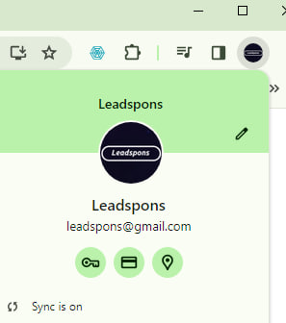 | 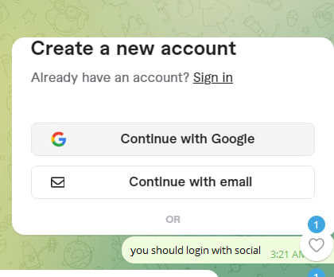
1.Chrome login and do | 2. Social Login
fiverr.com  leadspons@gmail.com  Metagallerys8!  Upwork.com  leadspons@gmail.com  Metagallerys8! | Do Social Login  (After Chrome google login) you should click this (not manual login)
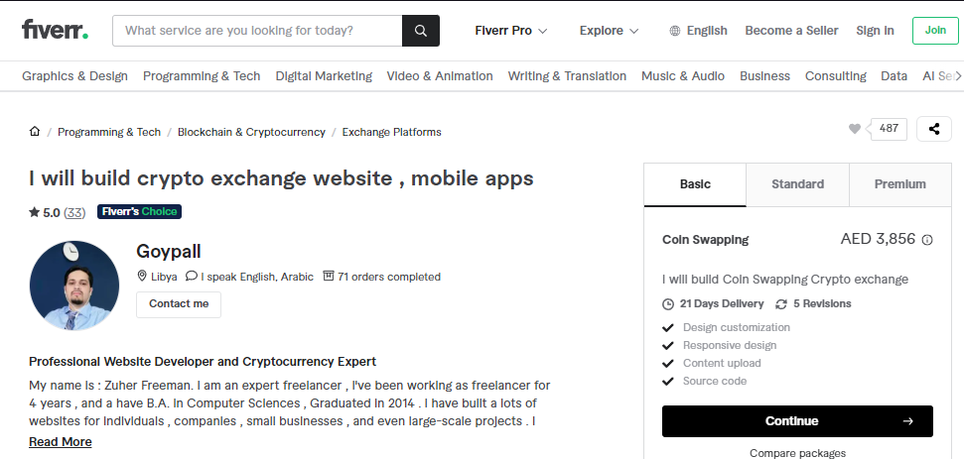
Find and Contact Top rated developers and reasonable price developers at
(Fiverr and Upwork)
1. Sending Requirement and Persuade freelancer ‘It’s easy’ to minimise the cost

Developers 1
https://www.fiverr.com/ranaali9320/create-cryptocurrency-exchange-website-for-you?context_referrer=search_gigs&source=top-bar&ref_ctx_id=ab2773d4c1254c5b975255c51dff7658&pckg_id=1&pos=8&context_type=auto&funnel=ab2773d4c1254c5b975255c51dff7658&imp_id=c104a724-61bc-4f69-ab81-2d2f1e990822

Developers 2
https://www.fiverr.com/cryptomason/build-crypto-exchange-website?context_referrer=search_gigs&source=top-bar&ref_ctx_id=ab2773d4c1254c5b975255c51dff7658&pckg_id=1&pos=1&ad_key=56987162-9249-4068-ad01-9be5f0153a53&context_type=auto&funnel=ab2773d4c1254c5b975255c51dff7658&fiverr_choice=true&imp_id=f24633e4-ec31-49dc-bae4-6da6bdb19900
(Get the estimation at least 5-7 developers per day)

Me
Feb 26, 2024, 4:17 AM
Hey Goypall, could you assist me with the Crypto Exchange Project? Can we find a convenient time for a meeting?

This message relates to:
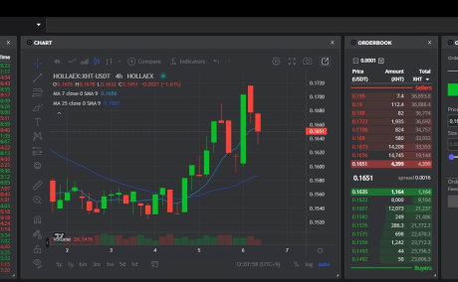
I will build crypto exchange website , mobile apps

Goypall
Feb 26, 2024, 4:17 AM
Hello , thank you for connecting me , please share the details of your project
I’ll send following info for your developmeent
1) User URL ID PW 2) Admin URL ID PW 3) To do : spot, future, calculator (indicator using trading view or manual indication : fibonacci orders) 4) Premium page (RSI, Stochastic RSI, FOMO/FUD ratio) (Development list)

[Example]  Please provide following info for all developers to let them test it (If we don’t have, let them know about our requirement easily)  1) User URL ID PW  2) Admin URL ID PW  3) To do (Requirement) : spot, future, calculator (indicator using trading view or manual indication : fibonacci orders)  4) Premium page (RSI, Stochastic RSI, FOMO/FUD ratio) (Development list) |   (Let developers know it easily and persuade this it’s easy development)
You should let developers play and look over current status using URL, ID, PW to test them (Like demo testing) Otherwise, developers definitely kill you 🙁
L
Me
Feb 26, 2024, 4:29 AM
(Video Explaining) BRICKON Service Development Easy Guideline for development https://drive.google.com/drive/folders/1ebBe23MZ2rDfxlzREDQdWqtZQv-t5pV-?usp=sharing
L
Me
Feb 26, 2024, 4:29 AM
UXUI https://www.figma.com/file/L0ovfftdFyKAvoLKclOr32/BRICKON-%26-MC9-%26-Premium-Service-and-all-(OKX-Layer-2-exchange)?type=design&node-id=0%3A1&mode=design&t=lgmE6UJmpNIAJw7t-1
L
Me
Feb 26, 2024, 4:29 AM
Exchange API https://www.okx.com/docs-v5/en/ Trading view API https://www.tradingview.com/rest-api-spec/
L
Me
Feb 26, 2024, 4:33 AM
ID: admin@email.com PW: 123456 Admin Site: https://admin.brickcon.io/ Brickon Site: https://brickcon.io/
L
Me
Only visible to you
This is our test Video (After almost complete) https://drive.google.com/drive/folders/1dFSKtAisMYsRHt0NHTLGC6-vEo8KMqHW?usp=sharing

L
Me
Feb 26, 2024, 4:38 AM
Indicators are really simple

Me

( Caution for internal employees : Don’t postpone more than 1hr. If midnight, don’t delay 4-5hrs in the midnight, have to do finish in day time asap) (if we detect someone made delayed meeting, we’ll deduct their incentive and give them a caution)

Developer : Yes sure, let’s do now (Or let’s do 3 hrs later because this is midnight, I’ll wake up and follow up) Thank you

Price Negotiation
Keep this compliance, this is so important.

Me :
Thank you for the meeting. Can I know the budget?

Developers
No it might take 3-4 weeks, can I do 3000?

Me : Hopefully, we only have 1500, 2.5 weeks can we do? (and negotiation as much as you can)

Developers
How about 2500 ?

Me : Yes I can do 2000 Maximum

Developers
Yes deal.

