Developers team OJT

1.Title : Scam Prevention and QAQC(Qualification)
(Qualification Steps to release the escrow for the 3rd Party developers team)
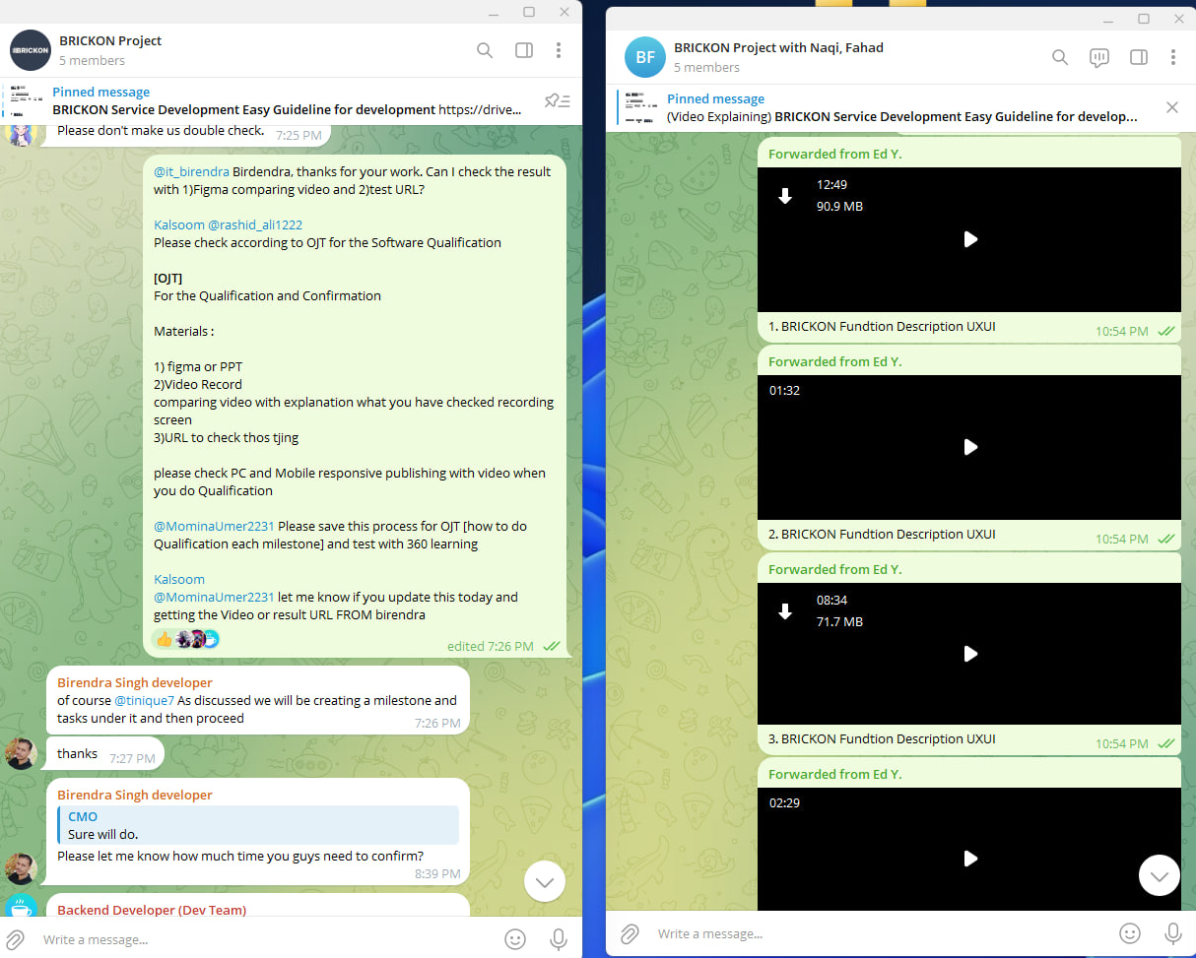
1. Yesterday's case was the worst case, wasting more than 1 month for this previous [NetSet] Team. If I didn't check it, our company was about to get risky a lot

In the development field, there are a lot of scammers. Scammers They made a lot of excuses even though we provided the video in detail and they said "YES" and pretended they made it even though I published all pages instead of them.

2. Check Before(RFP) & After (Result with URL)
To prevent further risk and absence, Please set the QAQC materials to check every milestone
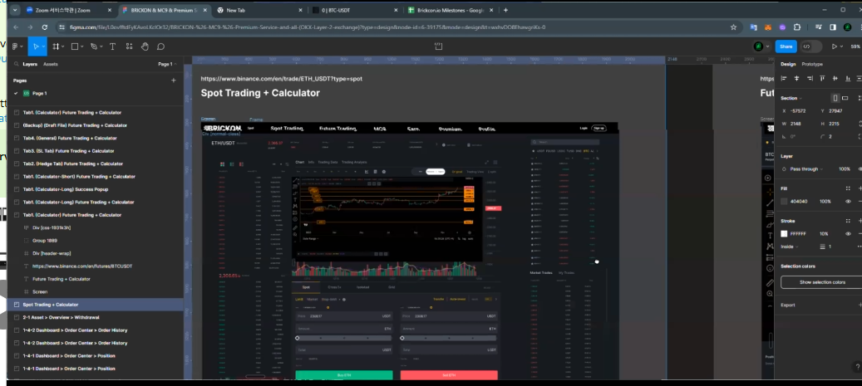
1.RFP and Proposal (including UXUI design + Figma)
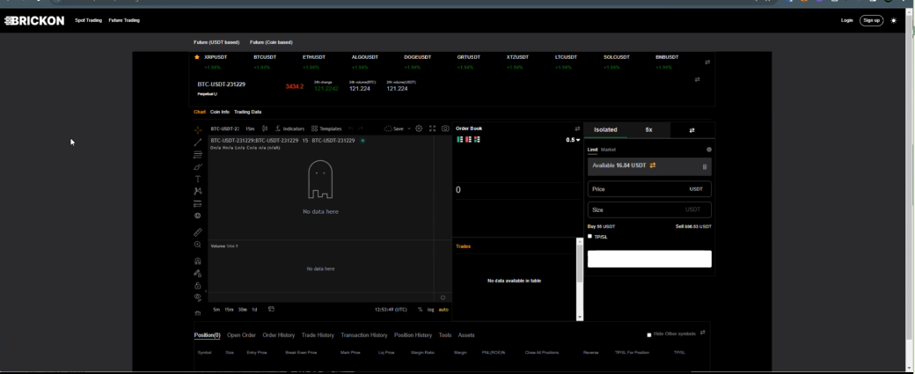
2.Different Result (URL)
Result : We have to request a refund and cancel. After then, we have to hire the 3rd party high Star rated developers immediately to replace them

OJT for Developers team

For the Qualification and Confirmation
Dev team should request
3rd Party Developers to report about finishing milestone with each Materials

Materials to Release milestone paycheck
for each 3rd outsourcing developers
1) figma or PPT(RFP : Requirements from clients and UXUI draft design) what we suggested or provided before to developers team
2) Please let them prepare the [Video Record comparing our Request (Figma with RFP)]
comparing video with explanation what you have checked recording screen
3)URL to check this thing
Guideline
please check PC and Mobile responsive publishing with video when you do Qualification
Due time to check : 10 Mins after get the materials
Caution : Without any Result, never trust out sourcing developers ‘Sure’ or ‘We done’ like this

@MominaUmer2231 Please save this process for OJT [how to do Qualification each milestone] and test with 360 learning

Kalsoom
@MominaUmer2231 let me know if you update this today and getting the Video or result URL FROM birendra

3. Don't release the milestone without any check.

Kalsoom, why you request me to proceed the payment? Company was about to waste our payment and lose the chance to detect the scam

4. [NEVER request me without any double check]
with 1)requirement 2)video or RFP 3) result URL.

without these material, no one can be trustful. Yesterday, we shouted to them because it was nothing change last 1 month even though only 4 page publishing.

4 page publishing I can do it in 5 mins using [Figma > HTML CSS converter] why you requested me to release money for them? Kalsoom, Rashid. you guys are 2. why no one take the responsibility related with this?

5. [Take the Job Responsibility]

Never request me to explain about these function to developer instead of you even though I explained multiple time for it even using the video. never CEO or others do their job instead of you. (-5 point for your incentive point if it happened. it possibly affect to your contract as well)

Emergency Case > Solution to check their status
when original developers are scammer

Solution
To prevent, PM has the responsibility to check
If we fired original 3rd party developers, we have to hire new skillful developers immediately and replace them

1. Every single 10 mins remind them to update about (important)
(For example, new developers are absent, we gotta request to start to work for them and let them start it first)

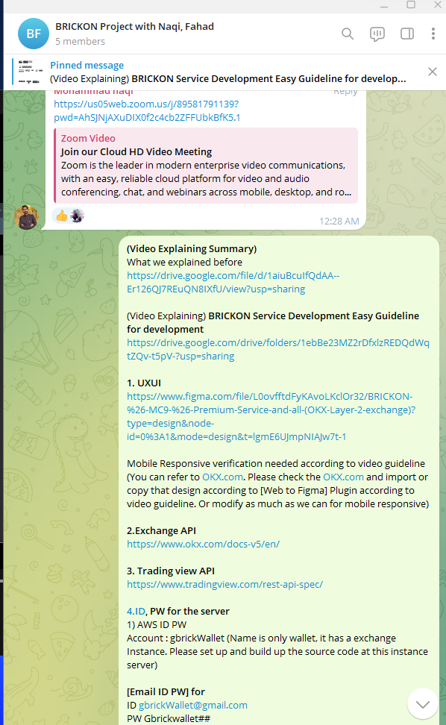 | (Video Explaining Summary)  What we explained before  https://drive.google.com/file/d/1aiuBcuIfQdAA--Er126QJ7REuQN8IXfU/view?usp=sharing  (Video Explaining) BRICKON Service Development Easy Guideline for development  https://drive.google.com/drive/folders/1ebBe23MZ2rDfxlzREDQdWqtZQv-t5pV-?usp=sharing  1. UXUI  https://www.figma.com/file/L0ovfftdFyKAvoLKclOr32/BRICKON-%26-MC9-%26-Premium-Service-and-all-(OKX-Layer-2-exchange)?type=design&node-id=0%3A1&mode=design&t=lgmE6UJmpNIAJw7t-1  Mobile Responsive verification needed according to video guideline (You can refer to OKX.com. Please check the OKX.com and import or copy that design according to [Web to Figma] Plugin according to video guideline. Or modify as much as we can for mobile responsive)  2.Exchange API  https://www.okx.com/docs-v5/en/  3. Trading view API  https://www.tradingview.com/rest-api-spec/  4.ID, PW for the server  1) AWS ID PW  Account : gbrickWallet (Name is only wallet, it has a exchange Instance. Please set up and build up the source code at this instance server)  [Email ID PW] for  ID gbrickWallet@gmail.com  PW Gbrickwallet##  DOMAIN : gbrickwallet.com  [username ID PW] for Admin  User : gbrickwallet  PW : Gbrickwallet123##  In this AWS server, they purchased the brickon.io (Duplicate Exchange using Bittok Exchange)  2) [DNS ID,PW] Domain Name Server  www.YESNIC.com (hosting site)  ID : gbrick / PW : Csk3839##  Brickon.io  3.[Dns]  Name Server: dns1.yesnic.com  Name Server: dns2.yesnic.com  Name Server: dns3.yesnic.com  Name Server: dns4.yesnic.com  These Tools will help your work load being less and easier than before.  It's really easy because of these plugins or extension.  [It take 15 mins]  (Publishing normally take 30min -1 hr to do totally)  Canva>Figma>Source code  (30 secs - 1 min)  1. Canva > Figma (Conversion)  https://youtu.be/W1_Xagat5mI?feature=shared  (30 secs - 1 min)  2.Figma > Visual Studio Code (Conversion)  https://youtube.com/shorts/ep59u8q3Hq0?feature=shared  (30 secs to 1 min)  3.Figma > Html Css or React JS, Flutter and etc all  https://youtu.be/zXckEyjM3dg?feature=shared

And ask them for an estimate (If they dont to reply to you, push them to reply as fast as we can in chat room. PM should request that)

1)Estimation (Time, Fee)
2)Check their daily status
3)Check API
4)Remind them about RFP and Design
5)Remind them milestone due time
6)Let them know about the milestone

2. Let them provide the result with materials (important)

1) figma or PPT(RFP : Requirements from clients and UXUI draft design) what we suggested or provided before to developers team
2) Please let them prepare the [Video Record comparing our Request (Figma with RFP)]
comparing video with explanation what you have checked recording screen
3)URL to check this thing

3. Update to project sheet and report to daily work sheet (+ Project due time sheet)
Let’s finish as fast as we can

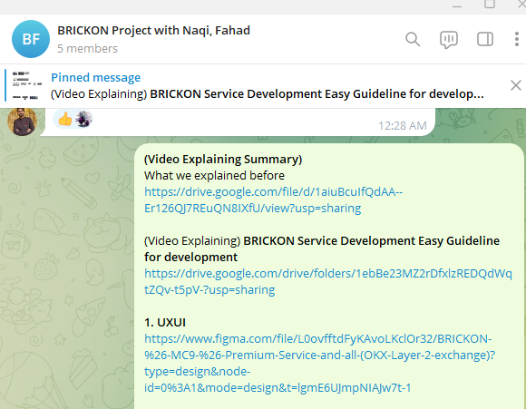
[Figure] Pinned Important information

And let 3rd party developers know important info all the time on PINNED(Announcement at Group chat)

Let’s clear all project we trust you all the time

- End -

