ADDING CUSTOM TOKEN TO CRYPTITAN WALLET
Objective: The purpose of this training document is to guide learners on how to add a custom BEP20 token to the Cryptitan wallet.

Step 1: Accessing the Custom Token Request Guide
- Open your web browser and navigate to Cryptitan Support or the platform where you purchased the source code Codecanyon.
Step 2: Email to Source Code Distributor
- Draft an email to the source code distributor using the following template:
Subject: Custom Token Addition Request for [Cryptitan Wallet]
Hi [Distributor's Name], This is Ed, a user who recently purchased the source code for the Cryptitan wallet. Following the custom token request guide, I am reaching out to request the addition of our custom BEP20 token to the wallet.
Token Details: -
Name: GBRICK - Symbol: GBXT - Chain Address: 0xaD1a818C61548Fb9A0669245079e606e6CeCD04f Reference Link: [Guide Link]
Kindly assist us in adding our custom BEP20 token to the Cryptitan wallet. Your support is highly appreciated.
Thank you, Ed
Step 3: Email to Support Team (broker.okex@gmail.com)
- Draft an email to the support team with the subject "Adding Custom BEP20 Token to Cryptitan Wallet" using the following template:
Subject: Adding Custom BEP20 Token to Cryptitan Wallet
Hi Team, I hope this email finds you well.
My name is Ed, and I recently purchased the Cryptitan wallet source code. We are looking to add our custom BEP20 token to the wallet.
Token Details: -
Name: GBRICK - Symbol: GBXT - Chain Address: 0xaD1a818C61548Fb9A0669245079e606e6CeCD04f AWS
Credential: - Username: gbrickwallet - ID: gbrickWallet@gmail.com - Password: Gbrickwallet## - Domain DNS: gbrickwallet.com (Admin)
Kindly assist us in customizing our source code to include the GBRICK token. Your prompt attention to this matter is appreciated. Thank you, Ed
Step 4: Await Response
- Patiently wait for a response from the source code distributor or the support team. They will provide guidance or implement the changes necessary.

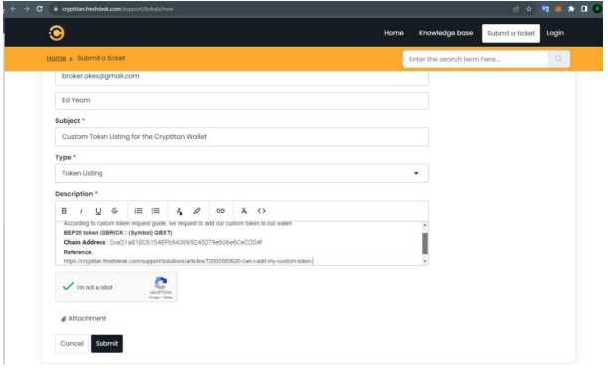

Note to Learners: Always ensure that the information provided, especially AWS credentials, is kept confidential and shared only with authorized support teams. If there are concerns or issues, contact the support team for assistance.
This training document is intended as a guide, and the process may vary based on the specific platform and support policies.

