On-the-Job Training: Creating a Token using SmartContracts Tools

Alright, let's begin our training session on creating a cryptocurrency token using the SmartContracts Tools Token Generator. This tool is a fantastic resource for anyone interested in the world of blockchain and cryptocurrencies. Today, I'm going to walk you through the entire process.

Introduction to Token Creation
First, let's understand what a token is. In the blockchain world, a token represents a unit of value issued by a project or organization. It can have various uses, from representing assets to granting access to services.

Accessing the Token Generator
Please open your web browsers and go to SmartContracts Tools Token Generator. Remember, always ensure you're using secure and trusted websites for any blockchain-related activities. You will see different chains on which tokens can be created. These are just like your banks, where you want to open your account. You can select any chain on which you want to generate the token depending on the requirement.
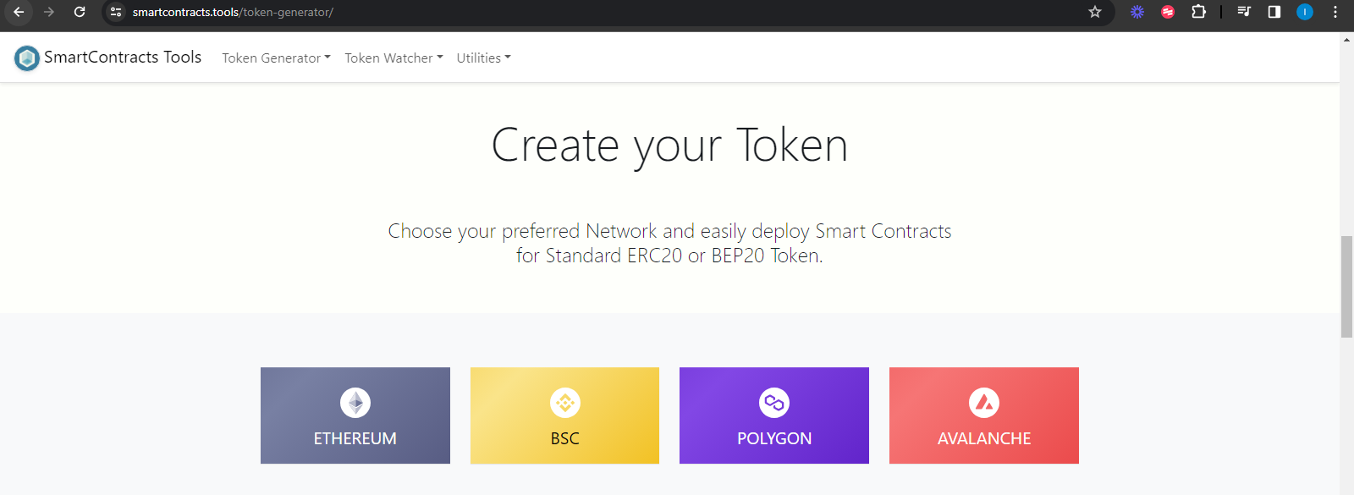

Exploring the Token Generator Interface
We will be creating the token on Binance Smart Chain. So click on BSC chain and then click on “Create BEP20 Token” Take a moment to look at the interface. You'll see fields for the token's name, symbol, and the total supply you want to create. There are also options for additional features like mintability (the ability to create more tokens in the future) and burnability (the ability to destroy tokens).
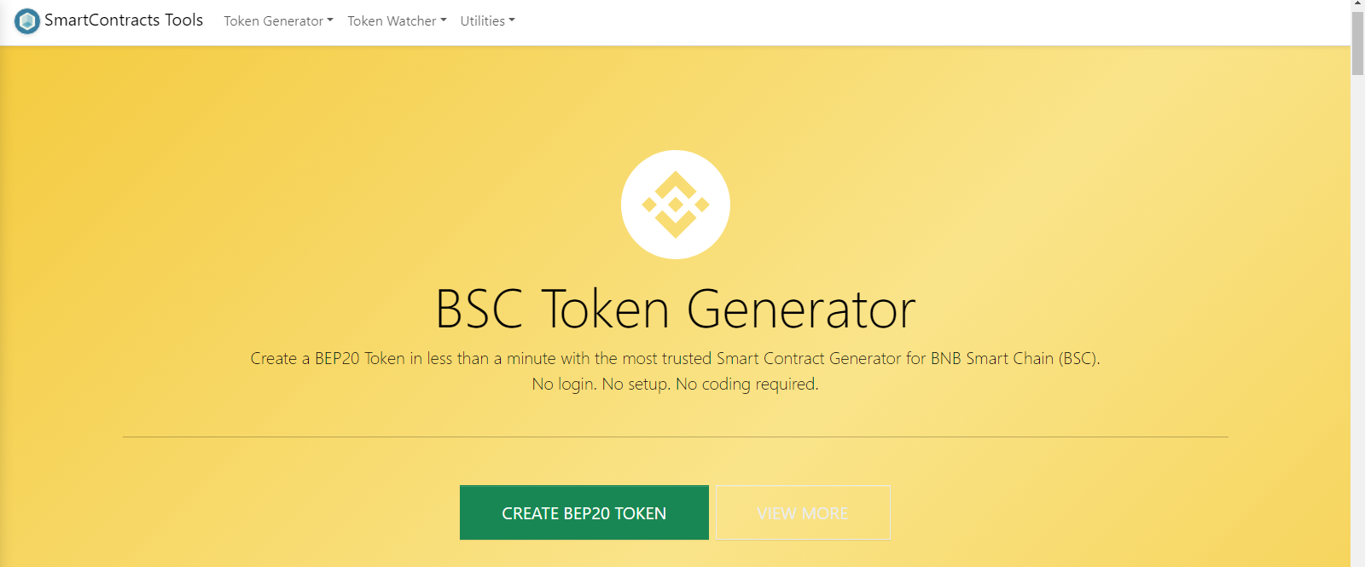
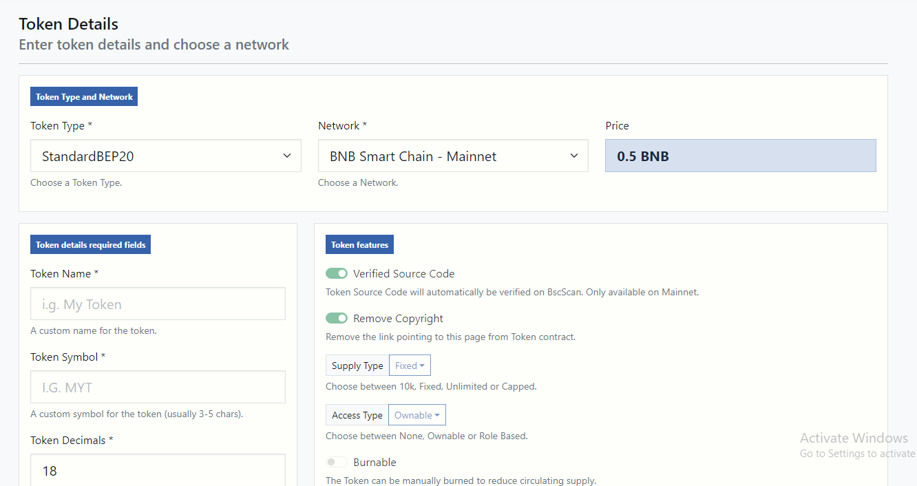

Creating Your Token
Now, let's create a token. You need to select the token type first, different token types has different functions, we will be creating standard BEP20 token, so we will select that option.
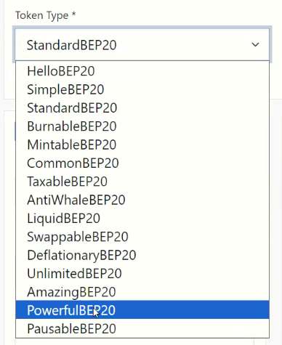
And then you can select the network, If you are testing the token or deploying it on main net.
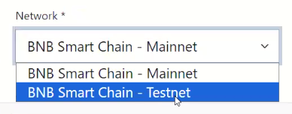

Now you will see some fields which needs to filled in, like Token name, Token Symbol and Token Decimal (It is the amount of decimals in circulating supply, how much tokens you want to create)
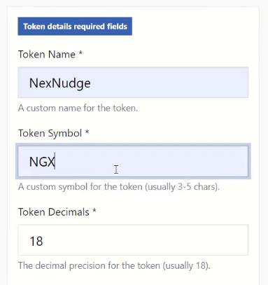

Now you can add the supply, how many tokens should be in the market in next columns.
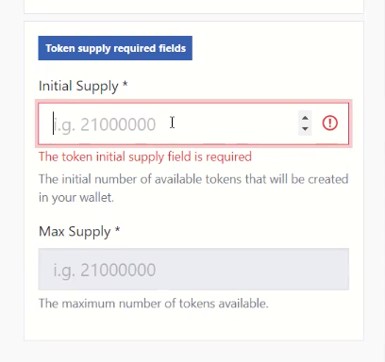

Deploying Your Token

Deployment is the final step. This is where your token goes live on the blockchain.
After filing in the token details, you will proceed to the next page and add billing information and add the Wallet Address where you want to deploy the tokens in to. You can add your company details here. These details are not verified so we can use any place to fill this.
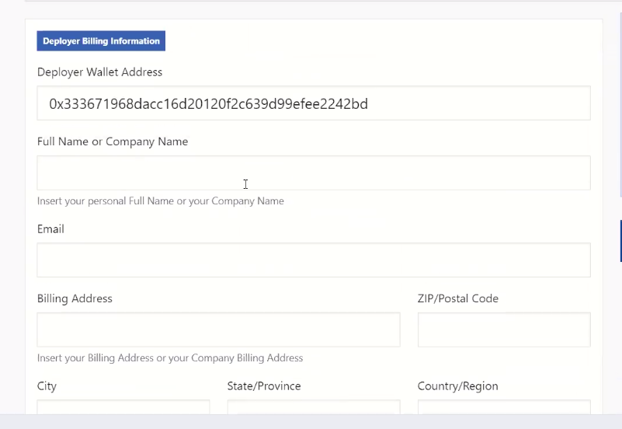

After this, it will connect to your MetaMask for the fees, and you can approve the transaction and you token will be created.

The video of this process is also saved in videos folder so you can check that as well. If you have any questions or need clarification, feel free to reach out.

