OJT Module: To Access A2 Hosting
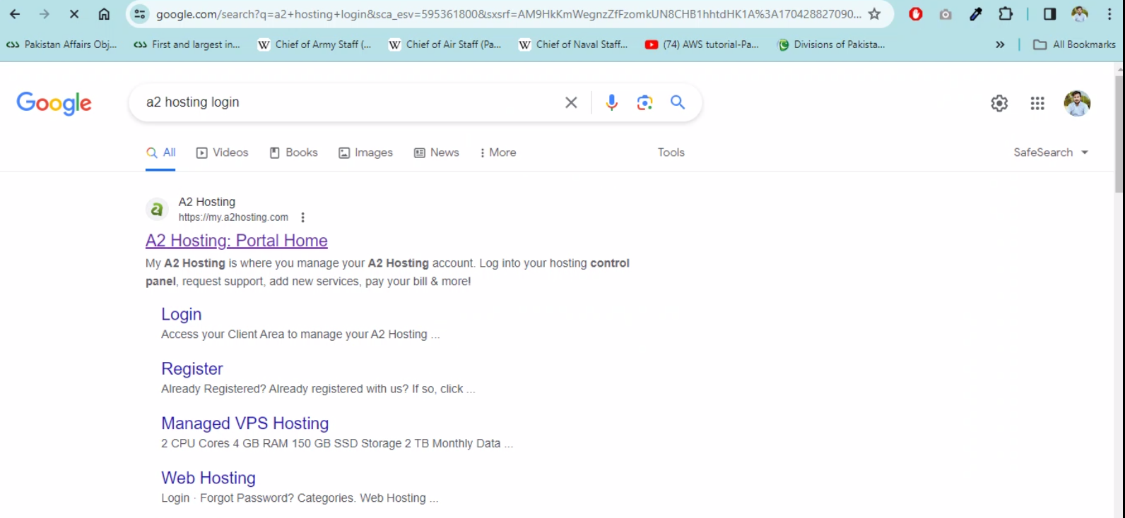
Step 1:
Go to A2 hosting website.
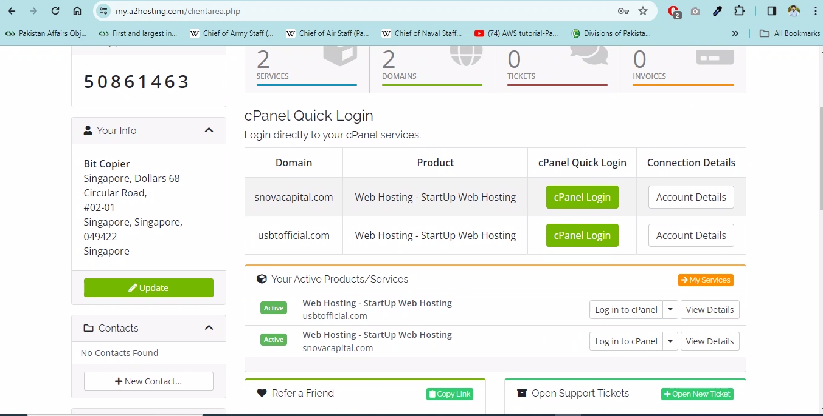
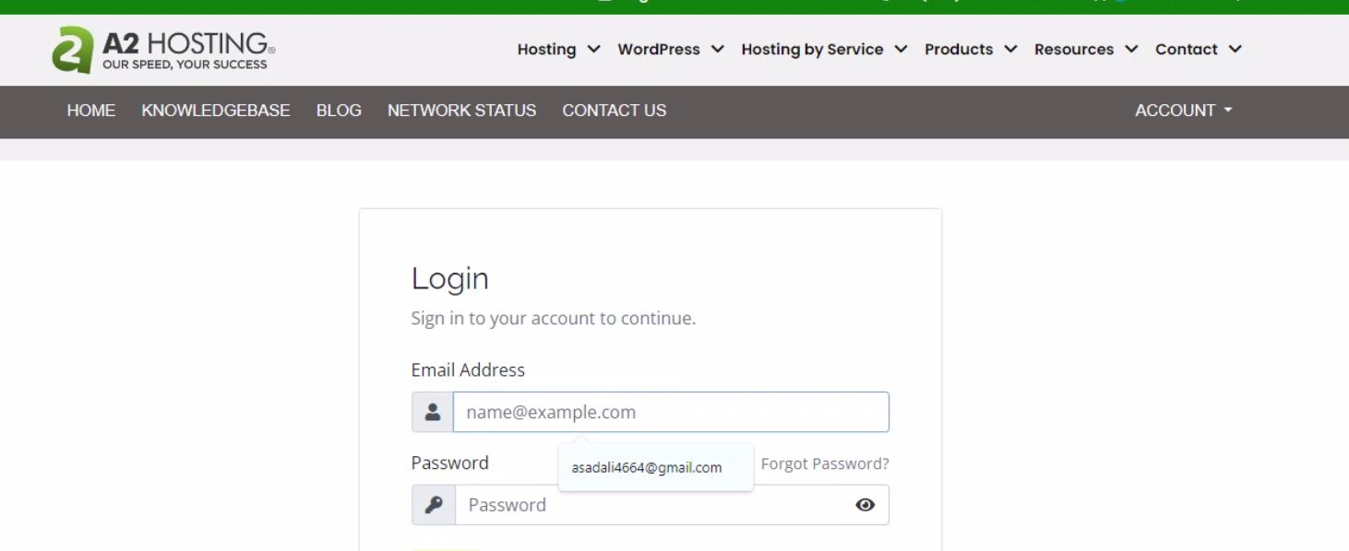
Step 2:
You will see a login page, add the username and password and log in, and you will have access to to cPanel

