QAQC GUIDE FOR WEBSITE CHANGES & MAINTAINENCE
Instructions to update the website:
In the process of enhancing the website, it is crucial to replace the logo on all pages and update contact information for accuracy. Consider streamlining the menu by removing unnecessary sections and introducing a well-crafted portfolio, complete with images and detailed descriptions. Attention to detail is key; verifying alignment and functionality across all pages ensures a seamless user experience. Take the opportunity to update team information, incorporating names, roles, and brief descriptions, utilizing text if images are unavailable. It is advisable to review and optimize the blog, examining thumbnails for accurate representation. Collaboration with other teams is encouraged for a thorough double-check, promoting consistency and alignment with overarching marketing strategies. Effective communication throughout this process is paramount, and seeking assistance when needed is not only welcomed but vital. The commitment to these improvements is appreciated, and collaborative efforts are crucial for achieving an impactful and cohesive web presence.
Website Maintenance Checklist:
To ensure your website is up-to-date, follow these steps:
- Logo and Image Replacement: Check and replace logos and images across all pages. Ensure consistency and correct sizing.
- Contact Information: Update phone numbers, addresses, and email addresses on every page, including the hidden menu. Replace the default email with your official admin email.
- Menu Modification: Review and modify the menu. Hide unnecessary items like the shop if not in use. Make sure the menu is well-organized and functional.
- Team Information: Update information about your team. Include names, roles, and a brief description. If images aren't available, use text.
- Blog and Portfolio: Customize the blog and portfolio sections. Add descriptions and images for portfolio items. Ensure everything is clickable and functional.
- Shop Section: If the shop is not in use, hide or remove it from the menu to avoid confusion.
- Contact Page: Update the contact page with the latest information. Include an official admin email and contact number.
- Advertisement Images: Replace any irrelevant or non-meaningful advertisement images with relevant ones.
- Blog Thumbnails: Check and update blog thumbnails. Ensure they accurately represent the content.
- Team Follow-Up: After making changes, follow up with the documented team or other relevant teams for a double-check. Ensure consistency and alignment with marketing strategies.
- Communication: Keep open communication with all teams involved in the website maintenance. Seek help when needed and collaborate for a cohesive effort.
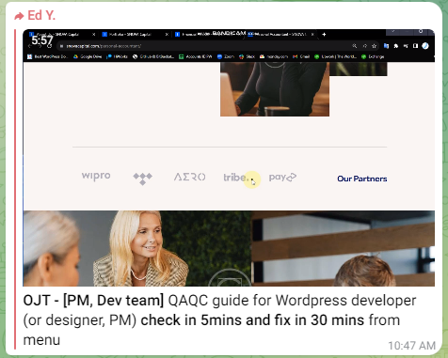
Remember, a well-maintained website reflects positively on your business. Thank you for your efforts, and feel free to ask for assistance as needed. Let's grow together!
If you want a recorded video tutorial for the above content, please feel free to ask.

