How to set the wordpress + auto posting using the ChatGPT + Wordpress?
1. First go to the website autoblogplugin.com and request your download link
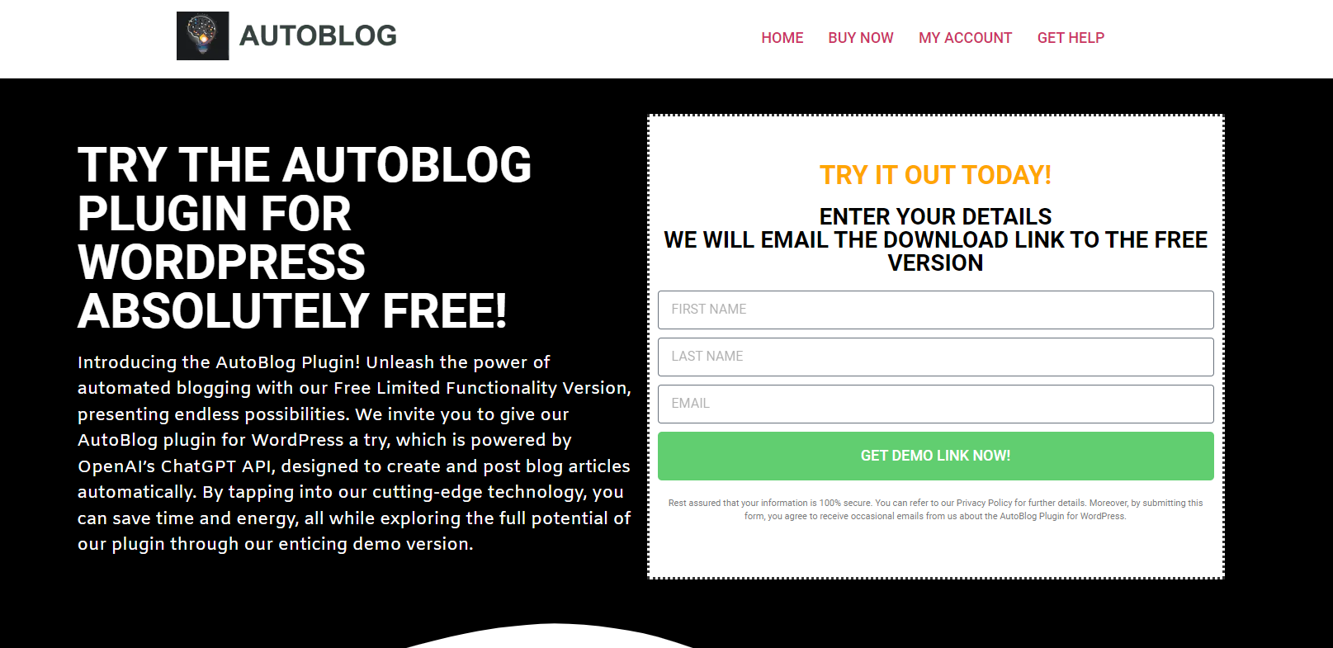

2. The second step is to update the AutoBlog Plugin settings

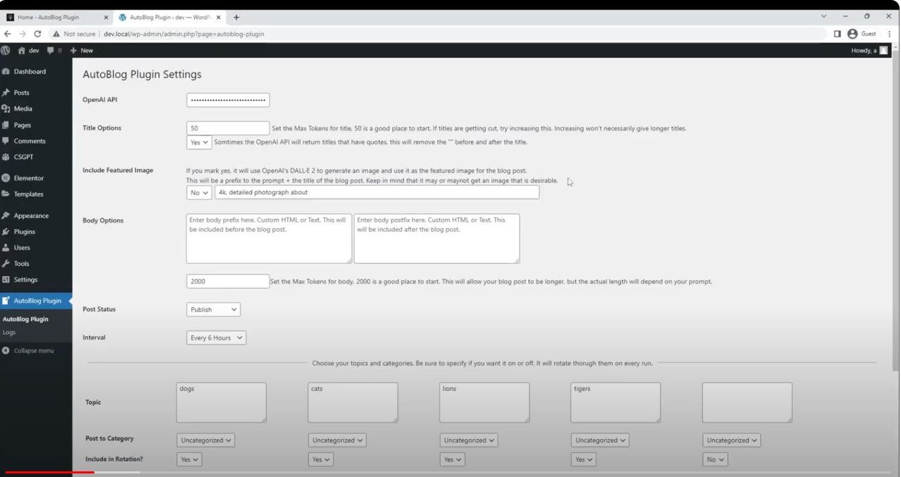

Autoblog Plugin Settings:
You need to fill in the following information
1. Enter your OpenAI API
2. Title options (Select 50 Max amount of tokens to start that let Open AI to use for each title.
3. Include Featured Image ( Mark Yes). It will use Open AI’s DALL-E to generate an image and use it as the featured image for the blog post.
4. Enter the body text before the blog post or after the blog post
5. Select the Max Tokens for body (2000 is good place to start)

6. Next Update your post status as “Publish”
7. Next set up the interval time for example “every 6 hours or you can also select an option after 24 hours”.

8. Add multiple topics and set the rotation option to “Yes”
Last Save changes and Run Test

Thank You

