(OJT) for Participants or Speakers Banner Creation by Designers Team

To ensure designers create effective banners for conferences or events that feature participants or speakers, enhancing the reputation of the brand and the event.

Steps:
1. Include Host or Conference Logo:
- Always place the logo of the host or the conference prominently on the banner. This establishes the identity and credibility of the event.



2. Search and Include Conference or Company Logos:
- Search for the logos of any featured conferences or companies.
- Ensure these logos are correctly placed on the banner to represent the involved organizations accurately.

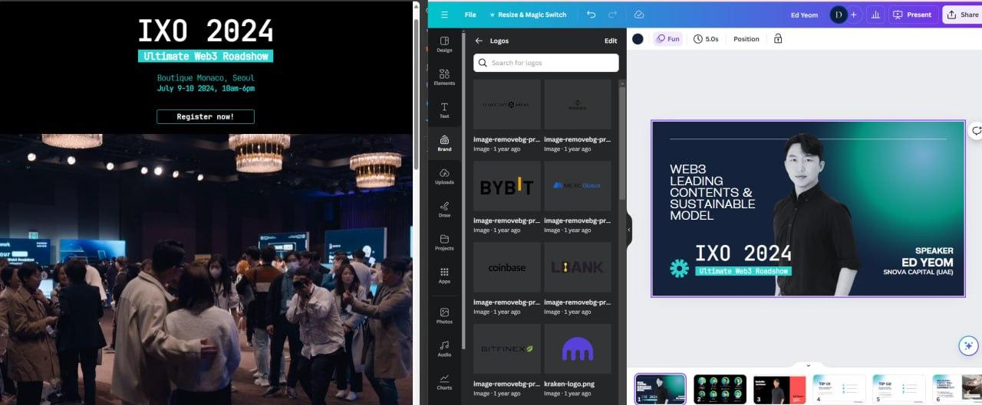

3. Feature Major Participants or Close Business Team Members:
- Identify and gather images or details of major participants or close business team members who are publicly associated with the event.
- Include their images or names on the banner to highlight their participation.
- This helps in elevating the event’s profile and attracting more attendees.
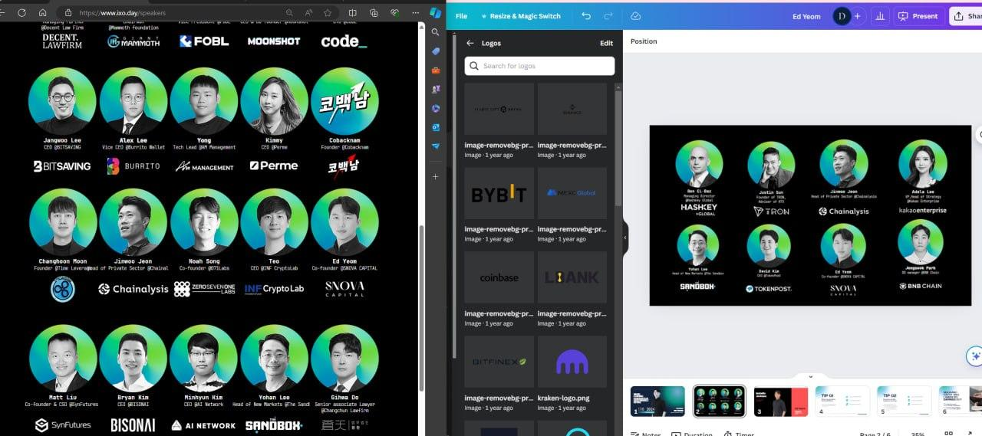

Tips for Designers:
- Logo Placement: Ensure logos are clear and appropriately sized relative to the banner.
- Image Quality: Use high-resolution images for all participants and logos to maintain a professional appearance.
- Brand Consistency: Stick to the event's color scheme and branding guidelines to ensure consistency.
- Hierarchy: Prioritize information by placing the most important elements (like the host logo and major participants) more prominently.
- Layout: Create a balanced and visually appealing layout that draws attention to key elements without clutter.

By following these steps, the designer's team can create impactful banners that effectively promote the event and enhance its reputation.

Additional Instructions:
- Perfect Sample Banner:
  - Here is a perfect sample of a banner. See this and before making any conference banner, follow the guidelines and create world-class banners like this.


- Canva Editable Link:
  - Also, here is the Canva editable link for the banner.
  - Canva Editable Link

