This OJT (On-the-Job Training) module for an investment proposal in the context of Investor Relations (IR) requires a focus on clarity, conciseness, and impact.
The aim is to equip employees, especially those in sales and design, with the skills to create compelling IR proposals that resonate with venture capitalists (VCs) and investors. Below, I outline a standard table design for an IR proposal, followed by a "Before" (bad example) and "After" (good example) comparison, complete with points for a Simplified Summary (PSS).

Standard Table Design for Investment Proposal

Table Components:
1. Company Overview:
Briefly introduce the company, its mission, and its unique value proposition.

2. Market Analysis:
Present data on market size, growth trends, and target customer segments.

3. Competitive Landscape:
Highlight your main competitors and your competitive advantages.

4. Product/Service Overview:
Detail the offerings and how they meet market needs.

5. Business Model:
Describe how the company makes money, pricing strategy, and sales channels.

6. Financial Summary:
Include key financials such as revenue, profit margins, and projections.

7. Team Overview:
Showcase the management team, advisors, and key personnel.

8. Funding Request:
State the amount of investment sought and the proposed use of funds.

9. Exit Strategy:
Outline potential exit options for investors.

10. Contact Information:
Provide details for further communication.
Before and After Examples with PSS

Before (Bad Example):

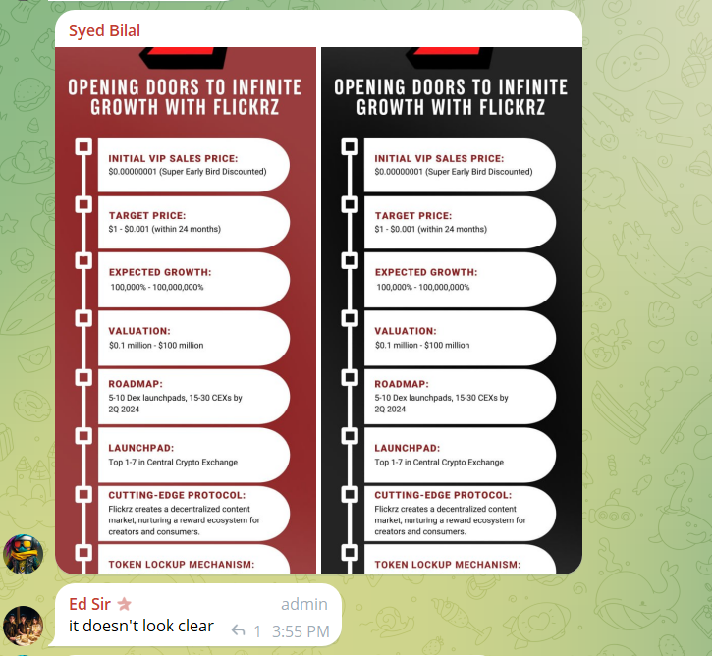

- The table is overloaded with text, making it hard to digest.
- Financials are presented without summaries, forcing readers to sift through detailed accounts.
- The competitive advantage is buried in a lengthy narrative.
- Contact information is missing, and the funding request is vague.

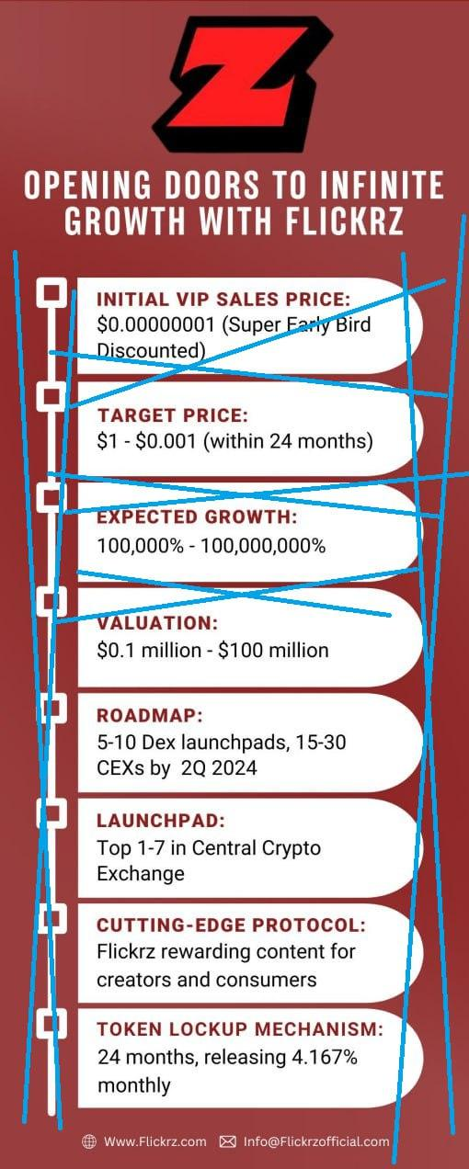
After (Good Example):
- Company Overview: One sentence that captures the essence of the business.
- Market Analysis: A bullet point list of key statistics and trends.
- Competitive Landscape: A simple chart highlighting strengths vs. main competitors.
- Product/Service Overview: Icons or quick bullets showcasing key features/benefits.
- Business Model: A diagram or a few bullet points explaining revenue generation.
- Financial Summary: A mini-chart showing past revenue, profit margin, and a 3-year projection.
- Team Overview: Photos with one-line qualifications/experience per key team member.
- Funding Request: A clear statement of the amount needed and a pie chart showing fund allocation.
- Exit Strategy: A few bullet points on potential exit paths.
- Contact Information: Prominently displayed for easy access.
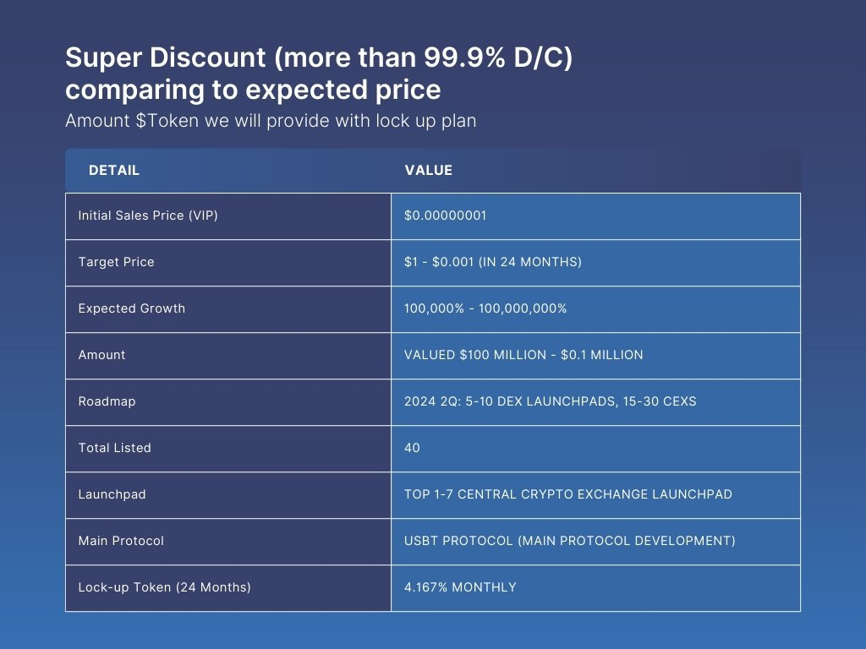

Simplified Summary (PSS)
- The "After" example uses visual elements and concise points to convey information quickly and effectively, improving readability and engagement.
- Financial summaries are clear and direct, making it easier for VCs and investors to understand the proposal's value.
- The addition of visual elements like charts, icons, and photos helps break up the text and highlight key information at a glance.

Implementing Across Teams
- Distribute the "Before" and "After" examples as part of an OJT module to all relevant teams.
- Include guidelines on designing IR proposals emphasizing simplicity, visual impact, and critical information.
- Conduct workshops where team members can practice transforming detailed text into concise, impactful tables and presentations.
- Regularly update the OJT module with new examples and feedback to improve proposal quality continuously.

This approach ensures employees understand how to effectively communicate value to VCs and investors, using a format that emphasizes clarity, brevity, and visual appeal.

