How to make event image and banner in 5mins

Due time: 5 Mins
(To make event image)
(according to color tone, text, and references of partner company)

Standard to create the banner
1. Partner logos color = Same color (Partner's signature color or white logo)
2. Logos size = Should be same and aligned
3. Catchphrase = Must be bold and biggest at the banner
4. Website or Social Links = At the bottom with social media links
5. Alignment = all the way left and right

In this lecture, we’ll learn how to make the banner in 5-10 mins according to references.

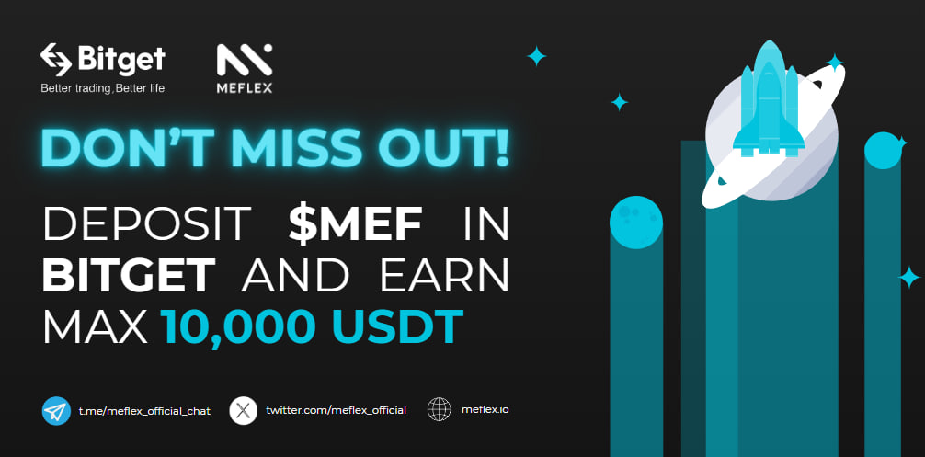
Figure [Result of Banner image for the events]

Template link (Canva)
https://www.canva.com/design/DAF-Ovxdgp0/DAvrzfteceA938U8eVZ7rg/edit?utm_content=DAF-Ovxdgp0&utm_campaign=designshare&utm_medium=link2&utm_source=sharebutton

How to variate Templates for each project (Most important)

(Ex. Meflex, Flickrz, SOMI, Findex, Bittok and etc) using the excel

(Variation in 5 - 30 Mins)
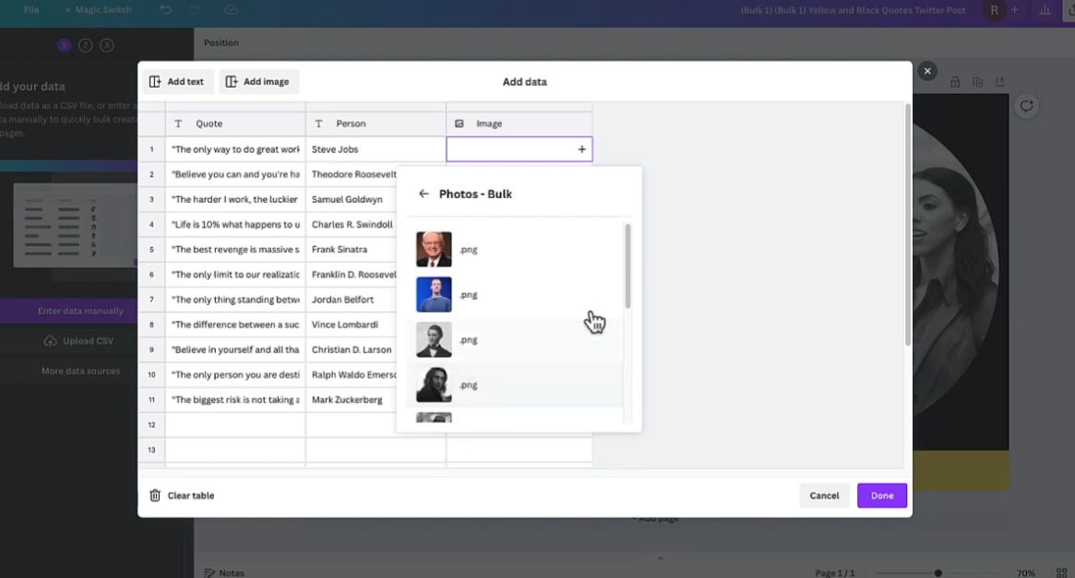
https://www.youtube.com/watch?v=nDw8rOXh6mU

Please memorize all steps using youtube lecture, and variate all the time for our banner, posts and events

Manual Guide
Step 1. Got Banner creation request from exchange or partners
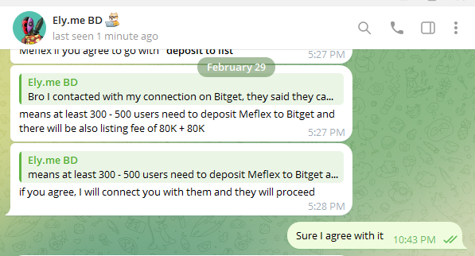

If you got the specific request for partnership, Search the reference

Google Search : bitget event
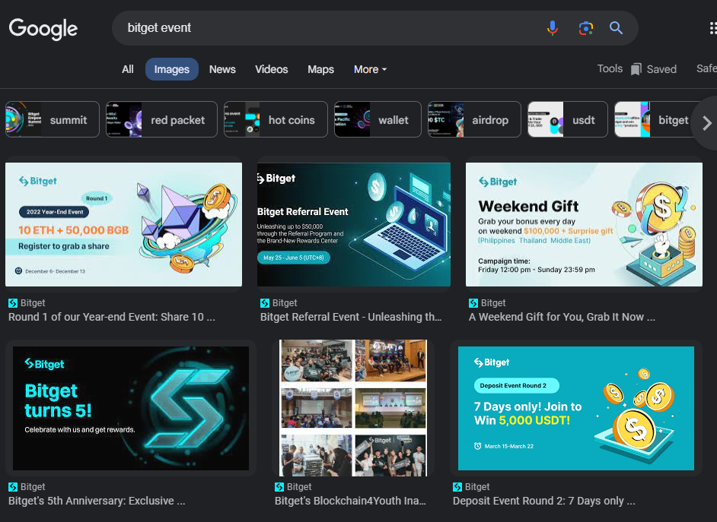

Step 2. Download the image extractor extension
Chrome extension : Image Downloader (install to google chrome extension)
(Optional steps for reference, not always)

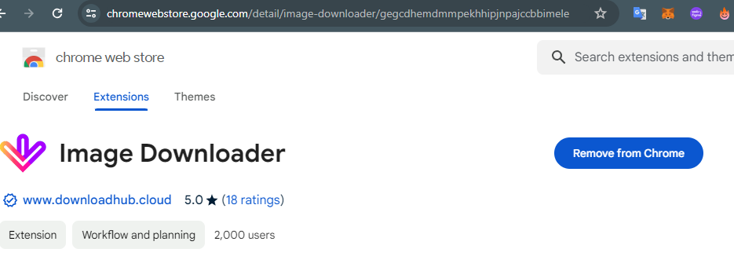

Step 3. Download all images
(Optional steps for reference, not always)
At the top right, right next to URL bar > Click the ‘Image Downlaoder’ and click the ‘select all’ and download all

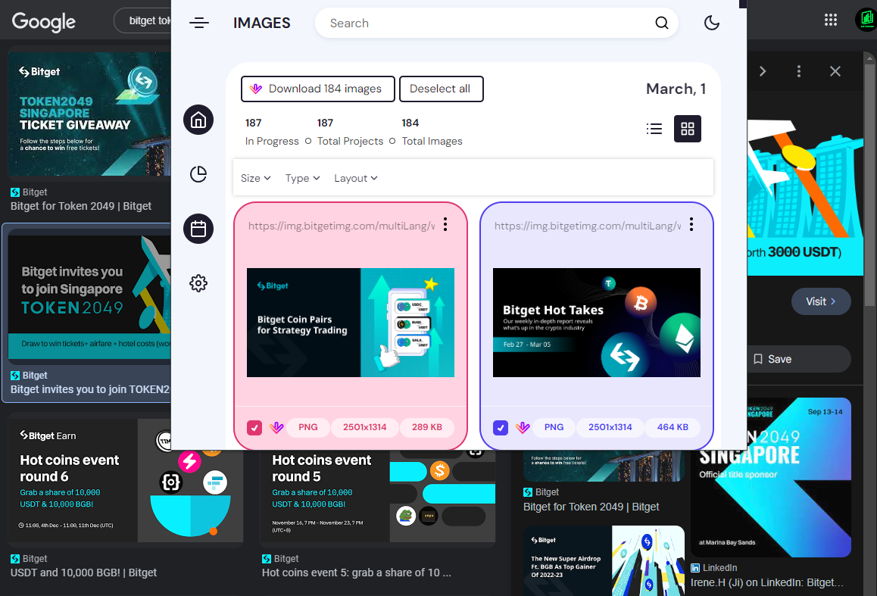
Step 4. Download anyway
(Optional steps for reference, not always)
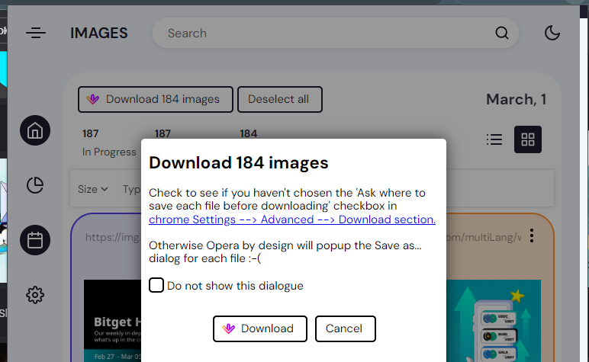

Step 5. Let’s learn about the image and
(Download process is Optional, You can pick up 1 of them and use as references)

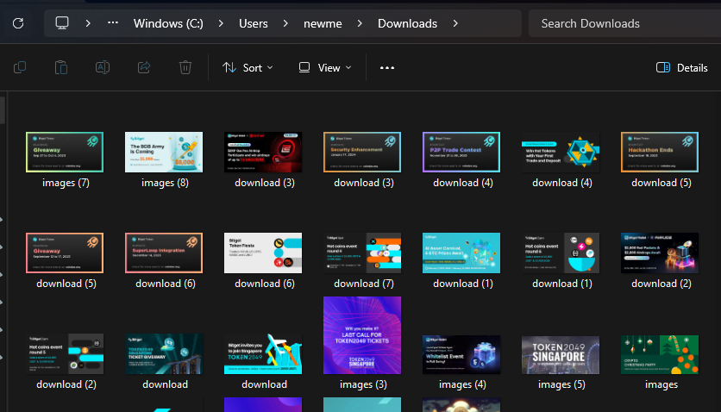
Step 6. Creating Banner According to Partner company Request in 5 - 10 mins

Create with Canva.com
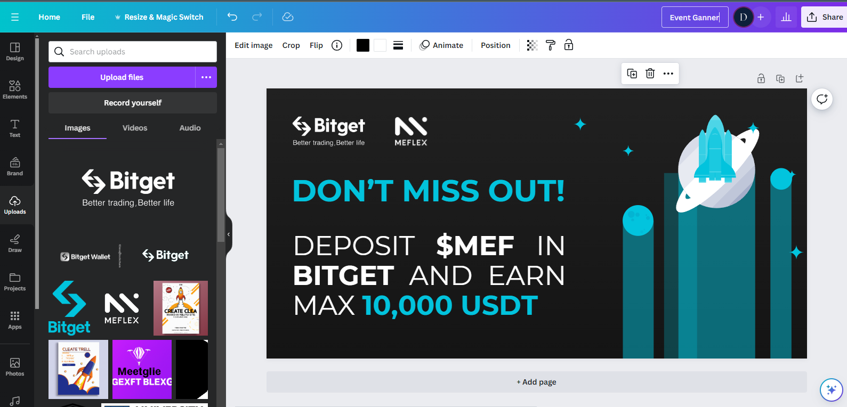

Step 7. Result Image

[Reference Images]

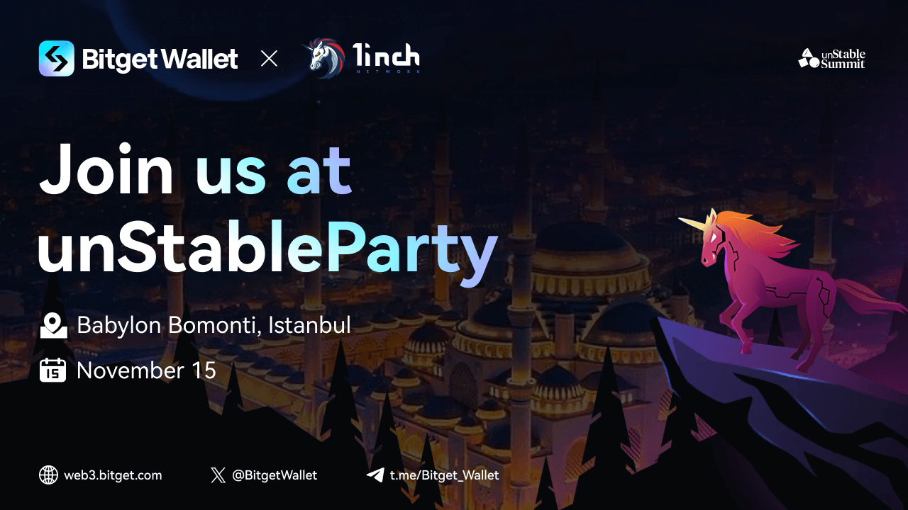Standard Reminder (Never miss)
1. Partner logo color = Same color (Partner's signature color or white logo)
2. Logos size = Should be the same and aligned
3. Catchphrase = Must be bold and biggest at the banner
4. Website or Social Links = At the bottom with social media links
5. Alignment = all the way left and right

End

