CREATING TEAMMATE BUSINESS PROFILE PICTURES WITH MOMO AI GENERATOR

Objective:
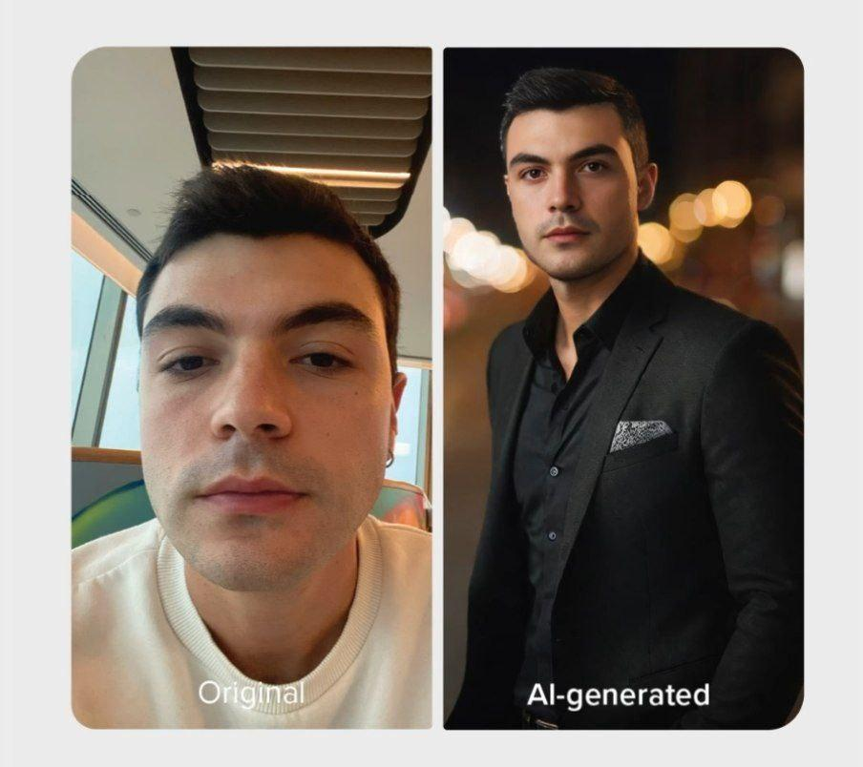
The goal of this training document is to guide you on how to collect and convert teammate and ambassador profile pictures using MOMO AI Generator, and subsequently store the images in the designated Google Drive folders.
Tools Required:
- Android/Apple Device
- MOMO AI Generator App (available on Google Play Store)

Procedure:
Install MOMO AI Generator:
  - Open the Google Play Store on your Android device.
  - Search for "MOMO AI Generator."
  - Install the MOMO AI Generator app on your device.
CONVERTING TEAMMATES PROFILE PICTURES
1. Collecting Teammate Profile Pictures:
  - Request teammate and CEO profile pictures.
  - Once received, ensure that the pictures are clear and suitable for professional use.
2. Converting Teammate Profile Pictures:
  - Open the MOMO AI Generator app on your device.
  - Choose the "Convert" option.
  - Select the teammate's profile picture.
  - Apply the desired AI-generated effects.
  - Save the converted image.
3. Saving to Google Drive:
  - Open the Google Drive app on your device.
  - Create a new folder named "Teammate Business Profile Images."
  - Save the converted teammate profile pictures into this folder.
COLLECTING AMBASSADOR PROFILE PICTURES
- Request for the picture
  - Invite ambassadors and inform them about the $100 compensation for using their profile images.
  - Request ambassador profile pictures upon acceptance.
2. Converting Ambassador Profile Pictures:
  - Follow the same steps as mentioned in the "Converting Teammate Profile Pictures" section for ambassadors.
3. Saving Ambassador Pictures to Google Drive:
  - Create a new folder named "Ambassador and Boardmembers Business Profile Images" in Google Drive.
  - Save the converted ambassador profile pictures into this folder.
4. Verification and Reporting:
  - Verify that all profile pictures are successfully converted and saved in the respective Google Drive folders.
  - Share the Google Drive URLs with the Design or Marketing team for further use.
Ongoing Update:
  - Regularly update the Google Drive folders with the latest profile pictures.
  - Communicate with ambassadors to keep the image collection up-to-date.

Note: Make sure to handle all images with respect to privacy and permissions, and comply with any relevant data protection regulations.

