OJT Module: How To Convert Figma Design To HTML CSS - Figma To HTML CSS
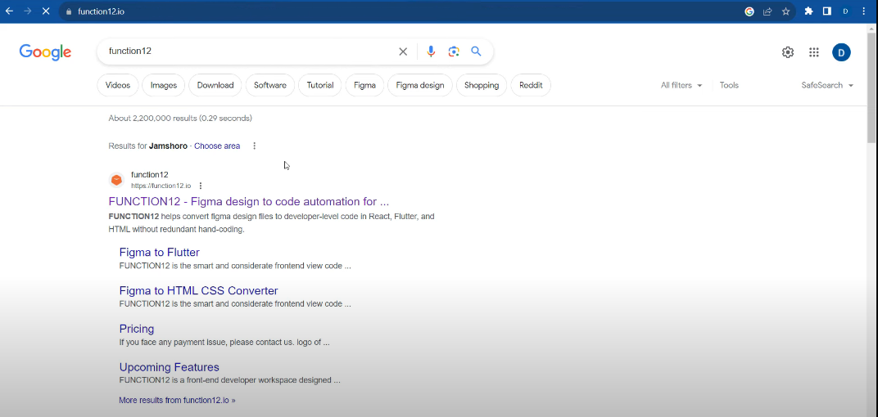
1st Step:
First, open the function12 website and sign up there.
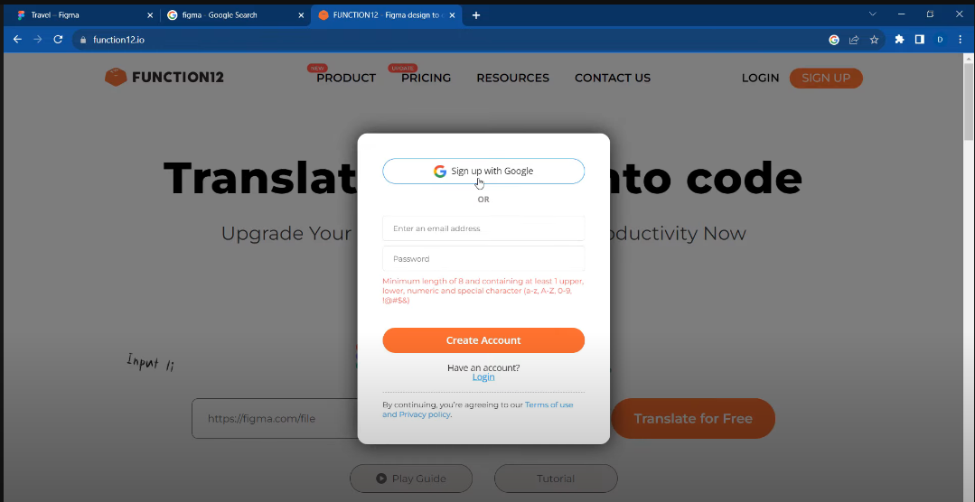

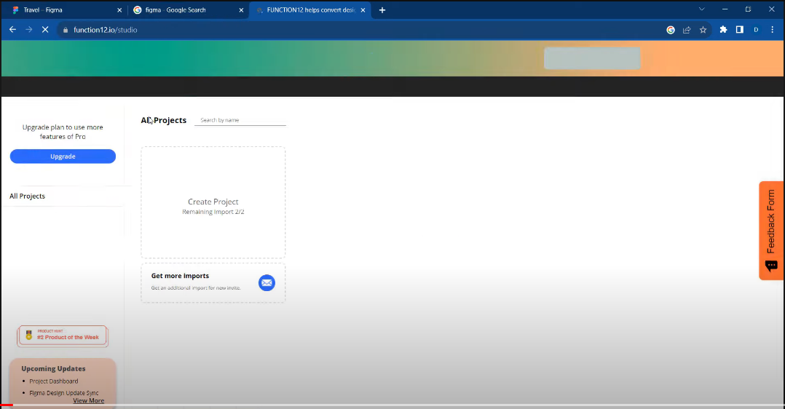
2nd Step:
After signing up on function12 website, you will see the Function12 dashboard.

3rd Step:
Click on create new project, and you will get this form page.
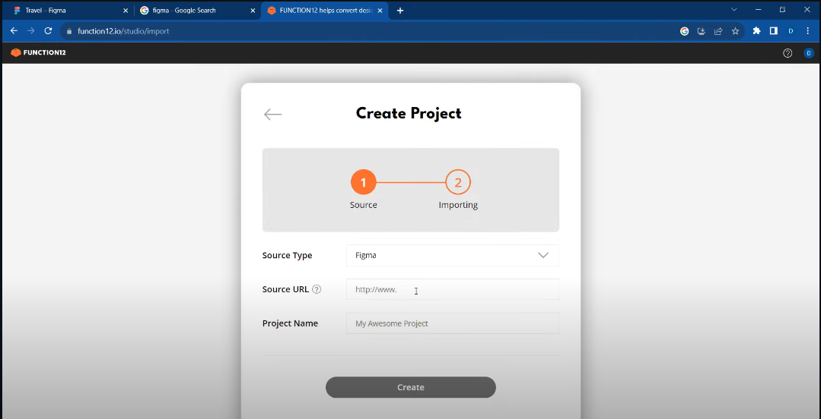
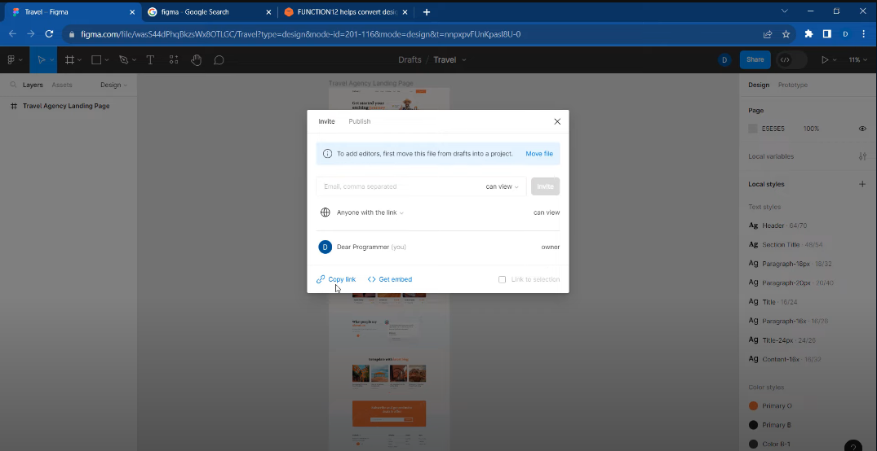
4th Step:
Fill in the details, Select Figma in Source Type and in Source URL, get the URL from Figma. Go to Figma open the desired project and click on share button and right top and then copy the link. Lastly, name the Project as well

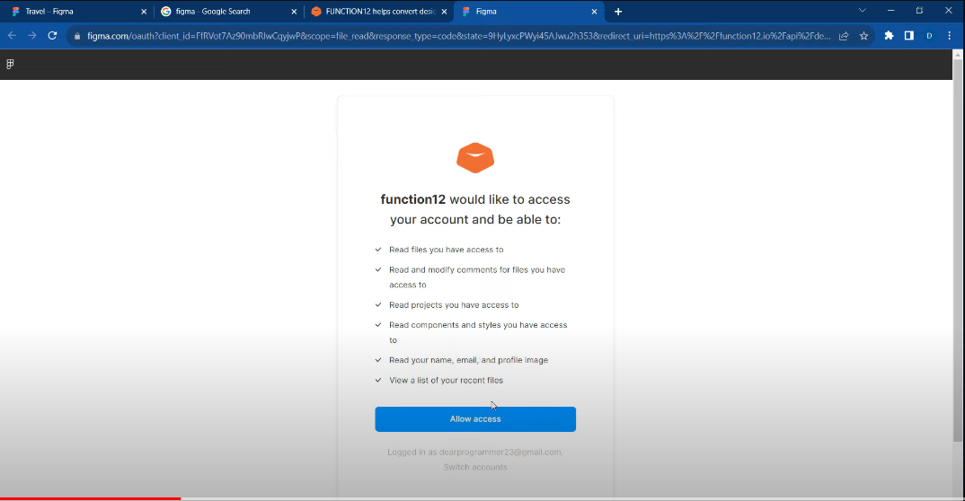
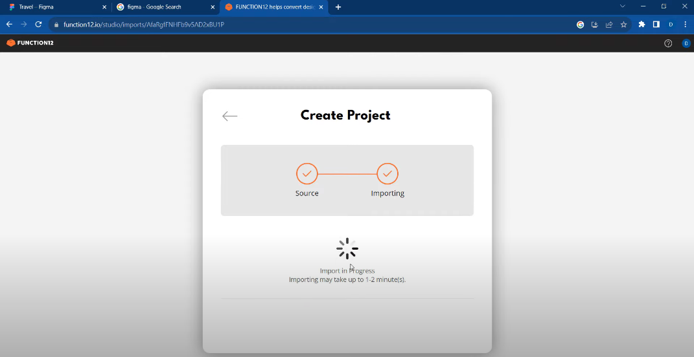
5th Step:
Give access to Function12, and wait for it to import the Figma Project

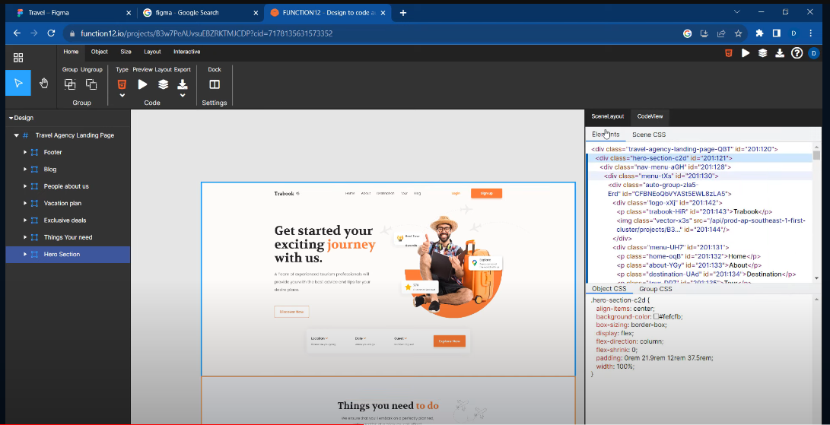
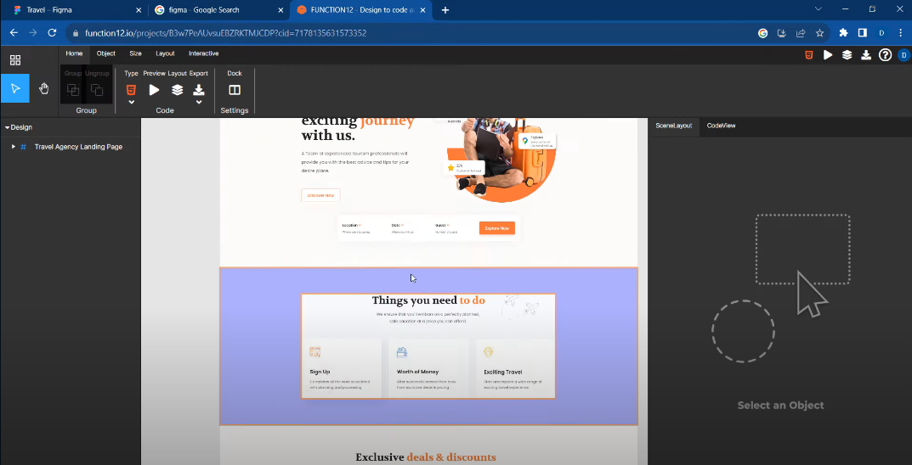
6th Step:
Once the Project is imported you will see on the right side, there will be a box with 2 option (Scene Layout and Code View), in Code Lay out you can see your code.

7th Step:
Now you can export this project by clicking export button on the top bar and save the file on your PC
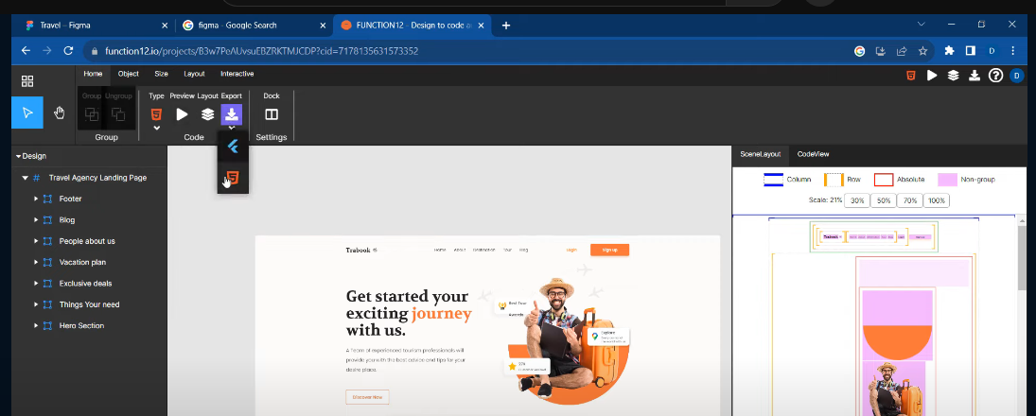

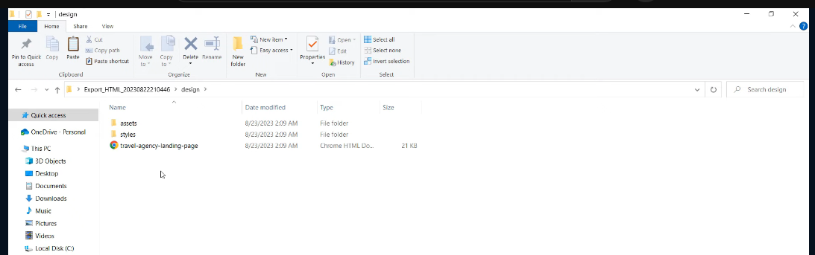
7th Step:
Once it is downloaded, you can extract the .rar file and use it.

8th Step:
To import the HTML file in to Visual Studio Code. right click anywhere in extracted folder and click open with code.
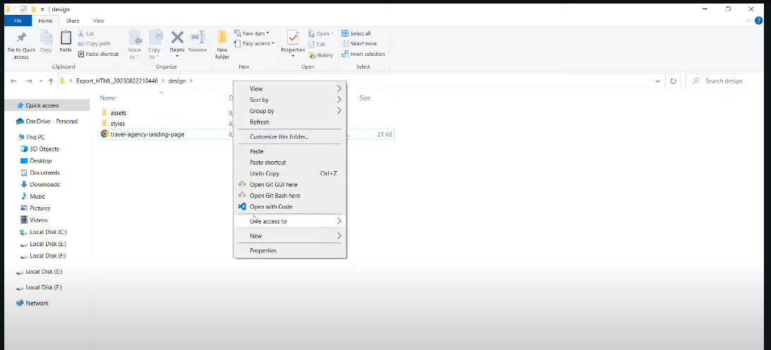

9th Step:
It will open in Visual Studios, and you have it. You FIgma design converted in to HTML
