On-the-Job Training Guide: Using the Web to Figma Plugin
Web to Figma is fantastic for importing web pages directly into Figma, which is incredibly useful for design and development work. Let's get started.

1. Installation and Setup
First, we need to install the plugin. Please open your Google Chrome browser. We're going to the Chrome App Store. Here’s how:

- Type "Chrome App Store" in your browser and hit Enter.
- In the App Store, search for "Web to Figma."
- Found it? Great! Now, click "Add to Chrome" to install it.
- Once installed, pin the extension to your browser for easy access.
Are you logged in to your Figma account? If not, please do so now. This plugin requires you to be logged into Figma to function correctly.

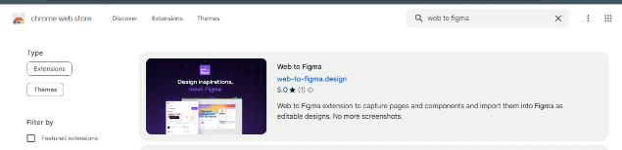

2. Using the Plugin (Installation and Execution)
Now, let's capture a website:
- Click on the Web to Figma extension icon in your browser.
- A small window will pop up. Here, you'll have to log in with your Figma account. Make sure you are logged in to your FIgma account, and allow access to the extension.
- You will see a notification page that you are successfully logged in to your account.
- And after logging In, when you click on the extension Icon you will see this window.
- To copy the website to make it on Figme, you have 2 options to select the full page or select some specific part of that website.
- When you click the full page it will start capturing the full page.
- After capturing It will show where to store the captured and converted file in the extension.
- You can create separate folders for separate projects.
- Now you need to Install Web to FIgma plugin in Figma, to do that go to Menu>Plugins>Development>New Plugin.
- Now search for “Web to Figma” plugin
- After Installing the Plugin In Figma, You can access that plugin and you will 3 tabs on the top [Import] - [Collections] - [Inspirations]
- Import will let you directly import any website to FIgma, just by Pasting the URL there, and the collection contains all the captures you made on different websites using “Web to Figma” extension on google chrome.
- Your website is now on FIgma, you'll see how the website's elements are now individual components in Figma and you can modify it according to the client's needs.
For your reference please see the complete detailed video in the videos folder in Designer OJT. https://drive.google.com/drive/folders/1Vpiu6g0u6iktW1vlm4j0db-hf1wRMLgC

