OJT Module: Embedding Canva Designs in Figma Presentations
You will learn to embed Canva designs into Figma presentations using the Pitch Deck plugin.
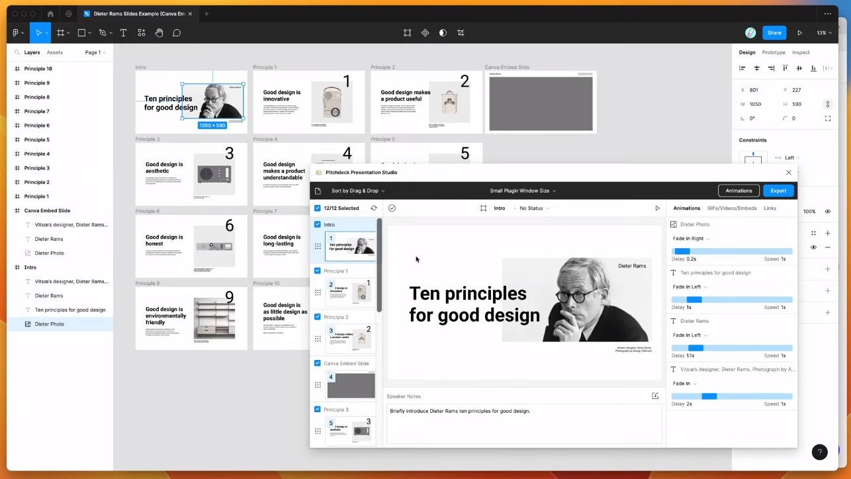

Installing Pitch Deck Plugin in Figma
- Navigate to the Figma file and click the resources icon.
- Search for "Pitch Deck" in the plugins tab.
- Install and save the plugin for future use.

Right-clicking anywhere on the Figma canvas, selecting Plugins, going to Saved Plugins, and clicking on the Pitch Deck item. This plugin treats frames on the Figma page as slides, allowing you to create slides with content such as text and images. The plugin also enables you to add animations, embeds, and links to the slide layers.

Preparing Canva Design for Embedding and Embedding in Figma Using Pitch Deck

- Create or open a design in Canva.
- Click on the share icon in Canva and select 'More' for additional options.
- Choose 'Embed' and enable the embed link, making the design public.
- In Figma, run the Pitch Deck plugin.
- Select a frame in Figma where the Canva design will be embedded.
- In the plugin, paste the copied Canva embed link into the designated slide.
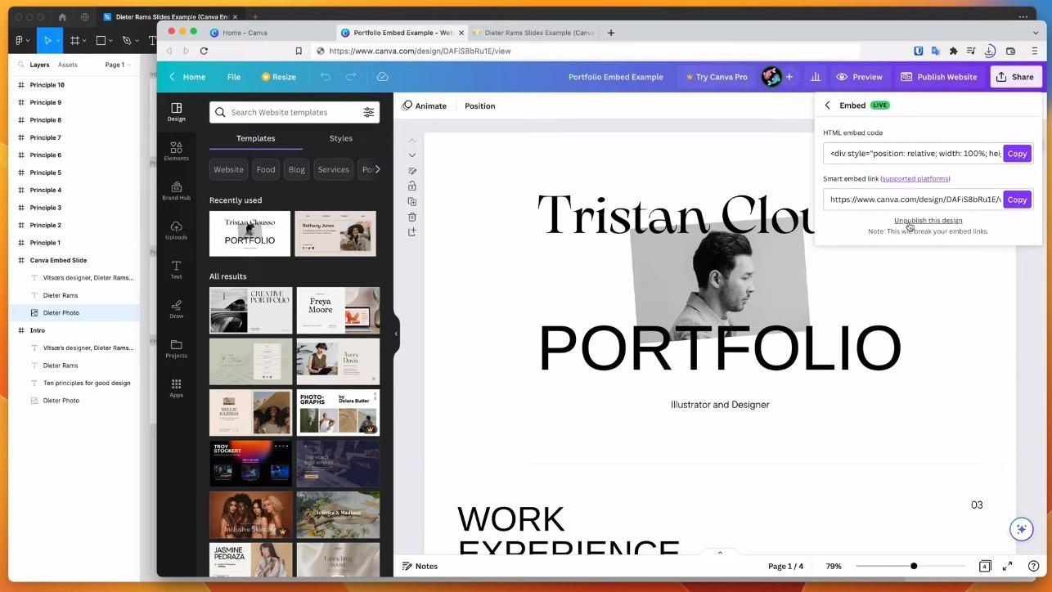
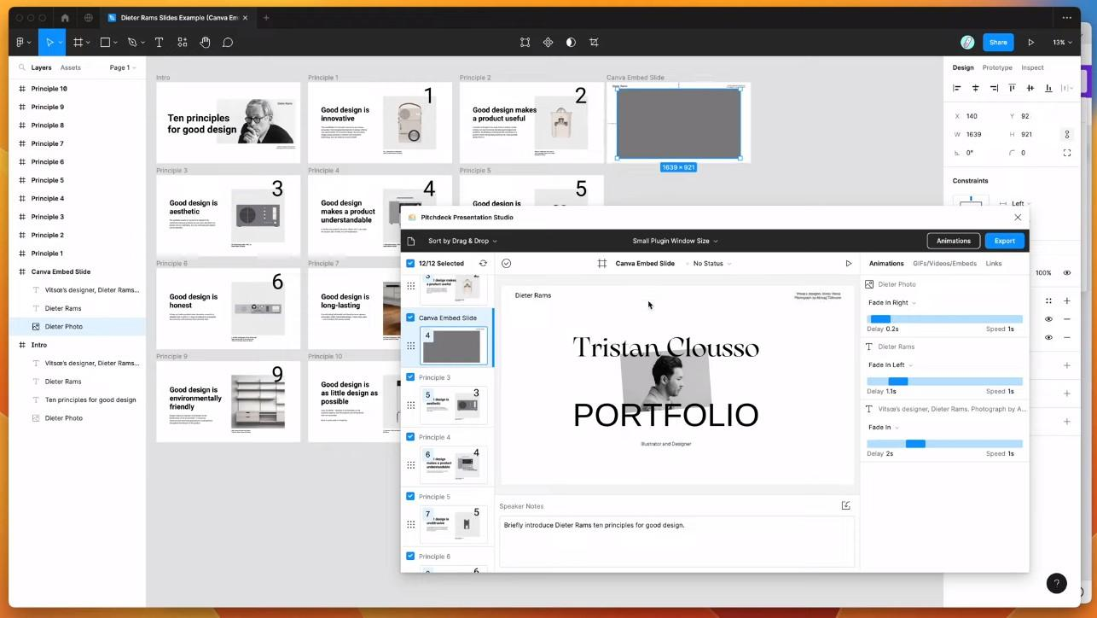
You need to go to Canva, open the design you want to embed, click on the share icon, select the 'Embed' option, enable the embeds, and copy the smart embed link. Then, in Figma, you need to select the slide in Pitch Deck, click on the Embeds tab, paste the Canva embed link, and the Canva design will be embedded into the slide.

You need to go to the Figma file, click on the resources icon, search for the Pitch Deck plugin, and click on the Plugins tab to find and install the Pitch Deck plugin. Save the plugin to the plugins list for easy access in the future.

Adjusting and Finalizing the Embedded Design
- Adjust the aspect ratio and size of the embedded design as needed.
- Add animations or other enhancements via the Pitch Deck plugin.
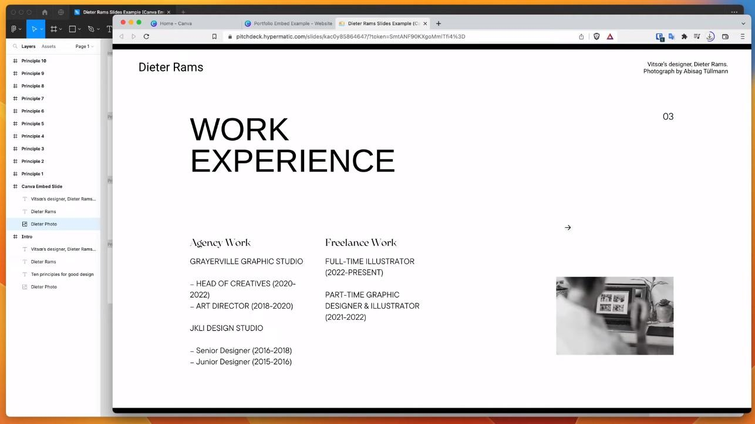
You can adjust the aspect ratio of the embedded Canva design by tweaking the width of the frame. This allows for better sizing and presentation of the embedded design.

Exporting and Sharing the Figma Presentation
- Export the presentation using the Pitch Deck web presentation URL.
- Share the presentation link with team members or clients.

Click on the export button in the Pitch Deck plugin, select the 'Pitch Deck Presentation Web URL' option, and update the web presentation. This will generate a link that can be shared with others. When the presentation is opened, the Canva design will be displayed as an embedded slide that can be interacted with just like a normal Canva link.
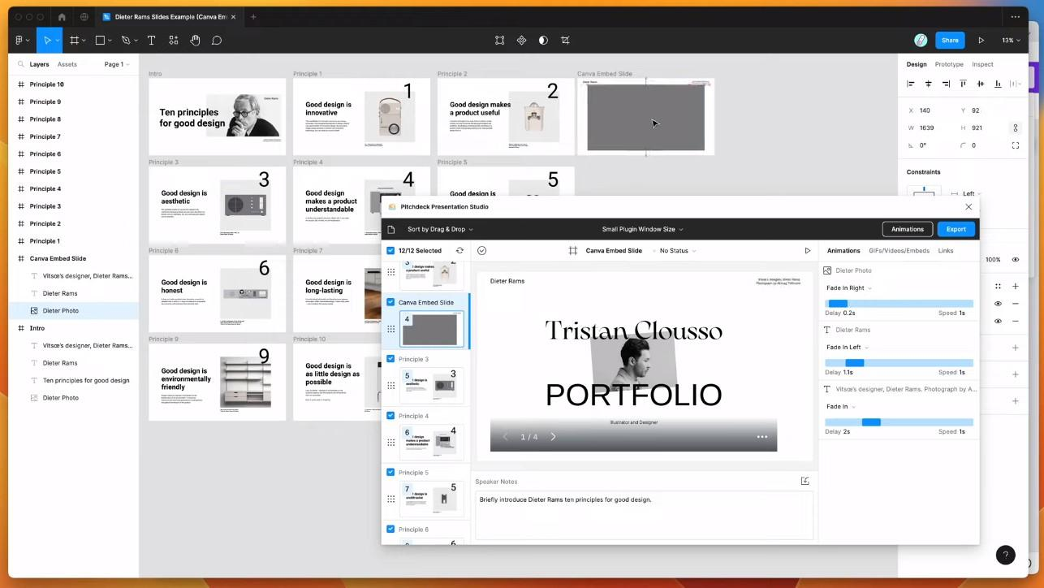

You have control over the embeds and can choose to unpublish them if needed. By clicking on 'Unpublish this design' in Canva, the embedded design will no longer load in the Figma presentation.
This OJT module aims to provide hands-on experience in integrating Canva designs into Figma presentations, enhancing the visual appeal and functionality of presentations.

