OJT FOR DESIGNER'S ROLE

Overview
- Understanding brand guidelines and the significance of design in blockchain technology.
Key Areas
- Graphic Design: Branding, digital and print media design.
- UX/UI Design: Web design principles, user experience, and interface design.
- Brand Consistency: Maintaining brand identity across various platforms.
- Design Tools: Mastery of software like Adobe Creative Suite, Figma, etc.
Training: Basic Guidelines for Graphic Designers
Understand the importance of already designed templates and logos and do not delete design templates and logos because they're made on purpose and can be used again. Be aware of the marketing tricks, like teaming up with others, to get more clients from different places. Keeping the colors and see-through parts the same is crucial when swapping out logos.

Graphic designers should not just advertise their work but also promote the services of partnered companies. They also talk about creating work history and descriptions for freelancers and getting big companies to sign up on the company's website.

The video suggests using news releases to show off services on sites like Bloomberg, Yahoo! Finance, and Benzinga. The main idea is for graphic designers to enjoy their work because the company wants everyone to grow together and offers good chances for learning and success.

Midjourney content creation guide
For creating a new design asset for the project, use the AI-based [Midjourney] to create the image to save time (using Midjourney, you can create the image in 3 mins).
Our all standards to create the content is [AI-based mid-journey to create]. we'll keep this standard continuously to help all team-!
MetagalleryS is bnb(BEP20) based token

Designing a Logo for a Partner
When designing logos for a partner company, remember to inform the partner about any special features and how to proceed with taking action. It is important to send images to the crochet and select one of them. Other teammates are also requested to vote timely on a particular design and leave comments in the group chat. It is important to consistently leave comments and promise to follow up.

Websites to follow
1. Flickrz: https://flickrz.com/
2. Meflex: https://www.meflex.io/
3. Play Kingdom: https://playkingdom.io/
4. Korea Sotheby's International Realty: https://www.sothebysrealty.com/kor
5. USBT https://usbtofficial.com/
6. Findex https://findexofficial.com/
7. SNOVA capital https://snovacapital.com/
8. Fandom Project

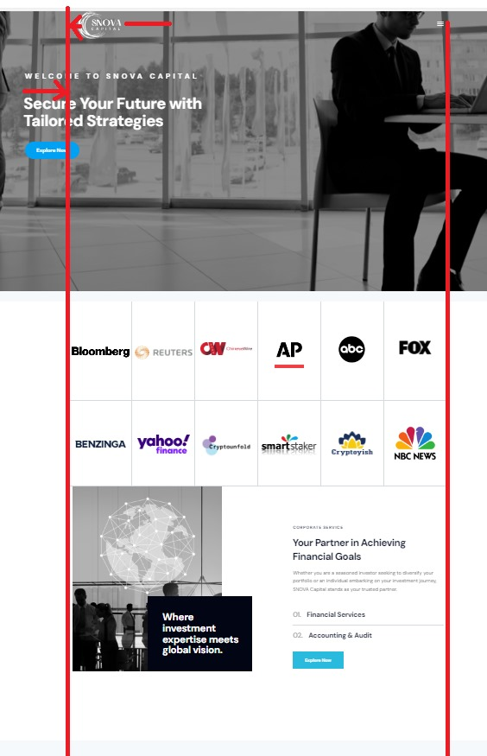
TITLE: For all design, [Text Alignment and Image Alignment are so important]

