1. Leadspons.com Company Introduction

1.1 Company Overview

Leadspons.com is a professional advertising agency that maximizes companies' sales through digital advertising.

We provide a variety of advertising solutions, including meta advertising, performance marketing, and DB recruitment advertising.

We ensure maximum effectiveness at minimum cost through customized advertising strategies.

We utilize the latest advertising technology and data at the forefront of the industry to create optimal advertising performance.

1.2 Key Performance & Data

As of 2024, we will be collaborating with more than 1,000 companies to run successful advertising campaigns.

Achieved average advertising ROI (return on investment) of over 300%

25% increase in customer conversion rate through DB recruitment advertising

Meta ad optimization improves conversion rate by 50% compared to advertising cost

2. Why Choose Leadspons.com?

2.1 Data-based advertising optimization

Introducing an advertising optimization system using AI and machine learning

Maximize campaign performance through real-time advertising performance analysis

Allocate advertising budget most efficiently to ensure maximum effect at minimum cost

2.2 Providing customized advertising solutions

Design customized advertising strategies tailored to the client’s industry, budget, and goals

Providing consulting on business growth strategies, not just simple advertising operations.

Apply advertising techniques that can target both global and local markets

2.3 Success Stories & Client Reviews

E-commerce brand company A: Advertising sales grew 200% in 3 months

IT startup company B: 40% increase in new customer conversion rate compared to advertising cost

Educational institution C: Number of applicants tripled through DB recruitment advertisement

3. Leadspons.com’s core advertising services

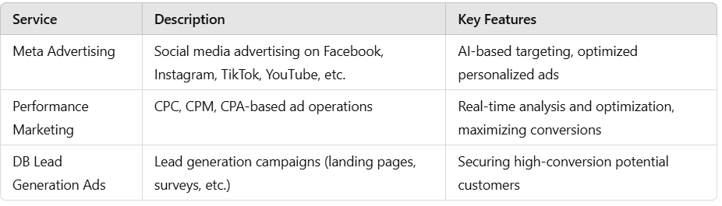

4. Benefits of choosing Leadspons.com

✅ Provide customized solutions to maximize advertising performance

Maximum ROI guaranteed with optimal advertising strategy tailored to customer goals

✅ Directly operated and managed by industry-leading experts

Experts with a deep understanding of the advertising market directly plan and execute campaigns

✅ Complete performance data analysis & real-time optimization

Analyze data in real time to continuously improve advertising performance

5. You can succeed with Leadspons.com!

Leadspons.com is more than just an advertising agency. We are a partner whose top priority is corporate growth and increased sales. If you want to experience the best advertising performance, join Leadspons.com today!

6. Advertising Market Overview & Role of Leadspons.com

6.1 Advertising market trends
- Growth of the digital advertising market (global digital advertising market size by 2024: approximately $600B+)
- of companies ROI-focused advertising investment increase
- Meta advertising, performance marketing, and DB recruitment are used as main advertising strategies.

6.2 Role of Leadspons.com
- increase in company salesAdvertising agency helping
- Provides various solutions such as meta advertising, performance advertising, DB recruitment, etc.
- Propose optimal advertising strategy according to advertiser (company) goals

7. Introduction to Leadspons.com advertising products

7.1 Meta ads
- Social media advertising such as Facebook, Instagram, TikTok, YouTube, etc.
- Achieve high conversion rates with AI-based targeting & advertising optimization

7.2 Performance Marketing
- CPC, CPM, CPA based advertising operation
- Maximize advertising efficiency through customer behavior analysis

7.3 DB recruitment advertisement
- Conduct customized lead generation campaigns (surveys, landing pages, retargeting, etc.)
- Secure customer information with a high probability of conversion

8. Customized sales strategy for each client type
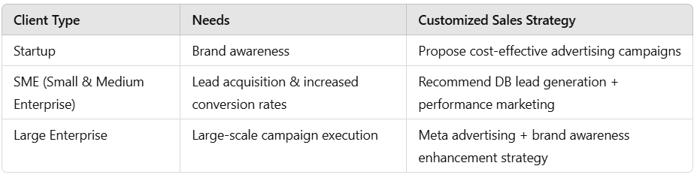

9. ROI-based advertising persuasion techniques & pitching script

9.1 ROI-centered persuasion techniques
- Clearly confirm the KPIs (sales, leads, exposure) desired by the client
- Leadspons.com advertising compared to traditional advertising cost-effective stress
- Build trust using success stories

9.2 Essential sales conversation methods (sentences to memorize)
1. Questions to understand customer needs
- “Are you currently running an ad? What are your goals?”
- “What customer base do you want to target?”
- “What are you most worried about right now?”
2. Expression that emphasizes advertising effectiveness
- “Leadspons.com is seeing an average increase in conversion rates of over 30%.”
- “There are examples of 5x ROAS increases in similar industries.”
- “Even with a small budget, we produce the best results through effective targeting.”
3. Expressions used when negotiating price
- “We can suggest strategies that achieve optimal advertising performance relative to your budget.”
- “I’ll show you how to achieve maximum efficiency with the budget you’re currently using.”
- “The higher the advertising budget, the greater the reach and conversion rate. Let’s work out an effective distribution strategy together.”
4. Answers that relieve client anxiety
- “If it doesn’t work, we’ll give you a full refund.” (if possible)
- “Test it for just one month and see the results for yourself.”
- “We will run advertisements that lead to conversion, not just exposure.”

10. How to respond to objection handling

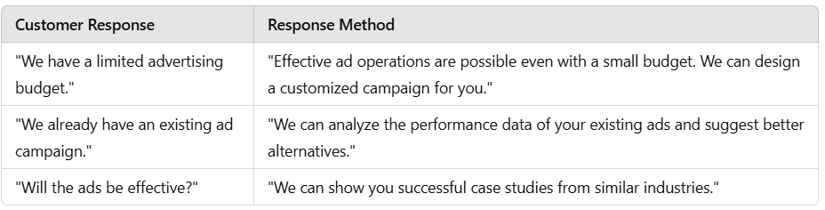

11. Role-Playing Scenarios

11.1 Attracting new clients
target: Practical exercise in attracting new advertisers to Leadspons.com
situation: A startup CEO with no advertising experience doubts the effectiveness of advertising.
Selling Point: Introducing performance marketing that can be done with a small budget and providing actual success stories

11.2 Advertising Budget Negotiation
target: Practice negotiation strategies to maximize your advertising budget
situation: Client only wants to set a minimum budget
Selling Point: Provide comparative data on advertising effectiveness according to budget size

11.3 Upsell to existing advertisers (offer additional services)
target: Increase advertising budgets for existing advertisers or sell additional advertising products
situation: Existing advertisers show interest in other advertising solutions
Selling Point: Analyze current advertising performance to highlight the need for additional products

12. Closing and Goal Setting
- Set weekly/monthly sales goals (Example: Attracting 5 new clients, increasing advertising budget by 30%)
- Sales performance review & feedback session operation
- Continuous role-playing and customer service practice

