How to Sign up as a Affiliate on Different Websites

There are different websites on which we can signup as an affiliate, I am mentioning a few below:
GetResponse – Email/Digital Marketing
Liquid Web – Web hosting
Expedia – Travel, Leisure
Walmart – Retail, Ecommerce
SEMrush – SEO/Digital Marketing
Shopify – Ecommerce
BigCommerce – Ecommerce
Bluehost – Web hosting
Fiverr – Outsourcing
Supermetrics – Analytics
Wix – Website Building
Coursera – Online Education
Elegant Themes – Website building
Grammarly – Copywriting
NordVPN – VPN
Udemy – Online Education
Teachable – Online Education
Pixlr – Graphic Design
Buzzsprout – Podcast Hosting
Adobe – Graphic Design
TripAdvisor – Travel, Leisure
Tailwind – Social Media
I will guide you on how to Sign Up as an Affiliate for Tesla, and these steps can be used for each of other websites to sign up. Usually they are the same, but If you find any difficulty you can ping any one from the Communication team.

To sign up as an affiliate for Tesla you need to follow these steps.

- Go to their website https://www.tesla.com/energy_partner-with-tesla , and you will get a form.

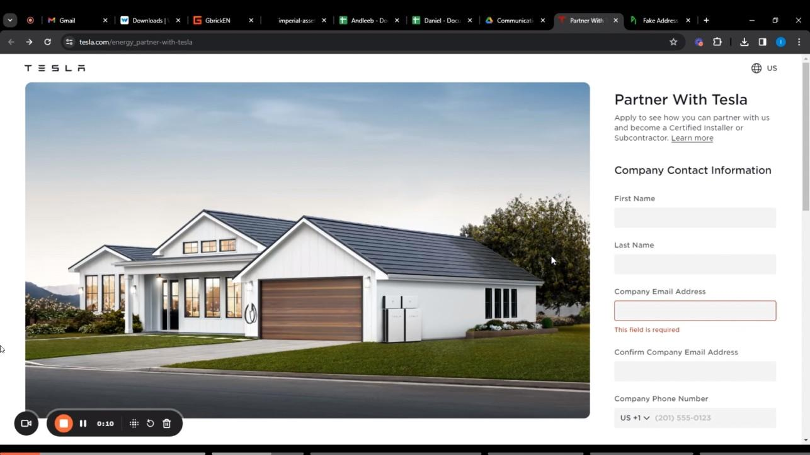

- Fill in with the clients information, as for now I am doing it for MeFlex
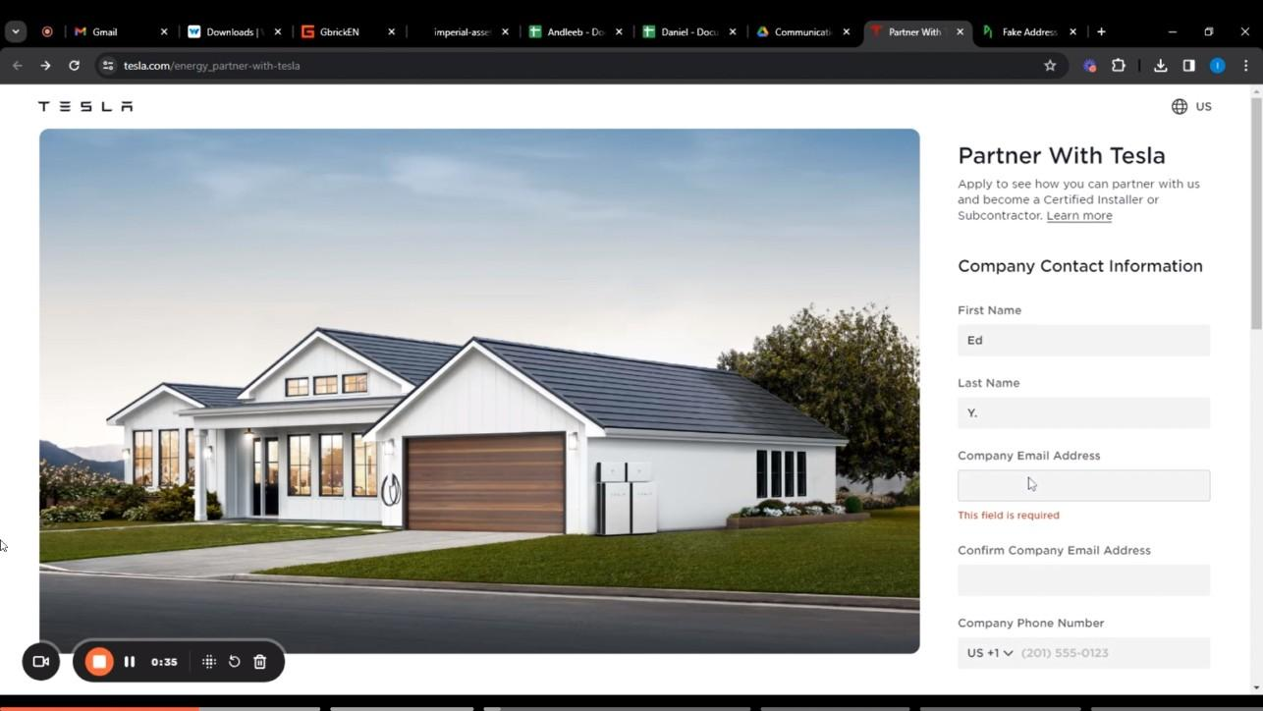

- We are using Ed’s information, we can put in Ed’s name and email. For address and number you need information of USA, for that you can google “FAKE USA ADDRESS GENERATOR'' and take information from there and add the address and number.

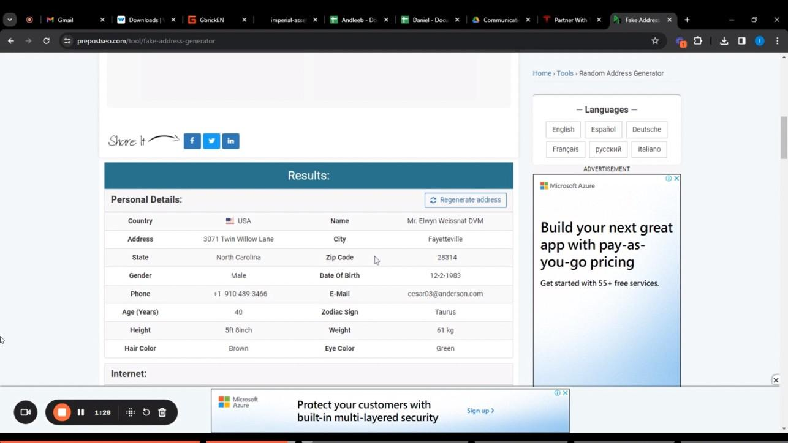

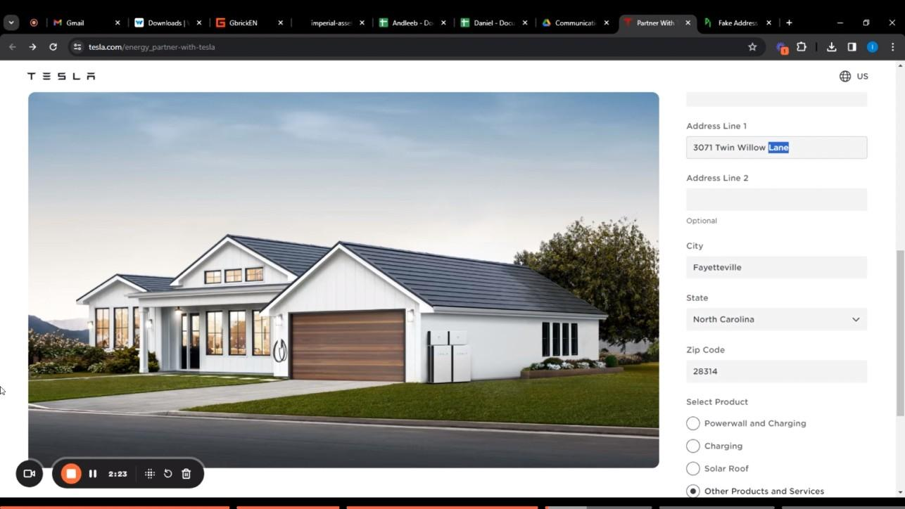

- After filling in all the information, you will be left with a selection of products. In this you will select “Other Product and Services” and in drop down menu you will select “Subcontracting (Service and Maintenance)”
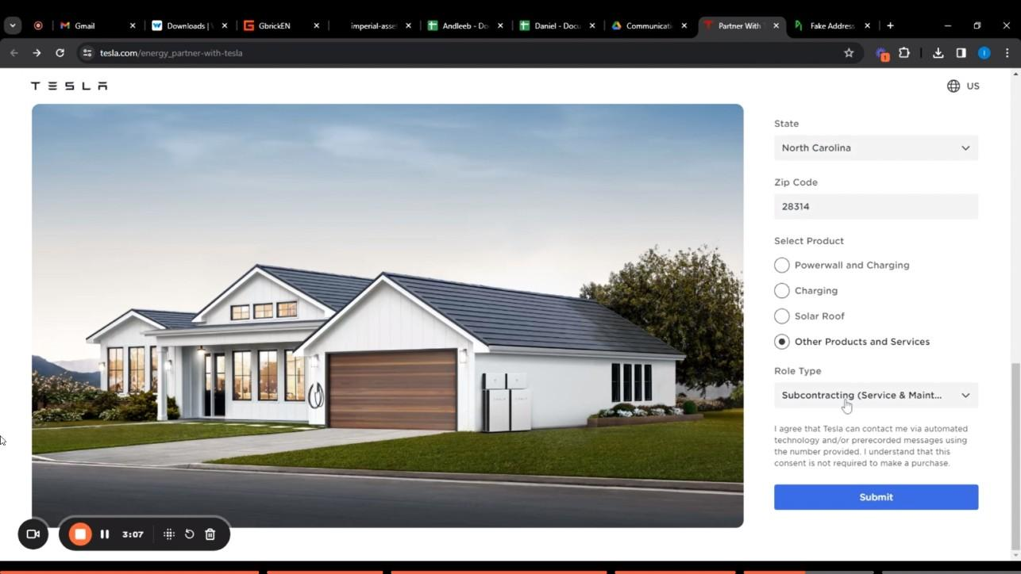

- In the end, cross check all the information and submit.
- After submitting, you have to follow the instructions which will be sent to you via email

These are instructions on how to register for the affiliate program and I encourage you to ask any questions for further assistance.

Thank you!

