How we make the Valuation Report Documentation

In order to make a Valuation Report Document for clients, please refer to this File.

Step 1:
You can make a copy of this file to make the edits which will be discussed below.

Step 2:
You need to change the name of the Project, you will use the project name of the project you are making a Valuation Report for.

Step 3:
Change the market size, check what the industry of your project is.
For example: JOBT (Jongro Boutique) is the beauty industry, MeFlex is the entertainment industry and so on.
Always add reference website, you can always check the market size of the industry by just googling the “[[Industry]] market size”
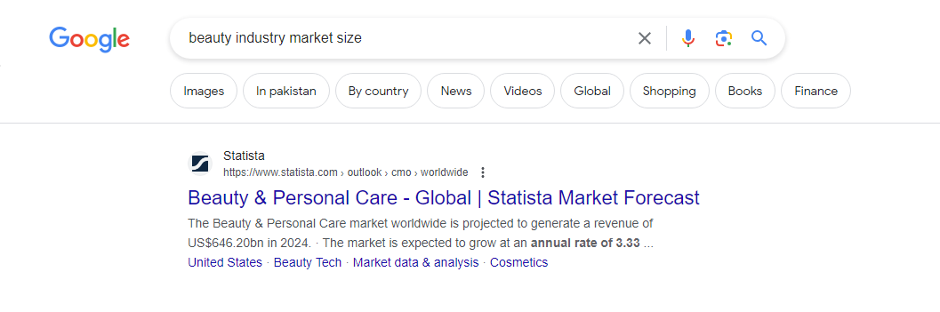

Step 4:
Change the company Name here as well and add link.

Step 5:
You need to leave this column as it is. The reason is these stats remain same for almost every Project.
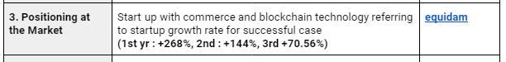

Step 6:
Here you need to check if your client product is patent and add the location where patent is filed.

Step 7:
You need to write down the affiliates registered with your project, and partners as well. We need to mention all the channels from where the Sales will be generated.
Don't forget to attach the Evidence sheet link.
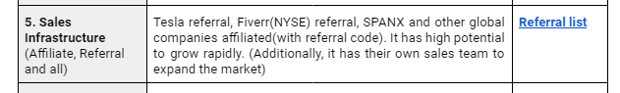

Step 8:
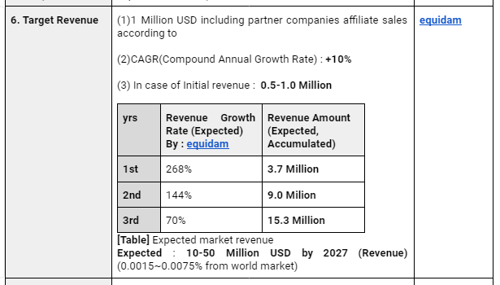
In Target Revenue, we will be sharing our Target revenue for upcoming years, you need leave it as it is, you just need to change the CAGR (Compound Annual Growth Rate), as it differs from industry to industry. You can easily google and find your industry's CAGR.

The rest of the things, graphs, stats, and Accountant signature will remain as it is.

The video of the process is also uploaded in the videos folder as well, feel free to watch them or feel free to contact Daniel any time :)

