OJT: How to Reach Out to Freelancers on Fiverr

Objective:
To train employees or team members on how to effectively search for, evaluate, and contact freelancers on Fiverr for project-based work or ongoing collaborations.

Step 1: Creating a Fiverr Account
- Goal: Ensure the user has access to Fiverr.
- Visit Fiverr.com.
- Sign up using an email address, Google, or Facebook account.
- Complete the profile setup (add name, details, and a profile picture if necessary).
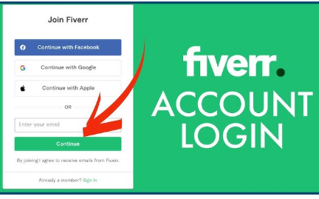

Step 2: Defining the Scope of Work
- Goal: Be clear on the project requirements before reaching out to freelancers.
- Write down detailed project specifications (deliverables, timelines, and budgets). Create a message and add links of videos about the task so that it is easier for the freelancer to understand the project.
- Identify the specific skills required for the project (e.g., graphic design, content writing, SEO).

Step 3: Searching for Freelancers
- Goal: Learn how to navigate Fiverr and find the right freelancer.
- Use the Search Bar at the top of Fiverr’s homepage.
  - Enter relevant keywords (e.g., "Logo Design," "Social Media Manager").
- Apply filters on the left side to narrow down results:
  - Service type: Filter for exact services needed.
  - Seller details: Filter based on seller level (e.g., Top Rated, Level 2).
  - Delivery Time: Select delivery time that fits the project schedule.
  - Budget Range: Set a maximum and minimum budget.
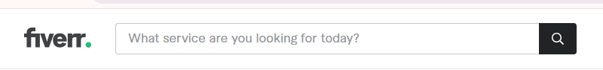

Step 4: Evaluating Freelancers
- Goal: Analyze freelancer profiles and reviews for the best fit.
- Click on the freelancer's Gig to view their profile.
- Review:
  - Portfolio Samples: Look for examples of their previous work.
  - Reviews & Ratings: Check feedback from other buyers.
  - Gig Description: Ensure the freelancer’s offerings match your needs.
  - Response Time: Check if they are responsive and active.
- Compare multiple freelancers based on pricing, skills, and reviews.
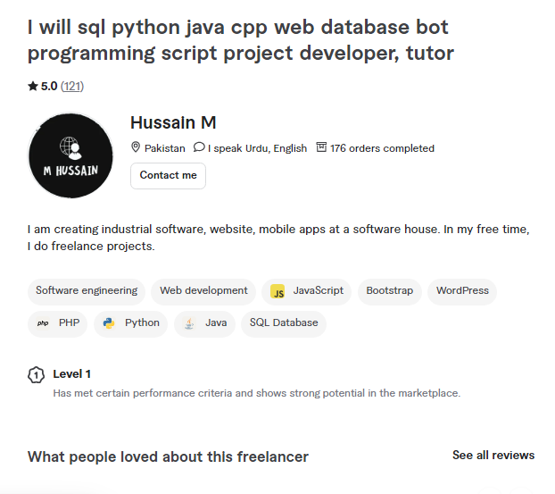

Step 5: Initiating Contact
- Goal: Reach out to the selected freelancers for more information or clarification.
- Click on the Contact Seller button on their profile.
- Start your message by introducing yourself and your project.
  - Example: "Hi [Freelancer Name], I’m [Your Name], and I’m interested in your services for a project related to [Project Brief]."
- Ask questions about:
  - Availability and timeline.
  - Whether they can meet specific requirements.
  - Their experience with similar projects.
- Discuss pricing and request a custom offer if the listed prices don’t match your budget.
- End the message politely, thanking them for their time.
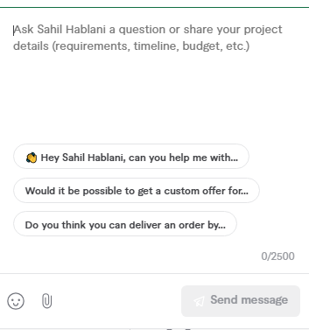

Step 6: Negotiating and Custom Offers
- Goal: Understand how to request and finalize a custom offer.
- Freelancers can provide a Custom Offer if your requirements don’t fit their standard gigs.
  - After discussing the project, ask for a Custom Offer if needed.
  - Review the offer details:
    - Price
    - Timeline
    - Deliverables
  - Negotiate terms if necessary (e.g., deadlines or scope adjustments).

Step 7: Finalizing and Hiring
- Goal: Secure the freelancer for the project.
- Once satisfied with the terms, accept the offer and make the payment through Fiverr.
- Provide the freelancer with any additional materials or guidelines they may need to start the project.
- Stay in contact during the project to ensure everything is going smoothly.

Step 8: Reviewing the Work
- Goal: Ensure quality output and completion of the project.
- Once the project is complete, review the work carefully.
- Provide feedback to the freelancer on Fiverr (this helps build relationships and improve future work).
- If any revisions are needed, use Fiverr’s Revisions feature.

Conclusion:
Following these steps ensures a structured and efficient approach when reaching out to freelancers on Fiverr, from initial contact to project completion.

