(OJT) for Bulk Address Creation and Token Distribution

Objective:
To train team members on the process of creating multiple wallets and distributing tokens efficiently using MetaMask and bulk distribution tools.

---

1. Introduction to Bulk Address Creation

To understand the need for bulk address creation and its importance in the construction of a token airdrop and holders ecosystem.
- Efficient management of token distribution.
- Scalability in handling large numbers of wallets and transactions.
- Enhancing the ecosystem by increasing token holders.

---

2. Tools and Platforms Overview

MoonDeploy - Bulk Address Creation:
A platform designed to create multiple wallets and distribute tokens efficiently.

Website: [MoonDeploy - Bulk Address Creation](https://moondeploy.com/bulk-address-creation/)

Ikalas - Bulk BEP20 Distribution:
A tool for distributing BEP20 tokens in bulk.

Website: [Ikalas](https://ikalas.com/app/bulk-bep20-distribution)

Multisender:
An additional tool for distributing tokens across multiple addresses.

Website: [Multisender](https://robotmultisender.app/)

—

3. Step-by-Step Process

A. Creating Wallets using MetaMask

1. Install MetaMask Extension:
- Ensure MetaMask is installed in your browser.

2. Set Up MetaMask:
- Create or import an existing wallet.
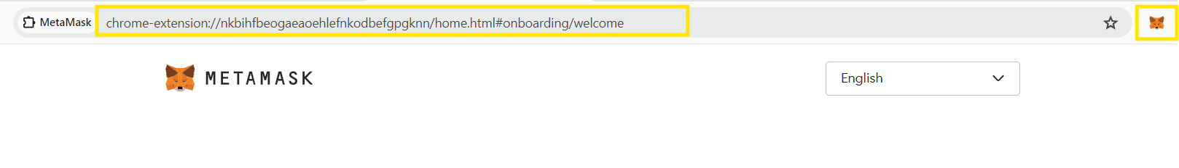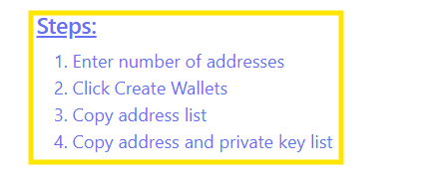
3. Bulk Wallet Creation:
- Use the MoonDeploy platform to automate the creation of 1000 wallets.
- Confirm the successful creation of wallets.
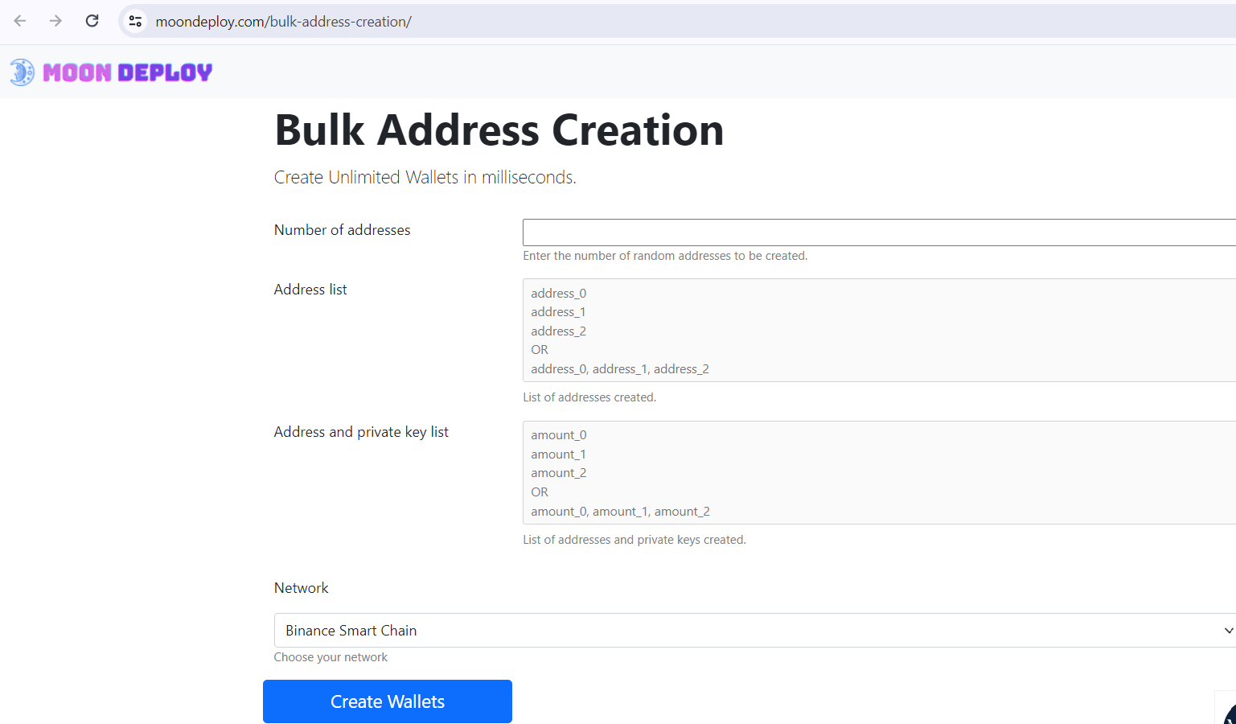

B. Allocating Tokens

1. Token Distribution via MoonDeploy:
- Allocate 1000 tokens across the created wallets using the MoonDeploy platform.
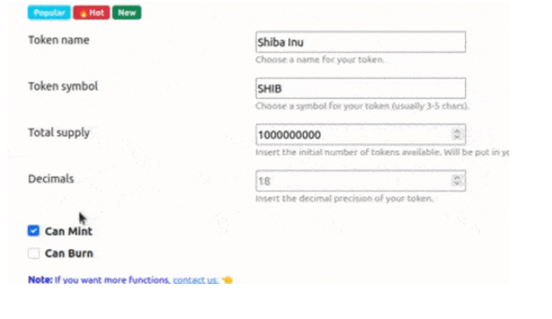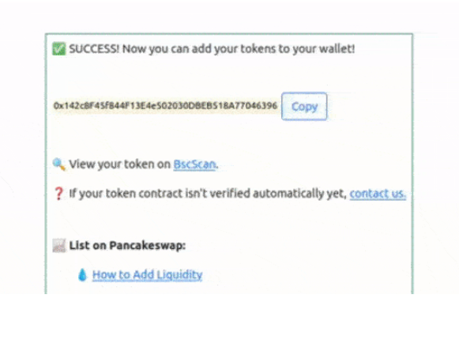

2. Using Ikalas for Bulk BEP20 Distribution:
- Access [Ikalas](https://ikalas.com/app/bulk-bep20-distribution) for BEP20 token distribution.
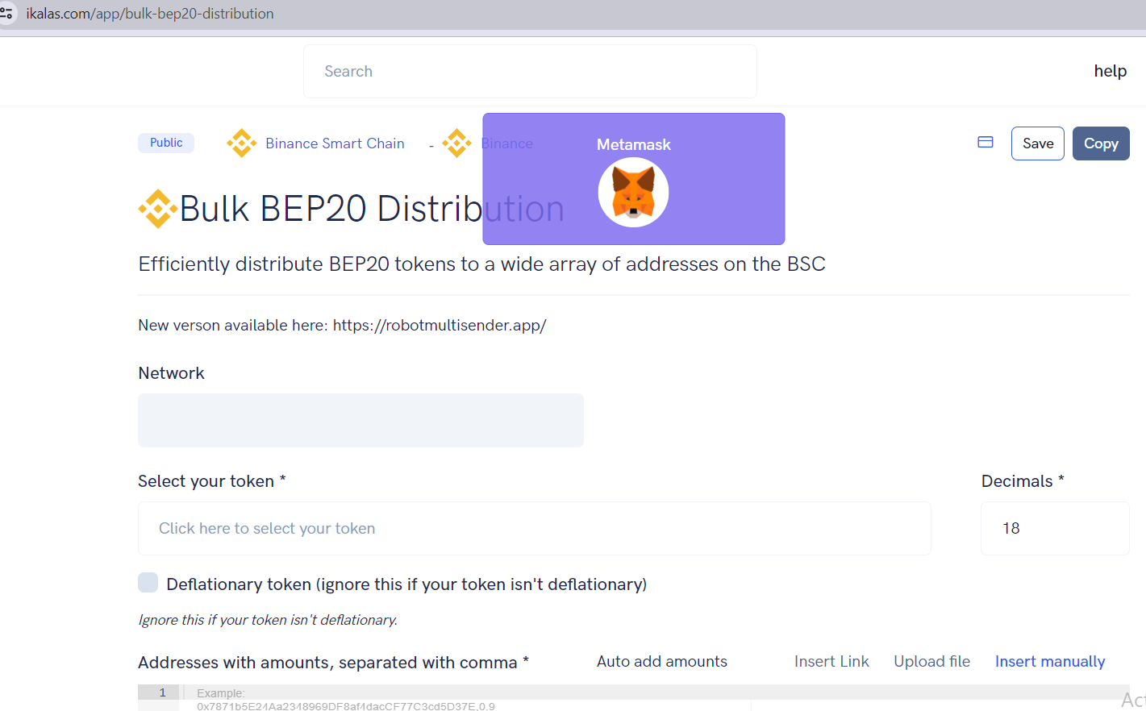

3. Using Multisender:
- Visit [Multisender](https://robotmultisender.app/) for alternative distribution methods.
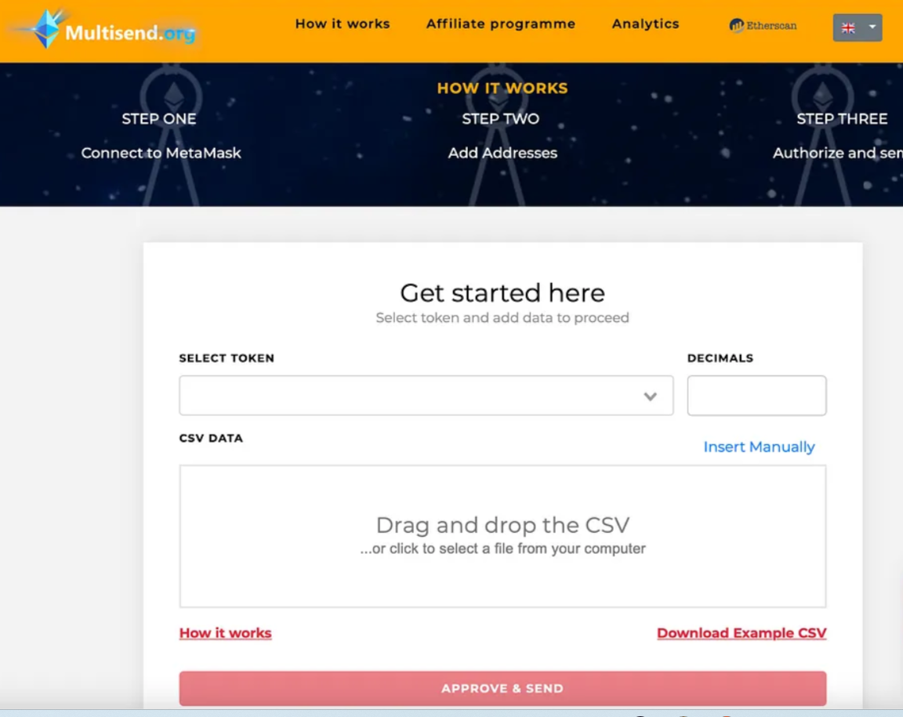

---

4. Testing and Validation

Testing:
- Perform a test to create 1000 wallets and allocate 1000 tokens.
- Ensure the process works seamlessly without errors.

Validation:
- Verify the creation of wallets.
- Confirm token allocation to each wallet.
- Check transaction records for accuracy.

---

By the end of this OJT, team members will be proficient in creating multiple wallets and distributing tokens efficiently using MetaMask and bulk distribution tools. This will enhance the token airdrop and holders ecosystem, ensuring scalability and reliability.

---

