What we don't have to do in the Zoom meeting

1. Avoid Text-Only Content:
- No one can understand the creation based on text-only.
- Text-only content wastes time.
- Always include whitepapers and images for better understanding.

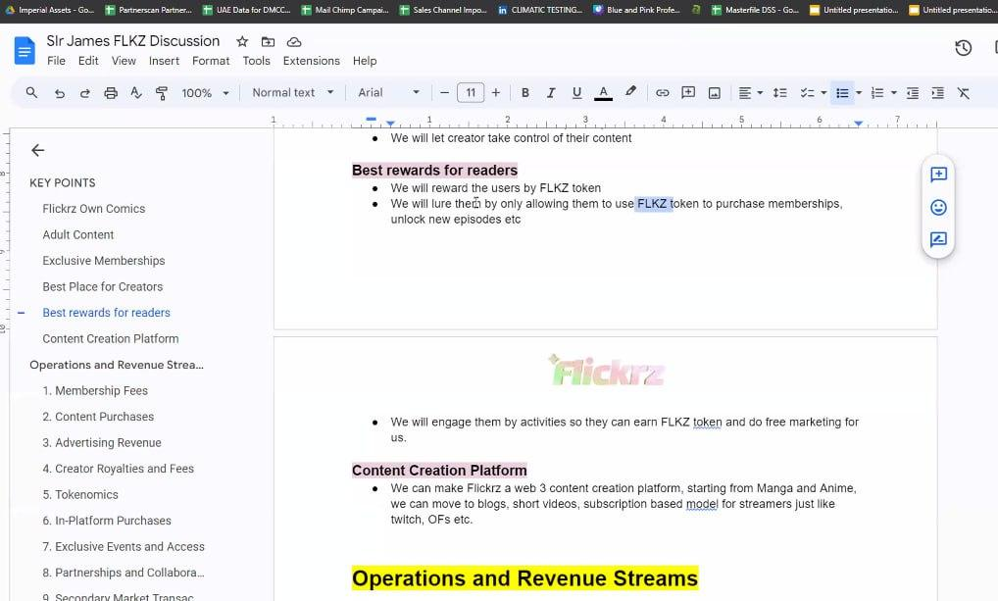

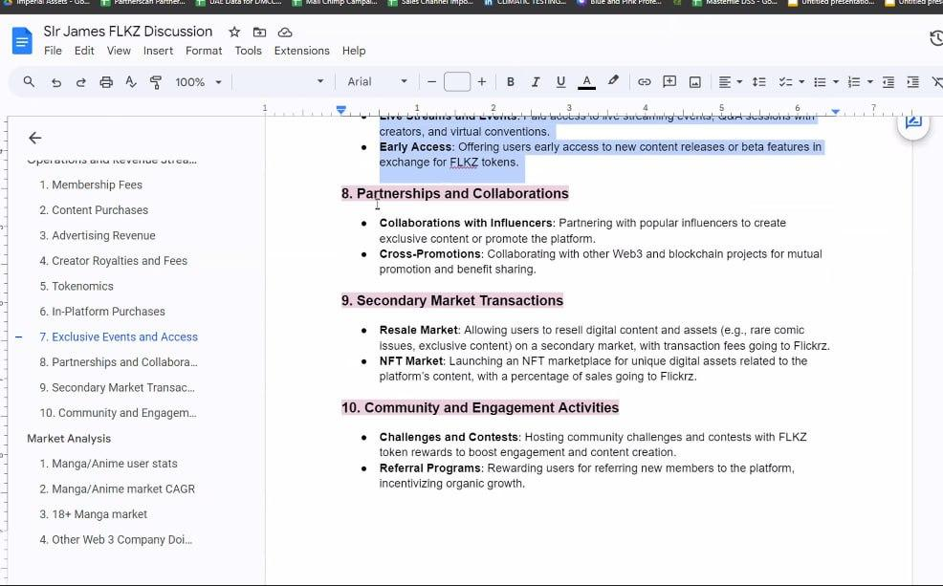

2. Always Include Visual Aids:
- For the meeting, never rely solely on text.
- Always prepare draft images for simulations and reference images at least.

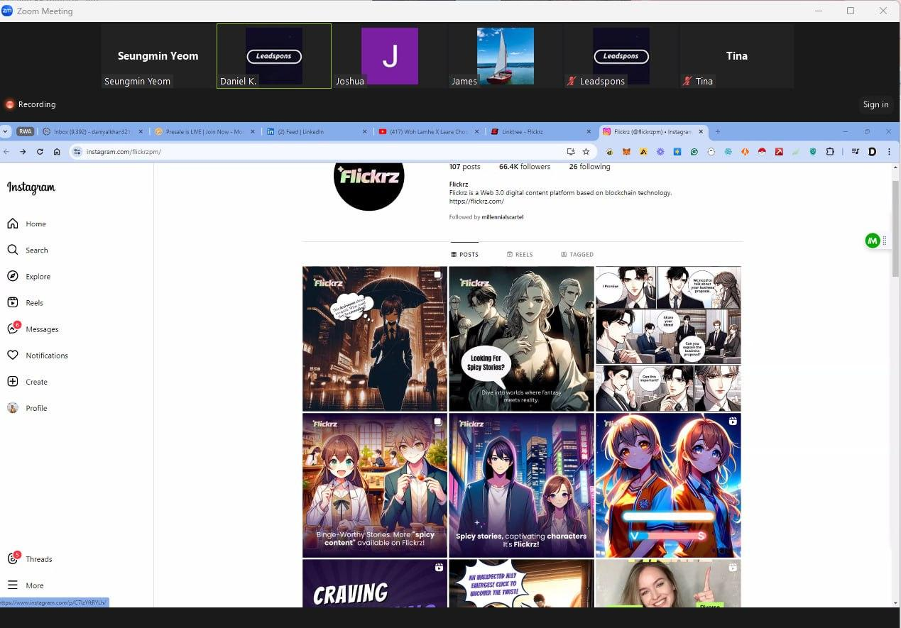

3. Prepare Substantial Content:
- Always come prepared with substantial content for the meetings.

4. Proper Account Usage:
- Ensure all participants use the correct accounts.
- Always use private accounts for Google and Zoom to avoid any bad business manners.
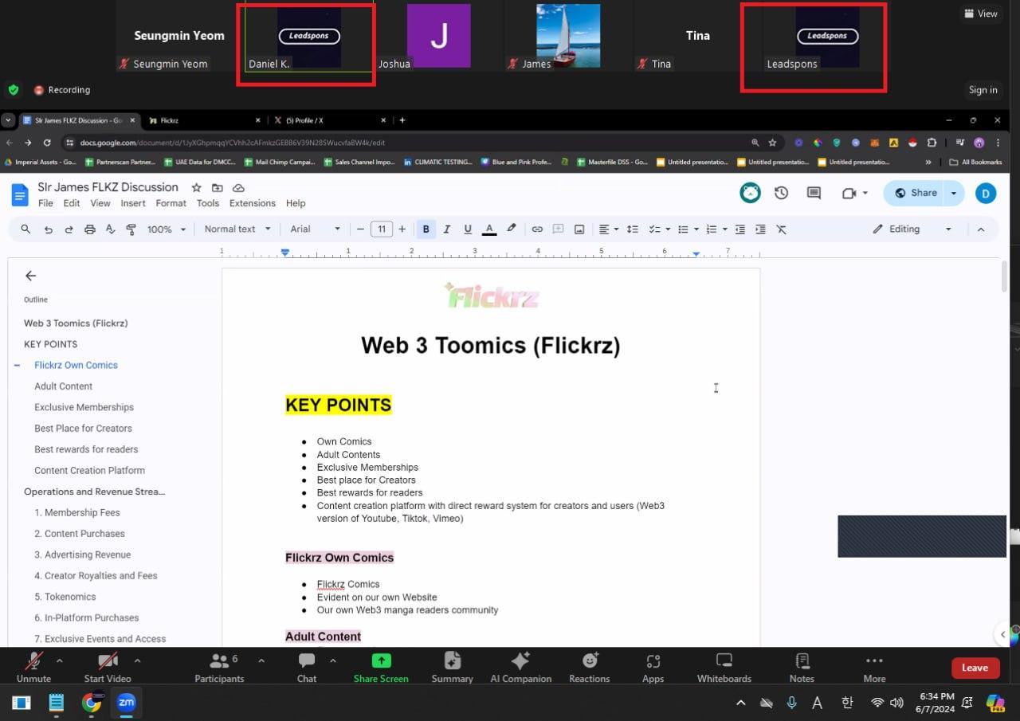

Reminders for the BD and M Teams
- Respect the guidelines to ensure smooth and effective meetings.
- Maintain professionalism and proper business manners.

Thank you for the reminder!

