Script 6
Automation Clients Matching DB Extraction Service

Project : Leadspons.com

1)staking and fund management service for the profit making
(Snovacapital) (farming and earn service)

[1:1 Client interview]

1)how is it going, it's great. I check you were looking for our service
2) I've seen your history you have a perfect potential to invest (or to use our service)
3) our history and portfolio were like this (+image and video instruction from youtuber or createstudio.io based instruction contents)
4)what was your impatience in your income our asset management?
(= blar blar > yes, right, sure(always you have to say optimistically in sales 1:1 meeting)
5)and then I found we have great solution for you (you have to say seriously)
6)if you invest to her 1)2)3)4) we propose minimum, moderate, vip package with (discount logically) you are so special for us because you have "OOO history" we re so impressive, I will put Discount using my referral code 30 % commission fee discount for 1 year . You can try our service monthly 1 time for free and you can get the report our daily report system.
You can refer to this

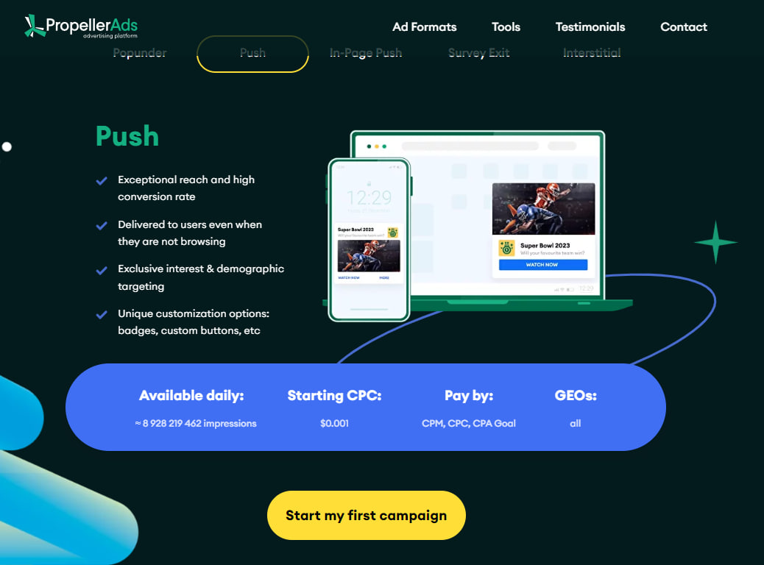

[OJT]
[Network Ads Marketing] Push, Notification, Banner

https://joinpropeller.com/adv-solutions-new/#!/tab/625151939-2

[Account : Email login ID,PW]
leadspons@gmail.com
Metagallerys8!

[Video Tutorial]
https://www.youtube.com/watch?v=wDumQnIaAJM
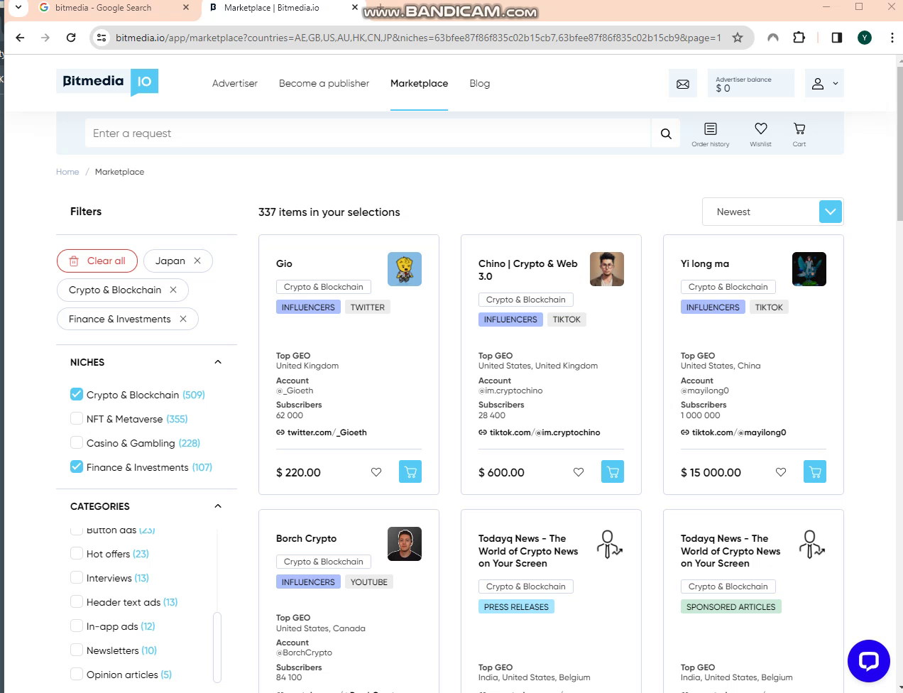

[OJT] Network Marketing and PR Site (1)coinscribble (2)Bitmedia

[Coin, Finance Engagement]

1. https://bitmedia.io/ (Great)
2. https://dash.cointraffic.io/marketplace (Great)
3. https://app.coinzilla.com/
4.https://app.coinscribble.com/portal/profile (Already signed up)

@tehreem_a Please signup with leadspons@gmail.com each website 1.~3. websites

and make the OJT @rakhshimalik Please make the OJT in google and upload to youtube OJT

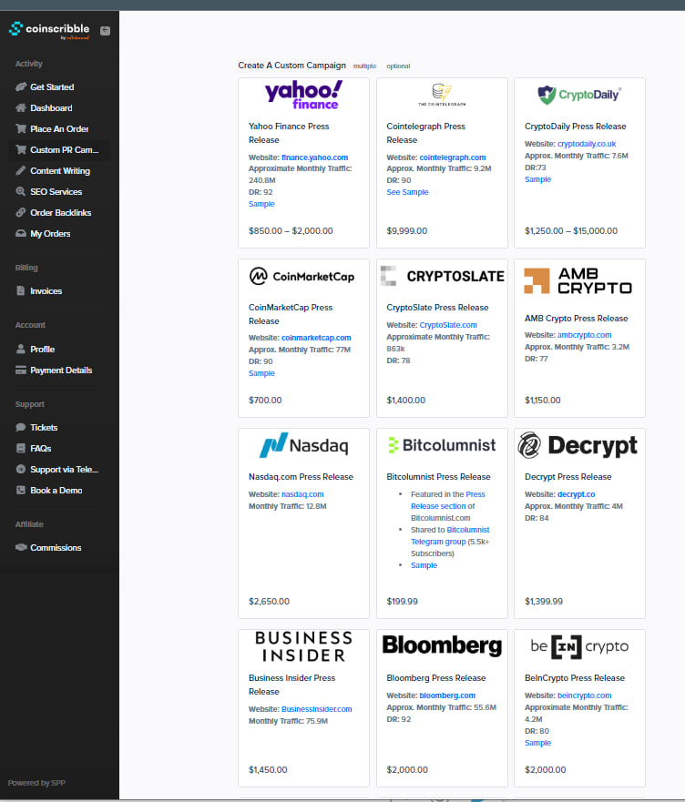
https://app.coinscribble.com/portal/profile
[Account ID PW]
leadspons@gmail.com
Metagallerys8!

https://www.fiverr.com/search/gigs?query=customer%20email&source=top-bar&ref_ctx_id=f6a033e4b21448beb71ba9260d4998f2&search_in=everywhere&search-autocomplete-original-term=customer%20email

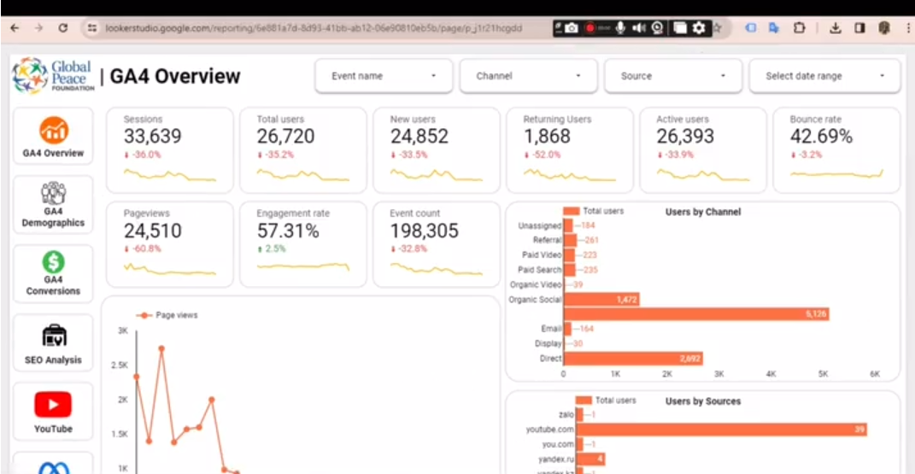

Network and Keyword Marketing Links (Marketing)

https://www.semrush.com/analytics/keywordmagic/start

https://www.hootsuite.com/social-media-tools/instagram-seo-tool

