Additionally, at the price table, you can create the sample price table for new customer

Welcome to partnerscan

1.Attraction contents : You can do partnership from 30 USD for each project.

2.please fill in detail your project
name, job title, email, project logo file, blockchain field, project website, social media

(After they filled in, show following list for each estimation at 1 single popup and let them proceed the pay for 375 usd)
(Usd = Usdt)

Use thin plugin
https://wordpress.org/plugins/cryptopay-wc-lite/

They can pay for using Bitcoin, Ethereum or etch token using this plugin.

To suggest to pay for partnership service, we will show (partnership contact service) product details at woocommerce product page

[Woocommerce total payment]

1st Package (1 Project)
from 55 USD, you can proceed the Partnership each project
(1)partnership contract issue 95 USD (required * )
(2) airdrop or event contents image generating 95 USD (required * )
(3) sales text generating 55 USD (optional * )
(4) posting info to our dashboard and social media to advertise your service 40 USD (optional * )
(5) PR 190 USD (1 of World Top 10 economic press) (optional * )

(475 usd / 1 project partnership process)

(Users can not purchase separately, users should purchase 1 whole package)

2nd Package (D/C)

[Sales discount]
If they purchase 10 partnerships for blockchain project > 4750 USD > 3380 (20% D/C)

[Referral for Project purchase for woocommerce : 30% reward for purchasing]
https://woo.com/products/referral-system-for-woocommerce/

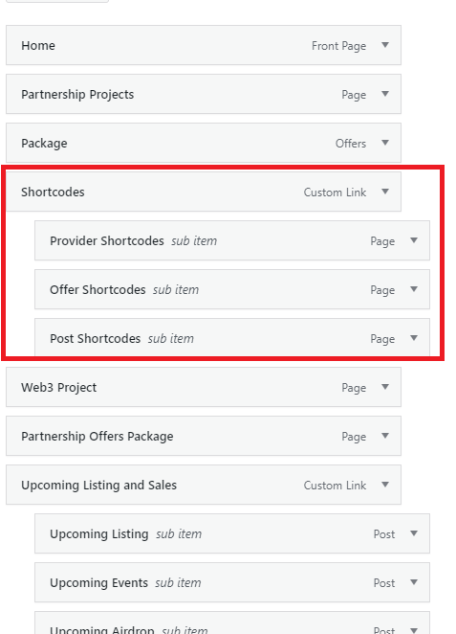
Hide these area and use it when we have to put this short code to each area

