Conversation Example
Compliance for the Work
Welcome to the Marketing team’s conversation practice and example document.
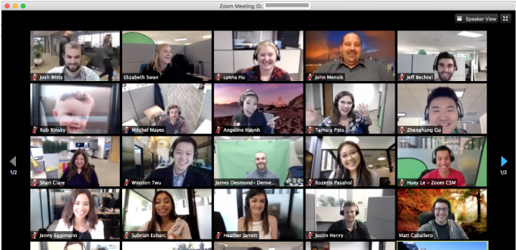
Escalation Process
(=Manager can follow up each solution against problem if they find the specific issue)
We manage our team process with an escalation process logically.

Team 5 (Designers and Marketers Team)
Case Study and To-Do List
Team name (DM : Designer and Marketers) | Job Description in each case
Designer and Marketers | Check list (=To Do List) to check the Project’s process
1.Compile Logo Files + Website collection + Image File support to PM team
  Category > | Action needed to > | Communication to
  Logo file | You can choose any option to make a logo Canva.com, logo maker or Illustrator manually to get confirmation about logo and brand Identity freely. | Client (or ourselves)  All the time, the case is different. So we need to check the RFP (Requirement) for each project.
  Website | If they don’t have a website, our designer make a website sample using the wordpress design sample | Developers team  Server setting : You can request to developers (Domain URL and storage). Developers team they will do development according to marketers requirements
  Image file for Advertisement | We can create the contents using www.canva.com or any others. | Marketers themselves or requesting clients  what they have used so far.
2. Design UX UI for the website with CMS tool or Wordpress (Elementor drag and drop) (If client they don't have a website)
  Category | Action needed to | Communication to
  Website UX-UI  (PC, Mobile) | Suggest tone and manner with sample site design 3 types for main page only not for all the pages (Policy) | Developers (Wordpress or others CMS)
  Server Credentials | If you get confirmed about UX UI design sample, you can pass that design to developers team or outsourcing developers team  (you can check who’s the development manager from Project Sheet) | Developers (Wordpress or others CMS)
  Admin info or others | Contents management(Banner and imanager etc) | Developers (Wordpress or others CMS)
3.PR SEO Marketing Contents design and Creation with SEO
  Category | Action needed to | Communication to
  Logo file | Bringing the files from step 1 | Client (or ourselves)
  Website | Bringing the files from step 1 | Client (or ourselves)
  Company Email and credentials | Bringing the files from step 1 | Client (or ourselves)
  Targeted website | For referral marketing or company branding, client will request or we can advise to use the PR contents freely to raise client’s or our own service revenue | Client (or ourselves)
4. Sponsorship (Social Media) marketing A/B test with sales team records
  Category | Action needed to | Communication to
  ID,PW for each social media | Instagram, Linkedin, Discord, Twitter, Telegram, Youtube and etc | Client (or ourselves)
  Create contents and set up sponsorship marketing | For each social media | Client (or ourselves)
  SEO and Cost-efficient keywords set up for google and each social media tag platform | At kwfinder or others platforms, we can check which keywords are cost-efficient keywords. And set up that one to raise the profit and payment | Client (or ourselves)
Designers and Marketers (Summary) | Even though we sometimes have to take information related to ID, PW. but incase of content, we have to create it ourselves because they ordered for us and trust us as specialists. Overally, we have to take the responsibility to create the contents to bring the new users to platforms.

Example for [Requesting PR confirm with client]
You can request to confirm the PR and re
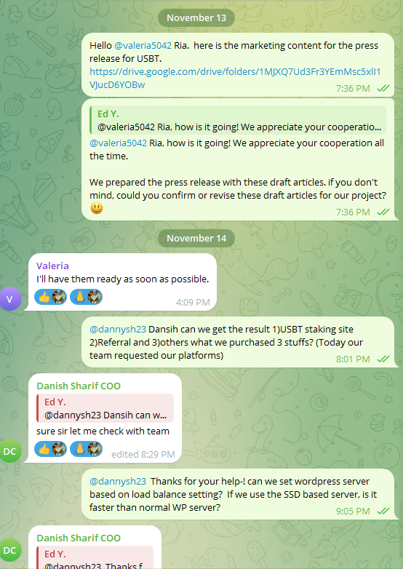 | Ed Y., [11/13/2023 7:36 PM]  Hello @valeria5042 Ria. here is the marketing content for the press release for USBT.  https://drive.google.com/drive/folders/1MJXQ7Ud3Fr3YEmMsc5xlI1VJucD6YOBw  Ed Y., [11/13/2023 7:36 PM]  @valeria5042 Ria, how is it going! We appreciate your cooperation all the time.  We prepared the press release with these draft articles. if you don't mind, could you confirm or revise these draft articles for our project?😃  Valeria, [11/14/2023 4:09 PM]  I'll have them ready as soon as possible.  Ed Y., [11/14/2023 8:01 PM]  @dannysh23 Dansih can we get the result 1)USBT staking site 2)Referral and 3)others what we purchased 3 stuffs? (Today our team requested our platforms)  Danish Sharif COO, [11/14/2023 8:29 PM]  sure sir let me check with team  Ed Y., [11/14/2023 9:05 PM]  @dannysh23 Thanks for your help-! can we set wordpress server based on load balance setting? If we use the SSD based server, is it faster than normal WP server?  Danish Sharif COO, [11/14/2023 9:06 PM]  will work on it.
[Image] Example of Conversation | [Text] Example of Conversation

Description
In case of PR confirmation we have to do the double check about PR(Press Release)

[Check point]
- According to white paper or business description from client website
- Using their Business Road Map, we create the contents with Chat GPT or our own strategy and modify them as fast as we can

[Time limit]
We have to get confirm in 1-2 days to release as fast as we can, otherwise our management fee will increase, so please push the client to get response asap.

Example for [Website design and Credentials confirmation]
You can request to confirm the PR and re
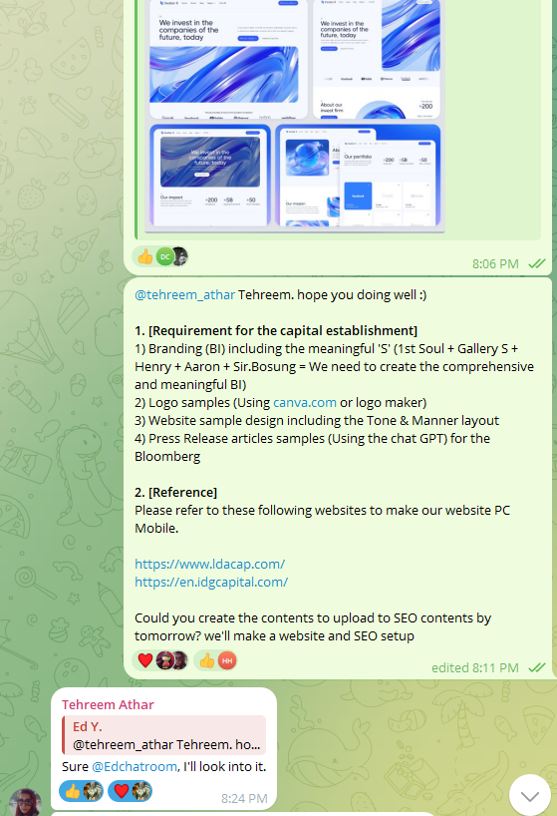 | [Project Manager]  @tehreem_athar Tehreem. hope you doing well :)  1. [Requirement for the capital establishment]  1) Branding (BI) including the meaningful 'S' (1st Soul + Gallery S + Henry + Aaron + Sir.Bosung = We need to create the comprehensive and meaningful BI)  2) Logo samples (Using canva.com or logo maker)  3) Website sample design including the Tone & Manner layout  4) Press Release articles samples (Using the chat GPT) for the Bloomberg  2. [Reference]  Please refer to these following websites to make our website PC Mobile.  https://www.ldacap.com/  https://en.idgcapital.com/  Could you create the contents to upload to SEO contents by tomorrow? we'll make a website and SEO setup  [Marketer]  Sure @Edchatroom, I'll look into it.  Do you want me to create a website design by using webflow?  [Project Manager]  [Ed.Y]  Yes Perfect-! You can also refer to them. not only for this sample but also wordpress template would be great for our investment firm-! https://elements.envato.com/investa-investment-business-opportunities-elemento-EP6CDHA  Because WordPress can be integrated with GA, Pixel, ChatGPT, Newswire and etc. additionally, good for the auto SEO.  You can freely design the UXUI for the website and their branding :)  [Marketer]  For editing the same theme I need the credentials of webflow account to design. Do we have a paid account?  [Project Manager]  Sure, I recommend this UXUI sample. https://elements.envato.com/ @tehreem_athar You can sign up this website using credentials and create design for the UXUI (You can just make description for each part simply. because we will use complete source code and design)  Additionally, you can get the card info from @dannysh23 Danish to register your account to make an UXUI
[Image] Example of Conversation | [Text] Example of Conversation
Description
In case of website UXUI confirmation we have to do the double check about website

[Check point]
- Using Wordpress complete source code, we can change the logo and color simply in 5-10 mins
- We can raise the time efficiency using this strategy
- According to white paper or business description from company’s interview or info
- Using their Business Road Map, we create the contents with Chat GPT or our own strategy and modify them as fast as we can
- Take the credentials (company info, contact, address and logo files and etc as much as we can)

[Time limit]
We have to get confirmation in 1-2 days to release as fast as we can, otherwise our management fee will increase, so please push the client to get a response asap.

