Qualified Ads Process (OJT)

1.Sponsorship Marketing (Payment Marketing)

List | Tool | Proposal | How to do
Mailchimp | Sponsorship | Formal | Click
Discord | Email Marketing | Text + Link | Email Link
Linkedin | Sponsorship | Text + Link | Click
Google | Sponsorship | Text + Link | Click
PR | EIN Press | Formal | Click
Youtube | Sponsorship | Text + Link | Click
Tiktok | Sponsorship | Text + Link | Click
Telegram | Sponsorship | Text + Link | Click
Instagram | Sponsorship | Text + Link | Click
Facebook | Sponsorship | Text + Link | Click

*Requirement
All text should include the SEO + #, @ Hash keywords for SEO (Text should be under 300 Words)

2.Test complete for Telegram
Block and Side Effect (Caution) So, let’s do Software for auto marketing

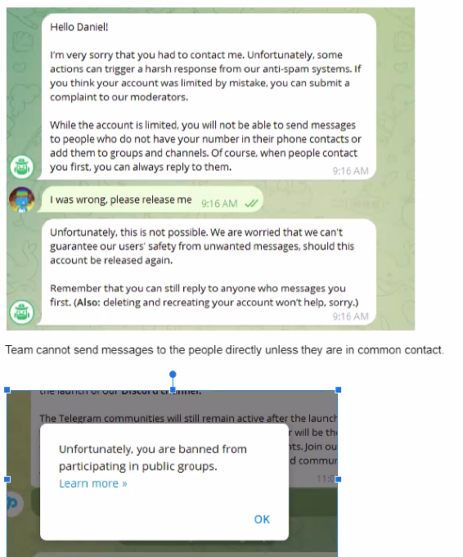
Blocked | Blocked

