Lecture Video Recording and Making the script
using the STT(Speech to text) to make contents for our internal team

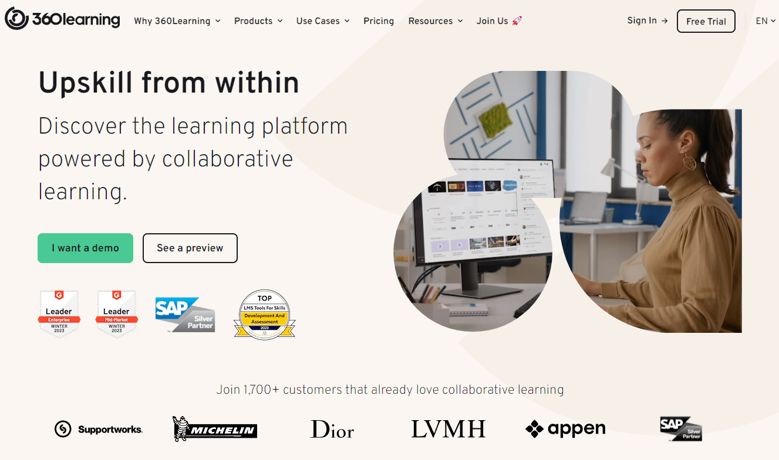

HR Senior Manager
Please create the contents for our following courses on this website

[Our Shared Drive]
https://drive.google.com/drive/folders/1JJX4oR355xHHRIgs_pMWf7tSTXF-hgFi?usp=sharing

Discord Activation for HR Management
In real time, we can communicate each other to check current status of each teammate
https://www.youtube.com/watch?v=J8I0vJeKQi0

[Reason] What is the purpose of video recording and making the script?
for our ON THE JOB TRAINING TEXTBOOK, we use the STT(Speech to text) https://cloud.google.com/speech-to-text?hl=en service to make contents for our internal team. After we create contents, we reflect to our LMS(Learning Management System)

[LMS for each team]
1. (Standard Entry) HR Team, Developers team, Communication Team, Sales team, Marketing team and all teams https://360learning.com/

2. (Additional Courses for the) Sales team, Marketing team https://seismic.com/seismic-learning-demo/

(Reference : Why we have to use world best 360 learning and seismic https://www.g2.com/categories/learning-management-system-lms )

3. (Recruitment for freelance adviser for each project) we can suggest partnership for each project

(Example to suggest to each freelancer : your skill is so impressive, we’ll bring the opportunities and orders together to proceed, if you don’t mind, I’ll advertise your skill and get the order according to partnership, shall we?)

(If they accept, we can use the profile for the advertisement for each project as board and partners advisors to promote each project)
https://docs.google.com/presentation/d/1Hme9coA8aqciuAj2IsckNvyja9uVK-AssZdYCpDmSMc/edit?usp=sharing

Let’s record our screen with a voice recording to let our new teammate’s OJT!

We gotta create a process for each teammate. Development, Marketing, Sales with sponsorship marketing and order reception courses to activate the services.

Describe every single step with documentation
Once documentation done to make a script

01. Tips for OJT to internal teammate
When we record the OJT for employees. We would be better to hire specialists in these fields and let them record about each step.

02. To Do list for each senior manager to record and create OJT Contents for employee

Developers team Senior Manager

1) how to create the hosting
Introduction https://www.cloudways.com/blog/introducing-vultr-high-frequency-compute-servers/

(Cloudways are the most fast service for Wordpress) https://onlinemediamasters.com/wp-content/uploads/2020/08/WordPress-Hosting-GTmetrix-Load-Times.png
Wordpress hosting and Registration
https://www.cloudways.com/en/vultr-hosting.php

2) how to set up DNS with domain
https://docs.digitalocean.com/products/networking/dns/

3) bring the elementors plugins based WordPress https://youtu.be/3AGnUeiYcAA?si=12mpFkis5P4TXVMa

4) PC, Mobile modification (Responsive)

5) website source code purchasing from envato elements https://elements.envato.com/?utm_source=redrct&utm_medium=clkr

6) Put WP-Form plugin and getting the order with form(wordpress)
https://www.youtube.com/watch?v=Hmfk_TCo9qk

7) contents creation with Chat GPT or modification
https://www.youtube.com/watch?v=3fQD2KAF62w&pp=ygUkd29yZHByZXNzIGNvbnRlbnRzIGNyZWF0aW9uIGNoYXQgR1BU

(Please create contents for financial company with trendy SEO)
https://www.youtube.com/watch?v=zDBkyHcTv8c

8) To get the help from the AI-Bard
https://blog.google/technology/ai/code-with-bard/

Marketing Senior Manager

7) social media account creation

8)making a follower and posts for each social media

9)comments creation

10)community posting with Zapier automatically integrating with Chat GPT

11)Setting the GA code to Wordpress
https://zapier.com/blog/add-google-analytics-wordpress/?utm_source=google&utm_medium=cpc&utm_campaign=gaw-row-nua-evr-search_nb_alldev_retargeting_developing1_developing2-ads&utm_adgroup=DSA-BestApps-Form_Builder&utm_term=&utm_content=1009871&gad_source=1&gclid=CjwKCAiA9dGqBhAqEiwAmRpTC3Hz8wpaMJWL4KfRhN0aGaMH8s6eYNHZU03Hsgjc5uRYHYfwBWM9AxoCdHQQAvD_BwE

Sales Senior Manager

12) PR and
Press release using (+550 News Distribution)
https://www.globenewswire.com/press-release-distribution-services

13) Google keywords marketing with SEO

14) Making a roadmap and manage with manager to let users to know we are following up the Roadmap process
https://docs.google.com/document/d/1ouJ-At0EjIIrwLmMNVtrYljVeVfoKVe2hQJW1egaCXI/edit?usp=sharing

15) Marketing Creation and Management
https://systeme.io/
https://zapier.com/apps/systemeio/integrations

Why do we use this systeme.io?
https://www.capterra.com/p/198994/Systeme/

All the course should be changed to text (STT : Speech to text)
You can use the video speech to text plugin to make a text

[LMS and Scoring the job performance]
After we create the text, we’ll make a LMS (Learning Management System to check our employee OJT progress and score their job performance’s growth rate using Dashboard)

Chat GPT > Google Sheet > Wordpress > Discord, Twitter, Telegram auto uploading system > Zapier

